Box-Behnken optimized copper oxide nanoparticles from Thymus vulgaris potentiate efficacy against multidrug-resistant bacterial pathogens and exhibit anticancer activity
Samah H. Abu-Hussien^{1*}, Akebe Luther King^{2,3}, Muhammad A. Khan⁴
¹Department of Agricultural Microbiology, Faculty of Agriculture, Ain Shams University, Cairo, 11241, Egypt
²Total Environment Research (TEN-R) Group, College of Health Sciences, University of KwaZulu-Natal, South Africa
³Environmental Research Foundation, Westville, South Africa
⁴Department of Biological Sciences, Faculty of Sciences, International Islamic University (IIU), Islamabad, Pakistan

Corresponding author*: Samah H. Abu-Hussien (samah_hashem1@agr.asu.edu.eg),

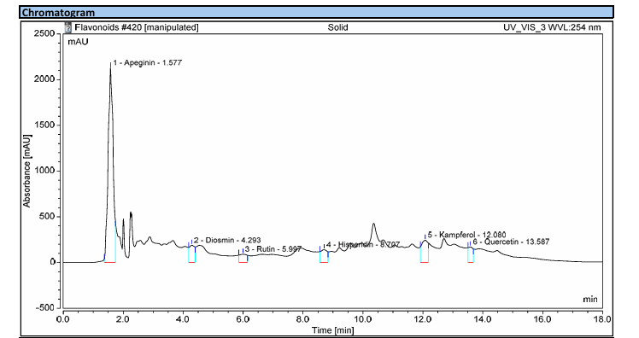

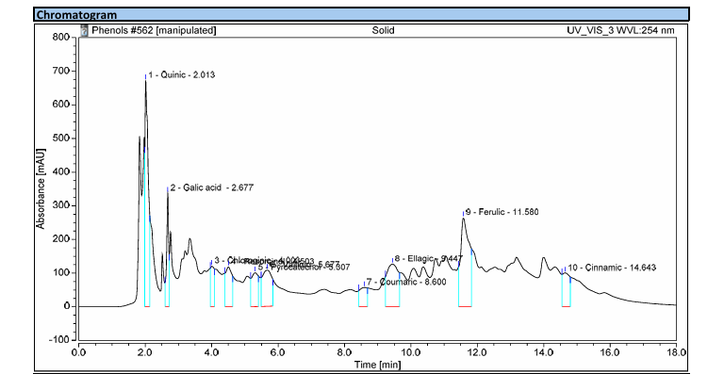Figure S1: Quantitative profiling of polyphenolics in RJ using HPLC Analysis. A: Flavenoides, b: Phenols

