Supplementary Information
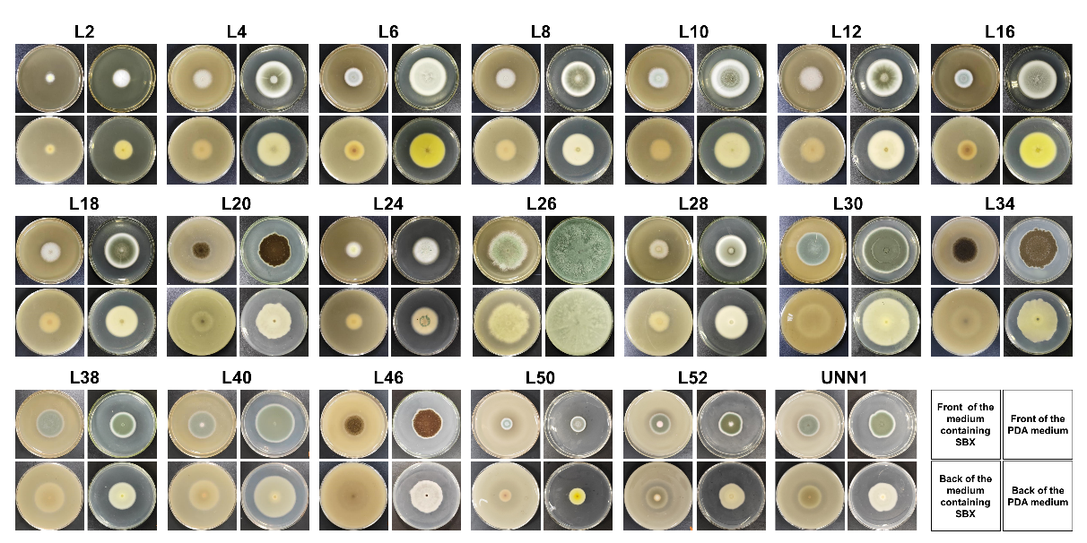
Fig. S1 Plate phenotypes of 20 xylanase-active strains. In this experiment, 2 μL of pure fungal spore suspension was inoculated onto a solid medium, followed by incubation at 28°C for 5 days before photographing and observation. SBX: sugarcane bagasse xylan (alkaline-extracted). PDA: potato dextrose agar

