research process

The first step: image preprocessing

Software: python pytorch

Code

import SimpleITK as sitk
import warnings
import glob
import numpy as np
import cv2
import numpy
import dicom
from matplotlib import pyplot as plt

imagePath = '/ Users/desk/data/breastcancer/YUAN LI PING.dcm '

input_image = sitk.readImage(imagePath)
mask_image = sitk.OtsuThreshold(input_image, 0, 1, 200)
input_image = sitk.Cast(input_image, sitk.sitkFloat32)
corrector = N4BiasFieldCorrectionImageFilter()
output_image = corrector.Execute(input_image, input_image)
output_image = sitk.Cast(output_image, sitk.sitkFloat16)
sitk.writeImage(output_image, '/Users/desk/data/breastcancer/YUAN LI PING.N4.dcm/'

The second step, image processing
Software: MATLAB 2018b MR Radiomics Platform

MR Radiomics Platform (MRP, http://www.ym.edu.tw/~cflu/MRP_MLinglioma.html).

Enter the software
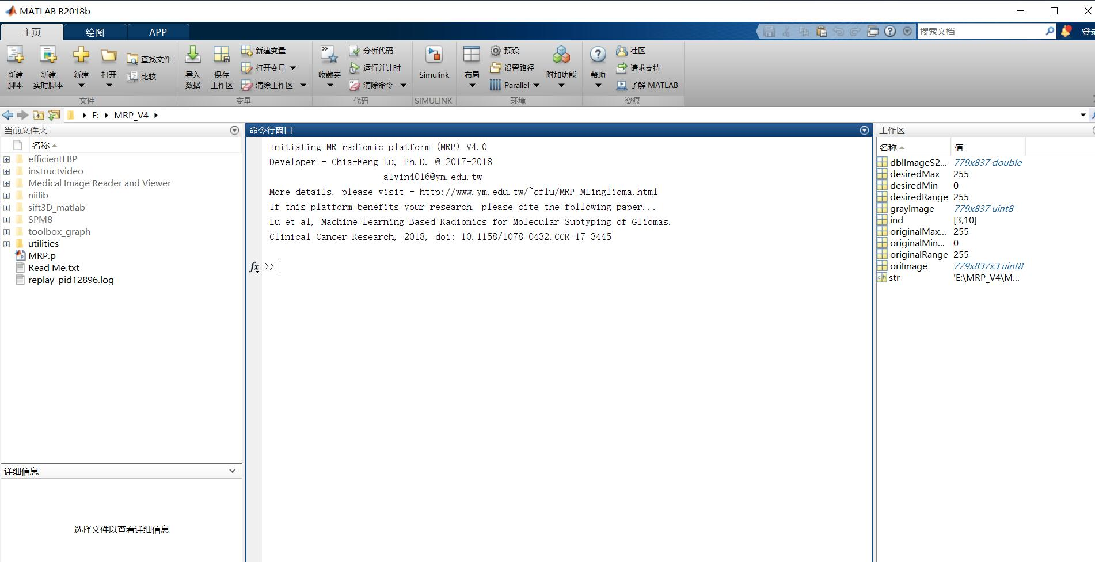

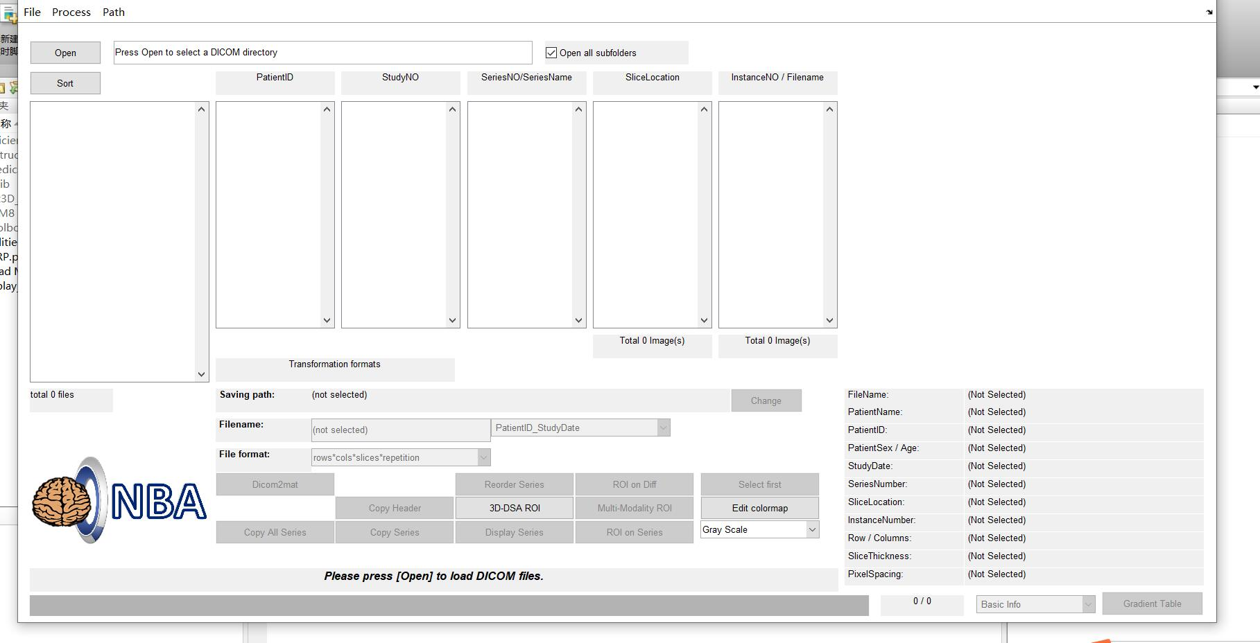

Read image
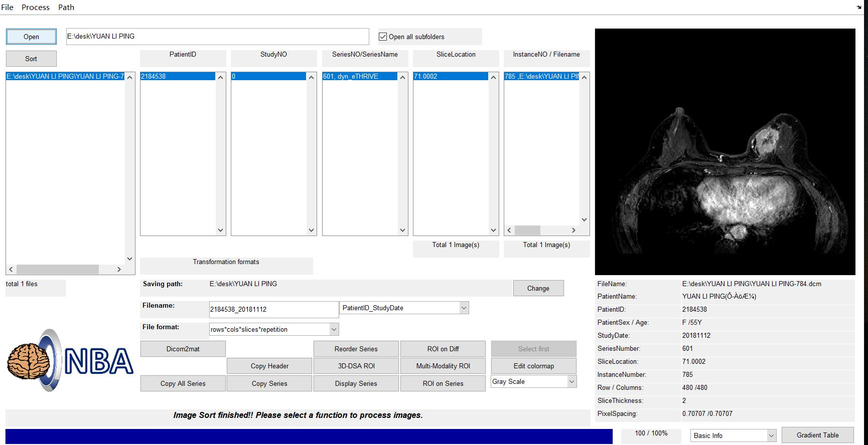

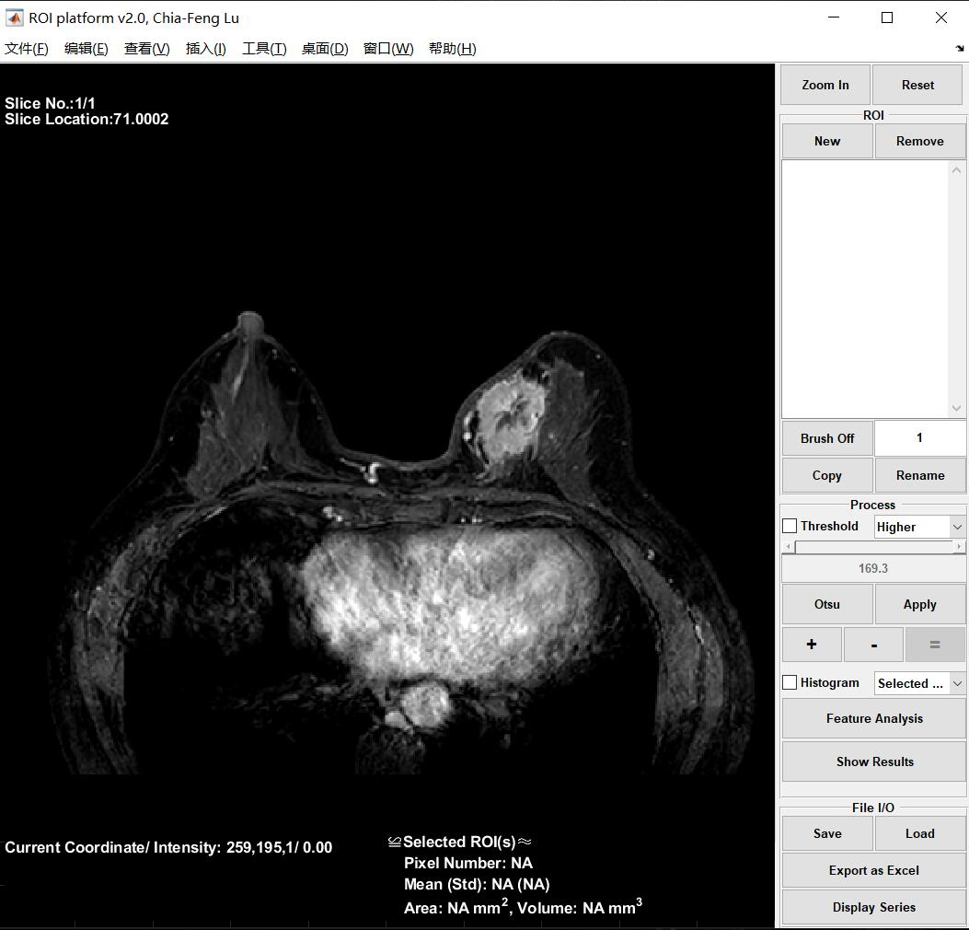
Draw ROI

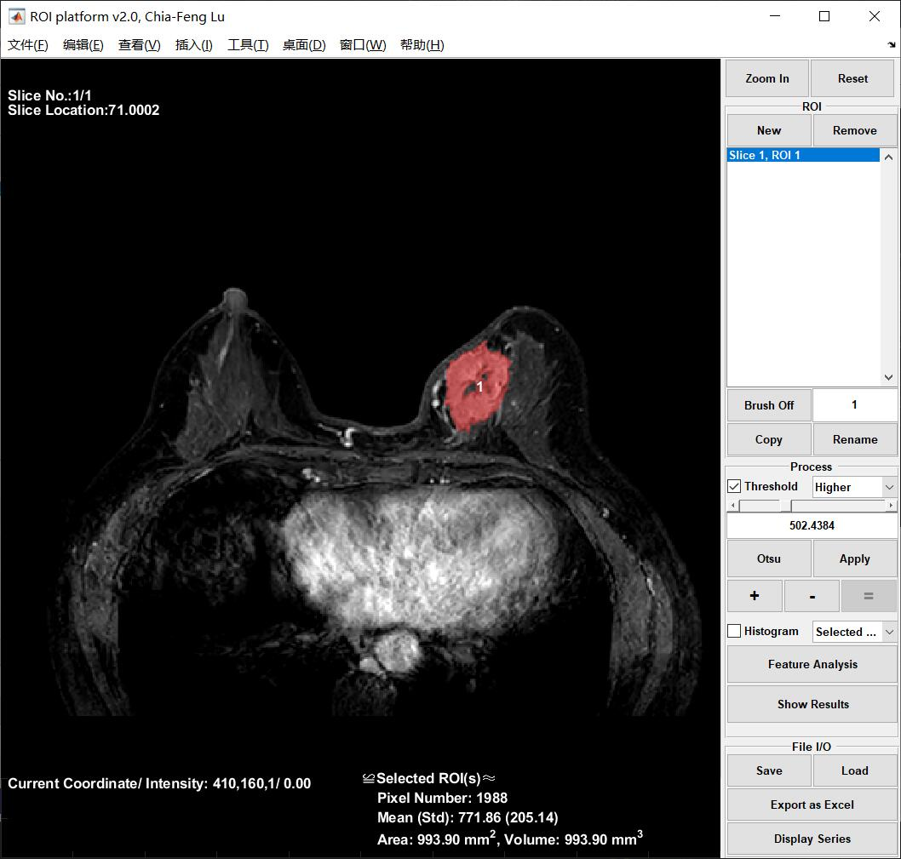

Calculate radiomics parameters
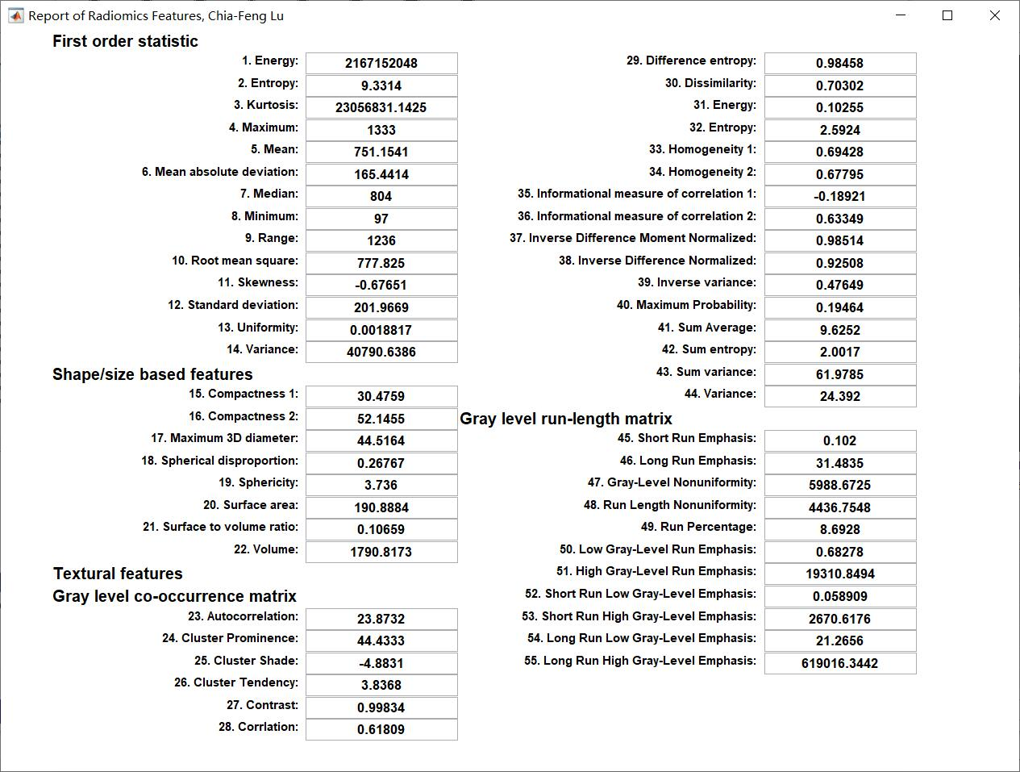

feature screening
Software R 3.6.2 Statistics package glmnet

code
data1 <- read.csv('E:\\desk\\training.csv')
x <- model.matrix(CLASS~.,data1)
x <- x[,-1]
y <- data1$CLASS
fit <- glmnet(x,y,alpha = 1,family = 'binomial')
plot(fit,xvar = "lambda",label = TRUE)
print(fit)
cv.fit <- cv.glmnet(x,y,alpha=1)
plot(cv.fit)
abline(v=log(c(cv.fit$lambda.min,cv.fit$lambda.1se)),lty=2)
plot(fit,xvar = "lambda",label = TRUE)
abline(v=log(c(cv.fit$lambda.min)),lty=1)
cv.fit$lambda.min
Coefficients <- coef(fit, s = cv.fit$lambda.min)
Active.Index <- which(Coefficients != 0)
Active.Coefficients <- Coefficients[Active.Index]
Active.Index
Active.Coefficients
row.names(Coefficients)[Active.Index]
predict(fit,s = cv.fit$lambda.min,type = "coefficients")

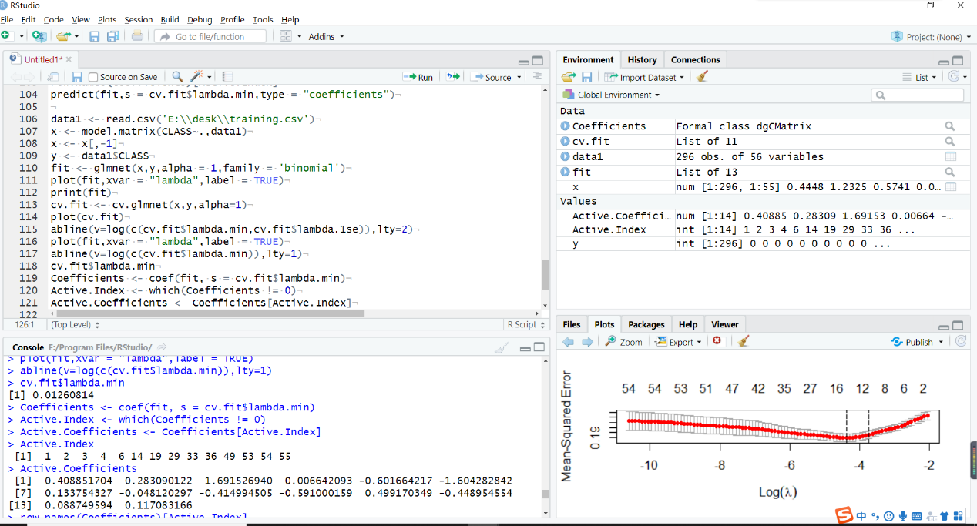
import results

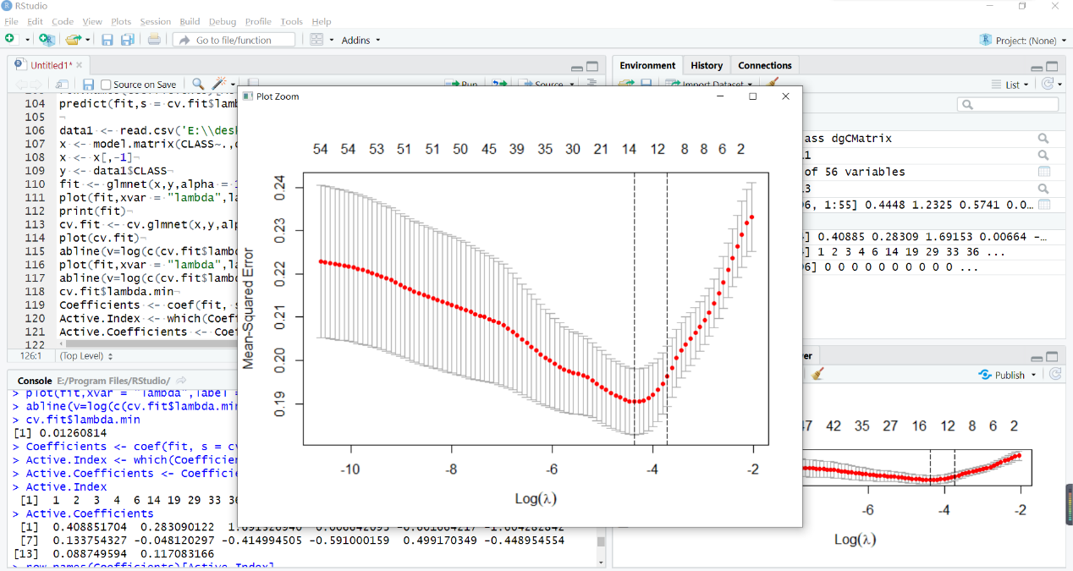

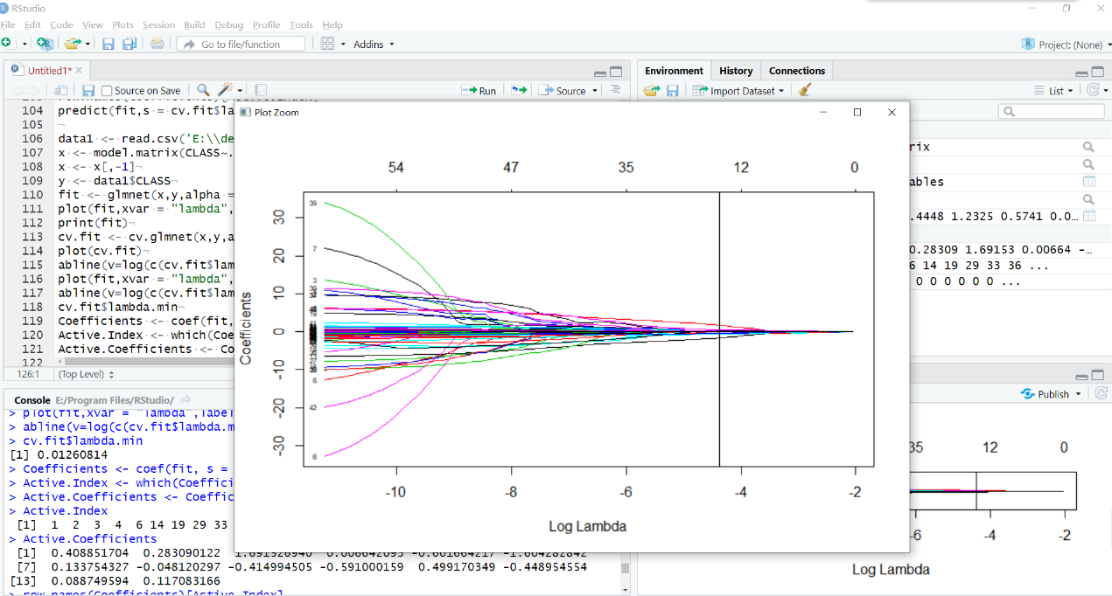

data1 <- read.csv('E:\\desk\\training.csv')
> x <- model.matrix(CLASS~.,data1)
> x <- x[,-1]
> y <- data1$CLASS
> fit <- glmnet(x,y,alpha = 1,family = 'binomial')
> plot(fit,xvar = "lambda",label = TRUE)
> print(fit)

Call: glmnet(x = x, y = y, family = "binomial", alpha = 1)

Df %Dev Lambda
1 0 0.00000 0.129000
2 2 0.01067 0.117600
3 2 0.02378 0.107100
4 4 0.03742 0.097620
5 4 0.05096 0.088950
6 5 0.06653 0.081050
7 5 0.08037 0.073850
8 6 0.09269 0.067290
9 6 0.10340 0.061310
10 6 0.11280 0.055860
11 8 0.12150 0.050900
12 8 0.13230 0.046380
13 8 0.14190 0.042260
14 8 0.15040 0.038500
15 9 0.15810 0.035080
16 10 0.17180 0.031970
17 10 0.18470 0.029130
18 11 0.19660 0.026540
19 11 0.20730 0.024180
20 11 0.21680 0.022030
21 12 0.22540 0.020080
22 12 0.23330 0.018290
23 12 0.24030 0.016670
24 12 0.24650 0.015190
25 12 0.25200 0.013840
26 13 0.25690 0.012610
27 14 0.26170 0.011490
28 16 0.26790 0.010470
29 16 0.27360 0.009538
30 17 0.27900 0.008690
31 17 0.28480 0.007918
32 18 0.29140 0.007215
33 19 0.29800 0.006574
34 20 0.30530 0.005990
35 21 0.31180 0.005458
36 24 0.31890 0.004973
37 26 0.32560 0.004531
38 28 0.33250 0.004129
39 30 0.33960 0.003762
40 32 0.34650 0.003428
41 33 0.35270 0.003123
42 34 0.35840 0.002846
43 35 0.36370 0.002593
44 35 0.36840 0.002363
45 36 0.37260 0.002153
46 38 0.37660 0.001961
47 39 0.38070 0.001787
48 40 0.38490 0.001628
49 40 0.38890 0.001484
50 41 0.39260 0.001352
51 43 0.39630 0.001232
52 44 0.39950 0.001122
53 43 0.40300 0.001023
54 43 0.40600 0.000932
55 43 0.40850 0.000849
56 42 0.41070 0.000774
57 42 0.41240 0.000705
58 42 0.41380 0.000642
59 43 0.41510 0.000585
60 45 0.41660 0.000533
61 47 0.41880 0.000486
62 48 0.42120 0.000443
63 48 0.42330 0.000403
64 47 0.42520 0.000368
65 47 0.42690 0.000335
66 47 0.42840 0.000305
67 49 0.42970 0.000278
68 50 0.43080 0.000253
69 50 0.43210 0.000231
70 49 0.43420 0.000210
71 49 0.43440 0.000192
72 48 0.43490 0.000175
73 50 0.43630 0.000159
74 49 0.43700 0.000145
75 50 0.43800 0.000132
76 50 0.44000 0.000120
77 50 0.44160 0.000110
78 51 0.44290 0.000100
79 51 0.44400 0.000091
80 52 0.44500 0.000083
81 53 0.44600 0.000076
82 52 0.44680 0.000069
83 53 0.44760 0.000063
84 54 0.44820 0.000057
85 54 0.44880 0.000052
86 54 0.44940 0.000047
87 54 0.45000 0.000043
88 54 0.45040 0.000039
89 54 0.45090 0.000036
90 54 0.45130 0.000033
91 54 0.45160 0.000030
92 54 0.45190 0.000027
93 54 0.45220 0.000025
94 54 0.45240 0.000023
95 54 0.45270 0.000021
96 54 0.45290 0.000019
97 54 0.45310 0.000017
98 55 0.45320 0.000016
99 55 0.45340 0.000014
100 55 0.45350 0.000013
> cv.fit <- cv.glmnet(x,y,alpha=1)
> plot(cv.fit)
> abline(v=log(c(cv.fit$lambda.min,cv.fit$lambda.1se)),lty=2)
> abline(v=log(c(cv.fit$lambda.min,cv.fit$lambda.1se)),lty=2)
> plot(fit,xvar = "lambda",label = TRUE)
> abline(v=log(c(cv.fit$lambda.min)),lty=1)
> cv.fit$lambda.min
[1] 0.01260814
> Coefficients <- coef(fit, s = cv.fit$lambda.min)
> Active.Index <- which(Coefficients != 0)
> Active.Coefficients <- Coefficients[Active.Index]
> Active.Index
[1] 1 2 3 4 6 14 19 29 33 36 49 53 54 55
> Active.Coefficients
[1] 0.408851704 0.283090122 1.691526940 0.006642093 -0.601664217 -1.604282842
[7] 0.133754327 -0.048120297 -0.414994505 -0.591000159 0.499170349 -0.448954554
[13] 0.088749594 0.117083166
> row.names(Coefficients)[Active.Index]
[1] "(Intercept)"
[2] "X1..Energy"
[3] "X2..Entropy"
[4] "X3..Kurtosis"
[5] "X5..Mean"
[6] "X13..Uniformity"
[7] "X18..Spherical.disproportion"
[8] "X28..Corrlation"
[9] "X32..Entropy"
[10] "X35..Informational.measure.of.correlation.1..IMC1."
[11] "X48..Run.Length.Nonuniformity..RLN."
[12] "X52..Short.Run.Low.Gray.Level.Emphasis..SRLGLE."
[13] "X53..Short.Run.High.Gray.Level.Emphasis..SRHGLE."
[14] "X54..Long.Run.Low.Gray.Level.Emphasis..LRLGLE."
> predict(fit,s = cv.fit$lambda.min,type = "coefficients")
56 x 1 sparse Matrix of class "dgCMatrix"
1
(Intercept) 0.408851704
X1..Energy 0.283090122
X2..Entropy 1.691526940
X3..Kurtosis 0.006642093
X4..Maximum .
X5..Mean -0.601664217
X6..Mean.absolute.deviation .
X7..Median .
X8.Minimum .
X9..Range .
X10..Root.mean.square .
X11..Skewness .
X12..Standard.deviation .
X13..Uniformity -1.604282842
X14..Variance .
X15..Compactness.1 .
X16..Compactness.2 .
X17..Maximum.3D.diameter .
X18..Spherical.disproportion 0.133754327
X19..Sphericity .
X20..Surface.area .
X21..Surface.to.volume.ratio .
X22..Volume .
X23..Autocorrelation .
X24..Cluster.Prominence .
X25..Cluster.Shade .
X26..Cluster.Tendency .
X27..Contrast .
X28..Corrlation -0.048120297
X29..Difference.entropy .
X30..Dissimilarity .
X31..Energy .
X32..Entropy -0.414994505
X33..Homogeneity.1 .
X34..Homogeneity.2 .
X35..Informational.measure.of.correlation.1..IMC1. -0.591000159
X36..Informational.measure.of.correlation.2..IMC2. .
X37..Inverse.Difference.Moment.Normalized..IDMN. .
X38..Inverse.Difference.Normalized..IDN. .
X39..Inverse.variance .
X40..maximum.Probability .
X41..Sum.Average .
X42..Sum.entropy .
X43..Sum.variance .
X44..Variance .
X45..Short.Run.Emphasis..SRE. .
X46..Long.Run.Emphasis..LRE. .
X47..Long.Run.Emphasis..LRE. .
X48..Run.Length.Nonuniformity..RLN. 0.499170349
X49..Run.Percentage..RP. .
X50..Low.Grag.Level.Run.Emphsis..LGLRE. .
X51..High.Grag.Level.Run.Emphsis..HGLRE. .
X52..Short.Run.Low.Gray.Level.Emphasis..SRLGLE. -0.448954554
X53..Short.Run.High.Gray.Level.Emphasis..SRHGLE. 0.088749594
X54..Long.Run.Low.Gray.Level.Emphasis..LRLGLE. 0.117083166
X55..Long.Run.High.Gray.Level.Emphasis..LRHGLE. .

Radiomics signature
0.408851704＋X1..Energy ×0.283090122 ＋ X2..Entropy ×1.691526940 ＋ X3..Kurtosis× 0.006642093 ＋Mean ×-0.601664217＋Uniformity× -1.604282842＋Spherical.disproportion× 0.133754327 ＋Corrlation× -0.048120297 ＋Entropy× -0.414994505＋Informational.measure.of.correlation.1..IMC1× -0.591000159 ＋ Run.Length.Nonuniformity..RLN× 0.499170349＋Short.Run.Low.Gray.Level.Emphasis..SRLGLE× -0.448954554＋Short.Run.High.Gray.Level.Emphasis..SRHGLE× 0.088749594 ＋ Long.Run.Low.Gray.Level.Emphasis..LRLGLE ×0.117083166

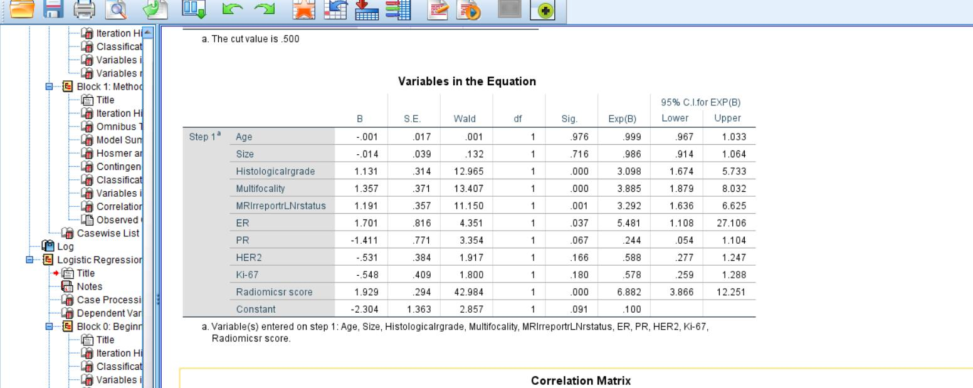
The statistical analysis of clinical data uses SPSS software

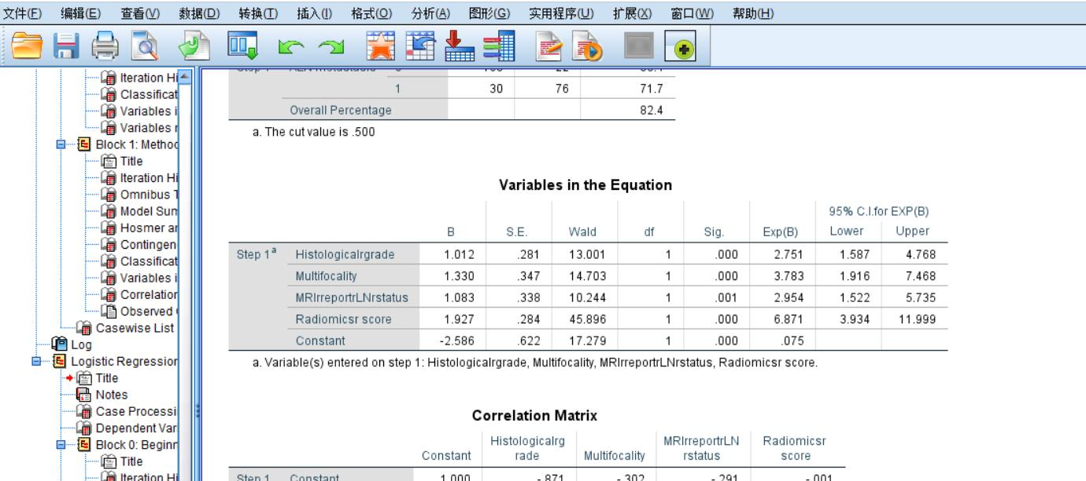

Nomogram and calibration curve

code
data1 <- read.csv('E:\\desk\\nomogram.validation.csv')
model1 <- glm(CLASS~Histologicalrgrade+Multifocality+MRIrreportrLNrstatus+Radiomicsrscore,data = data1,family = binomial())
summary(model1)

exp(coef(model1))#计算OR值和可信区间
exp(confint(model1))

ddist <- datadist(data1)
options(datadist = 'ddist')
model2 <- lrm(CLASS~Histologicalrgrade+Multifocality+MRIrreportrLNrstatus+Radiomicsrscore,data = data1)
nom <- nomogram(model2,fun = plogis,funlabel = "Lymph Node Metastasis Risk",lp = F)
plot(nom)
model3 <- lrm(CLASS~Histologicalrgrade+Multifocality+MRIrreportrLNrstatus+Radiomicsrscore,x = T,y = T,data = data1)
cal <- rms::calibrate(model3,method = "boot", B = 1000,bw = T,rule = 'p',sls = 0.05)
plot(cal,main = "Calibration Curve")

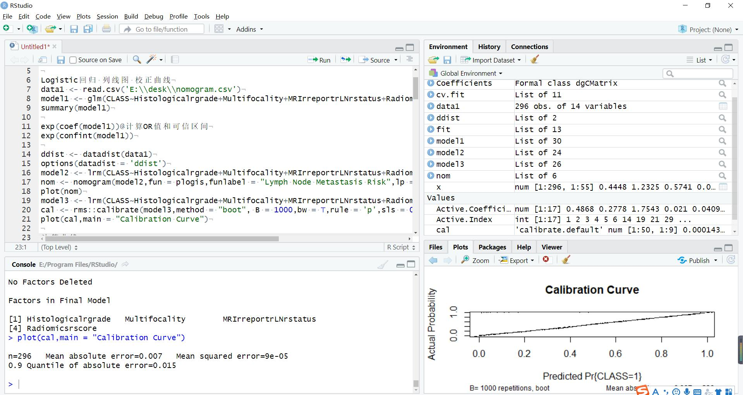

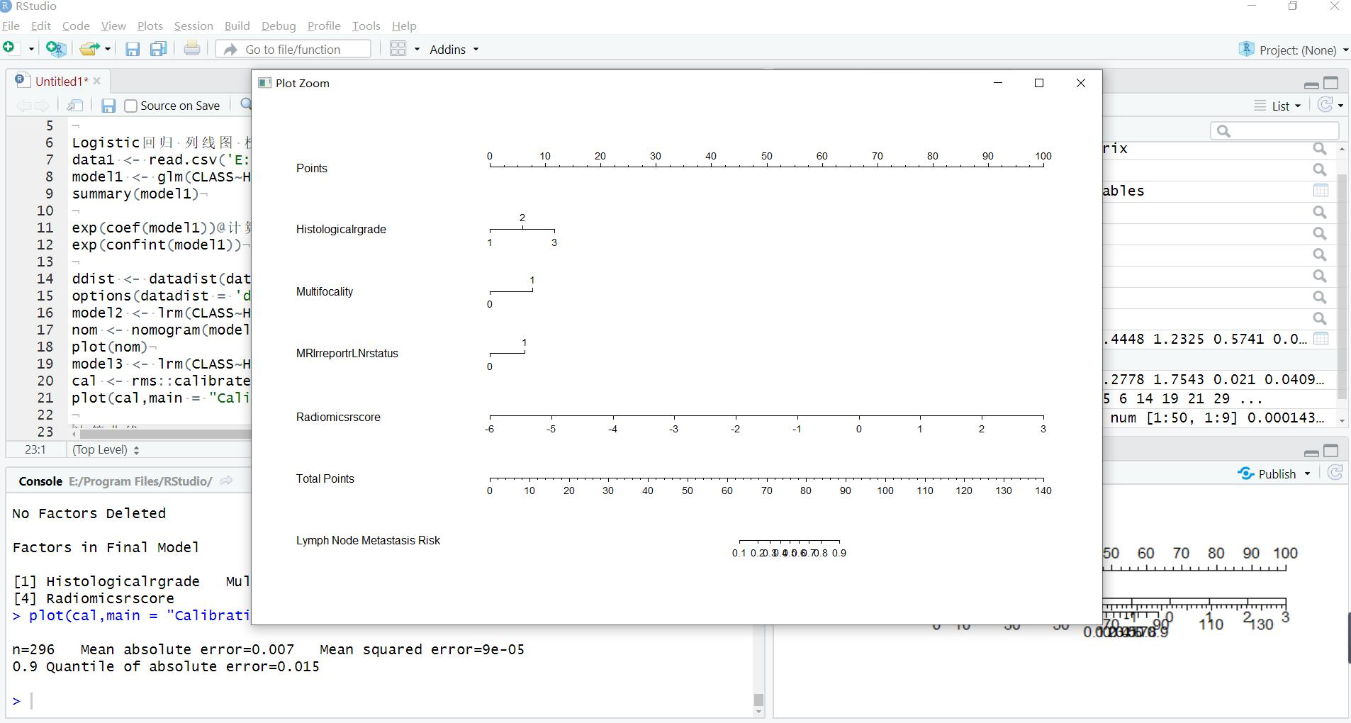

Training cohort calibration curve
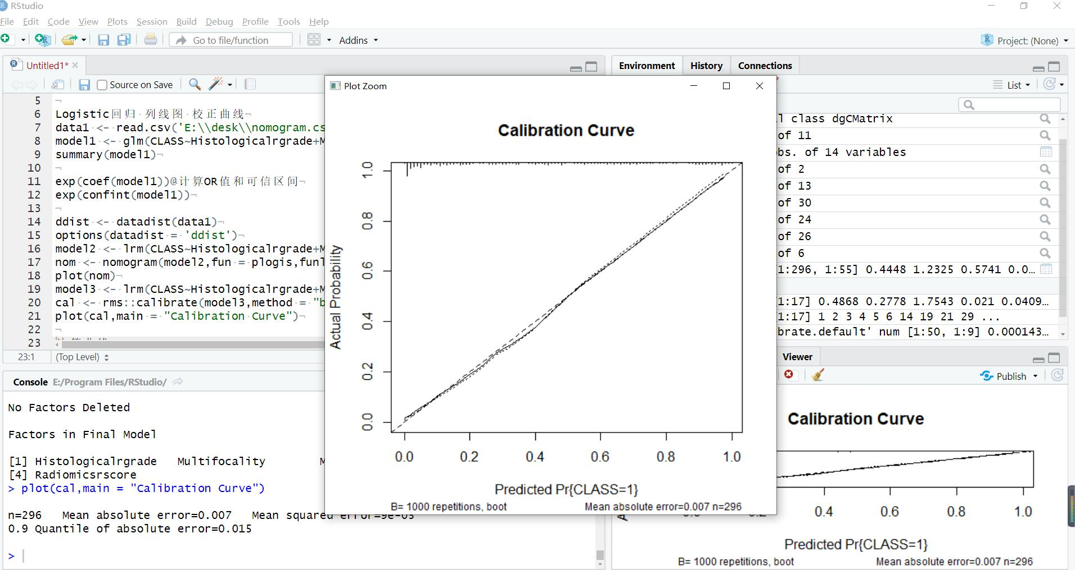

Validation cohort calibration curve
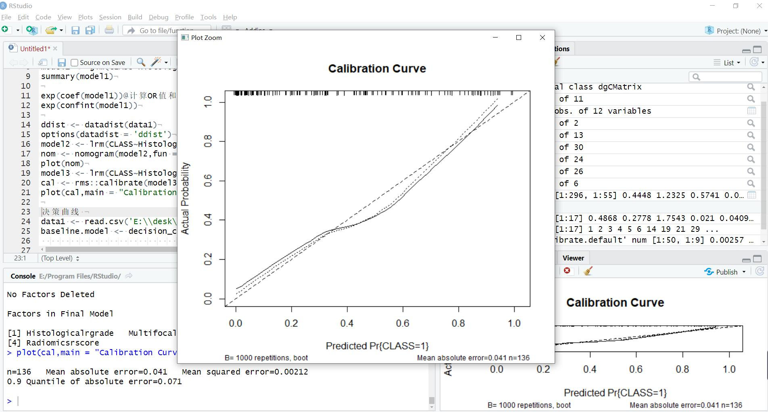

Import results

data1 <- read.csv('E:\\desk\\nomogram.csv')
> model1 <- glm(CLASS~Histologicalrgrade+Multifocality+MRIrreportrLNrstatus+Radiomicsrscore,data = data1,family = binomial())
> summary(model1)

Call:
glm(formula = CLASS ~ Histologicalrgrade + Multifocality + MRIrreportrLNrstatus +
Radiomicsrscore, family = binomial(), data = data1)

Deviance Residuals:
Min 1Q Median 3Q Max
-2.3203 -0.5768 -0.1813 0.5018 2.9337

Coefficients:
Estimate Std. Error z value Pr(>|z|)
(Intercept) -2.5861 0.6221 -4.157 3.23e-05 ***
Histologicalrgrade 1.0119 0.2806 3.606 0.000311 ***
Multifocality 1.3305 0.3470 3.835 0.000126 ***
MRIrreportrLNrstatus 1.0832 0.3384 3.201 0.001371 **
Radiomicsrscore 1.9273 0.2845 6.775 1.25e-11 ***
---
Signif. codes: 0 ‘***’ 0.001 ‘**’ 0.01 ‘*’ 0.05 ‘.’ 0.1 ‘ ’ 1

(Dispersion parameter for binomial family taken to be 1)

Null deviance: 386.17 on 295 degrees of freedom
Residual deviance: 226.96 on 291 degrees of freedom
AIC: 236.96

Number of Fisher Scoring iterations: 6

> exp(coef(model1))@计算OR值和可信区间
> exp(confint(model1))
Waiting for profiling to be done...
2.5 % 97.5 %
(Intercept) 0.02108816 0.2444555
Histologicalrgrade 1.61388633 4.8771587
Multifocality 1.94070713 7.6013337
MRIrreportrLNrstatus 1.53696003 5.8209260
Radiomicsrscore 4.12060195 12.6172144
> ddist <- datadist(data1)
> options(datadist = 'ddist')
> model2 <- lrm(CLASS~Histologicalrgrade+Multifocality+MRIrreportrLNrstatus+Radiomicsrscore,data = data1)
> nom <- nomogram(model2,fun = plogis,funlabel = "Lymph Node Metastasis Risk",lp = F)
> plot(nom)
> model3 <- lrm(CLASS~Histologicalrgrade+Multifocality+MRIrreportrLNrstatus+Radiomicsrscore,x = T,y = T,data = data1)
> cal <- rms::calibrate(model3,method = "boot", B = 1000,bw = T,rule = 'p',sls = 0.05)# 做不出图可删除B后面的命令。

Backwards Step-down - Original Model

No Factors Deleted

Factors in Final Model

[1] Histologicalrgrade Multifocality MRIrreportrLNrstatus
[4] Radiomicsrscore
> plot(cal,main = "Calibration Curve")

ROC curve
Software MedCalc

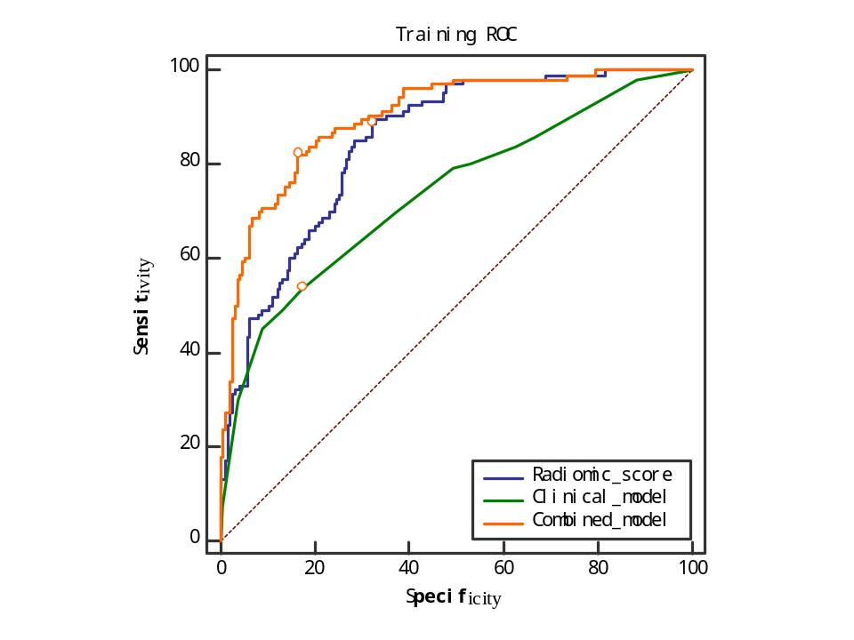
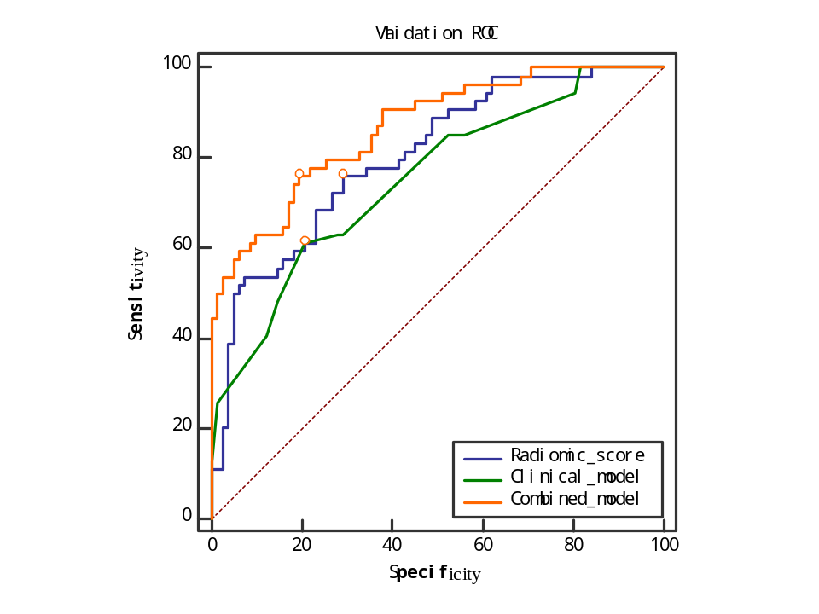

Decision curve
Software :R 3.6.2
Code

data1 <- read.csv('E:\\desk\\nomogram.csv')
baseline.model <- decision_curve(CLASS~Histologicalrgrade+Multifocality+MRIrreportrLNrstatus+Radiomicsrscore,
data = data1,
thresholds = seq(0,1, by = .005),
bootstraps = 10)

plot_decision_curve(baseline.model,curve.names = "baseline model")

set.seed(123)

plot_decision_curve( list(baseline.model),
curve.names = c("Baseline model"),
col = c("blue"),
lty = c(1),
lwd = c(1),
legend.position = "bottomright")

plot_decision_curve( list(baseline.model),
curve.names = c("Baseline model"),
col = c("blue"),
confidence.intervals = FALSE, #remove confidence intervals
cost.benefit.axis = FALSE, #remove cost benefit axis
legend.position = "none") #remove the legend

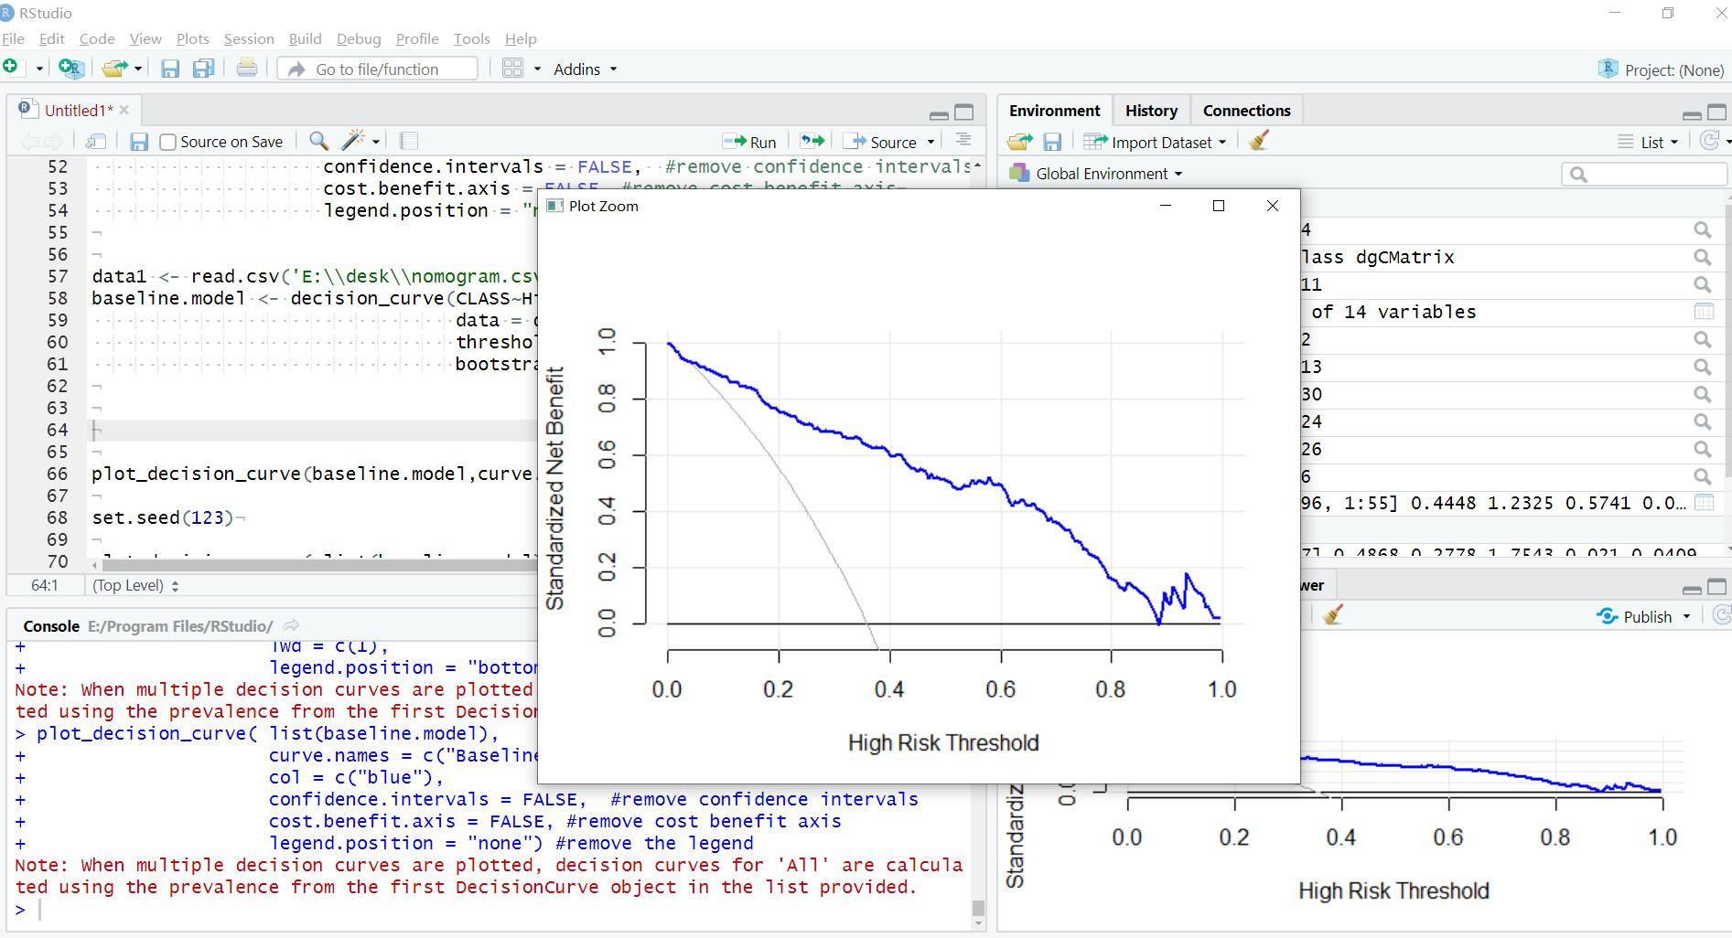

All the data are in the supplementary materials. All pictures are redrawn using Photoshop.
if you encounter any problems using the code, please contact me.

Deling Song
Email: s312016581@163.com

