Supplementary Material for

Nomograms Integrating CT Radiomic and Deep Learning Signatures to Predict Overall Survival and Progression-free Survival in NSCLC Patients with Chemotherapy

Fig. S1. Structure of deep learning models.
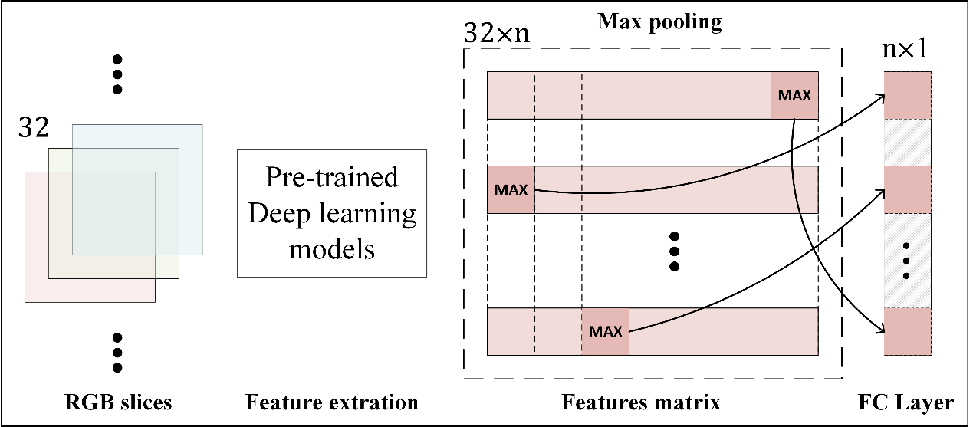

Fig. S2. Kaplan-Meier curves of TNM stage for over- and under-expression subgroups: A, Kaplan-Meier curves in OS; B, Kaplan-Meier curves in PFS.

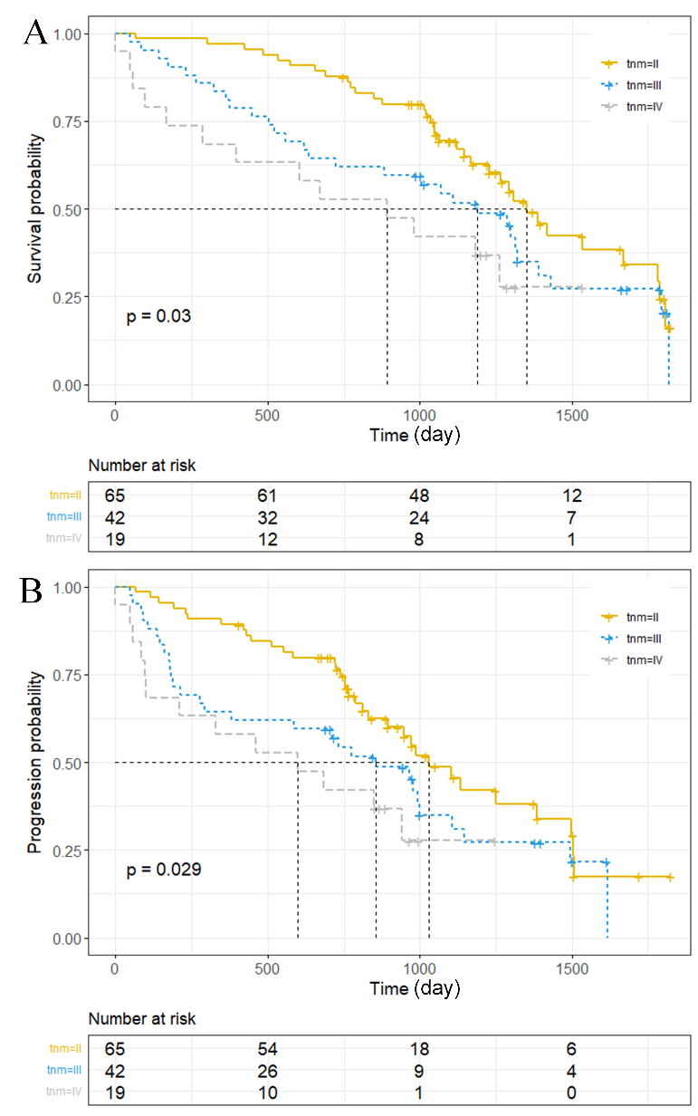

Fig. S3. Kaplan-Meier curves of S1 for over- and under-expression subgroups: A, Kaplan-Meier curves in OS; B, Kaplan-Meier curves in PFS.
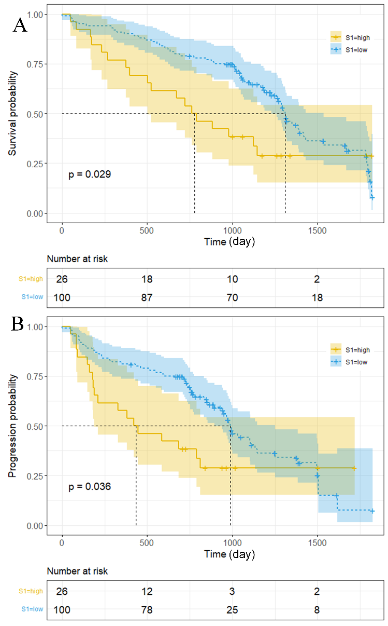

Fig. S4. Kaplan-Meier curves of S3 for over- and under-expression subgroups: A, Kaplan-Meier curves in OS; B, Kaplan-Meier curves in PFS.
