Supplementary Materials
Appendix 1: CHEERS Checklist
Topic | No. | Item | Location where item is reported
Title
Title | 1 | Identify the study as an economic evaluation and specify the interventions being compared. | Title, Page 1
Abstract
Abstract | 2 | Provide a structured summary that highlights context, key methods, results, and alternative analyses. | Abstract, Page 2
Introduction
Background and objectives | 3 | Give the context for the study, the study question, and its practical relevance for decision making in policy or practice. | Introduction, Paragraph 2
Methods
Health economic analysis plan | 4 | Indicate whether a health economic analysis plan was developed and where available. | Yes, written in the clinical trial protocol.
Study population | 5 | Describe characteristics of the study population (such as age range, demographics, socioeconomic, or clinical characteristics). | Methods, Paragraph 1
Setting and location | 6 | Provide relevant contextual information that may influence findings. | Methods, Paragraph 1
Comparators | 7 | Describe the interventions or strategies being compared and why chosen. | Methods, Paragraph 2
Perspective | 8 | State the perspective(s) adopted by the study and why chosen. | Methods, Paragraph 2
Time horizon | 9 | State the time horizon for the study and why appropriate. | Methods, Paragraph 2
Discount rate | 10 | Report the discount rate(s) and reason chosen. | Not reported as not required due to short time horizon
Selection of outcomes | 11 | Describe what outcomes were used as the measure(s) of benefit(s) and harm(s). | Methods, Paragraph 4
Measurement of outcomes | 12 | Describe how outcomes used to capture benefit(s) and harm(s) were measured. | Methods, Paragraph 4
Valuation of outcomes | 13 | Describe the population and methods used to measure and value outcomes. | Not reported (referenced clinical paper)
Measurement and valuation of resources and costs | 14 | Describe how costs were valued. | Methods, Paragraph 3
Currency, price date, and conversion | 15 | Report the dates of the estimated resource quantities and unit costs, plus the currency and year of conversion. | Methods, Paragraph 3
Rationale and description of model | 16 | If modelling is used, describe in detail and why used. Report if the model is publicly available and where it can be accessed. | Not applicable
Analytics and assumptions | 17 | Describe any methods for analysing or statistically transforming data, any extrapolation methods, and approaches for validating any model used. | Not applicable
Characterising heterogeneity | 18 | Describe any methods used for estimating how the results of the study vary for subgroups. | Methods, Paragraphs 7
Characterising distributional effects | 19 | Describe how impacts are distributed across different individuals or adjustments made to reflect priority populations. | Not considered
Characterising uncertainty | 20 | Describe methods to characterise any sources of uncertainty in the analysis. | Methods, Paragraphs 5 & 7
Approach to engagement with patients and others affected by the study | 21 | Describe any approaches to engage patients or service recipients, the general public, communities, or stakeholders (such as clinicians or payers) in the design of the study. | Not reported
Results
Study parameters | 22 | Report all analytic inputs (such as values, ranges, references) including uncertainty or distributional assumptions. | Results (Table 1), Appendices 2 & 3
Summary of main results | 23 | Report the mean values for the main categories of costs and outcomes of interest and summarise them in the most appropriate overall measure. | Results, Paragraphs 4 & 5
Effect of uncertainty | 24 | Describe how uncertainty about analytic judgments, inputs, or projections affect findings. Report the effect of choice of discount rate and time horizon, if applicable. | Results, Paragraph 5
Effect of engagement with patients and others affected by the study | 25 | Report on any difference patient/service recipient, general public, community, or stakeholder involvement made to the approach or findings of the study | Not reported
Discussion
Study findings, limitations, generalisability, and current knowledge | 26 | Report key findings, limitations, ethical or equity considerations not captured, and how these could affect patients, policy, or practice. | Discussion
Other relevant information
Source of funding | 27 | Describe how the study was funded and any role of the funder in the identification, design, conduct, and reporting of the analysis | End of manuscript
Conflicts of interest | 28 | Report authors conflicts of interest according to journal or International Committee of Medical Journal Editors requirements. | End of manuscript

From: Husereau D, Drummond M, Augustovski F, et al. Consolidated Health Economic Evaluation Reporting Standards 2022 (CHEERS 2022) Explanation and Elaboration: A Report of the ISPOR CHEERS II Good Practices Task Force. Value Health 2022;25. https://don-husereau.shinyapps.io/CHEERS/

Appendix 2: Unit cost resources table for costing
Item | Unit cost (AUD$ 2020) | Source
HOSPITALISATION | (per day)
Inpatient stay related to febrile neutropenia | 2931.44 | [1]
ICU admission | 210 | [2]
ANTIMICROBIALS | Varies depending on the medication | PMCC Pharmacy Department
DIAGNOSTIC IMAGING | (per scan)
FDG PET | 953 | MBS item number 61523
X-ray chest | 47.15 | MBS item number 58503
X-ray foot | 43.4 | MBS item number 57521
X-ray abdomen | 35.7 | MBS item number 58900
CTPA | 473.84 | MBS item number 57357
HRCT | 400 | MBS item number 56307
CT abdomen + pelvis (+/- neck) | 560 | MBS item number 56807
CT head | 250 | MBS item number 56013
CT kidneys, ureter, bladder | 155.2 | MBS item number 57201
CT upper abdomen | 360 | MBS item number 56407
CT upper abdomen + pelvis | 480.05 | MBS item number 56507
CT brain, chest (+/- upper abdomen) | 567.75 | MBS item number 57007
CT pelvis | 360 | MBS item number 56412
CT chest | 400 | MBS item number 56307
CT para sinuses | 336.8 | MBS item number 56028
CT neck | 340 | MBS item number 56107
CT thoracic spine | 351.4 | MBS item number 56225
CT angiography | 1307.71 | MBS item number 57353, 35321
MRI brain | 403.2 | MBS item number 63001
MRI brain and cervical spine | 492.8 | MBS item number 63111
MRI cholangiogram | 457.2 | MBS item number 63740
MRI full spine, brain | 448 | MBS item number 63201
MRI lumbar spine | 358.4 | MBS item number 63151
MRI perineum | 403.2 | MBS item number 63743
MRI thoracic and lumbar spine | 358.4 | MBS item number 63151
Gastrograffin follow through | 110.25 | MBS item number 58912
Nuclear medicine imaging GI bleed | 496.95 | MBS item number 61364
Nuclear medicine imaging renal | 332.5 | MBS item number 61386
Nasendoscopy | 124.8 | MBS item number 41764
Orthopantomography | 47.4 | MBS item number 57960
US doppler leg vein (both) | 283.81 | MBS item number 55886, 55244
US injection into joint | 152.85 | MBS item number 55850
US left upper limb | 169.5 | MBS item number 55252
US liver | 111.3 | MBS item number 55036
US neck | 109.1 | MBS item number 55032
US neck and right upper limb | 212.11 | MBS item number 55032, 55864
US pelvis female | 98.25 | MBS item number 55065
US renal tract | 109.1 | MBS item number 55038
US right chest wall | 109.1 | MBS item number 55812
US right foot | 109.1 | MBS item number 55892
US right upper limb | 103.01 | MBS item number 55864
US salivary gland | 109.1 | MBS item number 55030
US shoulder | 103.01 | MBS item number 55864
US testes | 109.5 | MBS item number 55048
US upper abdomen (+/-) urinary tract | 111.3 | MBS item number 55036
Ventilation perfusion scan | 443.35 | MBS item number 61348
INVASIVE DIAGNOSTICS | (per procedure)
Diagnostic biopsy
Skin | 53.05 | MBS item number 30071
Lymph node | 152.15 | MBS item number 30075
Punch biopsy of vulva lesion | 66.45 | MBS item numbers 36515
Bronchoscopy including anaesthesia | 381.9 | MBS item numbers 41889, 20520, 23045
Echocardiography
TTE (Transthoracic) | 214.33 | MBS item number 55126
Surgical procedures
Bilateral JJ stent insertion | 974.45 | MBS item numbers 36633, 20806, 20806
CT guided lung biopsy | 373.3 | MBS item numbers 38812, 20522, 20806
L. intercostal catheter insertion | 414.55 | MBS item numbers 38436, 20522, 20806
Angioembolisation of SMA | 1007.2 | MBS item numbers 35410, 20740, 20806
Colonoscopy | 339.7 | MBS item numbers 32223
Colonoscopy with APC | 1623.7 | MBS item numbers 30684, 20810, 20806
Lung wedge resection | 1587.65 | MBS item numbers 38440, 20540, 23085
Sigmoidoscopy | 213.65 | MBS item numbers 32084, 20900, 23025
Subdural haematoma evac | 602.1 | MBS item numbers 31551, 20305, 20806
Tooth extraction | 55.8 | MBS item numbers 75200
MICROBIOLOGY PATHOLOGY TESTS | (per test)
Blood culture | 30.75 | MBS item number 69354
Laboratory pathology tests
Stool | 52.9 | MBS item number 69345
Blood | 30.75 | MBS item number 69354
Hickman site | 48.15 | MBS item number 69321
Mouth | 22 | MBS item number 69303
Other | 48.15 | MBS item number 69321
Pleural | 48.15 | MBS item number 69321
Skin | 33.75 | MBS item number 69306
Sputum | 33.75 | MBS item number 69318
Urine | 43 | MBS item number 69324
Urogenital | 33.75 | MBS item number 69312
Vulval biopsy | 33.75 | MBS item number 69312
Cytology | 48.6 | MBS item number 73045
PCR | 28.65 | MBS item number 69494
Fungal culture | 48.15 | MBS item number 69309
Panfungal PCR | 133.58 | [2]
CVC RE-INSERTION | (per procedure)
Hickman or Permacath insertion | 560.45 | MBS item number 34527
PICC insertion | 115.45 | MBS item number 13815

[1] Lingaratnam S, Thursky K, Slavin M, Kirsa S, Bennett C, Worth L. The disease and economic burden of neutropenic fever in adult patients in Australian cancer treatment centres 2008: analysis of the Victorian Admitted Episodes Dataset. Internal medicine journal. 2011;41(1b):121-9.
[2] Independent Health and Aged Care Pricing Authority. National pricing model: technical specifications 2019–20: Independent Hospital Pricing Authority; 2019 [accessed 15 March 2022]. Available from: https://www.ihacpa.gov.au/health-care/pricing/national-pricing-model-technical-specifications.
[3] Garnham K, Halliday CL, Kok J, Jayawardena M, Ahuja V, Green W, et al. Knowledge at what cost? An audit of the utility of panfungal PCR performed on bronchoalveolar lavage fluid specimens at a tertiary mycology laboratory. Pathology. 2020;52(5):584-8.

Appendix 3: Resources used across both cohorts
 | FDG-PET-CT group (n=65) |  |  |  |  | Standard CT group (n=69)
 | Mean | Min | Max | Median | IQR | Mean | Min | Max | Median | IQR
Antimicrobials ª | 5.3 | 1 | 23 | 5 | 2 | 4.4 | 1 | 10 | 4 | 2
Diagnostic imaging ^{b} | 0.9 | 0 | 4 | 0 | 2 | 1.3 | 0 | 5 | 1 | 2
Invasive diagnostics ^{c} | 0.2 | 0 | 3 | 0 | 0 | 0.3 | 0 | 3 | 0 | 0
Pathology tests | 6.9 | 0 | 50 | 5 | 9 | 9.9 | 0 | 71 | 6 | 11
CVC reinsertion | 0.2 | 0 | 2 | 0 | 0 | 0.2 | 0 | 3 | 0 | 0
ICU (days) | 2.0 | 0 | 60 | 0 | 0 | 1.0 | 0 | 24 | 0 | 0
Total duration of hospitalisation (days) | 15.4 | 1 | 67 | 10 | 10 | 17.3 | 3 | 80 | 13 | 10
ª Related to treatment for febrile neutropenia episode
^{b} Includes x-rays, CT, MRI scans, echocardiograms. Does not include intervention FDG-PET-CT scan
^{c} Includes biopsies, bronchoscopies and any relevant surgical procedures

Appendix 4: Cost-effectiveness analysis results
Figure SM4.1: Cost-effectiveness analysis plane for 6-month mortality outcome
The red dot represents the ICER point estimate which sits in the south-west quadrant, indicating that the FDG-PET-CT intervention is cheaper and results in less deaths (more deaths averted) compared to standard CT.
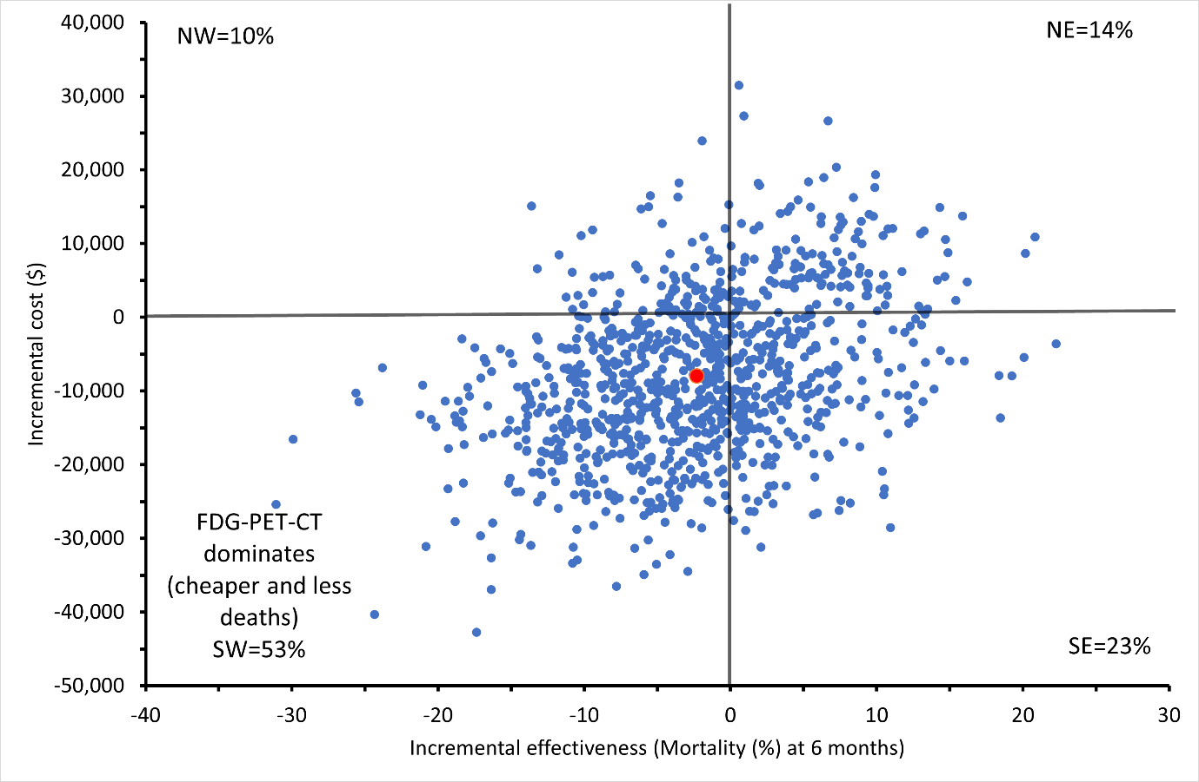
NW= north-west quadrant; intervention more costly, less deaths observed
NE= north-east quadrant; intervention more costly, more deaths observed
SE= south-east quadrant; intervention less costly, more deaths observed
SW= south-west quadrant; intervention less costly, less deaths observed

Appendix 5: Subgroup analysis results
Post-hoc subgroup analysis by reason of admission (chemotherapy or transplant)
 | FDG-PET-CT | Standard CT | Difference | ICER ($/QALY)
Chemotherapy
Total cost ($) | 45,540 | 52,963 | -7,423 | FDG-PET-CT dominates ª
Outcomes (QALY) | 0.285 | 0.284 | 0.002 | FDG-PET-CT dominates ª
Transplant
Total cost ($) | 49,396 | 57,448 | -8,052 | FDG-PET-CT dominates ª
Outcomes (QALY) | 0.286 | 0.284 | 0.002 | FDG-PET-CT dominates ª
ª FDG-PET-CT dominates indicates that FDG-PET-CT is less costly and more effective
Appendix 6: Sensitivity analyses results
To explore parameter uncertainty, several sensitivity analyses were conducted, and results (cost per QALY gained) presented in table below and on cost-effectiveness plane. The variables tested include:
- SA1: Excluding patient with prolonged ICU stay
- SA2: Increasing cost of FDG-PET-CT (intervention) by 20%
- SA3: Increase cost of FDG-PET-CT (intervention) by 100%
- SA4: Increase cost of hospitalisation by 20%
- SA5: Decrease cost of hospitalisation by 20%
- SA6: Decrease in-hospital utility value by 0.5 SD
- SA7: Decrease out-of-hospital utility value by 0.5 SD
- SA8: Decrease both in-hospital and out-of-hospital utility values by 0.5 SD
Table SM6.1: Sensitivity analyses results
 | FDG-PET-CT | Standard CT | Difference | ICER ($/QALY)
SA1: Excluding patient with prolonged ICU stay
Total cost ($) | 43,971 | 59,048 | -15,077 | FDG-PET-CT dominates ª
Outcomes (QALY) | 0.286 | 0.284 | 0.002
SA2: Increasing cost of FDG-PET-CT (intervention) by 20%
Total cost ($) | 49,638 | 57,300 | -7,662 | FDG-PET-CT dominates ª
Outcomes (QALY) | 0.285 | 0.284 | 0.001
SA3: Increase cost of FDG-PET-CT (intervention) by 100%
Total cost ($) | 50,668 | 57,467 | -6,799 | FDG-PET-CT dominates ª
Outcomes (QALY) | 0.285 | 0.284 | 0.001
SA4: Increase cost of hospitalisation by 20%
Total cost ($) | 56,465 | 67,789 | -11,324 | FDG-PET-CT dominates ª
Outcomes (QALY) | 0.285 | 0.284 | 0.001
SA5: Decrease cost of hospitalisation by 20%
Total cost ($) | 41,610 | 47,613 | -6,003 | FDG-PET-CT dominates ª
Outcomes (QALY) | 0.285 | 0.284 | 0.001
SA6: Decrease in-hospital utility value by 0.5 SD
Total cost ($) | 49,174 | 57,624 | -8,450 | FDG-PET-CT dominates ª
Outcomes (QALY) | 0.281 | 0.279 | 0.002
SA7: Decrease out-of-hospital utility value by 0.5 SD
Total cost ($) | 49,174 | 57,624 | -8,450 | FDG-PET-CT dominates ª
Outcomes (QALY) | 0.234 | 0.234 | 0.001
SA8: Decrease both in-hospital and out-of-hospital utility values by 0.5 SD
Total cost ($) | 49,174 | 57,624 | -8,450 | FDG-PET-CT dominates ª
Outcomes (QALY) | 0.230 | 0.229 | 0.001
ª FDG-PET-CT dominates indicates that FDG-PET-CT is less costly and more effective

Figure SM6.1: Cost-effectiveness plane showing results of sensitivity analyses (SA1-SA4)
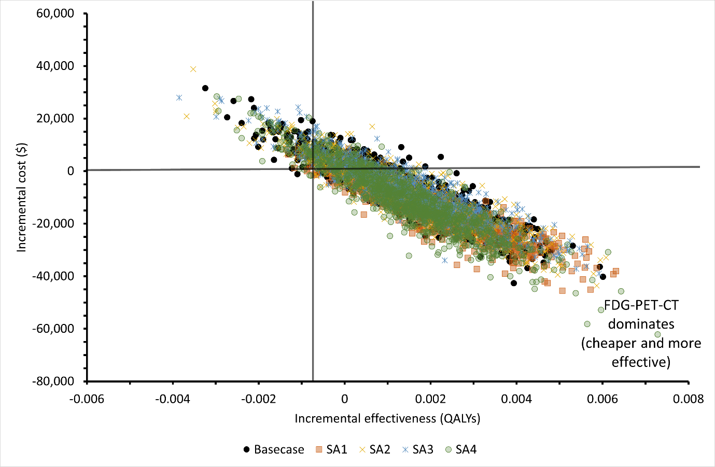

Figure SM6.2: Cost-effectiveness plane showing results of sensitivity analyses (SA5-SA8)
