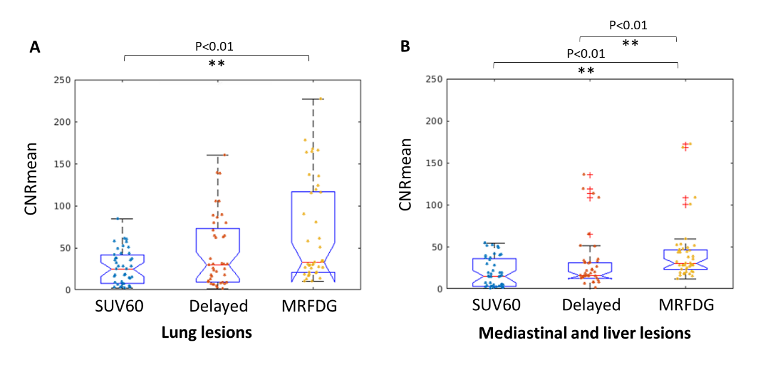
Supplement Figure 1 CNR were compared by dividing the lesions into the lung (A) and non-lung ones (B). In both regions, CNR from the delayed image was not significantly different from the ones of the regular SUV(60) (P=0.139, P=0.769). CNR from the MRFDG, on the other hand, was significantly higher in either group of lesions (P<0.01).

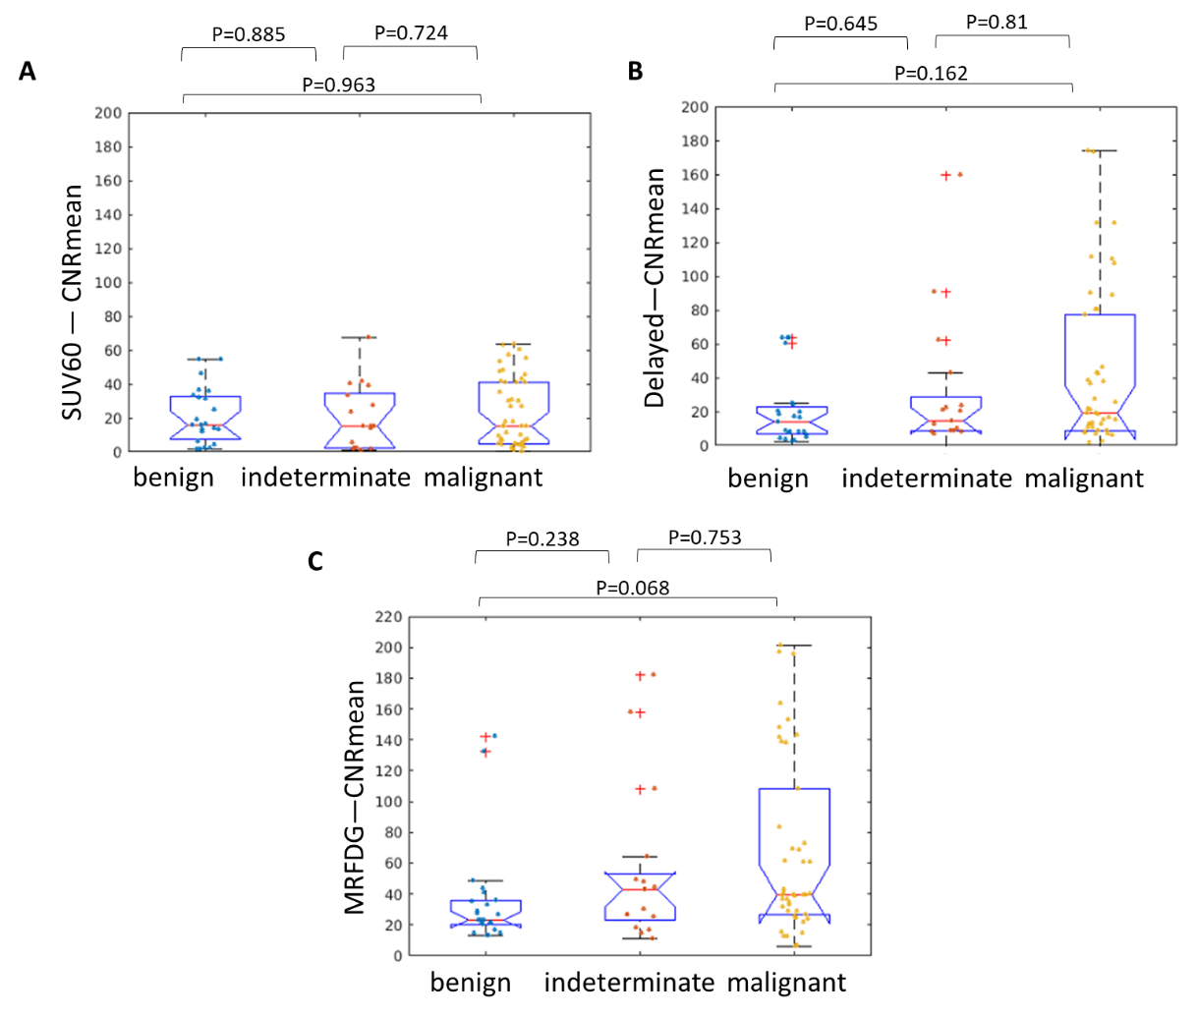
Supplement Figure 2 When quantifying CNR values, MRFDG has a better performance two (P=0.068, effect size 0.601) than the other two (P=0.963, effect size 0.103 for regular static image; P=0.162, effect size 0.495 for delayed image) in distinguishing benign and malignant lesions. Although, all measures cannot differ the lesion types significantly.

