Supplementary Material 1

DLCT scan parameters
All patients underwent pancreatic-protocol CT examination on a DLCT scanner (IQon Spectral CT, Philips Healthcare) with the following parameters: tube voltage, 120 kVp; tube current, modulated with automated exposure control; helical pitch, 0.798; rotation time, 0.5 seconds; collimation, 64 × 0.625 mm; matrix, 512 × 512; reconstructed slice thicknesses, 1.5 mm; and increments, 1.5 mm. After unenhanced scanning, approximately 65-75 mL of iodohexol (350 mg I/mL, Omnipaque, GE Healthcare) was injected into the antecubital vein at 3.5 mL/s via a pump injector followed by a 40-mL saline bolus. Arterial and Portal venous phases were carried out at 25-35 seconds and 60-70 seconds after injection, respectively.

Supplementary Table 1. Interobserver Agreement for spectral parameters
ICCs | AP | PVP
CT_{Hu} | 0.852 | 0.863
ID | 0.882 | 0.897
NID | 0.913 | 0.921
IDD  K-slope  Z_{eff} | 0.889  0.887  0.903 | 0.902  0.905  0.910
AP, arterial phase; PVP, portal venous phase; ID, iodine density; NID, normalized iodine density; IDD, Iodine density difference (ID-AP－ID-PVP); CT, computed tomography; K-slope, the slope of the attenuation curve; Z_{eff}, effective atomic number.
ICC: less than0.50, poor; 0.50–0.74, moderate; 0.75–0.90, good; greater than 0.90, excellent.

Supplementary Table 2. Baseline characteristics of the training and test cohorts
Characteristics | Training cohort（n=122） | Test cohort  （n=51） | p value
Age（y） | 61.6 ± 8.6 | 59.6 ± 9.9 | 0.183
Gender |  |  | 0.441
Male | 72 (59.0) | 34 (66.7)
Female | 50 (41.0) | 17 (33.3)
BMI | 22.2±3.2 | 22.4±3.3 | 0.593
Smoking | 27 (22.1) | 9(17.6) | 0.648
Diabetes | 26 (21.3) | 6 (11.8) | 0.208
Tumor location |  |  | 0.640
Head and neck | 71 (58.2) | 27 (52.9)
Body and tail | 51 (41.8) | 24 (47.1)
Tumor diameter |  |  | 0.423
≤ 2cm | 12 (9.8) | 2 (3.9)
> 2-4cm | 60 (49.2) | 26 (51.0)
> 4cm | 50 (41.0) | 23 (45.1)
CA19-9 (%) |  |  | 0.292
< 37 U/ml | 23 (18.9) | 14 (27.5)
≥ 37 U/ml | 99 (81.1) | 37 (72.5)
CA12-5 (%) |  |  | 0.066
< 35 U/ml | 66 (54.1) | 36 (70.6)
≥ 35 U/ml | 56 (45.9) | 15 (29.4)
CEA (%) |  |  | 0.603
< 5 ug/L | 60 (49.2) | 28 (54.9)
≥ 5 ug/L | 62 (50.8) | 23 (45.1)
CT_{Hu-}AP (Hu) | 84.9 ± 30.8 | 85.3 ± 31.3 | 0.946
CT_{Hu}-PVP (Hu) | 117.0 ± 36.3 | 114.4 ± 39.4 | 0.673
ID-AP (mg/ml) | 0.6 ± 0.4 | 0.6 ± 0.3 | 0.893
ID-PVP (mg/ml) | 1.0 ± 0.4 | 1.0 ± 0.4 | 0.586
IDD (mg/ml) | 0.8 ± 0.5 | 0.7 ± 0.5 | 0.275
K-slope-AP | 0.7 ± 0.5 | 0.8 ± 0.5 | 0.651
K-slope-PVP | 1.2 ± 0.5 | 1.2 ± 0.6 | 0.916
Z_{eff}-AP | 7.6 ± 0.2 | 7.7 ± 0.2 | 0.975
Ze_{ff}-PVP | 7.9 ± 0.2 | 7.8 ± 0.3 | 0.604
Note. Data are n (%) or mean (standard deviation); data in parentheses are percentages.
Abbreviation: AP, arterial phase; PVP, portal venous phase; ID, iodine density; NID, normalized iodine density; IDD, Iodine density difference (ID-AP－ID-PVP); CT, computed tomography; CA 19–9, carbohydrate antigen 19–9; CA 12–5, carbohydrate antigen 12–9; CEA, carcinoembryonic antigen. K-slope, the slope of the attenuation curve; Z_{eff}, effective atomic number.

Supplementary Fig. 1. Workflow of clinical-radiomics nomogram based on DLCT for the stage of patients with pancreatic ductal adenocarcinoma (PDAC). A. Radiomics signature construction. B. clinical model construction. C. construction of the combined model. D. performance of the combined model.

Image preprocessing
- Image Resampling: before feature extraction, images were resampled with a voxel size of 1×1×1 mm³ to eliminate interference caused by different devices and scanning parameters on radiomics features.
- Image Discretization: a method to set a suitable bin width is to extract the feature named first order range such that it remains approximately in this bin range. An absolute discretization was performed with a fixed bin size (bin size = 25).
- Image standardization:
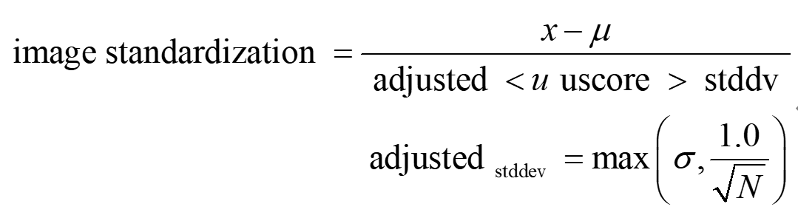
- Image normalization:
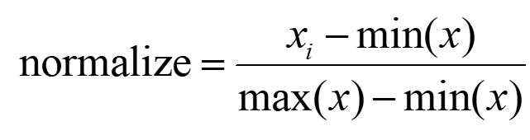

Supplementary Fig. 2. 1218 Radiomics features. Including First-order features; GlCM features; GLSZM features; GLRLM features; GLDM features and Shape features.

Supplementary Fig. 3. A. 40keV VMI-based and B.PEI-based radiomics features and their corresponding weight coefficients.
Supplementary Fig. 4. A. 40keV VMI-based radiomics score (Radscore_{40keV}) of PDAC patients in the training and test cohorts. B. PEI-based radiomics score (Radscore_{40keV}) of PDAC patients in the training and test cohorts. The blue box plot represents the early-stage group. The yellow box plot represents the advanced stage group.

Supplementary Fig. 5. Calibration curves for Radscore_{40keV}, clinical model and clinical-radiomics model in A. the training cohort and B. the test cohort. The red line represents the clinical-radiomics model. The blue line represents the Radscore_{40keV} and the yellow line represents the clinical model.

