Supplementary material
Materials and methods
Demographics included data about age, sex, and weight; Surgical information included date, type, and extension, histology included location and size of nodule, histological classification, and when applicable grading, molecular profile, and pathological staging according to the 7th or the 8th edition of the TNM classification. Follow-up data included date of recurrence if any, date/status at last follow-up.

Tables and figures

Supplementary Table 1: [¹⁸F]FDG PET/CT parameters for each scanner
Acquisition parameters | Biograph –  Siemens (P1) |  | Discovery 690 – General Electric (P2) |  | Vision - Siemens (P3)
Acquisition parameters | PET | CT | PET | CT | PET | CT
¹⁸F-FDG activity (MBq)* | 350–550 | – | 350–550 | – | 350–550 | –
Min/bed position | 2.5 | – | 2 | – | Flow-motion
Crystal | LSO | – | LYSO | – | LSO
Reconstruction | Iterative | – | Iterative, TOF Sharp IR | – | Iterative, Ultra HD | Iterative
Matrix (pixels) | 128×128 | 512×512 | 256×256 | 512×512 | 440 | 512
Resolution (mm) | 5.3×5.3 | 0.98×0.98 | 2.73×2.73 | 1.37×1.37 | 1.65x1.65 | 0.6x0.6
Slice thickness (mm) | 2.0 | 4.0 | 3.27 | 3.27 | 2.0
Slices | – | 6 | – | 64 |  | 64
Voltage (kV) | – | 130 | – | 140 |  | 120
Tube current (mA) | – | 95 | – | 140
Clinical reconstruction |  | – | Iterative, TOF Sharp IR | – | Iterative, TOF Ultra HD
*Administered activity was calculated according to the European Association of Nuclear Medicine (EANM) guidelines 2.0 [21]

Supplementary Table 2: stage of primary lung tumors according to histology
Histology | Stage
Histology | I (n, %) | II (n, %) | III (n, %) | Total (n, %)
Adk | 191, 53% | 65, 18% | 105, 29% | 361
Sqc | 40, 43% | 32, 34% | 21, 22% | 93
Carcinoids | 17, 65% | 8, 31% | 1, 4% | 26
Other | 15, 42% | 11, 30% | 5, 14% | 36*
Total | 263, 51% | 116, 22% | 132, 26% | 516*
*For 5 patients the stage was not assessed

Supplementary Table 3. Data on outcome according to the by primary tumour histology and stage
Outcome | Adenocarcinoma (n=361) | Squamous cell carcinoma  (n=93) | Carcinoid (n=26) | Other  (n=36)
Recurrence, n (%) | 106 (30%) | 29 (31%) | 1 (4%) | 9 (25%)
Progression-free survival, d  Mean ± SD  Median, IQR | 697 ± 692  446, 110-1184 | 586 ± 650  378, 72 - 927 | 728 ± 783  381, 23-1238 | 698 ± 720  391, 56 - 1299
Death, n (%) | 34 (9%) | 14 (15%) | 1 (4%) | 7 (20%)
Overall survival, d  Mean ± SD  Median, IQR | 859 ± 739  719, 166 - 1431 | 705 ± 666  576, 86-1075 | 788 ± 869  381, 23-1386 | 815 ± 788  671, 65-1589
 | Stage I (n=263) | Stage II (n=116) | Stage III (n=132) | Na (n=5)
Recurrence, n (%) | 48 (18%) | 42 (36%) | 52 (39%) | 3 (60%)
Progression-free survival, d  Mean ± SD  Median, IQR | 754 ± 715  545, 118-1271 | 771 ± 722  454, 151 - 1317 | 449 ± 554  230, 36 - 592 | 511 ± 529  356, 72 - 825
Death, n (%) | 20 (8%) | 14 (12%) | 22 (16%) | 0 (0%)
Overall survival, d  Mean ± SD  Median, IQR | 838 ± 745  661, 126-1423 | 945 ± 742  842, 295-1498 | 687 ± 689  523, 41-1084 | 1133 ± 1004  1582, 72-1896)

Supplementary Table 4: SUVmax and SUVmean according to histology
 | SUVmax | SUVmean
Histology
Benign | 3.15 (1.45 – 7.5) | 1.65 (1.2 – 3.3)
Adk | 6.1 (2.7 – 10.6) | 2.9 (1.6 – 5.3)
Sqc | 12.6 (8.4 – 20.2) | 5.9 (3.7 – 10.2)
Carcinoids | 3.2 (2.1 – 4) | 1.9 (1.6 – 2.3)
Other | 10.25 (6.1 – 15) | 4.95 (3.05 -8.6)
Mts | 7.4 (2.6 – 11.5) | 3.4 (1.9 – 5.6)

Supplementary Table 5: univariate and multivariate cox regression analysis for DFS
 | Univariate analysis |  | Multivariate analysis
Variable | HR (95% CI) | p-value | HR (95% CI) |  | p-value
Age | 0.99 (0.97-1.00) | 0.336 | 0.99 (0.98 – 1.02) | 0.88
Histology |  | 0.016*
Adenocarcinoma | 1 (Reference) |  | 1 (Reference)
Squamous cell carcinoma | 1.24 (0.82 – 1.86) | 0.313 | 1.11 (0.67 – 1.8) | 0.69
Carcinoid | 0.13 (0.02 – 0.96) | 0.045* | 0.19 (0.03 – 1.41) | 0.105
Other | 0.87 (0.4 – 1.7) | 0.7 | 0.58 (0.25 – 1.38) | 0.223
Primary tumour size | 1.18 (1.1 – 1.26) | <0.001* | 1.13 (1.04 – 1.24) | 0.005*
N descriptor |  | <0.001*
N0 | 1 (Reference) |  | 1 (Reference)
N1 | 2.1 (1.33 – 3.3) | 0.001* | 1.9 (1.18 – 3.05) | 0.008*
N2 | 2.86 (1.96 – 4.2) | <0.001* | 2.08 (1.35 – 3.2) | 0.001*
N3 | 15.14 (2.06 – 111.3) | 0.008* | 9.07 (1.07 – 76.83) | 0.043*
SUVmax | 1.03 (1.01 – 1.05) | 0.006* | 1.00 ( 0.97 – 1.03) | 0.92
Neoadjuvant therapy (no vs yes) | 2.00 (1.35 – 2.94) | <0.001* | 1.46 (0.9 – 2.35) | 0.123
Surgical approach |  | 0.001*
Open surgery | 1 (Reference) |  | 1 (Reference)
VATS | 0.48 (0.29 – 0.78) | 0.003* | 0.71 (0.42 – 1.22) | 0.215
RATS | 0.52 (0.28 – 0.97) | 0.041* | 0.79 (0.41 – 1.51) | 0.472
Type of surgery |  | 0.14
Lobectomy | 1 (Reference) |  | 1 (Reference)
Bilobectomy | nr |  | nr
Pneumonectomy | 2.57 (1.34 – 4.9) | 0.004* | 1.01 (0.46 – 2.21) | 0.982
Segmentectomy | 1.04 (0.54 – 2.00) | 0.91 | 1.18 ( 0.59 – 2.36) | 0.634
Resection | 0.6 (0.08 – 4.32) | 0.615 | 0.79 (0.11 – 5.83) | 0.821

Supplementary table 6: univariate and multivariate cox regression analysis for OS
 | Univariate analysis |  | Multivariate analysis
Variable | HR (95% CI) | p-value | HR (95% CI) | p-value
Age | 1.01 (0.98-1.04) | 0.43 | 1.04 (1.00 – 1.08) |  | 0.014*
Histology |  | 0.027*
Adenocarcinoma | 1 (Reference) |  | 1 (Reference)
Squamous cell carcinoma | 2.07 (1.1 – 3.87) | 0.023* | 5.0 (2.3 – 10.7) |  | <0.001*
Carcinoid | 0.32 (0.04 – 2.46) | 0.274 | 0.2 (0.01 – 3.15) |  | 0.26
Other | 2.18 (0.96 – 4.94) | 0.061* | 10.8 (3.9 – 29.4) |  | <0.001*
Primary tumour size | 1.1 (0.97 – 1.25) | 0.145 | 1.15 (0.98 – 1.36) |  | 0.089
N descriptor |  | <0.001*
N0 | 1 (Reference) |  | 1 (Reference)
N1 | 2.4 (1.17 – 4.95) | 0.017* | 1.7 (0.78 – 3.7) |  | 0.183
N2 | 3.4 (1.9 – 6.2) | <0.001* | 4.36 (2.14 – 8.9) |  | <0.001*
N3 | nr |  | nr
SUVmax | 0.99 (0.95 – 1.03) | 0.66 | 0.9 (0.84 – 0.97) |  | 0.004*
Neoadjuvant therapy (no vs yes) | 1.77 (0.96 – 3.24) | 0.066 | 0.82 (0.38 – 1.77) |  | 0.62
Surgical approach |  | 0.35
Open surgery | 1 (Reference) |  | 1 (Reference)
VATS | 0.65 (0.32 – 1.35) | 0.25 | 1.48 (0.65 – 3.36) |  | 0.34
RATS | 0.62 (0.22 – 1.7) | 0.36 | 0.78 (0.26 – 2.36) |  | 0.66
Type of surgery |  | 0.43
Lobectomy | 1 (Reference) |  | 1 (Reference)
Bilobectomy | nr |  | nr
Pneumonectomy | 2.08 (0.74 – 5.8) | 0.16 | 2.8 (0.84 – 9.5) |  | 0.093
Segmentectomy | 1.57 (0.65 – 3.76) | 0.31 | 2.08 (0.8 – 5-53) |  | 0.14
Resection | nr |  | nr
Disease relapse (no vs yes) | 4.6 (2.6 – 8.3) | <0.001* | 5.36 (2.8 – 10.36) |  | <0.001*

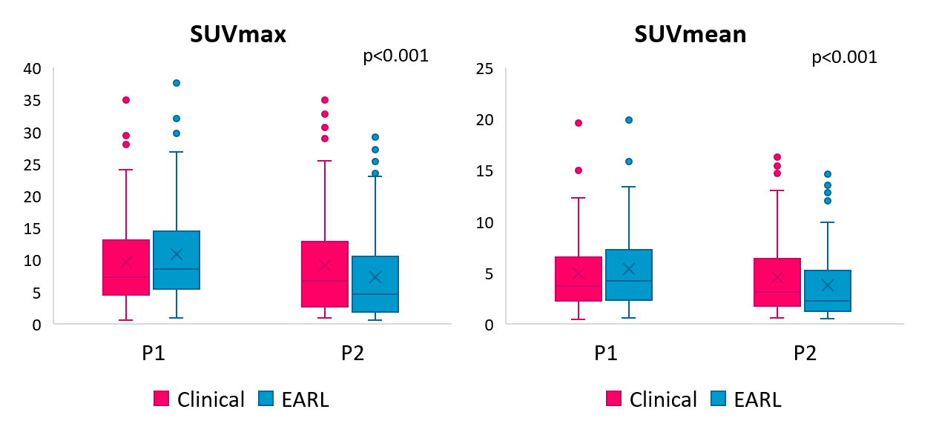
B
A
Supplementary Figure 1: box-plots of clinical and EARL SUVmax (a) and SUVmean (b) calculated for each scanner.

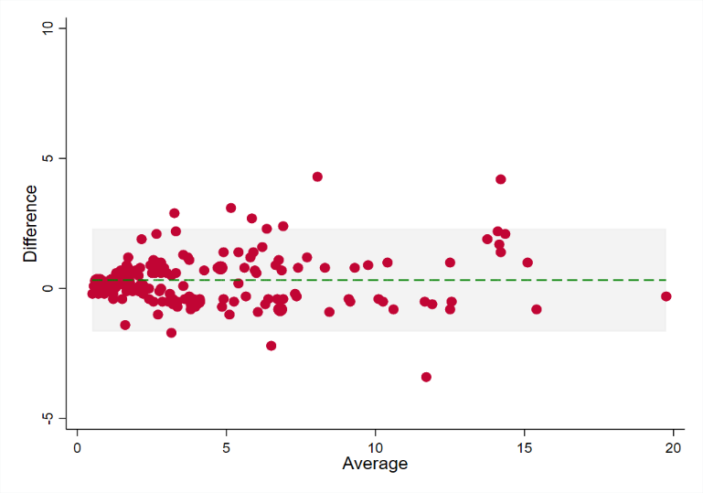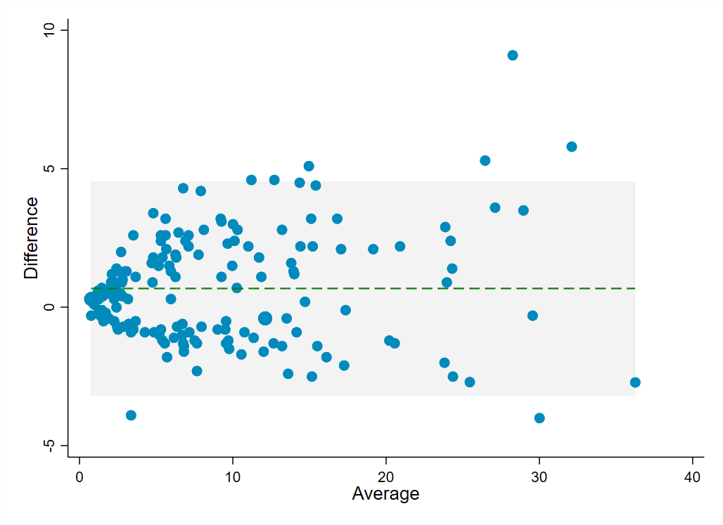
A
B
Supplementary Figure 2: Bland Altman plot for SUVmax (A) and SUVmean (B) .

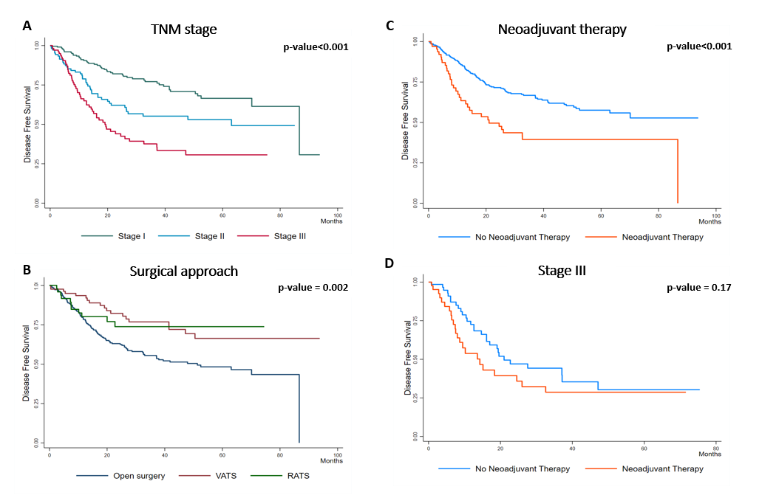
Supplementary Figure 3: Kaplan Meyer disease free survival estimate according to TNM stage (A), surgical approach (B), and neoadjuvant neoadjuvant therapy in the overall population (C) and in patients with advanced disease (D).

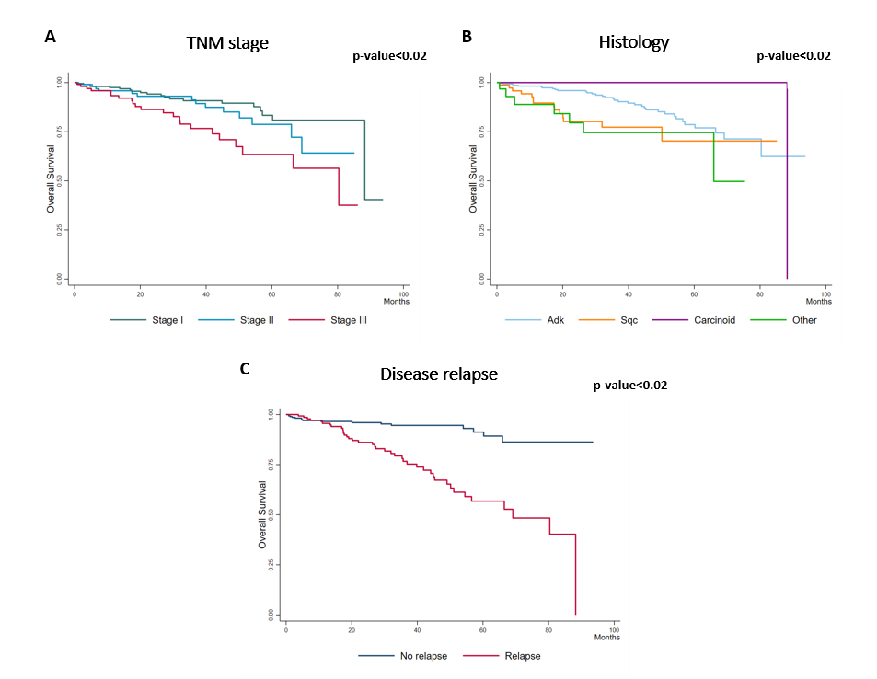
Supplementary Figure 4: Kaplan Meyer overall survival according to TNM stage (A), histology (B) and relapse (C).

