Appendix
Table S1 Patient Characteristics in the training and validation sets for high-grade pattern prediction.
Variables | Training set (n=370) |  |  | Validation set (n=159)
 | $<$ 20% | $≥$ 20% | P value | $<$ 20% | $≥$ 20% | P value
Age (years) | 58.252±8.948 | 60.521±9.806 | 0.014 | 57.393±9.269 | 58.939±8.119 | 0.442
Gender |  |  | 0.023 |  |  | 0.176
Male | 73 | 127 |  | 19 | 41
Female | 82 | 88 |  | 42 | 57
Diameter (cm) | 1.852±0.906 | 2.445±1.102 | $<$0.001 | 1.69±0.837 | 2.368±0.991 | $<$0.001
Types |  |  | $<$0.001 |  |  | $<$0.001
Solid | 88 | 187 |  | 31 | 80
Subsolid | 67 | 28 |  | 30 | 18
Nodule location |  |  | 0.014 |  |  | 0.037
Peripheral | 151 | 196 |  | 61 | 89
Central | 64 | 19 |  | 0 | 9
Shape |  |  | 0.317 |  |  | 0.030
Irregular | 53 | 63 |  | 27 | 27
Regular | 102 | 152 |  | 34 | 71
Lobulation |  |  | 0.165 |  |  | 0.081
No | 56 | 63 |  | 27 | 30
Yes | 99 | 152 |  | 34 | 68
Spiculation |  |  | $<$0.001 |  |  | $<$0.001
No | 85 | 77 |  | 37 | 29
Yes | 70 | 138 |  | 24 | 69
Cavitation |  |  | 0.060 |  |  | 0.760
No | 149 | 196 |  | 55 | 91
Yes | 6 | 19 |  | 6 | 7
Vacuole |  |  | 0.008 |  |  | 0.306
No | 134 | 162 |  | 53 | 79
Yes | 21 | 53 |  | 8 | 19
Air bronchograms |  |  | 0.246 |  |  | 0.016
No | 118 | 152 |  | 54 | 71
Yes | 37 | 63 |  | 7 | 27
Pleural traction |  |  | 0.001 |  |  | 0.011
No | 67 | 57 |  | 26 | 23
Yes | 88 | 158 |  | 35 | 75
Vascular convergence |  |  | 0.653 |  |  | 0.742
No | 67 | 98 |  | 27 | 46
Yes | 88 | 117 |  | 34 | 52
Obstructive pneumonia |  |  | $<$0.001 |  |  | 0.011
No | 150 | 184 |  | 61 | 86
Yes | 5 | 31 |  | 0 | 12

Table S2 Patient Characteristics in the training and validation sets for predominant subtype prediction.
Variables | Training set (n=370) |  |  | Validation set (n=159)
 | Lepidic | Acinar or papillary | P value | Lepidic | Acinar or papillary | P value
Age (years) | 57.6±8.923 | 59.99±9.591 | 0.041 | 58±10.025 | 58.399±8.382 | 0.929
Gender |  |  | 0.609 |  |  | 0.603
Male | 37 | 163 |  | 9 | 51
Female | 28 | 142 |  | 12 | 87
Diameter (cm) | 1.921±0.707 | 2.255±1.118 | 0.050 | 1.507±0.431 | 2.199±1.019 | 0.001
Types |  |  | $<$0.001 |  |  | $<$0.001
Solid | 24 | 251 |  | 3 | 108
Subsolid | 41 | 54 |  | 18 | 30
Nodule location |  |  | 0.151 |  |  | 0.485
Peripheral | 64 | 283 |  | 21 | 129
Central | 1 | 22 |  | 0 | 9
Shape |  |  | 0.174 |  |  | $<$0.001
Irregular | 25 | 91 |  | 15 | 39
Regular | 40 | 214 |  | 6 | 99
Lobulation |  |  | 0.540 |  |  | 0.002
No | 23 | 96 |  | 14 | 43
Yes | 42 | 209 |  | 7 | 95
Spiculation |  |  | 0.211 |  |  | 0.012
No | 33 | 129 |  | 14 | 52
Yes | 32 | 176 |  | 7 | 86
Cavitation |  |  | 0.303 |  |  | 0.853
No | 63 | 282 |  | 20 | 126
Yes | 2 | 23 |  | 1 | 12
Vacuole |  |  | 0.733 |  |  | 0.560
No | 51 | 245 |  | 16 | 116
Yes | 14 | 60 |  | 5 | 22
Air bronchograms |  |  | 0.043 |  |  | 0.571
No | 54 | 216 |  | 10 | 39
Yes | 11 | 89 |  | 11 | 99
Pleural traction |  |  | 0.821 |  |  | 0.073
No | 21 | 103 |  | 18 | 107
Yes | 44 | 202 |  | 3 | 31
Vascular convergence |  |  | 0.273 |  |  | 0.763
No | 25 | 140 |  | 21 | 126
Yes | 40 | 165 |  | 0 | 12
Obstructive pneumonia |  |  | 0.125 |  |  | 0.336
No | 62 | 272 |  | 9 | 64
Yes | 3 | 33 |  | 12 | 74

Table S3 Inter-reader agreement for semantic feature classifications assigned by radiologists (R1 and R2), evaluated using Cohen's Kappa.
Variables | Kappa values
Variables | R1 vs. R2 | R1 vs. Ground truth | R2 vs. Ground truth
Types | 0.94 | 0.97 | 0.97
Nodule location | 0.92 | 0.97 | 0.95
Shape | 0.88 | 0.96 | 0.92
Lobulation | 0.85 | 0.91 | 0.93
Spiculation | 0.90 | 0.95 | 0.94
Cavitation | 0.86 | 0.95 | 0.91
Vacuole | 0.92 | 0.96 | 0.96
Air bronchograms | 0.84 | 0.96 | 0.87
Pleural traction | 0.94 | 0.97 | 0.97
Vascular convergence | 0.73 | 0.88 | 0.83
Obstructive pneumonia | 0.82 | 0.89 | 0.92

Table S3 indicated that radiologists achieved a high level of inter-reader agreement in their assessments of most semantic features.

Table S4 Results of univariate and multivariate analysis in high-grade pattern prediction. OR represents the odds ratio.
Variable | Univariate analysis |  | Multivariate analysis
 | OR (95% CI) | p value | OR (95% CI) | p value
Age | 1.026 (1.003, 1.048) | 0.024
Gender | 0.617 (0.407, 0.935) | 0.023
Diameter | 1.935 (1.495, 2.504) | $<$0.001 | 1.736 (1.327, 2.272) | $<$0.001
Types | 0.197 (0.118, 0.327) | $<$0.001 | 0.188 (0.109, 0.325) | $<$0.001
Nodule location | 3.659 (1.219, 10.982) | 0.021
Shape | 1.254 (0.805, 1.953) | 0.317
Lobulation | 1.365 (0.879, 2.119) | 0.166
Spiculation | 2.176 (1.428, 3.318) | $<$0.001 | 1.861 (1.16, 2.983) | 0.010
Cavitation | 2.407 (0.938, 6.176) | 0.068
Vacuole | 2.088 (1.199, 3.636) | 0.009 | 2.320 (1.246, 4.32) | 0.008
Air bronchograms | 1.322 (0.825, 2.119) | 0.246
Pleural traction | 2.11 (1.361, 3.274) | 0.001
Vascular convergence | 0.909 (0.6, 1.378) | 0.653
Obstructive pneumonia | 5.054 (1.918, 13.318) | 0.001

Table S5 Results of univariate and multivariate analysis in predominant subtype prediction.
Variable | Univariate analysis |  | Multivariate analysis
 | OR (95% CI) | p value | OR (95% CI) | p value
Age | 1.026 (0.998, 1.054) | 0.067
Gender | 1.151 (0.671, 1.976) | 0.609
Diameter | 1.433 (1.052, 1.951) | 0.023
Types | 0.126 (0.07, 0.226) | $<$0.001 | 0.126 (0.07, 0.226) | $<$0.001
Nodule location | 4.975 (0.658, 37.591) | 0.120
Shape | 1.47 (0.842, 2.564) | 0.175
Lobulation | 1.192 (0.679, 2.093) | 0.540
Spiculation | 1.407 (0.823, 2.406) | 0.212
Cavitation | 2.569 (0.59, 11.179) | 0.209
Vacuole | 0.892 (0.463, 1.718) | 0.733
Air bronchograms | 2.023 (1.011, 4.048) | 0.047
Pleural traction | 0.936 (0.529, 1.658) | 0.821
Vascular convergence | 0.737 (0.426, 1.274) | 0.274
Obstructive pneumonia | 2.507 (0.745, 8.439) | 0.138

Table S6 Results of univariate and multivariate ordinal analysis for IASLC grading.
Variable | Univariate analysis |  | Multivariate analysis
 | OR (95% CI) | p value | OR (95% CI) | p value
Age | 1.323(1.062-1.632) | 0.011
Gender | 1.502(1.003-2.250) | 0.048
Diameter | 1.835(1.436-2.344) | $<$0.001
Types | 8.989(5.458-14.806) | $<$0.001 | 8.989(5.458-14.806) | $<$0.001
Nodule location | 0.261(0.086-0.793) | 0.018
Shape | 0.743(0.484-1.140) | 0.174
Lobulation | 0.729(0.477-1.115) | 0.145
Spiculation | 0.450(0.299-0.678) | $<$0.001
Cavitation | 0.387(0.149-1.002) | 0.051
Vacuole | 0.520(0.303-0.895) | 0.018
Air bronchograms | 0.651(0.408-1.039) | 0.072
Pleural traction | 0.497(0.326-0.758) | 0.001
Vascular convergence | 1.169(0.780-1.752) | 0.450
Obstructive pneumonia | 0.191(0.072-0.508) | 0.001

In the univariate analyses, we use of p-value < 0.1 for feature selection may have potential pitfalls. A more lenient threshold can sometimes help avoid missing features that could be predictive of IASLC grading. On the other hand, using a smaller threshold might result in overly stringent feature selection, leading to the exclusion of potentially relevant features. Therefore, we chose a p-value threshold of 0.1 for this analysis based on the tradeoff between maximizing feature selection and minimizing the risk of missing valuable information.
Besides, understanding predictive factors might be helpful to improve model interpretability for clinical use. In the prediction of high-grade patterns, diameter, types, spiculation, and vacuole were identified as risk variables. The odds ratio for diameter was positively correlated, indicating that pulmonary lesions with larger diameters were often associated with higher risk. The results for types showed that solid pulmonary adenocarcinoma was associated with high-grade patterns. This is consistent with clinical observations, where the solid and micropapillary subtypes of pulmonary adenocarcinoma are more commonly found. Additionally, spiculation and vacuole both indicated a higher likelihood of high-grade pulmonary adenocarcinoma. In the prediction of predominant subtypes, types was the only risk variable, suggesting that acinar/papillary predominant types were more likely to present as solid lesions. In the ordinal analysis for IASLC grading, the results showed that non-solid nodules were correlated with IASLC grade I, which aligns with the findings from the prediction of high-grade patterns and predominant subtypes. For radiomics features, firstorder_Skewness and firstorder_RobustMeanAbsoluteDeviation were overlapping risk variables across radiomics models. Firstorder_Skewness measured the asymmetry of the lesion distribution. A lower skewness value suggested a more regular lesion characteristic, which is likely to correspond to lower-grade lesions. In contrast, firstorder_RobustMeanAbsoluteDeviation represented the heterogeneity of data. Higher values of this feature indicating greater heterogeneity were associated with higher-grade lesions.
In the two-step model using radiomics features, the Rad-score equation for predicting high-grade patterns was as follows: Rad_score = 0.0853 * exponential_firstorder_RobustMeanAbsoluteDeviation - 0.2463 * lbp-2D_firstorder_Entropy - 0.0480 * logarithm_ngtdm_Strength + 0.1420 * wavelet-LLL_gldm_LargeDependenceHighGrayLevelEmphasis
In the two-step model using radiomics features, the Rad-score equation for predicting predominant types was as follows: Rad_score = 0.0323 * exponential_firstorder_RobustMeanAbsoluteDeviation - 0.0186 * logarithm_firstorder_Skewness - 0.0360 * logarithm_glcm_DifferenceAverage - 0.1779 * logarithm_glcm_Idn - 0.0434 * square_gldm_LargeDependenceLowGrayLevelEmphasis + 0.0731 * wavelet-LLL_gldm_LargeDependenceHighGrayLevelEmphasis
In the one-step model using radiomics features, the Rad-score equation for directly assessing IASLC grades was as follows: Rad_score = 0.2239 * exponential_firstorder_RobustMeanAbsoluteDeviation - 0.1549 * logarithm_firstorder_Skewness + 0.1495 * wavelet-LLL_glrlm_HighGrayLevelRunEmphasis

Table S7 Effect of CT acquisition variability on the model performance
Vendor | Slice thickness | Spacing | Total # | IASLC grading | Training AUC | Training F1 scores | Validation AUC | Validation F1 scores
GE | 1.25 | 0.984 | 228 | 1 | 0.98 | 0.75 | 0.95 | 0.64
 |  |  |  | 2 | 0.90 | 0.60 | 0.86 | 0.44
 |  |  |  | 3 | 0.96 | 0.91 | 0.96 | 0.90
Siemens | 1.5 | 0.95 | 301 | 1 | 0.94 | 0.56 | 0.96 | 0.42
 |  |  |  | 2 | 0.86 | 0.56 | 0.84 | 0.46
 |  |  |  | 3 | 0.95 | 0.87 | 0.97 | 0.90

The first-order statistics of firstorder_Skewness was mentioned in our study and another study[17], which may indicate its robustness in IASLC grading. Wavelet-related features were noted in both, but with different specifications, such as wavelet_HHH_glszm_LargeAreaEmphasis vs. wavelet-LLL_glrlm_HighGrayLevelRunEmphasis. This difference may be explained by the effects of varying vendors and imaging reconstruction parameters.

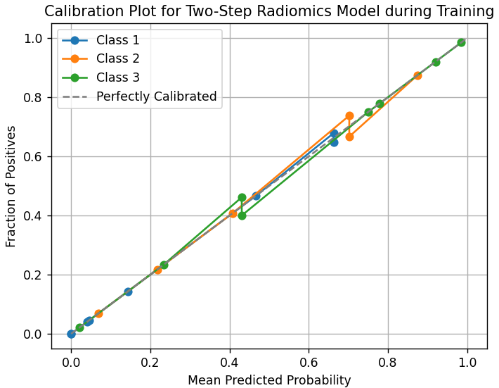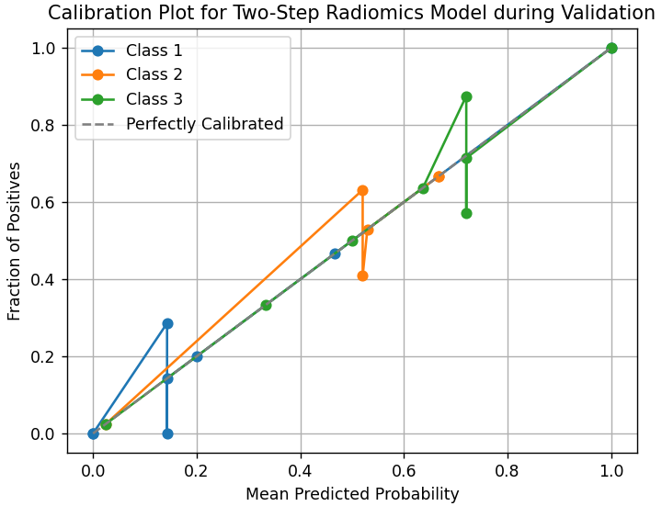
Figure S1 Calibration plots for the two-step radiomics model on the training and validation sets.

The figure shows that our two-step radiomics model predicted probabilities which were in agreement with the actual observed frequencies. This may suggest that the model was well-calibrated, providing reliable probability estimates that reflected the true likelihood of each class.

