Appendix S1
CNN models development
ResNet101
ResNet101 and Renset50 have similar network structures, with the difference being Conv4_ In X, more residual modules are used, changing from 6 to 23, deepening the depth of the model and improving the ability to extract image features. The network structure of ResNet101 is shown in Table S1.

DenseNet121
The network structure of DenseNet mainly consists of DenseBlocks and Transitions, with 4 DenseBlocks in a DenseNet. DenseBlock is a module that contains many layers, each with the same size of feature maps, and is densely connected between layers. The Transition module connects two adjacent DenseBlocks and reduces the size of the feature map. The Densenet121 architecture is shown in Table S2.

EfficientNet-b0
EfficientNet proposes a compound scaling method, which uses the NAS (neural network architecture search) method to expand the network by combining width, depth and resolution. The EfficientNet is constructed by stacking multiple MBConv Blocks. MBConv Block consists of two 1×1 convolution layers, depthwise convolution layer, and SE layer. One of the 1×1 convolution is used to reduce the dimension of the feature map and the other is used to raise the dimension. The EfficientNet-b0 architecture is shown in Table S3.

VIT_base
Vision Transformer (VIT) cuts the image into many small pieces, and then encodes each small piece into a 768-dimensional vector. The Transformer Encoder actually stacks the Encoder Block multiple times, mainly consisting of Layer Norm, Multi Head Attention, Dropout, and MLP Block. The VIT_base architecture is shown in Table S4 and Figure S1.

Convit_base
Due to the low CNN upper limit and the high VIT upper limit, the VIT lower limit is too low due to the large amount of data required, and training is more time-consuming and labor-intensive. The use of attention modules with position encoding can achieve convolutional like effects, and can be combined with VIT to achieve better results. The Convt block is mainly composed of LayerNorm, dropout, GPSA Block, and ML Block. The Convit_base architecture is shown in Table S5 and Figure S2.

Appendix S2
Conventional SWE assessment
The unnecessary biopsy rate of breast lesions was recalculated with SWE. The management decisions are followed by the World Federation of Ultrasound in Medicine and Biology guidelines and recommendations for the clinically used applications of elastography used in breast imaging [1]. In our study, the breast SWE examination was performed by Aixplorer (SuperSonic Imagine, Aixen Provence, France) with a 15-4 MHz linear transducer following the standard protocol. The probe was vertically placed on the skin without consciously applying any vibration/compression, lightly touching the skin, and trying not to apply pressure. The stabilized SWE images of the lesion were saved after a few seconds of immobilization. The tissue elasticity was represented as a colour-coded map in kilopascals (kPa) at each pixel and a colour scale ranging from 0 (dark blue, soft) to 180 kPa (red, hard). The detailed criteria are listed as follow:
a. Aggressive rule: low stiffness would be considered with E Max below 80 kPa (5.2 m/s) or E Color light blue or below with SWE scale set at 180 kPa (7.7 m/s).
b. Conservative rule: low stiffness would be considered with E Max below 30 kPa (3.2 m/s) or E Color dark blue or below with SWE scale set at 180 kPa (7.7 m/s).
The aggressive rule would have enabled a higher improvement in specificity; however, 4 cancers would have been downgraded to follow-up. With the conservative rule, all cancers would have remained in the initial biopsy group, while retaining a significant increase in sensitivity.

Conventional CEUS assessment
The unnecessary biopsy rate of breast lesions was recalculated with CEUS. The management decisions are based on a CEUS score system [2]. A lesion with a score of 1 by breast CEUS: there is no enhancement in the lesion, with a clear borderline separating the lesion from the surrounding tissue. A lesion with a score of 2 by breast CEUS: the lesion displayed iso- and synchronous enhancement with the surrounding tissue, without a clear outline in the contrast-enhanced image. A lesion with a score of 3 by breast CEUS: the lesion exhibits earlier enhancement compared with the surrounding tissue, homogeneous or heterogeneous, with a clear margin (sometimes with ring-like enhancement). The scope of the lesion is almost identical to that shown by grayscale ultrasound. A lesion with a score of 4 by breast CEUS: the lesion displays earlier enhancement than the surrounding tissue, usually heterogeneous. The scope of the lesion in the contrast-enhanced image is larger than in the corresponding grayscale image, but the lesion still displays a clear margin, with/without a perfusion defect in the lesions and without crab claw-like enhancement. A lesion with a score of 5 by breast CEUS: the lesion is heterogeneously enhanced, with a larger region (compared with that of a grayscale US image), earlier enhancement, and with/without perfusion defect, particularly with a typical crab claw-like enhancement and an unclear borderline. A score of 1-3 represents a benign tumor, whereas a score of 4–5 represents a malignant tumor.
The combination of BI-RADS and CEUS was carried out in two steps. First, a score ranging from 1 to 5 was designated for BI-RADS, score 1 for BI-RADS 3, score 2 for BI-RADS 4a, score 3 for BI-RADS 4b, score 4 for BI-RADS 4c and score 5 for BI-RADS 5. The BI-RADS and CEUS values were added to determine a final score for each lesion, which ranged from 2 to 10, theoretically. A score of 6 was chosen as the cutoff point; thus, lesions with scores > 6 were considered malignant, whereas those with scores <= 6 were considered benign. In our study, US examinations were performed before surgery or biopsy and any treatment, including radiotherapy, or neoadjuvant therapies, et cetera. Therefore, a lesion presented with BI-RADS score 5 and CEUS score 1 could barely happen in our study.

References
[1] R.G. Barr, K. Nakashima, D. Amy, D. Cosgrove, A. Farrokh, F. Schafer, J.C. Bamber, L. Castera, B.I. Choi, Y.H. Chou, C.F. Dietrich, H. Ding, G. Ferraioli, C. Filice, M. Friedrich-Rust, T.J. Hall, K.R. Nightingale, M.L. Palmeri, T. Shiina, S. Suzuki, I. Sporea, S. Wilson, M. Kudo, WFUMB guidelines and recommendations for clinical use of ultrasound elastography: Part 2: breast, Ultrasound Med Biol 41(5) (2015) 1148-60.
[2] X. Xiao, L. Dong, Q. Jiang, X. Guan, H. Wu, B. Luo, Incorporating Contrast-Enhanced Ultrasound into the BI-RADS Scoring System Improves Accuracy in Breast Tumor Diagnosis: A Preliminary Study in China, Ultrasound Med Biol 42(11) (2016) 2630-2638.

Table S1. The network architecture of ResNet101
Layers | Output size | 101-layer
Conv1 | 112×112 | 7×7, stride 2
Pooling | 56×56 | 3×3 max pool, stride 2
Conv2_x | 56×56 | 1×1 Conv  3×3 Conv  1×1 Conv  ×36
Conv3_x | 28×28 | 1×1 Conv  3×3 Conv  1×1 Conv  ×46
Conv4_x | 14×14 | 1×1 Conv  3×3 Conv  1×1 Conv  ×3
Conv5_x | 7×7 | 1×1 Conv  3×3 Conv  1×1 Conv  ×36
Classification layer | 1×1 | Average pool  2-d fc, SoftMax

Table S2. The network architecture of DenseNet 121
Layers | Output size | 121-layer
Convolution | 112×112 | 7×7 conv, stride 2
Pooling | 56×56 | 3×3 max pool, stride 2
Dense block (1) | 56×56 | $\left[\begin{aligned}1 × 1 conv \\ 3 × 3 conv\end{aligned}\right]$×6
Transition layer (1) | 56×56 | 1×1 conv
Transition layer (1) | 28×28 | 2×2 max pool, stride 2
Dense block (2) | 28×28 | $\left[\begin{aligned}1 × 1 conv \\ 3 × 3 conv\end{aligned}\right]$×12
Transition layer (2) | 28×28 | 1×1 conv
Transition layer (2) | 14×14 | 2×2 max pool, stride 2
Dense block (3) | 14×14 | $\left[\begin{aligned}1 × 1 conv \\ 3 × 3 conv\end{aligned}\right]$×24
Transition layer (3) | 14×14 | 1×1 conv
Transition layer (3) | 7×7 | 2×2 max pool, stride 2
Dense block (4) | 7×7 | $\left[\begin{aligned}1 × 1 conv \\ 3 × 3 conv\end{aligned}\right]$×16
Classification layer | 1×1 | 7×7 global average pool
Classification layer |  | 2-d fc, SoftMax

Table S3. The network architecture of EfficientNet-b0
Layers | Output size | Kernel size,stride
Conv2d | 112×112×32 | 3×3, stride 2
MBConv1 | 112×112×16 | 3×3, stride 1
MBConv6 ×2 | 56×56×24 | 3×3, stride 2
MBConv6 ×2 | 28×28×40 | 5×5, stride 2
MBConv6 ×3 | 14×14×80 | 3×3, stride 2
MBConv6 ×3 | 14×14×112 | 5×5, stride 1
MBConv6 ×4 | 7×7×192 | 5×5, stride 2
MBConv6 | 7×7×320 | 3×3, stride 1
Conv2d | 7×7×1280 | 1×1, stride 1
Classification layer | 1×1 | 7×7 global average pool  2-d fc, SoftMax

Table S4. The network architecture of VIT_base
Layers | Output size | VIT_base
Patch_embed | 768×14×14 | 16×16, stride 16
Transformer Encoder ×12 | 1×768 | -
Classification layer | 2 | LayerNorm + fc + SoftMax

Table S5. The network architecture of Convit_base
Layers | Output size | Convit_base
Patch_embed | 768×14×14 | 16x16, stride 16
Dropout | 196×768 | -
Convit blocks (GPSA) ×10 | 1×768 | -
Convit blocks (MHSA) ×2 | 1×768 | -
Classification layer | 2 | LayerNorm + fc

Table S6. Comparison of the Dc-HR model, SWE, and CEUS in differentiating benign and malignant lesions and reducing the unnecessary biopsy rate with different BI-RADS categories
Methods  BI-RADS | Sensitivity (%) | Specificity (%) | NPV (%) | PPV (%) | Accuracy (%) | AUC | Undetected malignancies (%) | Unnecessary biopsy rate (%) | Reduction of unnecessary biopsies (%)
BI-RADS 4a
Transverse | 100 | 90.70 | 100 | 20.00 | 90.91 | 0.954 | 0 (0/44) | 80.00 (4/5) | 90.70 (4 vs. 43)
Longitudinal | 100 | 95.35 | 100 | 33.33 | 95.45 | 1.000 | 0 (044) | 66.67 (2/3) | 95.34 (2 vs. 43)
Both | 100 | 100 | 100 | 100 | 100 | 1.000 | 0 (0/44) | 0 (0/1) | 100 (0 vs. 43)
Aggressive rule | 0 | 76.74 | 97.06 | 0 | 75.00 | 0.384 | 2.27 (1/44) | 100 (10/10) | 76.74 (10 vs. 43)
Conservative rule | 100 | 20.93 | 100 | 2.86 | 22.73 | 0.605 | 0 (0/44) | 97.14 (34/35) | 20.93 (34 vs. 43)
CEUS score | 100 | 76.74 | 100 | 9.09 | 77.27 | 0.884 | 0 (0/44) | 90.91 (10/11) | 76.74 (10 vs. 43)
BI-RADS + CEUS score | 100 | 95.35 | 100 | 33.33 | 95.45 | 0.977 | 0 (0/44) | 66.67 (2/3) | 95.34 (2 vs. 43)
BI-RADS 4b and 4c
Transverse | 96.43 | 50.00 | 50.00 | 96.43 | 93.33 | 0.768 | 3.33 (1/30) | 3.70 (1/27) | 50.00 (1 vs. 2)
Longitudinal | 92.86 | 100 | 50.00 | 100 | 93.33 | 0.946 | 6.67 (2/30) | 0 (0/26) | 100 (0 vs. 2)
Both | 96.43 | 100 | 66.67 | 100 | 96.67 | 0.964 | 3.33 (1/30) | 0 (0/27) | 100 (0 vs. 2)
Aggressive rule | 53.57 | 50.00 | 7.14 | 93.75 | 53.33 | 0.518 | 43.33 (13/30) | 6.25 (1/16) | 50.00 (1 vs. 2)
Conservative rule | 96.43 | 50.00 | 50.00 | 96.43 | 93.33 | 0.732 | 3.33 (1/30) | 3.57 (1/28) | 50.00 (1 vs. 2)
CEUS score | 89.29 | 0 | 0 | 92.59 | 83.33 | 0.446 | 10.00 (3/30) | 7.41 (2/27) | 0 (2 vs. 2)
BI-RADS + CEUS score | 92.86 | 0 | 0 | 92.86 | 86.67 | 0.464 | 6.67 (2/30) | 7.14 (2/28) | 0 (2 vs. 2)

Supplementary Figures

Transformer Encoder
LayerNorm
Multi-Head
Attention
LayerNorm

⊕

MLP

⊕

Linear
GELU
Dropout
Linear
Dropout
rop
MLP Block
Figure S1. The structure of VIT_base model.

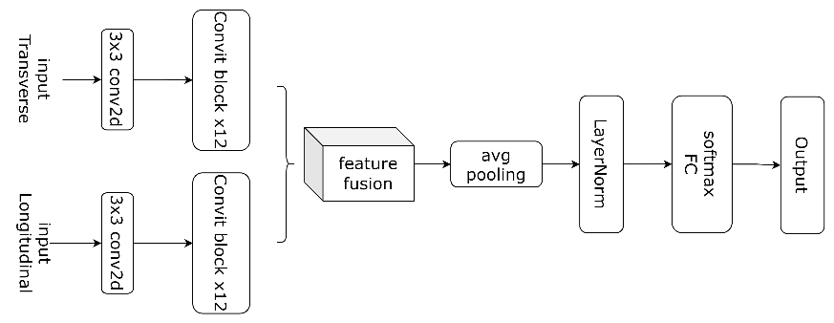
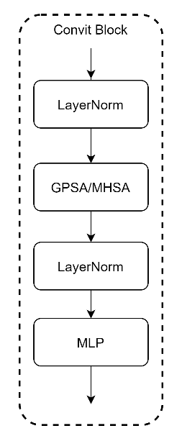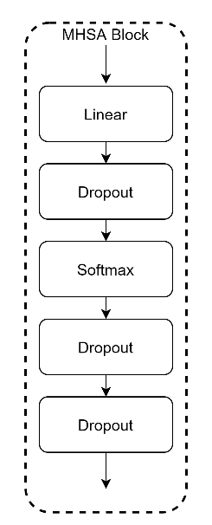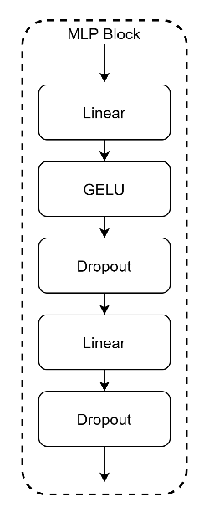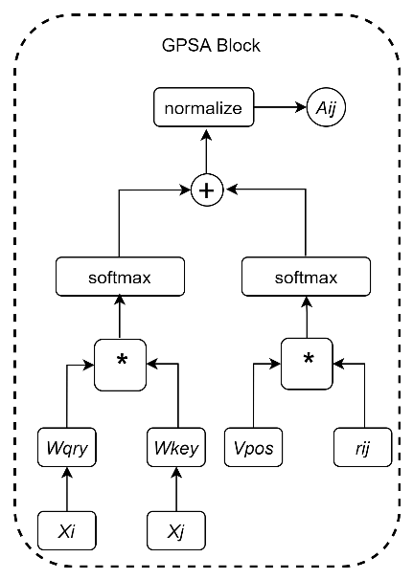
Figure S2. The structure of Convit_base model.

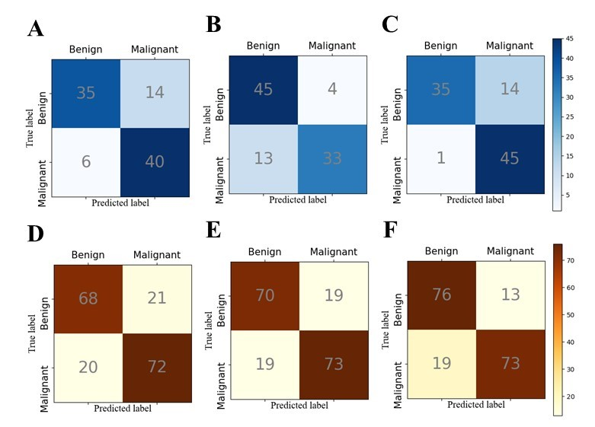
Figure S3. The confusion matrices of random forest-based radiomic approach for predicting benign and malignant breast lesions. The random forest-based radiomic approach applied with (A) transverse US images, (B) longitudinal US images, and (C) dual-view US images in the internal validation cohort, respectively. The random forest-based radiomic approach applied with (D) transverse US images, (E) longitudinal US images, and (F) dual-view US images in the external validation cohort, respectively.

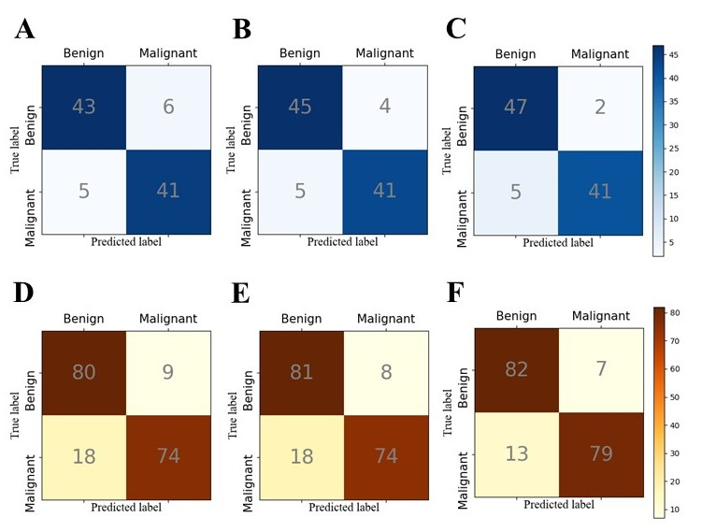
Figure S4. The confusion matrices of the Convit_base-based radiomic approach for predicting benign and malignant breast lesions. The Convit_base-based radiomic approach applied with (A) transverse US images, (B) longitudinal US images, and (C) dual-view US images in the internal validation cohort, respectively. The Convit_base-based radiomic approach applied with (D) transverse US images, (E) longitudinal US images, and (F) dual-view US images in the external validation cohort, respectively.

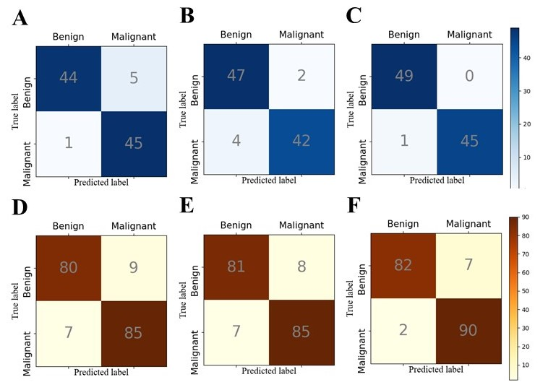
Figure S5. The confusion matrices of the Dc-HR approach for predicting benign and malignant breast lesions. The Dc-HR approach applied with (A) transverse US images, (B) longitudinal US images, and (C) dual-view US images in the internal validation cohort, respectively. The Dc-HR approach applied with (D) transverse US images, (E) longitudinal US images, and (F) dual-view US images in the external validation cohort, respectively.

Figure S6. The confusion matrices of the Dc-HR approach and SWE or CEUS assessment. The Dc-HR approach applied with (A) transverse US images, (B) longitudinal US images, and (C) dual-view US images in patients underwent SWE examination, respectively. The confusion matrices of aggressive rule of SWE (D) and conservative rule of SWE (E). The Dc-HR model applied with (F) transverse US images, (G) longitudinal US images, and (H) dual-view US images in patients underwent CEUS examination, respectively. The confusion matrices of CEUS score (D) and BI-RADS + CEUS score (E).

