Microstructure Mapping withTime-dependent Diffusion MRI Differentiates Primary Central Nervous System Lymphoma from Glioblastoma
ELECTRONIC SUPPLEMENTARY MATERIAL
Supplementary Text
Routine structural MRI
Routine structural MRI included T1-weighted images before and after Gd-enhancement, and T2-FLAIR images, with a total acquisition time of 17 min. The protocol parameters were as follows: CE-T1w (TE = 3.5 ms; TR = 7.9 ms; FOV = 250 × 199 × 170 mm³; slice thickness = 1 mm) and FLAIR (TE = 313 ms; TR = 4800 ms; FOV = 250 × 250 × 150 mm³; slice thickness = 2 mm).
Data Analysis and Principle of IMPULSED
t_{d}-MRI signals ($S$) were fitted using the IMPULSED model [1], a 2-compartment model comprising intra- ($S_{in}$) and extracellular ($S_{ex}$) components:
$S=V_{\text{in}}*S_{in}+(1-V_{in})*S_{ex}$
where $S$ is the measured t_{d}-MRI signal, $S_{in}$and $S_{ex}$are the intracellular and extracellular signals, respectively, and $V_{in}$represents the volume fraction of the intracellular space. $S_{in}$uses sphere geometry and adapts for trapezoid OGSE waveforms [2]. $S_{ex}$ assumes a t_{d}-independent exponential decay with extracellular diffusivity (D_{ex}).
Microstructural parameters including diameter ($d$), $V_{in}$, and $D_{ex}$ were estimated from Eq. 1 using a nonlinear least squares algorithm in Matlab R2024b (Mathworks, Natick, MA) with a fixed intracellular diffusion coefficient at 1.0 µm²/ms. The fitting was repeated 100 times with randomized initializations to avoid local minimums, under the following physiological constraints: 1< $d$ <50 µm, 0.01< $V_{in}$ <1, 0.5< $d$ <3.5 µm²/ms. Cellularity was defined as $V_{in} / d * 100$ [3]. ADC maps were calculated at each td according to the log-linear fitting $S/S0=e^{-bD }$to obtain ADC_{0Hz} (PGSE), ADC_{25Hz} and ADC_{50Hz}. The change in ADC (rADC₁, rADC₂) were calculated using the combination of the ADC:
$rADC_{1}=\frac{(ADC_{25Hz}-ADC_{0Hz})}{ADC_{25Hz}}$*100
$rADC_{2}=\frac{\left(ADC_{50Hz}-ADC_{0Hz}\right)}{ADC_{50Hz}}$*100

References
1. Jiang X, Li H, Xie J, et al. In vivo imaging of cancer cell size and cellularity using temporal diffusion spectroscopy. Magn Reson Med 2017;78:156-164. https://doi.org/10.1002/mrm.26356.
2. Xu J, Jiang X, Li H, et al. Magnetic resonance imaging of mean cell size in human breast tumors. Magn Reson Med 2020;83:2002-2014. https://doi.org/10.1002/mrm.28056.
3. Wu D, Jiang K, Li H, et al. Time-Dependent Diffusion MRI for Quantitative Microstructural Mapping of Prostate Cancer. Radiology 2022;303:578-587. https://doi.org/10.1148/radiol.211180.
Supplementary Figures
Supplementary Figure S1. Ridge trace plot for penalty parameter (K) selection.
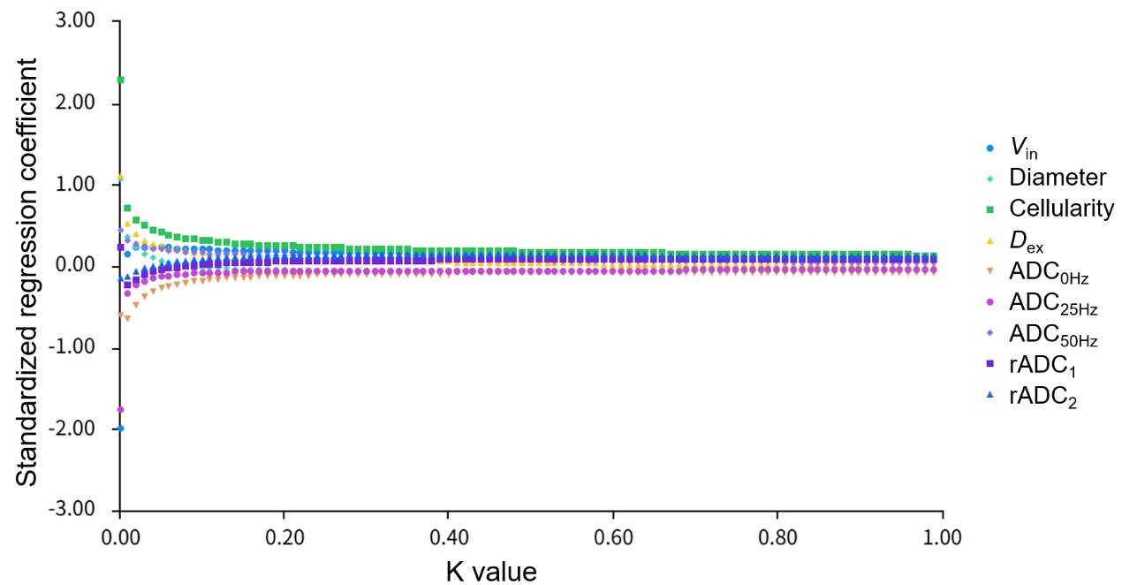

Supplementary Figure S2. (a-b) ADC values measured at 0 Hz, 25 Hz, 50 Hz in tumor region or (c-d) peritumoral edema in GBM and PCNSL. * p < 0.05, ** p < 0.01, *** p < 0.001，ns show no significance.
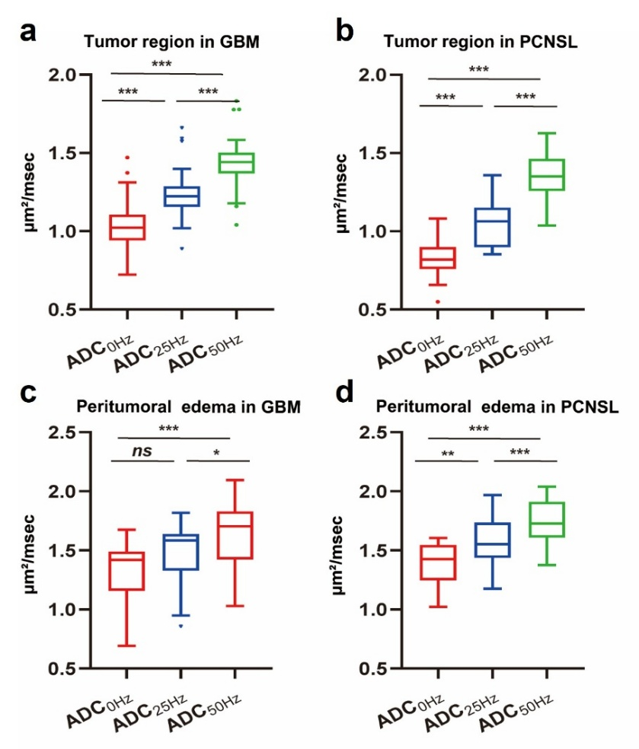
Supplementary Figure S3. Correlations between the ADC at 0 Hz and cellularity(a) or diameter(b) estimated from t_{d}-dMRI.
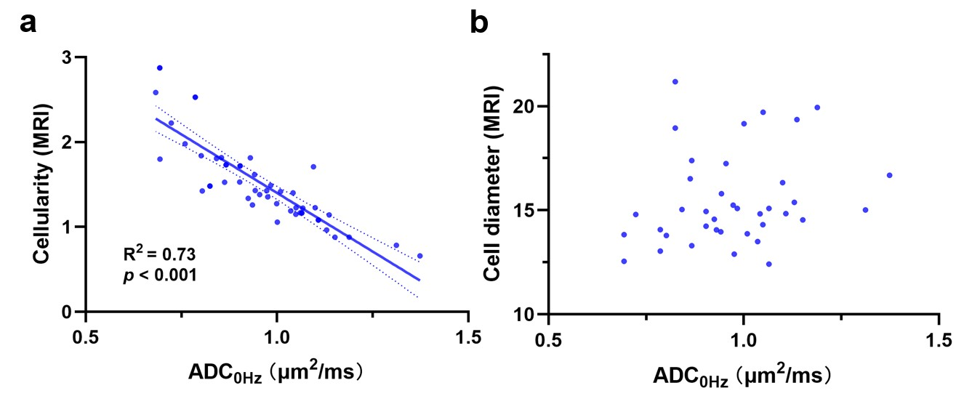

Supplementary Tables
Supplementary Table S1. Multicollinearity diagnostics using ordinary least squares (OLS) prior to ridge regression.
Variable | VIF
V_{in} | 464.618
Diameter | 49.976
Cellularity | 224.536
D_{ex} | 79.701
ADC_{0Hz} | 345.994
ADC_{25Hz} | 686.226
ADC_{50Hz} | 37.868
rADC₁ | 86.380
rADC₂ | 29.788
Note: All VIF values are substantially above 10, indicating severe multicollinearity among predictors. This justifies the use of ridge regression (L2 penalization) to obtain stable coefficient estimates. VIF: variance inflation factor.

Supplementary Table S2. Comparison of patient information between PCNSL and GBM.
 | PCNSL (n = 19) | GBM (n = 32) | p value
Gender  Male  Female | 10 (52.6%)  9 (47.4%) | 20 (62.5%)  12 (37.5%) | 0.489
Age | 59.95 ± 2.03 | 58.28 ± 2.20 | 0.785
Number of lesions (%)  Single  Multiple | 12 (63.2%)  7 (36.8%) | 21 (65.6%)  11 (34.4%) |  | 0.859
Location (%)  Only supratentorial  Only infratentorial  Supra-and infratentorial | 15 (78.9%)  0 (0%)  4 (21.1%) | 31 (96.9%)  1 (3.1%)  0 (0%) |  | 0.016
Note: Continuous variables are expressed as mean ± standard deviation, while categorical variables are presented as number (percentage).

Supplementary Table S7. Results of binary logistic regression analysis for differentiating PCNSL from GBM.
Variable | B | Wald χ² | p value
V_{in} | 1.893 | 3.103 | 0.078
Cellularity | 0.858 | 0.741 | 0.389
Constant | -0.837 | 3.719 | 0.054
Note: V_{in} = intracellular fraction.

