Table S1. Comparison of quantitative PCCT spectral parameters in lung adenocarcinoma with 19Del and L858R mutations
Characteristics | EGFR 19 deletion mutation group | EGFR L858R mutation group | t/Z | P
A-IC | 0.85±0.40 | 0.65±0.30 | 1.554 | 0.131
A-NIC | 0.10 (0.08, 0.15) | 0.08 (0.06, 0.13) | -1.096 | 0.273
A-40 keV | 115.61±35.96 | 96.20±25.70 | 1.772 | 0.087
A-70 keV | 63.70±12.39 | 58.30±9.36 | 1.403 | 0.171
A-100 keV | 50.31±7.36 | 48.65±6.67 | 0.672 | 0.507
A-λHU | 1.09±0.51 | 0.82±0.37 | 1.685 | 0.102
A-Zeff | 7.80 (7.70, 7.90) | 7.70 (7.65, 8.10) | -0.987 | 0.324
A-DEI | 0.015 (0.007, 0.019) | 0.007 (0.005, 0.011) | -1.968 | 0.049
AEF | 0.54 (0.39, 0.78) | 0.49 (0.33, 0.60) | 0.220 | 0.230
V-IC | 1.49±0.51 | 1.37±0.27 | 0.800 | 0.430
V-NIC | 0.40±0.17 | 0.35±0.11 | 0.982 | 0.334
V-40 keV | 161.77±44.75 | 153.72±24.55 | 0.641 | 0.527
V-70 keV | 76.33±14.75 | 74.71±9.69 | 0.373 | 0.712
V-100 keV | 54.68±7.64 | 54.74±7.06 | -0.024 | 0.981
V-λHU | 1.79±0.64 | 1.68±0.40 | 0.560 | 0.580
V-Zeff | 8.24±0.25 | 8.18±0.22 | 0.704 | 0.487
V-DEI | 0.014±0.005 | 0.013±0.004 | 0.674 | 0.505
ECV | 0.24±0.09 | 0.22±0.07 | 0.855 | 0.399
A= arterial phase; AEF= arterial enhancement fraction; DEI= dual-energy index; ECV= extracellular volume; IC= iodine concentration; NIC= normalized iodine concentration; V= portal venous phase; Zeff= effective atomic number; λHU= slope of the spectral HU curve.
Note: P < 0.05. PCCT spectral parameters were compared between the EGFR 19Del and L858R mutation groups using the Mann–Whitney U test or t-test.

Table S2. Collinearity diagnostics for the arterial phase regression model predicting EGFR status
Variable | Tolerance | VIF | Eigenvalue | Condition Index
Constant | - | - | 3.252 | 1.000
A-70 keV | 0.131 | 7.644 | 0.021 | 12.321
A-100 keV | 0.131 | 7.633 | 0.002 | 40.731
A-DEI | 0.978 | 1.022 | 0.725 | 2.118
Note: Condition index > 10 indicates potential collinearity; values > 30 indicate strong collinearity. The high condition index (40.731) suggests strong collinearity, primarily driven by the correlation between A-70 keV and A-100 keV.

Table S3. Collinearity diagnostics for the venous phase regression model predicting EGFR status
Variable | Tolerance | VIF | Eigenvalue | Condition Index
Constant | - | - | 4.913 | 1.000
V- 40 keV | 0.001 | 737.883 | 1.36×10⁻⁵ | 600.518
V-70 keV | 0.001 | 1578.424 | 1.36×10⁻⁵ | 600.518
V-100 keV | 0.003 | 314.601 | 1.36×10⁻⁵ | 600.518
V-λHU | 0.014 | 71.254 | 0.000 | 105.007
Note: Condition index > 10 indicates potential collinearity, while values > 30 indicate severe collinearity. The extremely high VIF values (all > 100, some > 1500) and a maximum condition index of 600.518 indicate severe multicollinearity, primarily driven by the high correlation among the keV parameters.

Table S4. Univariate and multivariate binary logistic regression analyses (unstandardized raw units) for predicting EGFR mutation status in lung adenocarcinoma
Factor | Univariate analysis |  | Multivariate analysis
Factor | OR (95% CI) | P | OR (95% CI) | P
Clinical factors
Gender | 6.750 (2.362,19.290) | <0.001 | 5.714 (1.336,24.442) | 0.019
Smoking history | 4.286 (1.497,12.272) | 0.011 | 0.889 (0.212,3.722) | 0.872
NSE | 1.140 (1.038,1.251) | 0.017 | 1.065(0.981,1.155) | 0.132
MO (×10⁹/L) | 20.930 (1.047,418.418) | 0.041 | 1.611(0.019,35.407) | 0.819
PCCT spectral parameters
A-IC | 0.308 (0.077,1.237) | 0.097 | - | -
A-NIC | 0.002 (0.000,13.288) | 0.163 | - | -
A-40 keV | 0.986 (0.971,1.002) | 0.064 | - | -
A-70 keV | 0.948 (0.905,0.992) | 0.016 | - | -
A-100 keV | 0.905 (0.839,0.976) | 0.009 | 0.921(0.849,0.998) | 0.044
A-λHU | 0.497 (0.158,1.446) | 0.136 | - | -
A-Zeff | 1.180 (0.976,1.426) | 0.097 | - | -
A-DEI | 0.001 (0.000,0.658) | 0.042 | - | -
AEF | 1.488 (0.265,8.366) | 0.529 | - | -
V-IC | 0.280 (0.093,0.842) | 0.018 | - | -
V-NIC | 0.139 (0.005,3.774) | 0.174 | - | -
V-40 keV | 0.986 (0.973,0.999) | 0.029 | - | -
V-70 keV | 0.956 (0.919,0.995) | 0.022 | - | -
V-100 keV | 0.929 (0.868,0.995) | 0.033 | - | -
V-λHU | 0.398 (0.162,0.976) | 0.036 | 0.582(0.217,1.557) | 0.281
V-Zeff | 0.261 (0.042,1.642) | 0.152 | - | -
V-DEI | - | 0.600 | - | -
ECV | 0.002(0.000,0.692) | 0.038 | - | -
A=arterial phase; AEF= arterial enhancement fraction; DEI=dual-energy index; ECV=extracellular volume; IC=iodine concentration; MO=monocyte count; NSE=neuron-specific enolase; NIC= normalized iodine concentration; V=portal venous phase; Zeff= effective atomic number; λHU=slope of the spectral HU curve.
Note: P < 0.05. P-values were derived from univariate and multivariate binary logistic regression analyses. Categorical variables (gender, smoking history) were analyzed with original dummy coding; all continuous variables retained original raw measurement units without Z-standardization. OR values of continuous variables represent the odds ratio per one-unit increment of the original metric.

Table S5. Univariate logistic regression analyses for predicting 19Del and L858R mutations in lung adenocarcinoma
Factor | Univariate analysis
Factor | OR (95% CI) | P
A-IC | 0.190 (0.021,1.714) | 0.139
A-NIC | 7.437 (0.040,1389.246) | 0.452
A-40 keV | 0.979 (0.954,1.004) | 0.098
A-70 keV | 0.953(0.888,1.022) | 0.175
A-100 keV | 0.965 (0.870,1.070) | 0.494
A-λHU | 0.241 (0.042,1.384) | 0.111
A-Zeff | 1.234 (0.969,1.573) | 0.088
A-DEI | 0.001 (0.000,2.434) | 0.084
AEF | 0.091 (0.003,3.225) | 0.188
V-IC | 0.470 (0.075,2.934) | 0.419
V-NIC | 0.077 (0.001,12.554) | 0.324
V-40 keV | 0.993 (0.973,1.014) | 0.514
V-70 keV | 0.989 (0.933,1.048) | 0.702
V-100 keV | 1.001 (0.908,1.104) | 0.980
V-λHU | 0.668 (0.168,23.656) | 0.567
V-Zeff | 0.318 (0.014,7.324) | 0.474
V-DEI | - | 0.493
ECV | 0.018(0.000,162.791) | 0.388

A=arterial phase; ECV=extracellular volume; AEF= arterial enhancement fraction; DEI=dual-energy index; IC=iodine concentration; NIC= normalized iodine concentration; V=portal venous phase; Zeff= effective atomic number; λHU=the slope of the spectral HU curve; OR = odds ratio; 95% CI= 95% confidence interval.
Note: P < 0.05, P-values were derived from univariate binary logistic regression analyses.

Table S6. ROC curve analysis of PCCT spectral parameters for predicting 19Del and L858R mutations in lung adenocarcinoma
Parameters | AUC | Threshold | P | 95%CI | Sensitivity | Specificity | Optimism-corrected AUC | 95% BCa Bootstrap CI
A-IC | 0.686 | >0.57 | 0.0590 | 0.499-0.838 | 93.33 | 47.06 | 0.682 | 0.483-0.851
A-NIC | 0.614 | >0.09 | 0.2744 | 0.426-0.780 | 60.00 | 70.59 | 0.611 | 0.411-0.803
A-40 keV | 0.694 | >113.74 | 0.0472 | 0.507-0.844 | 53.33 | 82.35 | 0.688 | 0.486-0.855
A-70 keV | 0.671 | >62.29 | 0.0985 | 0.483-0.826 | 60.00 | 76.47 | 0.664 | 0.451-0.851
A-100 keV | 0.596 | >48.61 | 0.3627 | 0.409-0.765 | 73.33 | 58.82 | 0.590 | 0.393-0.790
A-λHU | 0.682 | >0.71 | 0.0676 | 0.495-0.835 | 86.67 | 58.82 | 0.677 | 0.475-0.851
A-Zeff | 0.602 | ≤7.5 | 0.3371 | 0.414-0.770 | 46.67 | 82.35 | 0.598 | 0.364-0.786
A-DEI | 0.704 | >0.012 | 0.0340 | 0.517-0.851 | 53.33 | 88.24 | 0.697 | 0.513-0.875
AEF | 0.561 | >0.4904 | 0.5676 | 0.375-0.735 | 66.67 | 52.94 | 0.556 | 0.368-0.765
V- IC | 0.565 | >1.6 | 0.5653 | 0.379-0.738 | 46.67 | 82.35 | 0.561 | 0.360-0.795
V- NIC | 0.596 | >0.44 | 0.3895 | 0.409-0.765 | 53.33 | 88.24 | 0.592 | 0.385-0.812
V- 40 keV | 0.541 | >169.21 | 0.7090 | 0.357-0.718 | 40.00 | 82.35 | 0.535 | 0.346-0.766
V- 70 keV | 0.541 | >79.08 | 0.7063 | 0.357-0.718 | 46.67 | 76.47 | 0.536 | 0.345-0.755
V- 100 keV | 0.502 | >44.89 | 0.9853 | 0.321-0.683 | 86.67 | 47.06 | 0.497 | 0.314-0.717
V- λHU | 0.553 | >1.92 | 0.6316 | 0.368-0.728 | 40.00 | 82.35 | 0.548 | 0.363-0.782
V-Zeff | 0.578 | >8.3 | 0.4512 | 0.392-0.750 | 40.00 | 82.35 | 0.572 | 0.395-0.782
V-DEI | 0.578 | >0.015 | 0.4613 | 0.392-0.750 | 40.00 | 82.35 | 0.573 | 0.394-0.799
ECV | 0.620 | >0.2167 | 0.2615 | 0.432-0.785 | 66.67 | 70.59 | 0.614 | 0.411-0.823
A=arterial phase; ECV=extracellular volume; AEF= arterial enhancement fraction; DEI=dual-energy index; IC=iodine concentration; NIC= normalized iodine concentration; V=portal venous phase; Zeff= effective atomic number; λHU=slope of the spectral HU curve; ROC=receiver operating characteristic; AUC= area under the curve; 95% CI=95% DeLong confidence interval.
Note: P < 0.05, the P-value is derived from the receiver operating characteristic (ROC) curve analysis.

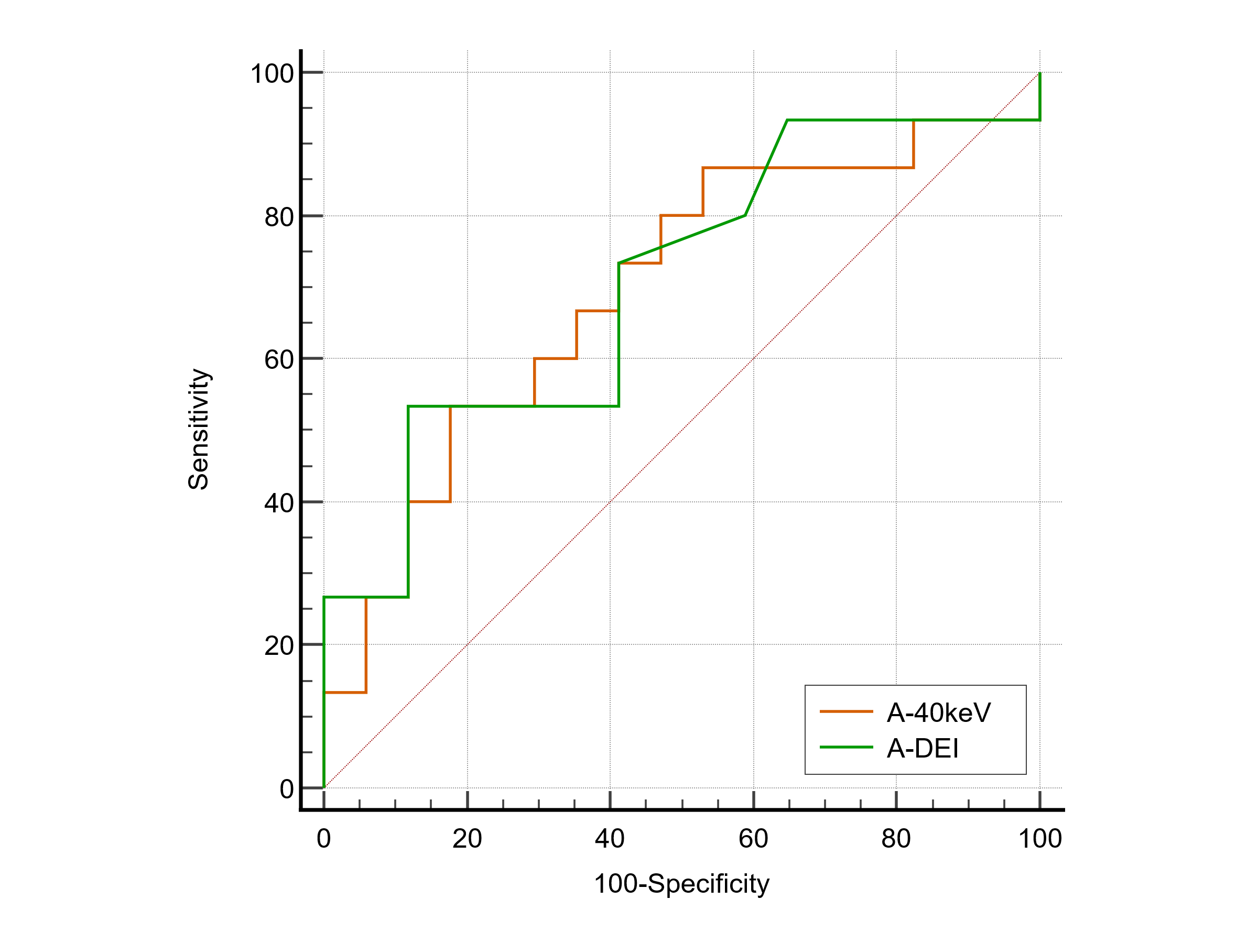
Fig S1. ROC curves of PCCT spectral parameters A-40keV and A-DEI for predicting EGFR 19Del and L858R mutations in patients with lung adenocarcinoma

