Text S1 Emission scenarios
We used the INDC emissions data submitted by 192 countries according to the Paris Agreement. The INDC dataset is continuously updated and can be obtained from the UNFCCC website (UNFCCC 2019). The emissions targets reported by each country vary from absolute emissions targets to emissions targets relative to a base year level, or emissions reduction targets relative to a baseline emissions scenario. We analysed and extracted the emissions targets of most countries. Of the 165 INDCs, 124 (covering 151 countries) were assessed and quantified, accounting for 93.6% of global greenhouse gas (GHG) emissions. The mitigation targets of the remaining INDCs could not be assessed because of a lack of quantified goals; however, they account for only a small part of global GHG emissions. For more details on the global INDC emissions calculations, refer to Wang et al. (2018). Global INDC emissions before 2030 were estimated by adding up all national INDC emissions.
Simulations of future emissions, obtained using 28 socioeconomic models (IPCC AR5 scenario database, https://tntcat.iiasa.ac.at/AR5DB/), were used to extend the INDC scenarios until the end of this century. We considered the rate of decarbonization, carbon capture and storage technology (CCS), energy structure improvement, and time to carbon neutralization. We also considered the many possible interpretations of “INDC mitigation actions” available in the scenarios that contributed to the IPCC AR5 scenario database. We used scenarios that conform to the 2030 GHG emission levels that are consistent with the INDCs (50−56 Gt CO₂ eq/yr) and assumed that there are no sudden changes in climate over the 21st century. Considering the difficulty and uncertainty of carbon removal technology in the future, we took a conservative approach with respect to the future availability of negative emissions technologies and scenarios by using CCS > 15 Gt CO₂ eq/yr.
We classified the emissions pathways into six groups using key characteristics such as emissions targets for specific years, renewable energy structure, and the amount of CCS (see Fig. S1). Group I (baseline scenario) includes scenarios without any additional climate policies or mitigation actions, where the GHG emissions continue to grow according to current trends. Group II is similar to Group I but allows for lower energy intensity in the future. Group III represents a weak policy baseline scenario that considers existing climate policies, a weak interpretation (e.g., 2020 Copenhagen Pledges), and extrapolation of these targets beyond 2020 based on emissions intensity. Global emissions were assumed to peak in 2030 in Groups IV, V, and VI. Specifically, Group IV can be described as a “continued action” pathway. The relatively constant decarbonization rates were roughly followed in the period after 2030. The overall trend of Group V is close to that of Group IV, but mitigation is more rapid after 2030. Group VI involves CCS technology accelerating decarbonization and determining negative emissions in some pathways. In this study, we focused on Groups III and IV, which represent the INDC “continued action” scenario.
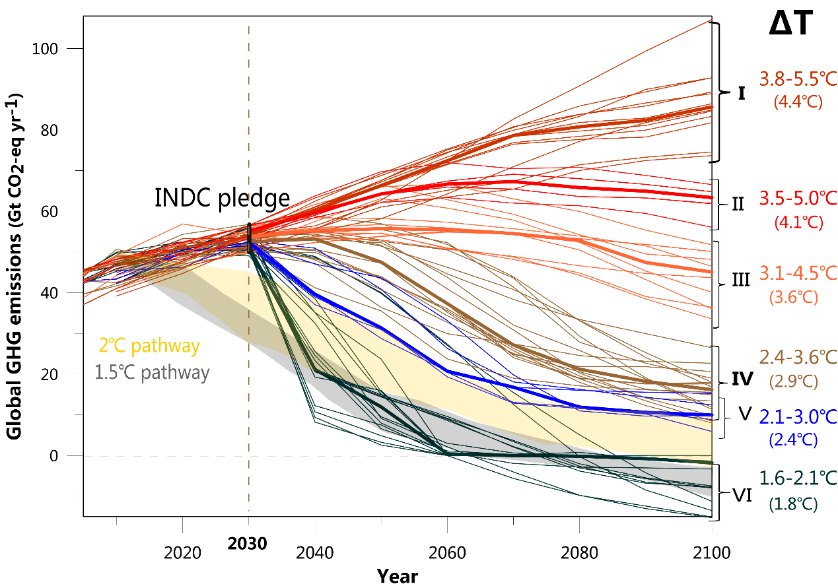
Figure S1 Future emissions pathways analysed in this example. The dashed vertical line delineates the range of conditional and unconditional INDC pledges in 2030, and the thin lines show the selected emissions pathways that are classified into the six groups, differentiated by different colours. The grey and yellow shaded areas are the ranges of the 1.5 °C and 2 °C pathways, respectively, which are shown for reference (CAT 2017). The right-hand y-axis shows the estimates of warming above the preindustrial level (ΔT) for each scenario group (the temperature range is the uncertainty range of 33−66% and the median is in parentheses).

Text S2 Global warming responses to INDC emission reductions
Running a full suite of comprehensive Earth system models (ESMs), such as the CMIP5 model, to simulate climate response under INDC scenarios is unrealistic because of the high computational cost, while running only one model is not representative of climate response because of potential biases of the model. Recent studies have shown an approximately linear relationship between cumulative CO₂ emissions and temperature change, thereby providing a way to evaluate climate response under INDC scenarios without the need to run additional simulations using comprehensive ESMs. Global mean warming under different INDC scenarios can be inferred from the relationship between climate warming and cumulative CO₂ emissions (Collins et al. 2013, Gillett et al. 2013, Matthews et al. 2009, Tokarska et al. 2016, Zickfeld et al. 2009). A function of temperature change responses to cumulative CO₂ emissions (TRCE) was constructed from multimodel simulations and defined as ${TCRE}_{all}=∆T/∆I$, where $∆I$ represents the cumulative anthropogenic CO₂ emissions and $∆T$ is the corresponding change in global mean temperature, subject to decadal smoothing. All non-CO₂ emissions in the INDC scenarios were converted into a unit of CO₂ equivalent emissions.
The IPCC AR5 projected future climate change under a set of Representative Concentration Pathways (RCP) scenarios, using an ensemble of comprehensive ESMs (CMIP5) and a reduced-complexity carbon-cycle and climate model [Model for the Assessment of Greenhouse Gas Induced Climate Change (MAGICC)]. The TCRE is relatively constant over time and is independent of the CO₂ emissions pathway based on the results of the CMIP5/MAGICC model (Matthews et al. 2009, Allen et al. 2009, Rogelj, Meinshausen, and Knutti 2012). Based on a reliable estimate of TCRE, warming in response to the INDC scenarios was defined as ${∆T}_{INDC}={TCRE}_{all}×{∆I}_{INDC}$, where ${∆I}_{INDC}$ is the cumulative emissions under the INDC scenarios.
Several studies also provided evaluation results. For example, the United Nations Environment Program (UNEP) published the Emissions Gap Report (UNEP 2017), which hypothesized that global emissions in accordance with the INDCs would result in global warming 3–4 °C (probability >66%) above the preindustrial level by 2100 and would have a profound impact on the climate. Rogelj et al. (2016) showed that the median temperature rise at the end of this century will be ~2.6–3.1 °C, with a stronger temperature increase likely. The CI (2016) reported a range of ~2.0–4.6 °C based on INDC scenarios. Wang et al. (2018) pointed out that the INDC emissions would lead to a global mean warming of 1.4 °C (1.3–1.7 °C) by 2030 and 3.2 °C (2.6–4.3 °C) by 2100. We synthesised the results from the above-mentioned studies and assessed the corresponding potential global mean temperature rise for various emission scenarios based on 78 climate sensitivity experiments from the GCM ensemble of CMIP5 (Taylor, Stouffer, and Meehl 2011). As the results, we determined that ${∆T}_{INDC}≈2.93.3 °C$(median 3.1 °C) is the most likely temperature increase range for the “continued action” pathways of the INDCs.

Table S1 Basic information on the 17 GCMs in the CMIP5 used in this study. The selection of these 17 models is mainly based on the availability of data (precipitation and all the inputs required for the Penman-Monteith model).
Model name | Institute | Country | Horizontal resolution
BCC-CSM1-1 | Beijing Climate Center, China Meteorological Administration | China | 128 × 64
BCC-CSM1-1-m | Beijing Climate Center, China Meteorological Administration | China | 320 × 160
BNU-ESM | Beijing Normal University | China | 128 × 64
CanESM2 | Canadian Centre for Climate Modelling and Analysis | Canada | 128 × 64
CNRM-CM5 | Centre National de Recherches Météorologiques, Centre Européen de Recherche et de Formation Avancée en Calcul Scientifique | France | 256 × 128
CSIRO-Mk3-6-0 | Commonwealth Scientific and Industrial Research Organisation (CSIRO), Queensland Climate Change Centre of Excellence | Australia | 192 × 96
FGOALS-s2 | Institute of Atmospheric Physics, Chinese Academy of Science | China | 128 × 108
GFDL-CM3 | Geophysical Fluid Dynamics Laboratory | USA | 144 × 90
GFDL-ESM2G | Geophysical Fluid Dynamics Laboratory | USA | 144 × 90
GFDL-ESM2M | Geophysical Fluid Dynamics Laboratory | USA | 144 × 90
INM-CM4 | Russian Academy of Sciences, Institute of Numerical Mathematics | Russia | 180 × 120
IPSL-CM5A-LR | Institut Pierre Simon Laplace | France | 96 × 96
IPSL-CM5A-MR | Institut Pierre Simon Laplace | France | 144 × 143
IPSL-CM5B-LR | Institut Pierre Simon Laplace | France | 96 × 96
MIROC-ESM  MIROC-ESM-CHEM | Atmosphere and Ocean Research Institute (The University of Tokyo), National Institute for Environmental Studies, Japan Agency for Marine-Earth Science and Technology | Japan | 128 × 64  128 × 64
MRI-CGCM3 | Meteorological Research Institute | Japan | 320 × 160

Text S3 Bias correction method
To correct the climatology of precipitation and PET in our model, a bias correction method was applied to the model data. A mean correction additive scaling factor was defined as the difference between observed and simulated precipitation plus PET over the period of 1961−1990 (Durman et al. 2001):
$$T_{MC}=T_{model}+({TT}_{obs}-{TT}_{model})$$
where $T_{model}$ and $T_{MC}$ are the simulated and corrected daily precipitation plus PET values, respectively, and ${TT}_{obs}$ and ${TT}_{model}$ are the climatological monthly mean of the observed and simulated precipitation plus PET, respectively. Thus, ${TT}_{obs}-{TT}_{model}$ represents the scaling factor and changes from month to month.

Text S4 Time-slice approach
This study was based on the historical run of the past approximately 150 years that used all forcings and the 21st century projection forced by the RCP8.5 scenario within the CMIP5 framework (Taylor, Stouffer, and Meehl 2011). Since we are primarily interested in the dependence of the distribution of other climate indicators on prevailing time-averaged temperature conditions, the time series of globally averaged near-surface air temperature and associated climate indicators is smoothed by a 21-year running mean to filter out the interannual variability under the historical run and the RCP scenarios for individual models. The 21-year time slice used for this average includes the median year for which the global mean surface temperature crosses a given warming target (${∆T}_{INDC}$, or 1.5 °C, 2.0 °C), as well as the 10 years preceding and following the median year (see Fig. S2).
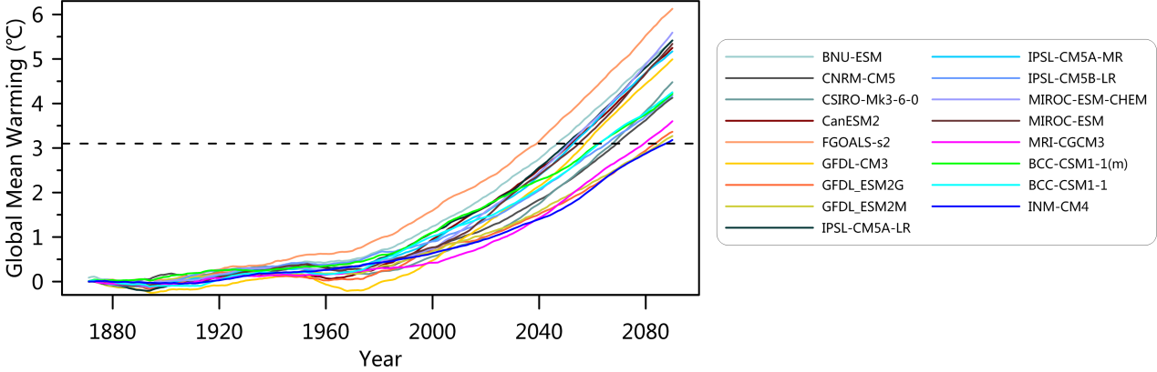
Figure S2 Time series of global mean annual temperature changes (with 21-year running mean) relative to the baseline climatology of the preindustrial period (1861−1880), as derived from the individual GCMs under RCP8.5 (see legend). The horizontal dashed line indicates the warming target ${∆T}_{INDC}$.

Text S5 Penman–Monteith model
The Penman–Monteith model is a widely used method for simulating PET (Allen and Ingram 2002). With its emphasis on the radiative and aerodynamic controls on PET, the Penman–Monteith model is more appropriate for projections of long-term drought and dryland conditions under climate change (Sherwood and Fu 2014, Huang et al. 2017). The modified Penman–Monteith model, recommended in 1998 by the Food and Agriculture Organization of the United Nations (hereafter the FAO56-PM model), has been applied in both arid and humid environments. Therefore, we used the Penman–Monteith model to simulate PET over Asia:
$$PET=[0.408∆\left(R_{n}-G\right)+γ\frac{900}{T+273.15}U_{2}(e_{s}e_{a})]/[+(1+0.34U_{2})]$$
where $R_{n}$ is the net radiation (MJ m^{–2}), $G$ is the soil heat flux (MJ m^{–2}), $γ$ is the psychrometric constant (kPa °C^{–1}), $∆$ is the slope of the saturation vapor pressure curve (kPa °C^{–1}), $T$ is the average temperature (°C), $U_{2}$ is the wind speed at the height of 2 m (m s^{–1}), $e_{s}$ is the mean saturation vapor pressure (kPa), and $e_{a}$ is the actual vapor pressure (kPa). We amuse soil heat flux is approximately equal to zero over a longer time scale.

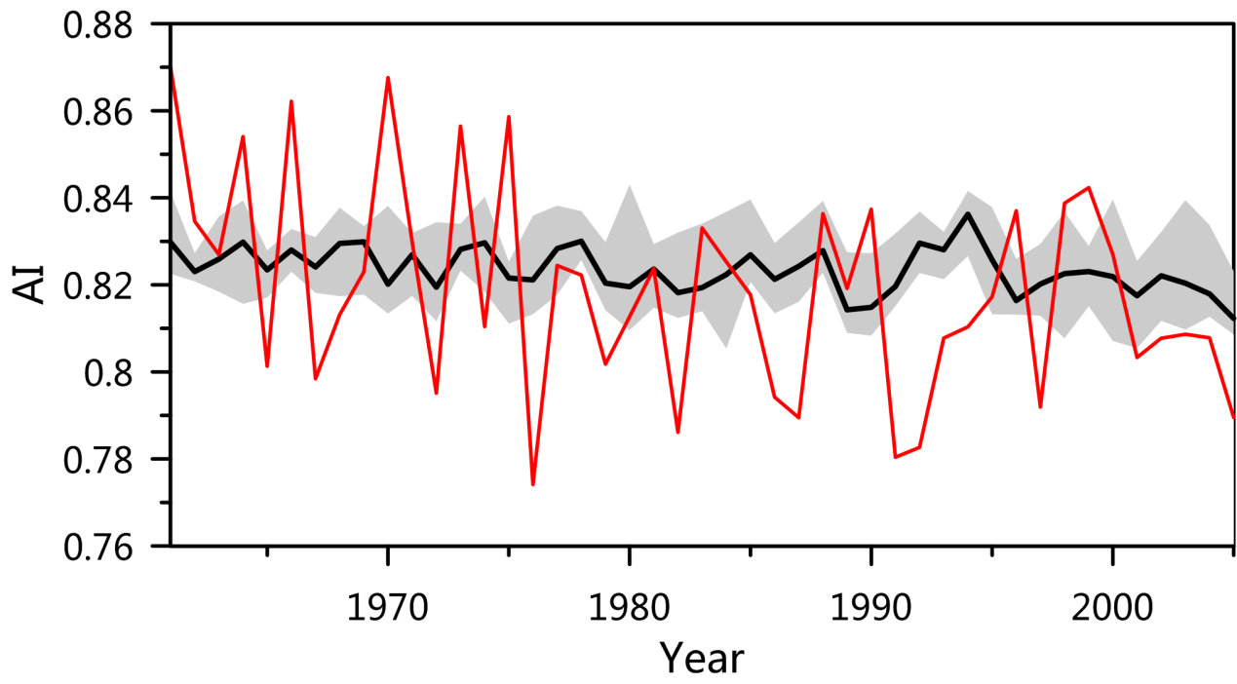
Figure S3 Observed (red line) and corrected-simulated (black line and shaded area are the multimodel median and interquartile range, respectively) time series of the mean AI for Asia from 1961 to 2005.

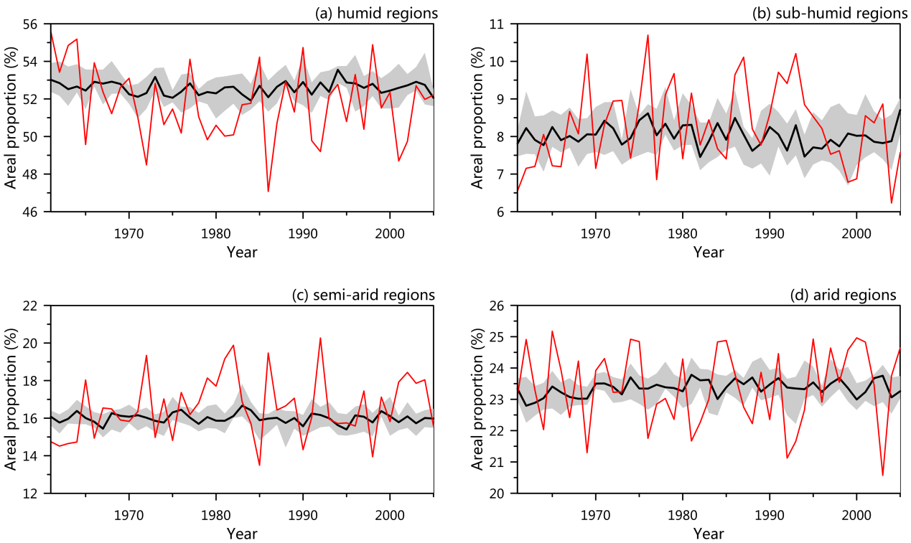
Figure S4 Observed (red line) and corrected-simulated (black line and shaded area are the multimodel median and interquartile range, respectively) time series of the areal proportion of (a) humid, (b) sub-humid, (c) semi-arid, and (d) arid regions from 1961 to 2005.
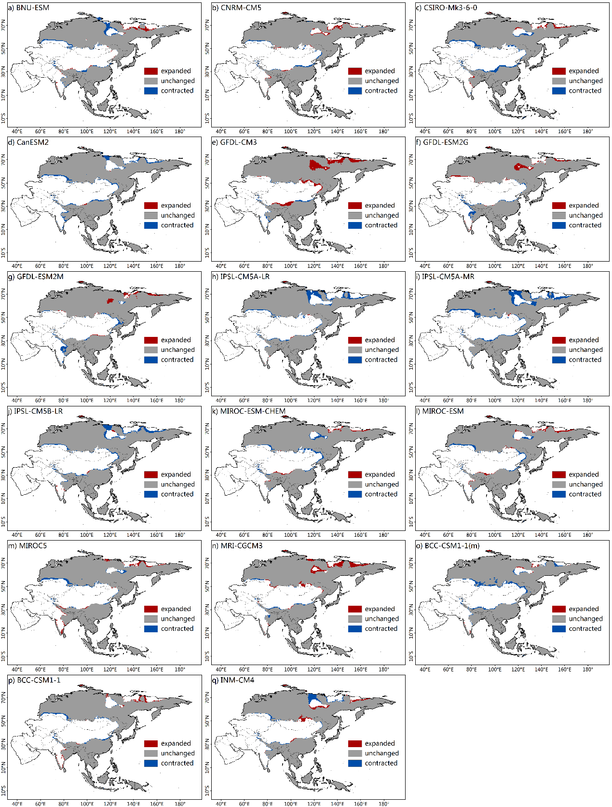
Figure S5. Spatial distribution of humid regions over Asia for the INDC-pledge scenario. Spatial distribution of humid regions over Asia for the INDC-pledge scenario, based on simulated AI by separate models. The different colours indicate changed and unchanged areas relative to the present period.
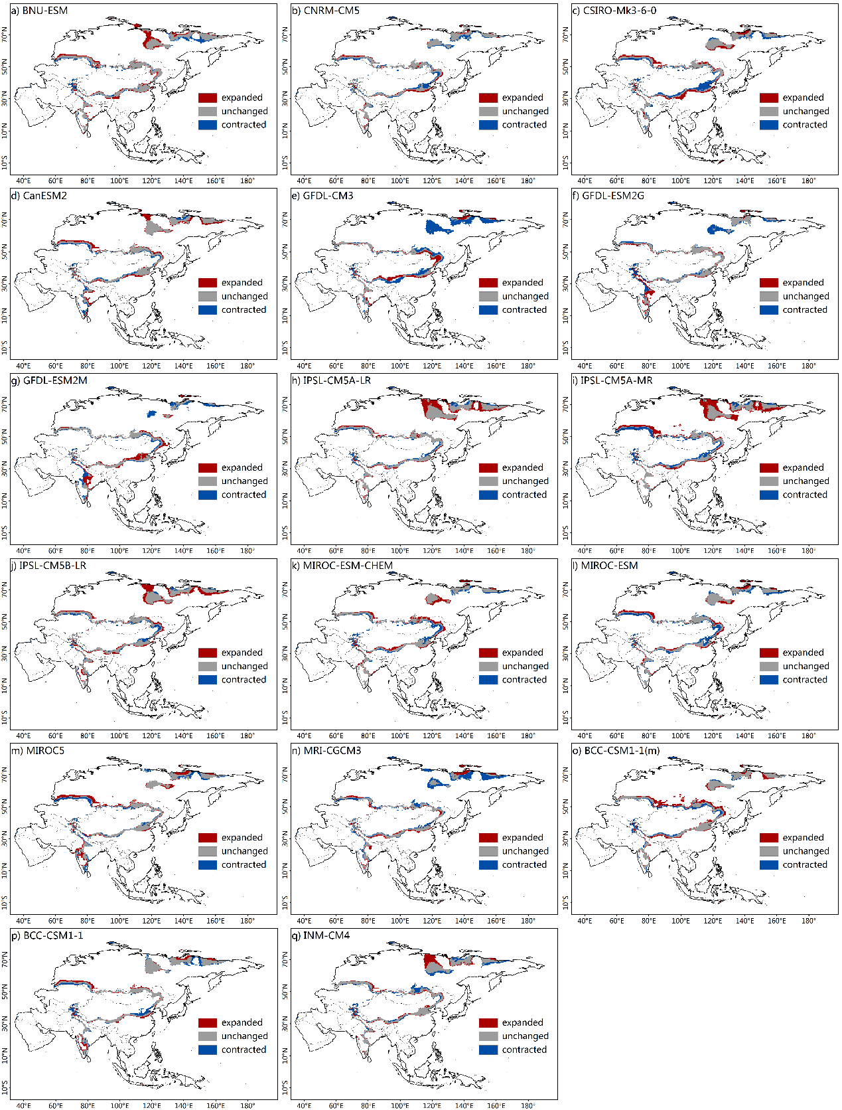
Figure S6. Spatial distribution of sub-humid regions over Asia for the INDC-pledge scenario. Spatial distribution of sub-humid regions over Asia for the INDC-pledge scenario, based on simulated AI by separate models. The different colours indicate changed and unchanged areas relative to the present period.

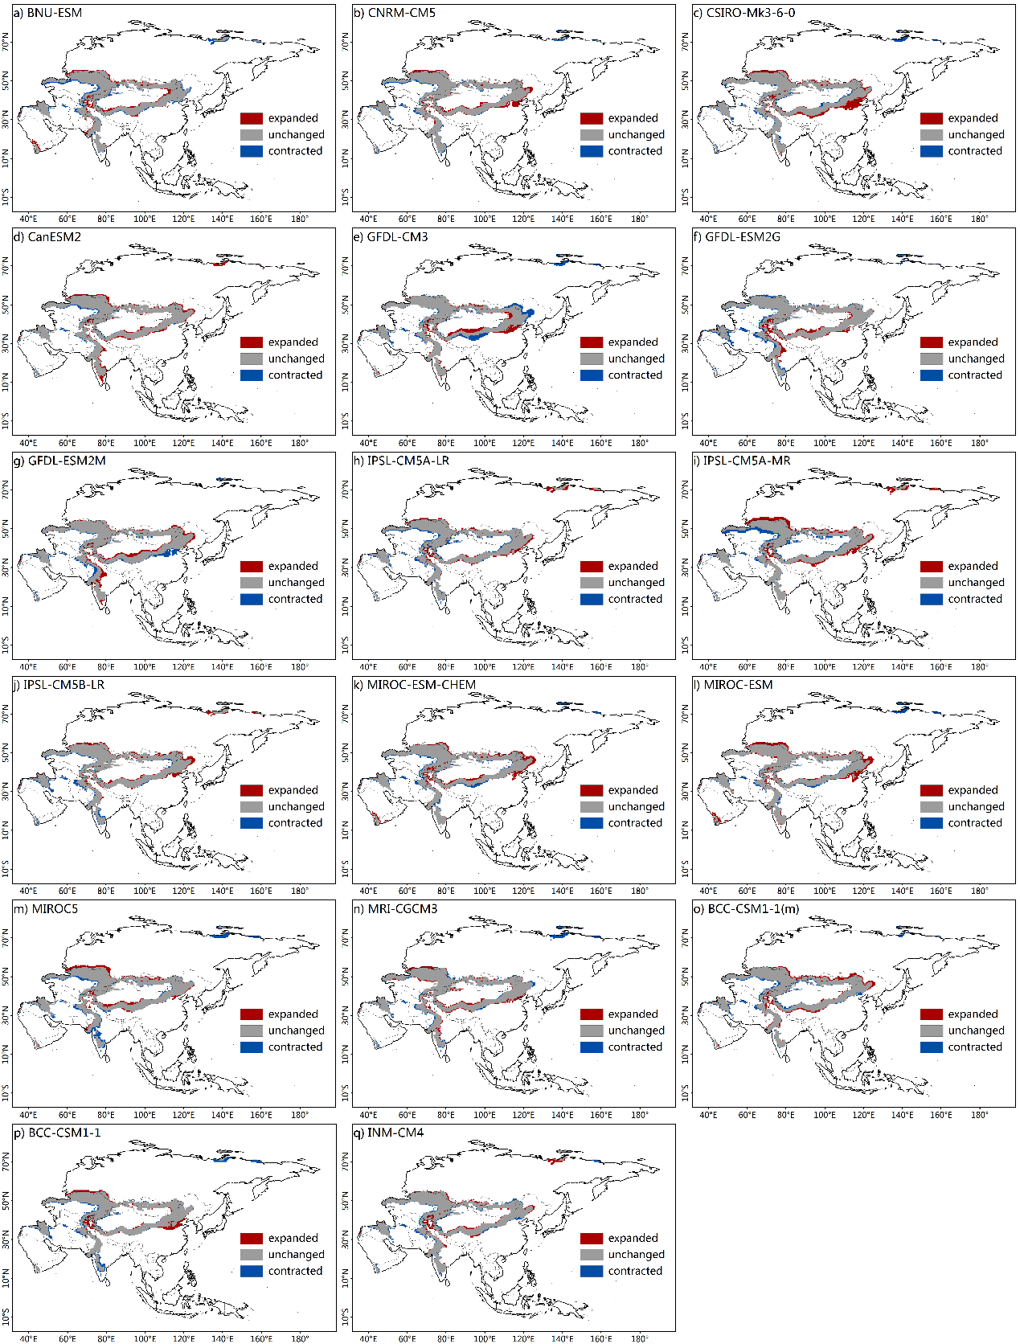
Figure S7. Spatial distribution of semi-arid regions over Asia for the INDC-pledge scenario. Spatial distribution of semi-arid regions over Asia for the INDC-pledge scenario, based on simulated AI by separate models. The different colours indicate changed and unchanged areas relative to the present period.

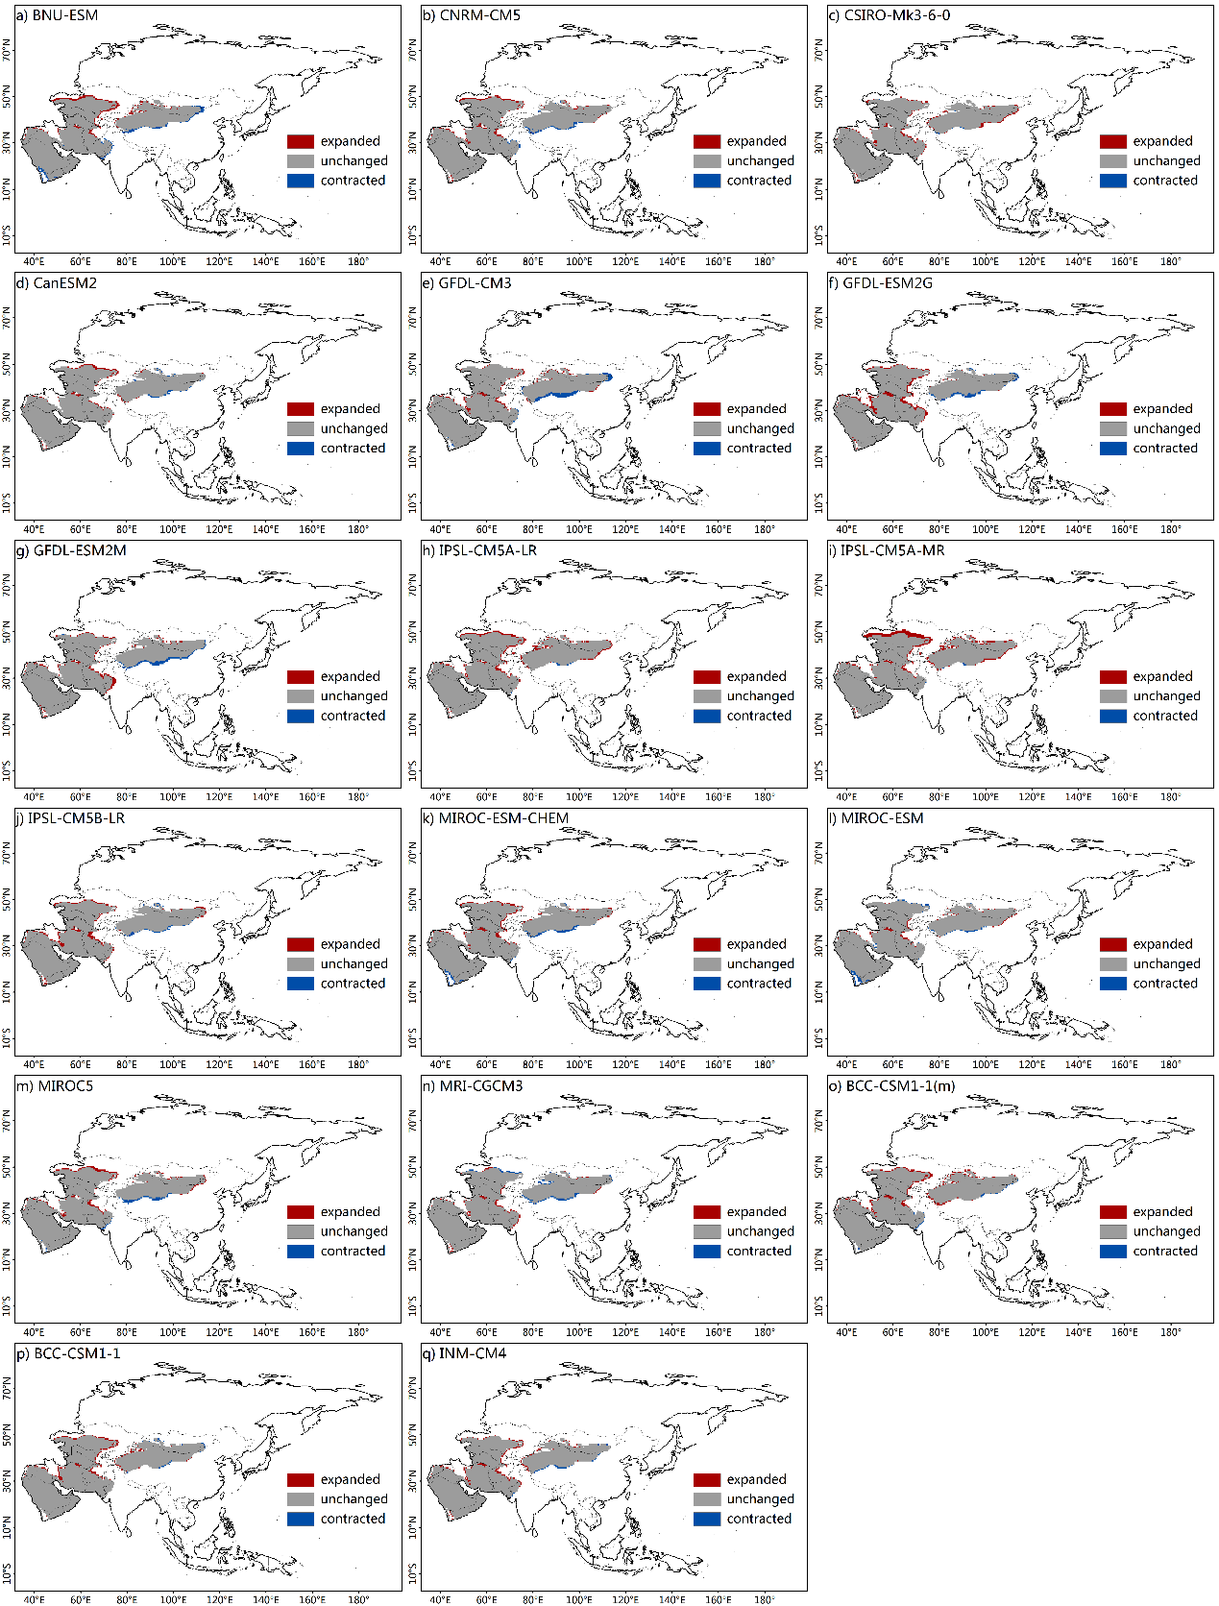
Figure S8. Spatial distribution of arid regions over Asia for the INDC-pledge scenario. Spatial distribution of arid regions over Asia for the INDC-pledge scenario, based on simulated AI by separate models. The different colours indicate changed and unchanged areas relative to the present period.

References
Allen, Myles R., David J. Frame, Chris Huntingford, Chris D. Jones, Jason A. Lowe, Malte Meinshausen, and Nicolai Meinshausen. (2009). "Warming caused by cumulative carbon emissions towards the trillionth tonne." Nature 458:1163. doi: 10.1038/nature08019
Allen, Myles R., and William J. Ingram. (2002). "Constraints on future changes in climate and the hydrologic cycle." Nature 419:224. doi: 10.1038/nature01092.
CAT. (2017). "Addressing global warming." https://climateactiontracker.org/global/temperatures/.
CI. (2016). Climate scoreboard. https://www.climateinteractive.org/
Collins, M., R. Knutti, J. Arblaster, J.-L. Dufresne, T. Fichefet, P. Friedlingstein, X. Gao, W.J. Gutowski, T. Johns, G. Krinner, M. Shongwe, C. Tebaldi, A.J. Weaver, and M. Wehner. (2013). "Long-term Climate Change: Projections, Commitments and Irreversibility." In Climate Change 2013: The Physical Science Basis. Contribution of Working Group I to the Fifth Assessment Report of the Intergovernmental Panel on Climate Change, edited by T.F. Stocker, D. Qin, G.-K. Plattner, M. Tignor, S.K. Allen, J. Boschung, A. Nauels, Y. Xia, V. Bex and P.M. Midgley. Cambridge, UK, and New York, NY, USA: Cambridge University Press.
Durman, C. F., J. M. Gregory, D. C. Hassell, R. G. Jones, and J. M. Murphy. (2001). "A comparison of extreme European daily precipitation simulated by a global and a regional climate model for present and future climates." Quarterly Journal of the Royal Meteorological Society 127 (573):1005-1015. doi: 10.1002/qj.49712757316.
Gillett, Nathan P., Vivek K. Arora, Damon Matthews, and Myles R. Allen. (2013). "Constraining the Ratio of Global Warming to Cumulative CO 2 Emissions Using CMIP5 Simulations." Journal of Climate 26 (18):6844-6858. doi: 10.1175/JCLI-D-12-00476.1.
Huang, Jianping, Haipeng Yu, Aiguo Dai, Yun Wei, and Litai Kang. (2017). "Drylands face potential threat under 2 °C global warming target." Nature Climate Change 7:417. doi: 10.1038/nclimate3275
Matthews, H. Damon, Nathan P. Gillett, Peter A. Stott, and Kirsten Zickfeld. (2009). "The proportionality of global warming to cumulative carbon emissions." Nature 459:829. doi: 10.1038/nature08047
Rogelj, Joeri, Michel den Elzen, Niklas Höhne, Taryn Fransen, Hanna Fekete, Harald Winkler, Roberto Schaeffer, Fu Sha, Keywan Riahi, and Malte Meinshausen. (2016). "Paris Agreement climate proposals need a boost to keep warming well below 2 °C." Nature 534:631. doi: 10.1038/nature18307
Rogelj, Joeri, Malte Meinshausen, and Reto Knutti. (2012). "Global warming under old and new scenarios using IPCC climate sensitivity range estimates." Nature Climate Change 2:248. doi: 10.1038/nclimate1385
Sherwood, Steven, and Qiang Fu. (2014). "A Drier Future?" Science (New York, N.Y.) 343:737-9. doi: 10.1126/science.1247620.
Taylor, Karl E., Ronald J. Stouffer, and Gerald A. Meehl. (2011). "An Overview of CMIP5 and the Experiment Design." Bulletin of the American Meteorological Society 93 (4):485-498. doi: 10.1175/BAMS-D-11-00094.1.
Tokarska, K. B., N. P. Gillett, A. J. Weaver, V. K. Arora, and M. Eby. (2016). "The climate response to five trillion tonnes of carbon." Nature Climate Change 6 (9):851-855. doi: 10.1038/nclimate3036.
UNEP. (2017). The Emissions Gap Report. Nairobi.
UNFCCC. (2019). National Inventory Submissions.
Wang, Fang, Katarzyna B. Tokarska, Jintao Zhang, Quansheng Ge, Zhixin Hao, Xuezhen Zhang, and Maowei Wu. (2018). "Climate Warming in Response to Emission Reductions Consistent with the Paris Agreement." Advances in Meteorology 2018:1-9. doi: 10.1155/2018/2487962.
Zickfeld, Kirsten, Michael Eby, H. Damon Matthews, and Andrew J. Weaver. (2009). "Setting cumulative emissions targets to reduce the risk of dangerous climate change." Proceedings of the National Academy of Sciences 106 (38):16129-16134. doi: 10.1073/pnas.0805800106.

