Additional file S4: Fig. S2
SEM photographs of the planktonic foraminifer G. bulloides

Fig. S2.
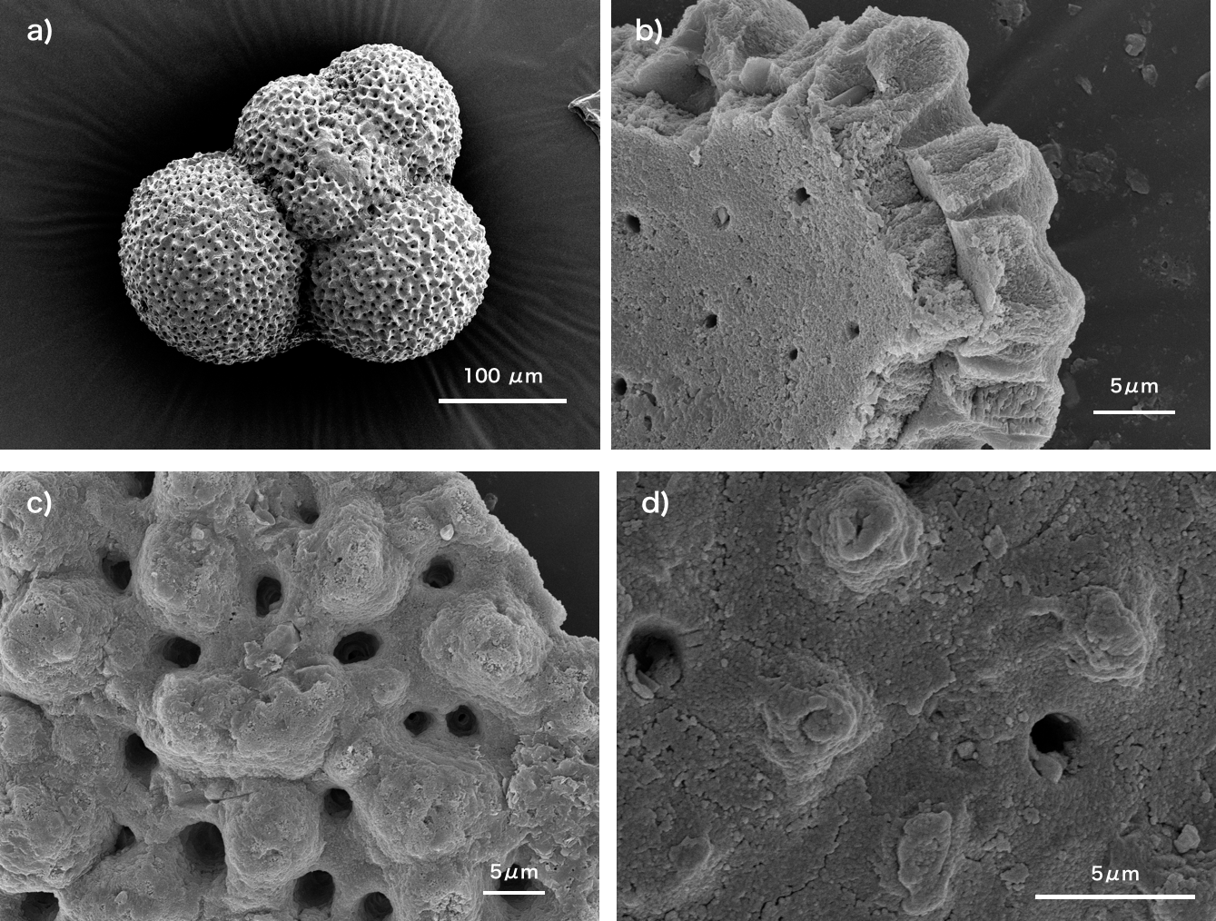
Fig. S2. SEM photographs of the planktonic foraminifer G. bulloides from sample ID TB2-13. The foraminiferal tests were coated with Au for SEM. a) Spiral side (3 kV, spot size = 40), b) internal test wall (15 kV, spot size = 40), c) and d) external test surface (15 kV, spot size = 40) showing spine bases.

