Supplementary materials
Evaluation of Earth Systems Models and Atmospheric Inversions using Total Column CO₂ Observations from GOSAT and OCO-2

Prabir K. Patra^{1,2}
Corresponding author (Email: prabir@jamstec.go.jp)

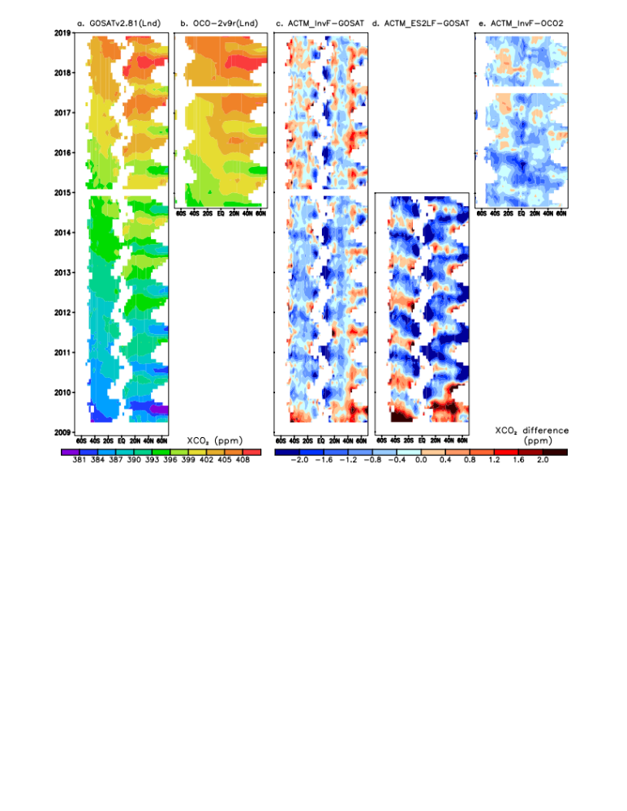
Figure S1: Same as Figure 5 but for data over land surface only.

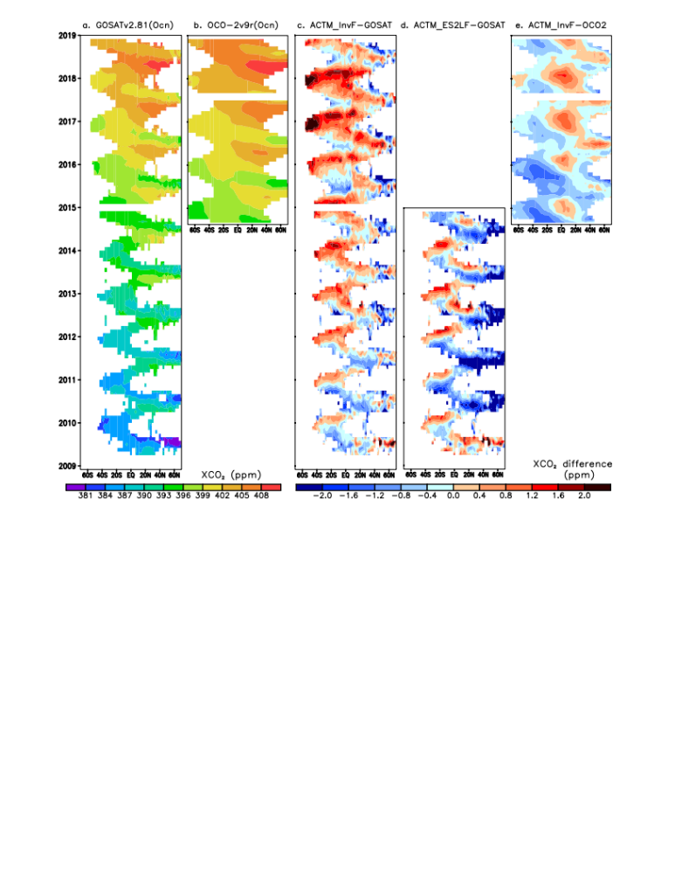
Figure S2: Same as Figure 5, but for the observations over water bodies only.

Animation S1: Same as Figure 6 for the time series of XCO₂ for all the 15 land regions and 11 ocean regions for the period of 2009-2018. Note that these plots consist of 2 additional panels showing the model-measurement differences and the detrended seasonal cycles, for which the statistics are presented in Table 1. (https://ebcrpa.jamstec.go.jp/~prabir/data/Pubctn/XCO2model/Animation_S1.gif)

Animation S2: Same as Animation S1, but for the OCO-2 measurement period (2014-2018).
(https://ebcrpa.jamstec.go.jp/~prabir/data/Pubctn/XCO2model/Animation_S2.gif)

Animation S3: Same as Figure 7 for XCO₂ seasonal cycle amplitudes for different years, and those for ACTM_InvF and OCO-2 only for the period 2014 to 2018.
(https://ebcrpa.jamstec.go.jp/~prabir/data/Pubctn/XCO2model/Animation_S3.gif)

