Additional file 1

NanoSIMS and EPMA Dating of Lunar Zirconolite
Nian Wang^{1, 2†}, Qian Mao^{3†}, Ting Zhang^{1, 2}, Jialong Hao¹, Yangting Lin¹*

¹Key Laboratory of Earth and Planetary Physics, Institute of Geology and Geophysics, Chinese Academy of Sciences, Beijing 100029, China
²University of Chinese Academy of Sciences, Beijing 100049, China
³State Key Laboratory of Lithospheric Evolution, Institute of Geology and Geophysics, Chinese Academy of Sciences, Beijing 100029, China
† Nian Wang and Qian Mao contributed equally to this work.

Corresponding author: Yangting Lin (Email: linyt@mail.iggcas.ac.cn)

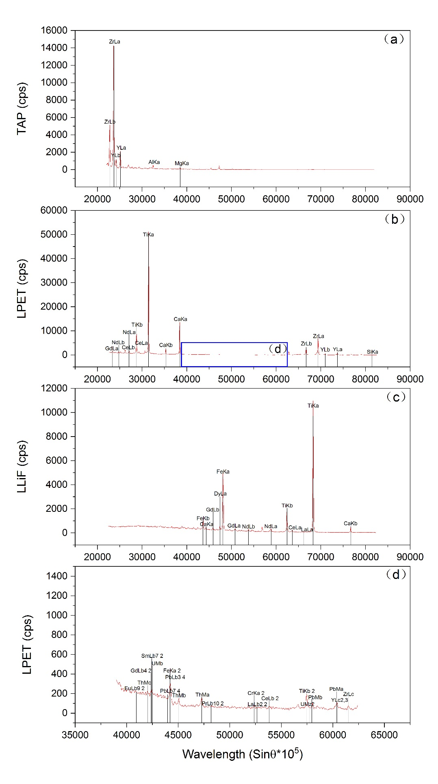
Fig. S1 Full range WDS Wavescans of the large zirconolite grain acquired with TAP (a), LPET (b, d), and LLiF (c) diffractors. The enlarged map of blue rectangle in (b) are displayed in (d), showing the details of low cps peaks.
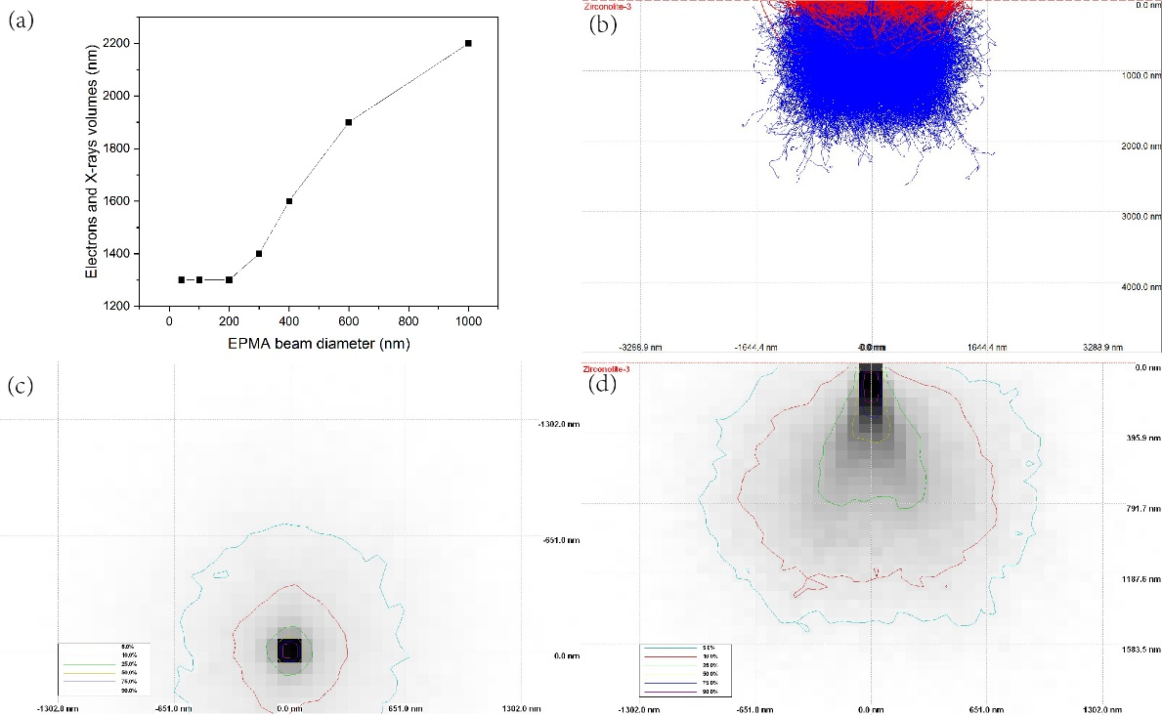

Fig. S2 Monte Carlo simulations of the interaction volumes of electrons and generation volumes of X-rays in zirconolite generated using Casino (Drouin et al., 2007) at 20 kV with a focused beam. The density of zirconolite is defined as 4.8 g/cm³. 1*10⁴ electron trajectories were calculated and displayed. In order to acquire the smallest beam size, we plotted the correlation between electrons and X-rays volumes and EPMA beam diameter (a). The smallest XY dimensional diameter of electrons and X-rays of 1.3 μm was acquired when the focused EPMA beam diameter are no more than 200 nm. (b) The interaction volumes of electrons and generation volumes of X-rays at 20 kV with 200 nm EPMA beam diameter. (c) The XY dimensional energy distribution with 20 kV voltage and 200 nm beam size. (d) The YZ dimensional energy distribution with 20 kV voltage and 200 nm beam size shows 95% of energy are distributed less than 1.5 μm in depth.

References

Drouin, D., Couture, A.R., Joly, D., Tastet, X., Aimez, V. and Gauvin, R. (2007) CASINO V2.42: a fast and easy-to-use modeling tool for scanning electron microscopy and microanalysis users. Scanning 29, 92-101. 10.1002/sca.20000

