Supplementary Information
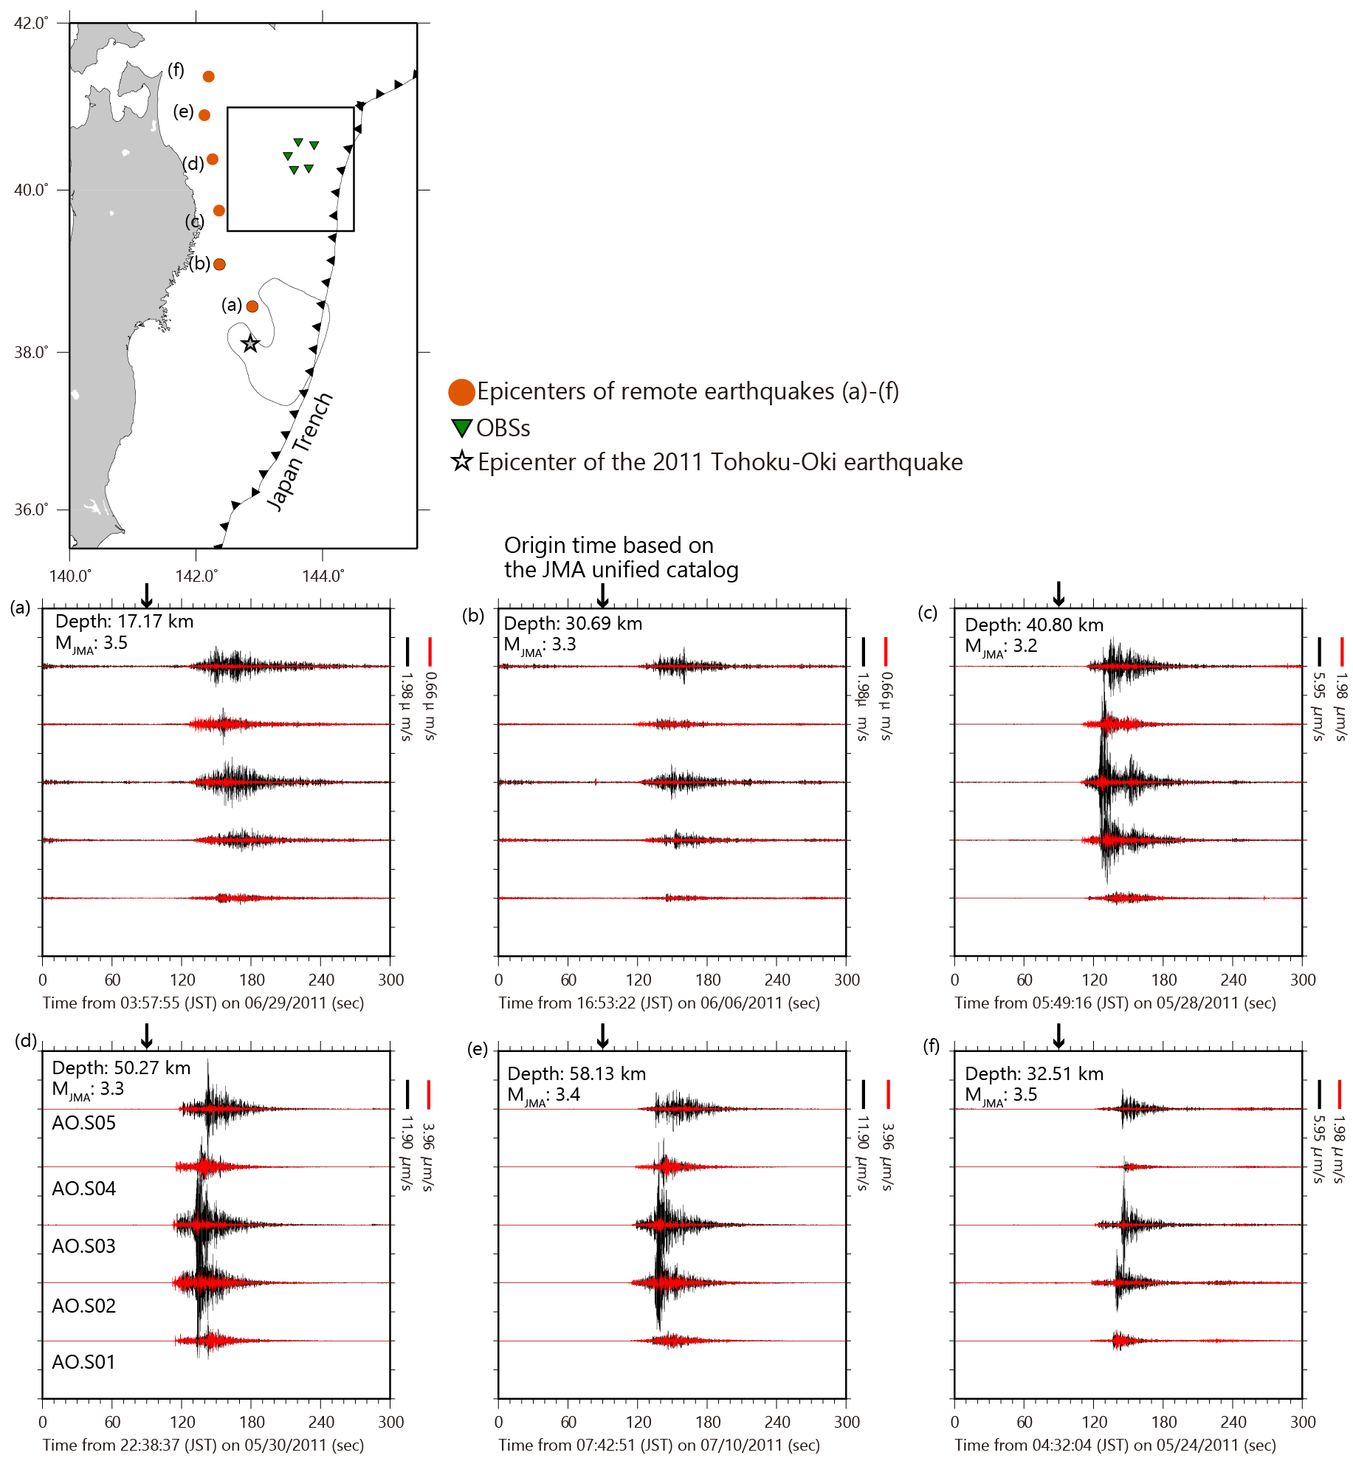
Figure S1. Waveforms of the remote earthqukaes and corresponding epicenters. Rectangles indicate the study area shown in Figure 1.

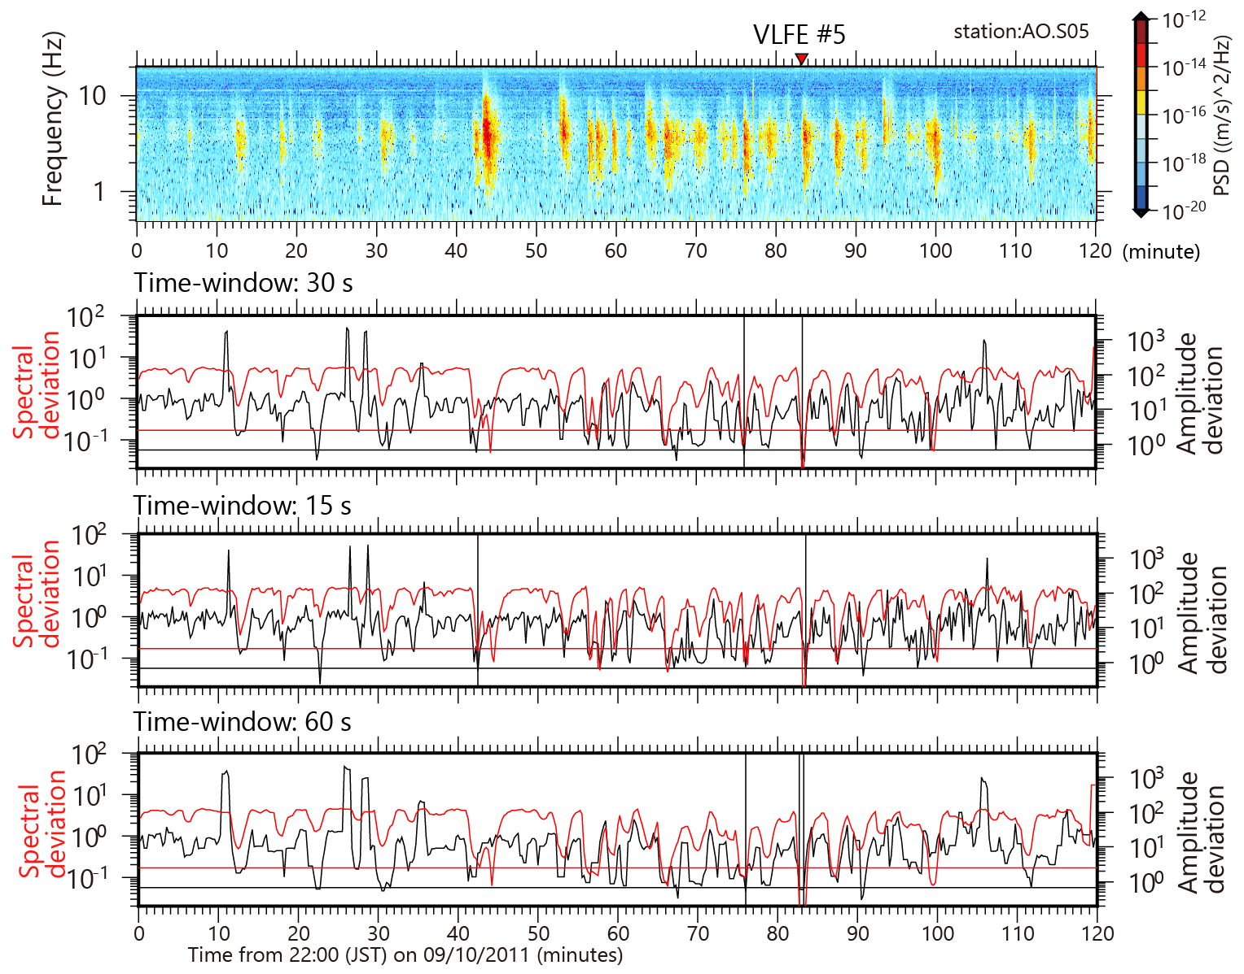
Figure S2. Two-hour spectrograms with the occurrence time of VLFE #5 and corresponding Amplitude deviation and Spectral deviation with different time-windows. Red inverted triangle indicates the occurrence time of VLFE, while vertical black lines show the time with satisfaction with two thresholds.

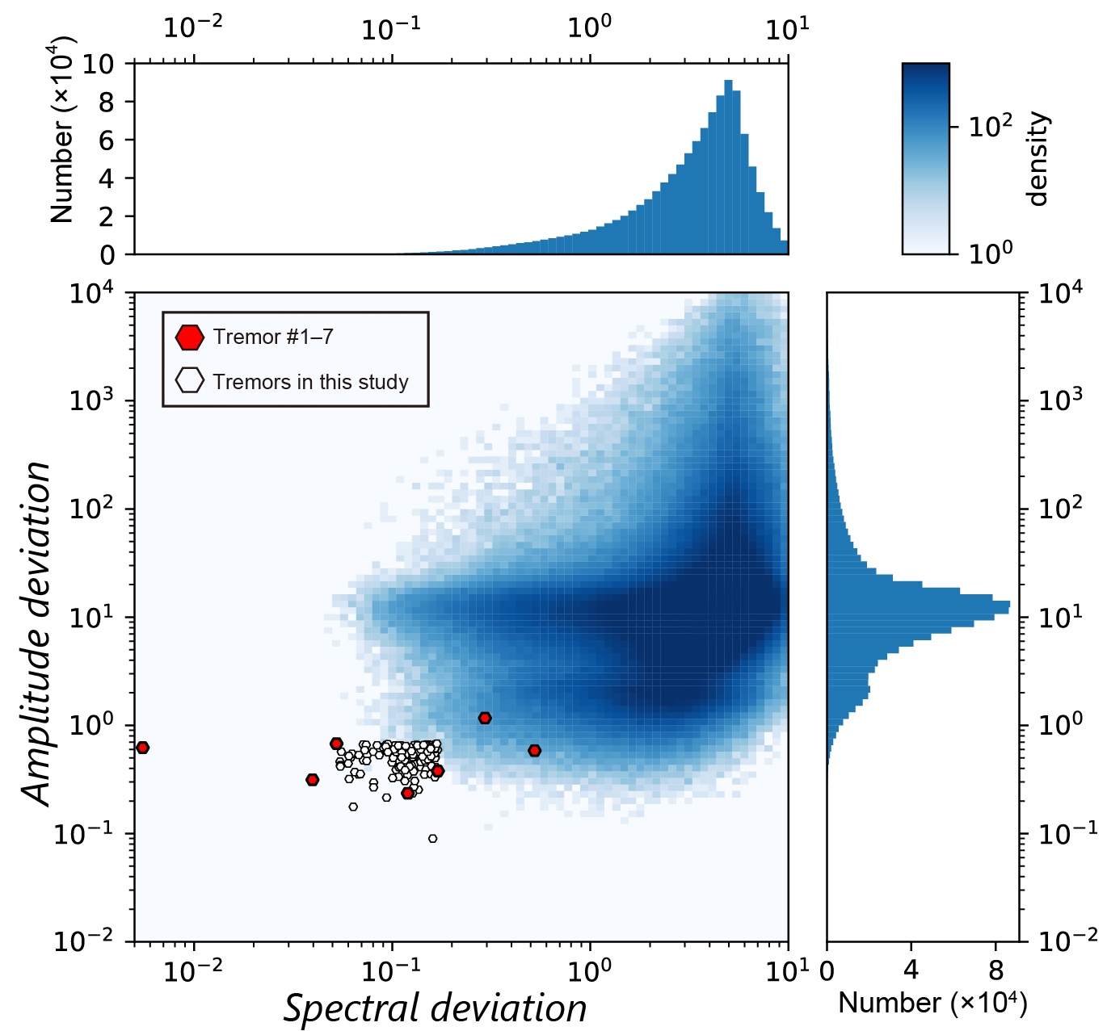
Figure S3. Classification results of the entire period. Red hexagons represent tremors #1–7, and open hexagons represent the other 131 tremors detected with two-dimensional frequency distribution of amplitude deviation and Spectral deviation.

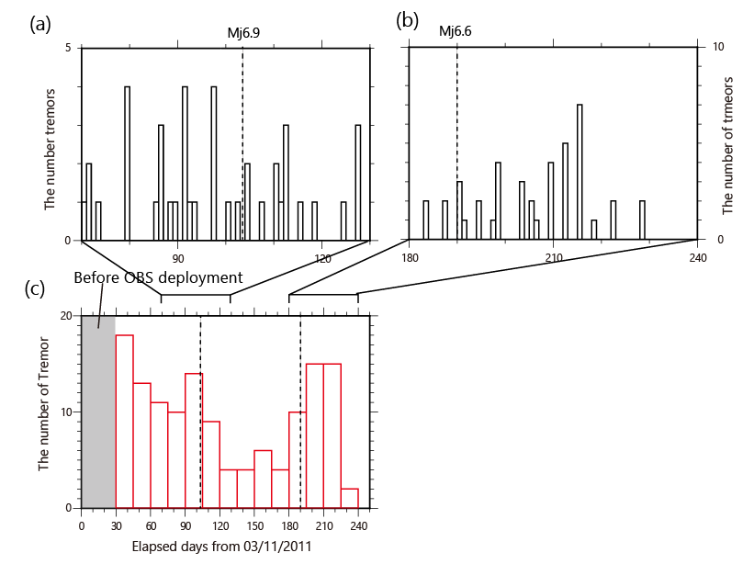

Figure S4. The number of tremors in 2011 identified in the present study. This figure resembles that of Figure 11a, except with enlarged views for the two prominent activities. (a) The number of tremors per day between 70 and 130 from 03/11/2011. (b) The numbers of tremors per day between 180 and 240 days from 03/11/2011. (c) The number of tremors during observations per 15 days from 03/11/2011. Vertical dashed lines show the occurrence times of M6.9 and M6.6 earthquakes.

