Additional file 1

Recurrence intervals for M>7 Miyagi-ken-Oki earthquakes during an M~9 earthquake cycle
Ryoko Nakata¹
Corresponding author
Email: rnakata@eps.s.u-tokyo.ac.jp

Naoki Uchida^{2,3}
Email: naoki.uchida.b6@tohoku.ac.jp

Takane Hori⁴
Email: horit@jamstec.go.jp

Ryota Hino²
Email: hino@tohoku.ac.jp

(Institutional addresses)
¹ Graduate School of Science, The University of Tokyo, 7-3-1 Hongo, Bunkyo-ku, Tokyo 113-0033, Japan
² Graduate School of Science, Tohoku University, 6-6, Aramaki-aza-aoba, Aoba-ku, Sendai 980-8578, Japan
³ Earthquake Research Institute, The University of Tokyo, 1-1-1 Yayoi, Bunkyo-ku, Tokyo 113-0032, Japan
⁴ Research and Development Center for Earthquake and Tsunami Forecasting (FEAT), Research Institute for Marine Geodynamics (IMG), Japan Agency for Marine-Earth Science and Technology (JAMSTEC), 3173-25 Showa-machi, Kanazawa-ku, Yokohama 236-0001, Japan

1. Methods

1.1 Numerical simulation of earthquake generation cycles
We discretized the curved subducting plate interface into small planar triangular elements (Additional file 1: 1.2 and 1.3). Three triangular elements were treated as one rectangular-like subfault. Hereafter, subscripts i and j denote the subfaults modelled for the simulation. Seismic and aseismic events on a discretized geometry were modelled to represent the release of the slip deficit or backslip, which accumulates during interseismic periods (Rice 1993). Such spatiotemporal variations in the slip velocity were assumed to indicate an unstable slip with a frictional interface. The time derivative of shear stress τ on the i-th subfault owing to the slip at the j-th subfault was calculated as follows:

$\frac{dτ_{i}}{dt}=\sum_{j}{Κ_{ij}\left(V_{j}-V_{pl,j}\right)-η\frac{dV_{i}}{dt}}$, (1)

where K_{ij} is the stress increment on subfault i owing to unit slip on subfault j. Slip response K_{ij} are represented here by the combined effect of angular dislocations by three triangular elements within a rectangle-like subfault (Comninou and Dundurs 1975). The stress change was estimated at the center of each subfault in the direction of slip acceleration. K_{ij} was evaluated in a homogeneous elastic half space. V_{j} is the slip rate of the j-th subfault in the plate convergence direction, and V_{pl,j} is the plate convergence rate of the j-th subfault. η denotes the seismic radiation damping term (Rice 1993). To treat the long cycle, we used the quasi-dynamic (QD) model (Rice 1993) with a smaller radiation damping term instead of a fully dynamic (FD) model. The QD model typically cannot simulate fast slips during seismic events; however, in models with standard rate-and-state friction and relatively uniform fault properties, the FD and QD simulations produce qualitatively similar fault behaviors, with crack-like ruptures and similar earthquake patterns (Thomas et al. 2014). Then, we used η = 0.3G/2β, where G is the rigidity and β is the shear wave speed.
We employed a rate- and state-dependent frictional law (Dieterich 1979) as an approximate mathematical model for large-scale frictional behavior at the plate interface, and a fault constitutive law (Nakatani 2001) to determine the slip rate V_{i} for a given stress τ_{i} and strengthτ_{si} value (Equation 2).

$V_{i}=V^{*}exp\left[\frac{τ_{i}-\left(τ_{s*i}+∆τ_{si}\right)}{A_{i}}\right]$, (2)

$\frac{d{∆τ}_{si}}{dt}=\frac{B_{i}}{{L_{i}}/{V^{*}}}exp\left(-\frac{{∆τ}_{si}}{B_{i}}\right)-B_{i}\frac{V_{i}}{L_{i}}$. (3)

When we set the reference velocity V* at a slip velocity level below which the slip is sufficiently slow to be negligible, the value of τ_{si} (= τ_{s*i} + Δτ_{si}) is the threshold level of the stress τ_{i} required to cause significant slip velocity. Therefore, the value of τ_{si} is analogous to the ‘strength as a threshold’ (Nakatani 2001), and is referred to hereafter simply as ‘strength’. V* was set to V_{pl} in the calculation below; here, τ_{s*} (= μ*σ) represents the steady-state strength with V = V*, and Δτ_{s} is the variation in strength from the steady state. The parameter A (= aσ) controls the slip increase rate at which the stress reaches the strength. We did not directly consider the effective normal stress σ because it is difficult to differentiate its effect from that of the frictional parameter a (and b, as described below) for natural earthquakes.
Equation (3) is an ageing law (Dieterich 1979; Ruina 1983). When strength is defined in this manner, equation (3) can be considered an evolution law for strength change Δτ_{s}, which varies depending on the prior slip history. Parameters B (= bσ) and L control strength recovery and slip weakening. For slip weakening, B and L primarily determine the amplitude of strength variation Δτ_{s} and slip weakening distance D_{c}. These are the minimum characteristics of large-scale friction and are caused by various small-scale physical processes.
To solve equations (1)–(3), we removed the time derivative of stress dτ_{i}/dt and obtained differential equations for slip rate V and strength Δτ_{s}. Assuming the initial values given below, differential equations were solved using an adaptive time step fifth-order Runge–Kutta algorithm (Press et al. 1996). For the initial conditions, the slip velocity V was assumed to be uniform at 0.9V_{pl}, and the strength was calculated as τ_{s*i} + Δτ_{si} = Δτ_{si} = –B_{i}ln(V_{i}/V_{pl}). For the boundary conditions, the slip velocity was assumed to be constant and equal to V_{pl} outside the model region. The parameters given are listed in Table S1.

1.2 Geometry of the plate interface
We utilized the realistic 3D geometry of the subducting Pacific Plate along the Japan Trench (Baba et al. 2006). The model presented here runs from offshore of the Ibaraki Prefecture to the Iwate Prefecture (Figure 2). The length of the modeled domain in the strike direction (N21.5°E) was approximately 480 km on the shallower side, and the depth range of the model region was 7–77 km (Figure 2). If the free surface in the elastic half space model was set to sea level, the tip of the plate boundary was buried in the elastic body. In that case, unrealistic stress concentration at the tip could be caused by slip on the plate boundary. Therefore, the free surface is shifted to the depth of the trough axis (Hyodo and Hori 2013) (7 km, in this case). The edge of the modelled region was set parallel to the direction of the subducting plate (N68.5°W) (arrow in Figure 2a). The domain was first divided into small rectangular meshes on XZ plane (Figure S1a; Hyodo et al. 2016). The small meshes were set with lengths of 1.0 and 0.1 km in the strike (X) and depth (Z) directions (i.e., vertical to the horizontal plane), respectively. We approximated a rectangular-like subfault by three triangles (Figure S1b) to allow calculation of angular dislocation (Comninou and Dundurs 1975).
We define a 3-D coordinate system, as shown in Figure S1a. Using this coordinate system, the plate interface is divided into triangular elements. We treat three triangular elements as one subfault so that the projections of subfaults onto the X-Z plane form homogeneous rectangular grid cells (area enclosed by four black circles). For these subfaults, we prepare the slip responses Kij in Equation (1). As subfaults generally form nonplanar configurations, we approximated a subfault with a set of three triangles (light blue lines in Figure S1b). All vertices of the triangle (white and black circles in Figure S1b) are on iso-contours of the plate interface. Then, Kij was evaluated at the center of the subfault i (crosses in Figure S1b) as the combined stress changes owing to unit slips on a set of three triangles representing subfault j. The direction of a unit slip on each triangle in a subfault is determined from the direction of subduction and the configuration of the triangle (i.e., strike and dip) as follows. First, we divide the horizontal unit vector with the direction of subduction direction into two components: the strike direction of the triangle and the direction perpendicular to it. Then, the latter component of the unit vector is rotated to the direction of the dip of this triangle, and this rotated vector is assumed to become the dip component of the unit slip. Finally, we define the tangential slip which can occur on the triangle as the dislocation along the unit vector consisting of the strike and dip components as mentioned above.
Similar to our previous studies, to shorten the calculation time, we adopted large sizes for apparent subfaults, which were set to lengths of 1.0, 3.0, or 9.0 km in the strike (X) direction and 0.1, 0.3, or 0.9 km in the depth (Z) direction as briefly introduced below.

1.3 Combining small subfaults into larger sizes
The total number of 1-km-subfaults equaled 336,000 in the area used in this study. Among them, where seismic slip was not assumed, 1-km-subfaults were merged into larger sizes. Using the 480 km length of the strike direction, 360 km of which were located on the south side of the model region, we then calculated the stress changes by summing the effects of nine (3 × 3) small subfaults (length of each apparent subfault in the strike direction = 3.0 km) at depths of 7–13 and 44–59 km, and 81 (9 × 9) small subfaults (length in the strike direction = 9.0 km) at depths of 59–77 km. For the remaining 120 km on the north side of the model, we used subfaults that combined the 9 and 81 smallest subfaults at depths of 7–59 km and 59–77 km, respectively. Consequently, the total number of apparent subfaults was reduced to 127,367. This is the same number as that in Nakata et al. (2016).

1.4 Frictional parameters
Frictional parameters A, B, and L are mathematical fitting parameters, which were assumed to be constant over the earthquake cycle in our simulations. In addition, we assumed depth-dependent heterogeneity of A–B. Here, we assumed frictional parameters for each subfault based on Nakata et al. (2016; 2021). In addition, we referenced nondimensional numbers Rb and Ru, which controlled characteristics of the simulated slip. The nondimensional numbers are expressed by equations (4) and (5), respectively (Barbot 2020).

$$Rb=\frac{\left(b-a\right)}{b} (4)$$

$$Ru=\frac{\left(b-a\right)σ}{G}\frac{W}{L}\left(1-ν\right) (5)$$

a, b, L, σ and G are the same as in Additional file 1 (1.1). Although W is the width of the velocity-weakening patch in the two-dimensional model, in our three-dimensional model, we treated it as the length along the strike direction or the diameter. ν is the Poisson’s ratio. When Ru > 1, the fault slip is unstable. Conversely, it is quasi-stable when Ru is close to 1 and stable when Ru < 1 (Barbot 2020). A low positive Rb number is associated with conditions approaching a neutral velocity, while a large Rb number approaching 1 from below corresponds to strong weakening unless a is abnormally large (Barbot 2020). We assumed A–B and/or L to satisfy the above conditions for Rb and Ru. In addition to A–B and L, these nondimensional parameters are shown in Table 1 in the main text.
The frictional parameters in the background area are the same as those in Nakata et al. (2021). As shown in Figure 2a and Table 1 in the main text, A–B < 0 (i.e., velocity weakening in steady-state slip) was set for depths of 7–46 km of the model region. In contrast, we set A–B > 0 for depths > 62 km. Between 46 and 62 km depth, A–B gradually changed from negative to positive. Subsequently, this area was adjusted with reference to the western limit of the interplate earthquake distribution according to Igarashi et al. (2001) (the gray solid line in Figures 2a and b). The velocity weakening area shallower than the limit was divided into four segments: the northern, middle, southern, and deep segments. Transition boundaries were set at depths of 20–24, 20–24, and 15–17 km in the northern to deep, middle to deep, and southern to deep segments, respectively. For these velocity weakening areas, aseismic slips were expected to occur from small Rb and/or Ru, except in the middle segments. A velocity strengthening area with a large L (13 m) satisfies the conditions of stable sliding. In the shallowest boundary of the model region, we set A–B = 0. Both boundaries of the model along the strike direction were also A–B = 0 (10 km inward from the model boundary). A–B gradually transitioned from 0 to an arbitrary value between 10 and 20 km inward from the model boundary. L remained constant at the boundary.
The M ~ 9 source area assumed in the middle segment was expressed by a rectangle-like shape (170 km along the strike and a depth shallower than 24 km) (Nakata et al. 2021). At the boundary between the southern and northern sides of the M ~ 9 source area, the frictional characteristics steeply changed (Figure 2c and 2d) (Nakata et al. 2021). We expressed the source area of the earlier M > 7 Miyagi-ken-Oki (MYG) earthquakes using a circular patch projected onto a XY plane. The patch assumed the same radius (23 km) at the same location as the MYG patch used in Nakata et al. (2016). The values of frictional parameters for these seismic sources were slightly different from those in our previous studies due to the results of several tests. In these seismic areas, Ru > 1 with a low Rb. Based on these results, earthquakes were expected to occur within these unstable zones.

References S1
Baba T, Ito A, Kaneda Y, Hayakawa T, Furumura T (2006) 3-D seismic wave velocity structures in the Nankai and Japan Trench subduction zones derived from marine seismic surveys. Abstract S111-006 presented at the JpGU Meeting 2006, Makuhari, Japan, 14-18 May 2006. https://www2.jpgu.org/meeting/2006/pdf/S111/S111-006_e.pdf. Accessed 1 July 2022.
Barbot S (2020) Frictional and structural controls of seismic super‑cycles at the Japan trench. Earth Planets Space 72:63. doi:10.1186/s40623-020-01185-3.
Comninou M, Dundurs J (1975) The angular dislocation in a half space. J Elast 5:203–216. doi:10.1007/BF00126985.
Dieterich JH (1979) Modeling of rock friction: 1. Experimental results and constitutive equations. J Geophys Res 84:2161–2168. doi:10.1029/JB084iB05p02161.
Hyodo M, Hori T (2013) Re-examination of possible great interplate earthquake scenarios in the Nankai Trough, southwest Japan, based on recent findings and numerical simulations. Tectonophysics 600:175–186. doi:10.1016/j.tecto.2013.02.038.
Hyodo M, Hori T, Kaneda Y (2016) A possible scenario for earlier occurrence of the next Nankai earthquake due to triggering by an earthquake at Hyuga-nada, off southwest Japan. Earth Planets Space 68:6:1–17. doi:10.1186/s40623-016-0384-6.
Igarashi T, Matsuzawa T, Umino N, Hasegawa A (2001) Spatial distribution of focal mechanisms for interplate and intraplate earthquakes associated with the subducting Pacific plate beneath the northeastern Japan arc: A triple-planed deep seismic zone. J Geophys Res 106:2177–2191.
Nakata R, Hori T, Hyodo M, Ariyoshi K (2016) Possible scenarios for occurrence of M~7 interplate earthquakes prior to and following the 2011 Tohoku-Oki earthquake based on numerical simulation. Sci Rep 6:25704.
Nakata R, Hori T, Miura S, Hino R (2021) Presence of interplate channel layer controls of slip during and after the 2011 Tohoku-Oki earthquake through the frictional characteristics. Sci Rep 11:6480. doi:10.1038/s41598-021-86020-9.
Nakatani M (2001) Conceptual and physical clarification of rate and state friction: Frictional sliding as a thermally activated rheology. J Geophys Res 106:13347–13380. doi:10.1029/2000JB900453.
Press WH, Teukolsky SA, Vetterling WT, Flannery BP (1996) Numerical Recipes in Fortran 77: The Art of Scientific Computing. Vol. 1 of Fortran Numerical Recipes. Cambridge University Press, Cambridge.
Rice JR (1993) Spatio-temporal complexity of slip on a fault. J Geophys Res 98:9885–9907. doi:10.1029/93JB00191.
Ruina A (1983) Slip instability and state variable friction laws. J Geophys Res 88:10359–10370. doi:10.1029/JB088iB12p10359.
Thomas MY, Lapusta N, Noda H, Avouac JP (2014) Quasi-dynamic versus fully dynamic simulations of earthquakes and aseismic slip with and without enhanced coseismic weakening. J Geophys Res 119:1986–2004. doi:10.1002/2013JB010615.

Table
Table S1 Parameters used in this study.
Parameters |  | Values
Rigidity | G | 30 GPa
Shear wave speed | β | 3.27 km/s
Poisson’s ratio | ν | 0.25
Plate convergence rate | V_{pl} | 8.4 cm/yr
Effective normal stress (> 9.8 km depth) | σ | 50 MPa
(< 9.8 km depth) |  | 0~50 MPa

Figure
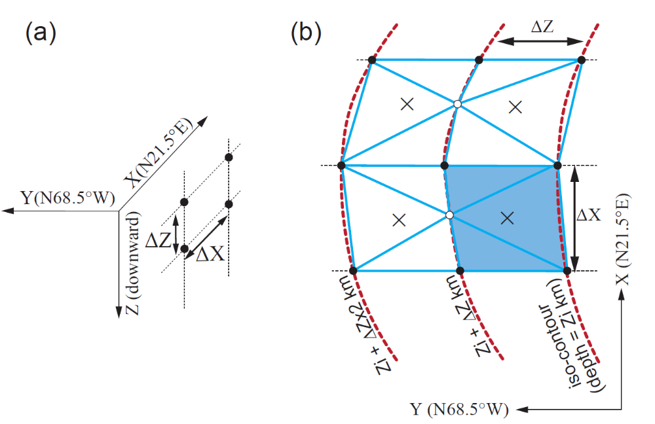
Figure S1. Schematic illustration of the definition of subfaults. (a) A 3-D coordinate system of the plate interface with homogeneous rectangular grid cells onto the X-Z plane of the coordinate system. (b) Approximation of a non-planar subfault with a set of three triangles. The light blue area is one subfault. The red dotted lines indicated the iso-depth contour of the plate interface. Crosses indicated the center of each subfault, which evaluated Kij.

