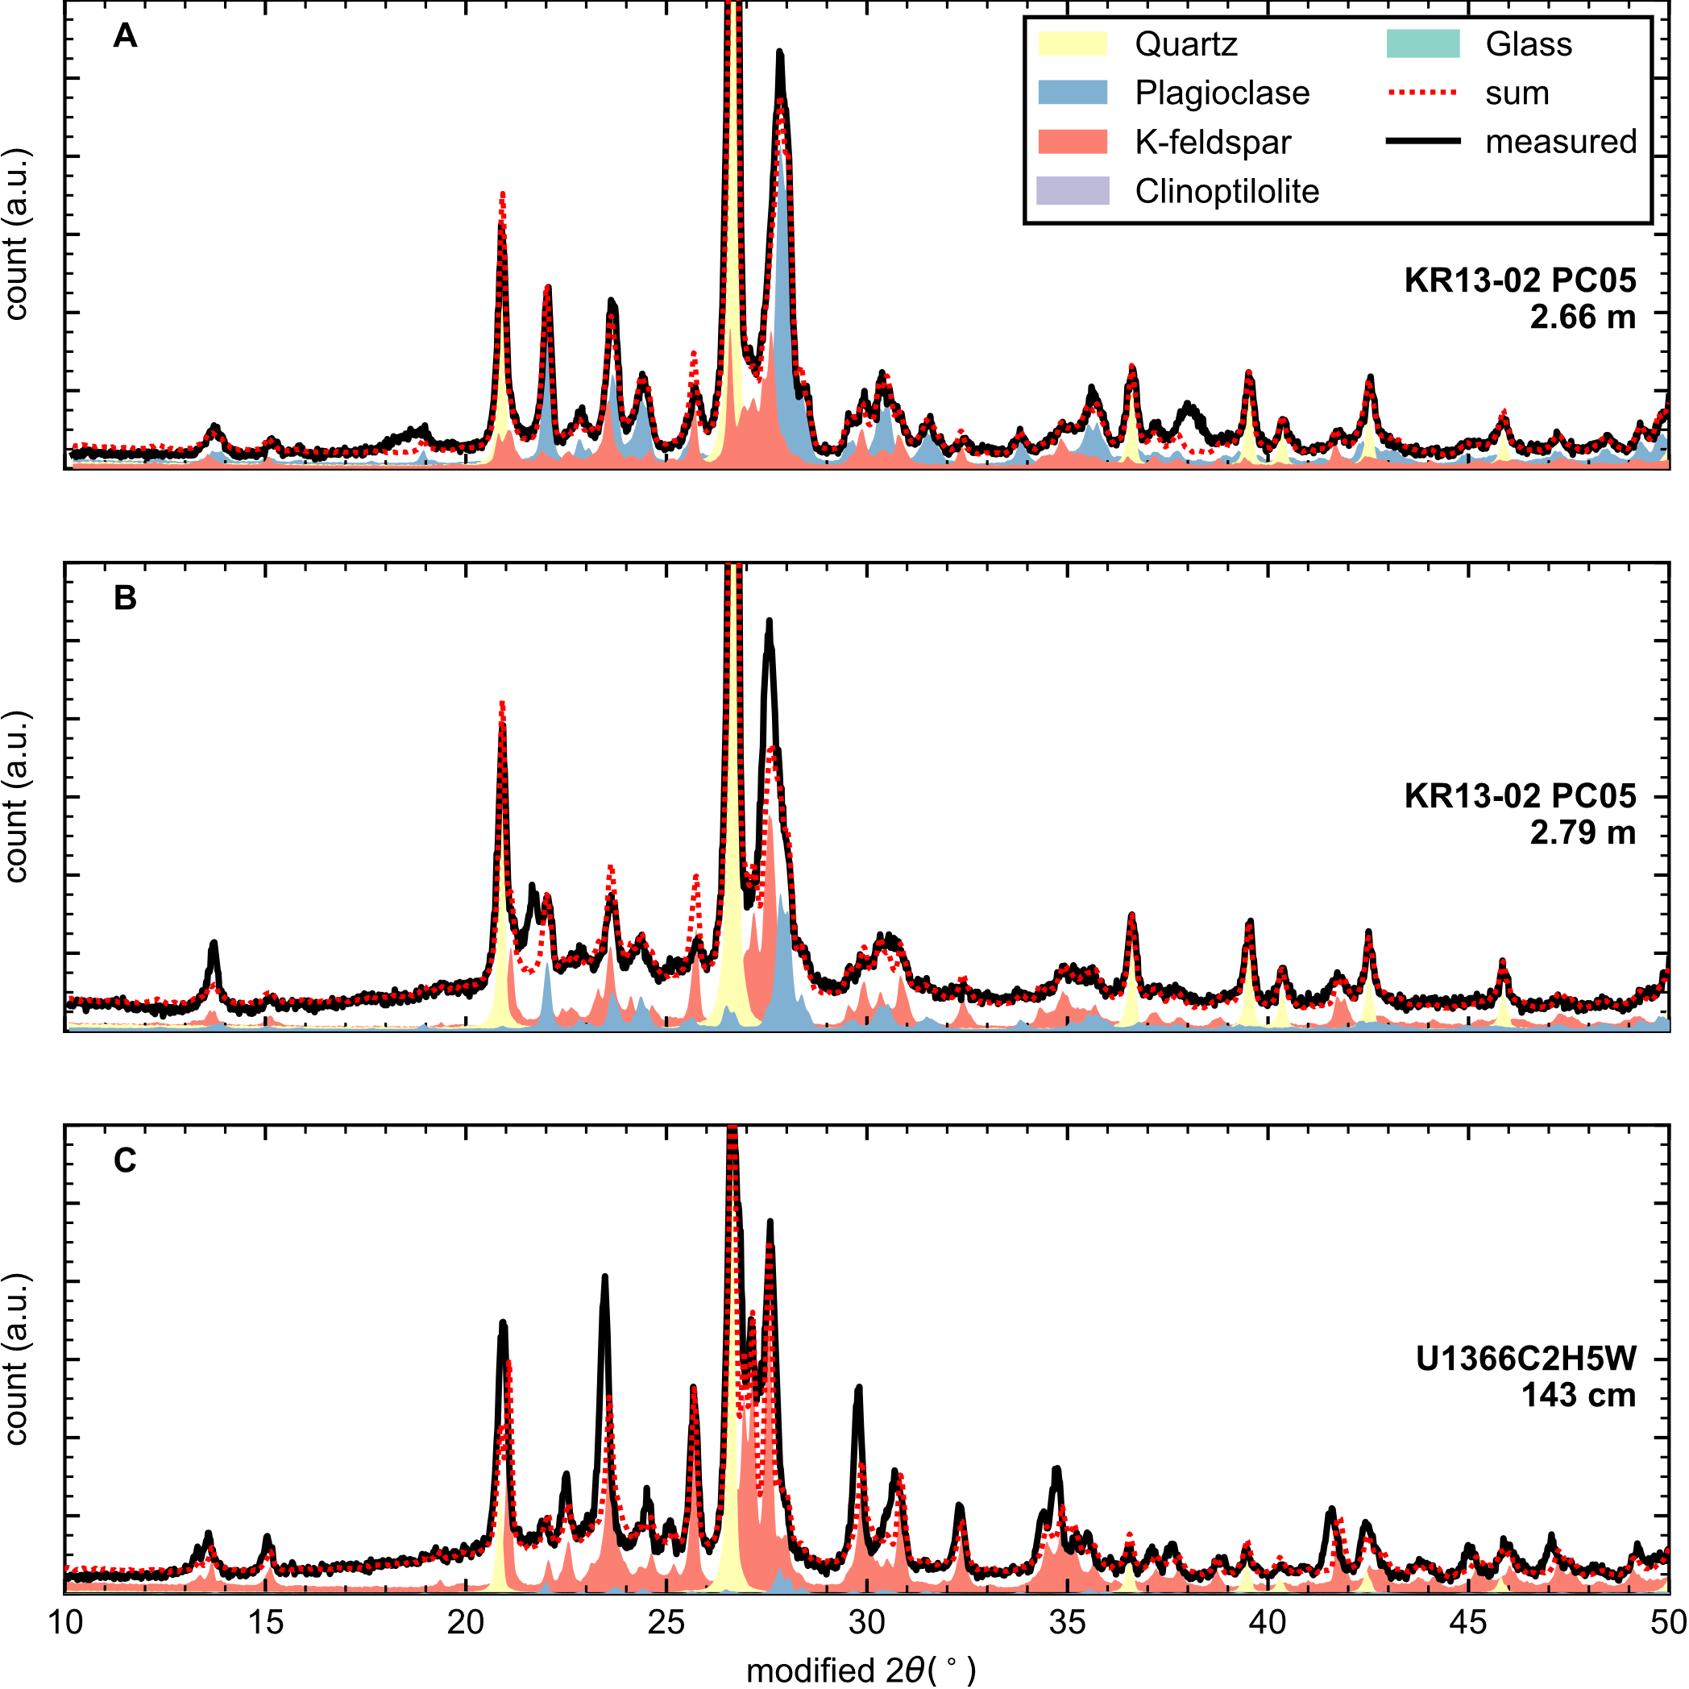

Additional File AF1. Samples with poorly fitted XRD diggractogram. A. KR13-02 PC05, 2.66 m, showing unfitted peaks at around 19° and 38°. B. KR13-02 PC05, 2.79 m, showing ill-fitted peaks at around 13° and 27°. B. U1366C-2H-5W, 143 cm, showing multiple peaks fitted with insufficient intensity between 20°-35°. C. U1366C-2H-5W, 143 cm, showing peaks at around 21°, 24°, and 29° fitted with insufficient intensity.

