Supplementary Materials:
Sensitivity of Slip Distribution on Tsunami Trace Heights and Geological Evidences: A Case Study of the 2011 Tohoku-Oki Earthquake

Satoshi Kusumoto¹
Corresponding author
Email: kusumotos@jamstec.go.jp

Kentaro Imai¹
Email: imaik@jamstec.go.jp

Takane Hori¹
Email: horit@jamstec.go.jp

Daisuke Sugawara²
Email: sugawara@irides.tohoku.ac.jp

Kenji Satake³
Email: satake@eri.u-tokyo.ac.jp

¹Japan Agency for Marine–Earth Science and Technology, 3173–25 Showa–machi, Kanazawa, Yokohama, 236–0001, Japan
²International Research Institute of Disaster Science, Tohoku University, 468-1 Aoba, Aramaki, Aoba-ku, Sendai, Miyagi, Japan
³Earthquake Research Institute, University of Tokyo, 1–1–1, Yayoi, Bunkyo–ku, Tokyo 113–0032, Japan

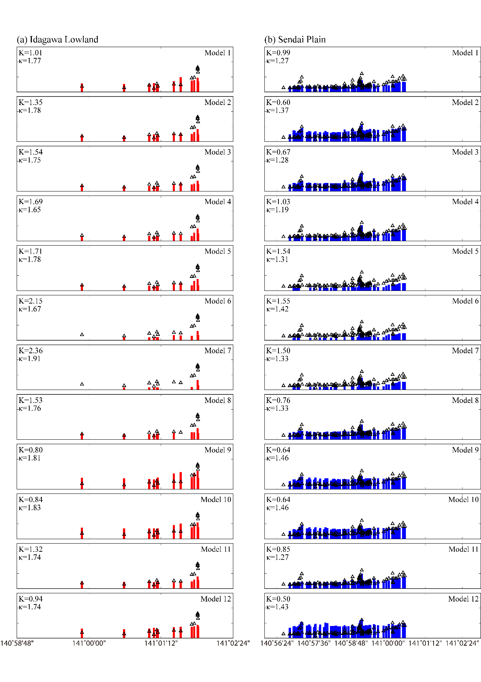
Figure S1. Comparison of observed tsunami inundation heights and the simulated heights for each model around the Idagawa Lowland and Sendai Plain. Triangles and red/blue bars show the observed trace heights and simulated heights, respectively. K and kappa are the geometric mean and standard deviation by Aida (1978).

