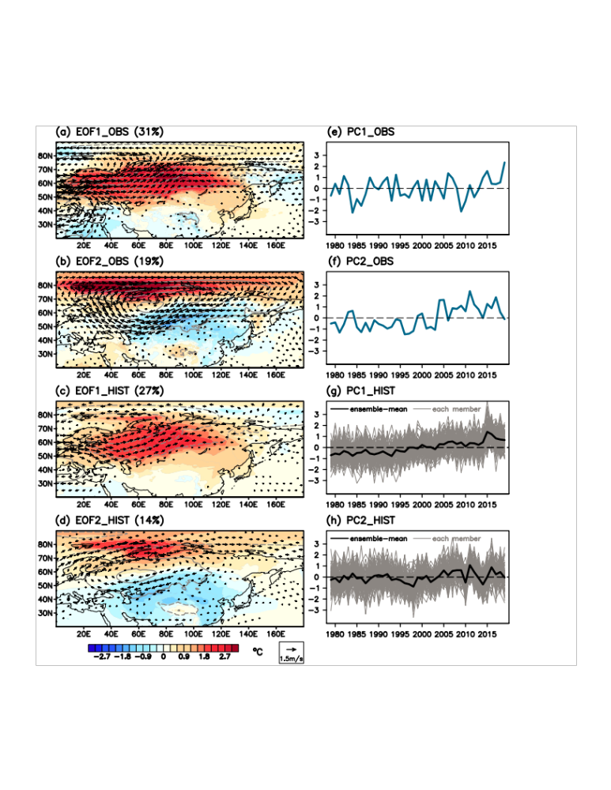
Figure S1. Two leading modes governing the winter temperature over Eurasia. a, b Regression patterns of observed winter SAT (shading; °C), SLP (contour; hPa; 0.2 intervals with negative values shown by dashed lines), and 850-hPa wind (vector; m/s) anomalies against the observed 41 PC1 in (e) and 41 PC2 in (f), respectively. c, d Regression patterns of simulated winter SAT, SLP, and 850-hPa wind anomalies against the member-concatenated simulated 4100 PC1 in (g) and 4100 PC2 in (h), respectively. Specified values in (a) and (b) denote the explained variance ratio. Grey and black lines in (g) and (h) denote the result for each member and for the 100-member ensemble-mean, respectively.

