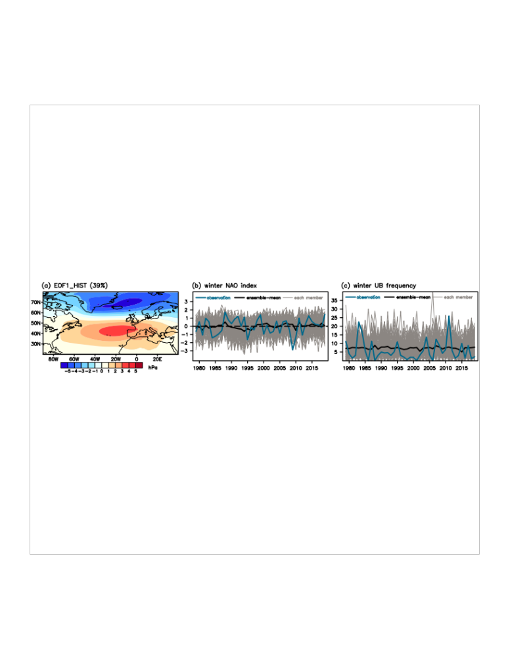
Figure S2. Winter NAO index and UB frequency. a Regression patterns of simulated winter SLP (hPa) against the member-concatenated simulated winter NAO index in (b). b Interannual variation of the observed and the simulated winter NAO index. Blue, grey, and black lines denote the results for the observations, for each member, and for the 100-member ensemble-mean, respectively. c Similar to (b) but for the winter UB frequency (days/winter).

