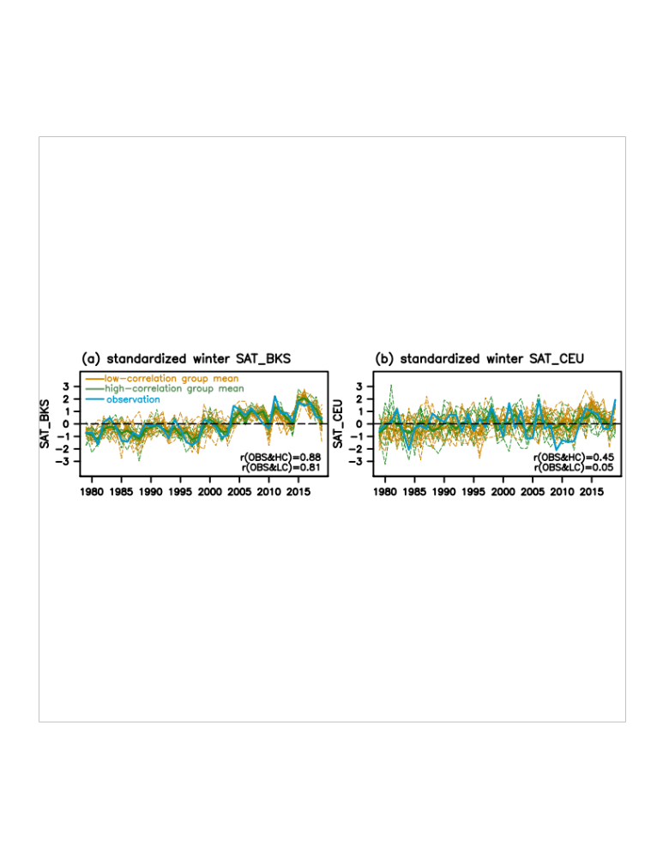
Figure S3. Winter temperature change over the BKS and CEU in selected two groups. Interannual variation of the standardized winter SAT over the BKS a and CEU b for the observation, high-correlation group, and low-correlation group. The blue line denotes the observed winter SAT; thin and thick green lines denote the 10 members of the high-correlation group and their average, respectively; thin and thick orange lines denote the 10 members of the low-correlation group and their average, respectively.

