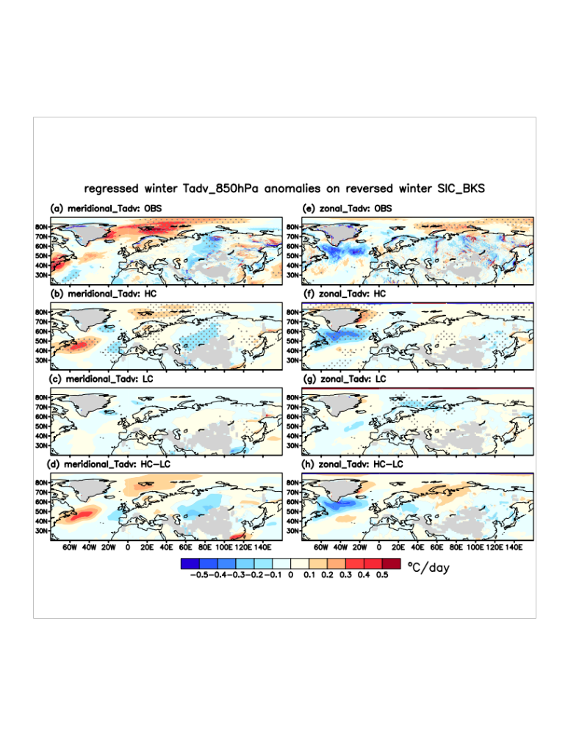
Figure S4. Winter meridional and zonal temperature advection pattern related to reversed winter sea ice change over the BKS. a Regressed observed winter meridional temperature advection anomalies on observed winter SIC over the BKS. Note that SIC was sign-reversed and normalized. b, c Similar to (a), but (b) is for the 10-member mean of the high-correlation group, (c) is for the 10-member mean of the low-correlation group. d The difference between (b) and (c). e-h Similar to (a)-(d), but for zonal meridional temperature advection. Dots in (a)-(c) and (e)-(g) denote shading statistically significant at the 0.05 level by Student's t-test. The grey shadings denote the topography.

