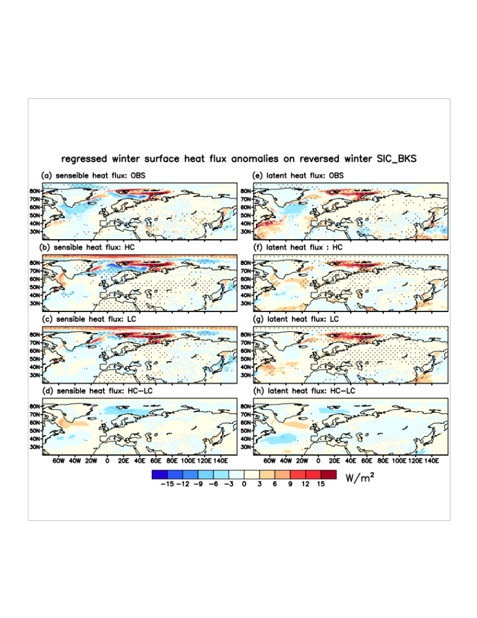
Figure S5. Winter sensible and latent heat flux pattern related to reversed winter sea ice change over the BKS. Similar to Fig. S4, but for winter sensible heat flux (a)-(d) and latent heat flux (e)-(h). Dots in (a)-(c) and (e)-(g) denote shading statistically significant at the 0.05 level by Student's t-test.

