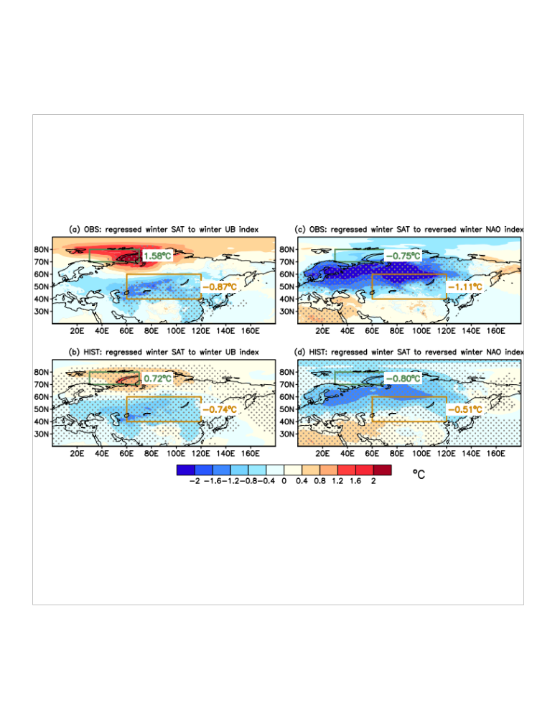
Figure S6. Winter SAT pattern related to internal atmospheric variability change. a Regressed observed winter SAT anomalies to observed winter UB index during 1979/1980–2019/2020. b Regressed simulated winter SAT anomalies to member-concatenated simulated winter UB index. c, d Similar to (a) and (b), but for regression to reversed winter NAO index. Areas indicated by the green and orange lines denote the locations of the BKS and CEU, respectively. Dots denote shading statistically significant at the 0.01 level by Student's t-test.

