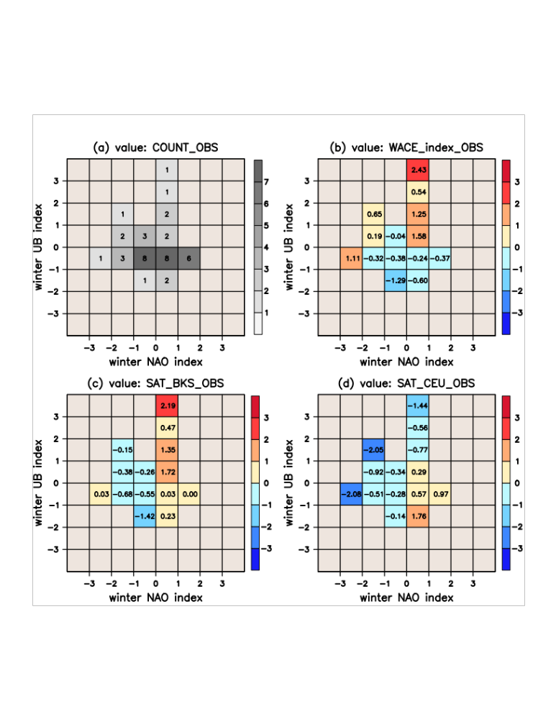
Figure S7. Relationships among winter UB, the NAO, and the WACE pattern for the observed 41 years. Similar to Fig. 6, but for observed 41 years.

