Supplementary information for

Detection of a recent large Hyuga-nada long-term slow slip event and estimation of its spatiotemporal slip distributions

Hiroki Kawabata¹
Corresponding author
Email: 222s410s@gsuite.kobe-u.ac.jp

Yukinari Seshimo¹

Shoichi Yoshioka^{2,1}

Francisco Ortega-Culaciati ^{3,4}

(Institutional addresses)
¹ Department of Planetology, Graduate School of Science, Kobe University, Rokkodai-cho 1-1, Nada ward, Kobe 657-8501, Japan
² Research Center for Urban Safety and Security, Kobe University, Rokkodai-cho 1-1, Nada ward, Kobe 657-8501, Japan
³ Department of Geophysics, Faculty of Physical and Mathematical Sciences, University of Chile, Santiago, Chile.
⁴ Data Observatory Foundation, ANID Technology Center No. DO210001, Santiago, Chile

Contents of this file
Table S1
Figure S1-S4
Table S1 GNSS stations in southeastern Kyushu used in the inversion analysis in this study.
GNSS stations | Latitude ($°N$) | Longitude ($°E$)
960711 | 32.5570 | 131.5307
950478 | 32.4566 | 131.1489
940094 | 32.4454 | 131.6323
02P122 | 32.4286 | 131.6696
960712 | 32.3844 | 131.3340
021084 | 32.3162 | 131.5830
950479 | 32.2459 | 131.1852
950480 | 32.1704 | 131.5158
021085 | 32.1119 | 131.3475
960713 | 32.0691 | 131.4860
021086 | 32.0018 | 131.2545
960715 | 31.8421 | 131.3063
021088 | 31.7860 | 131.4701
960714 | 32.0477 | 130.8656
950481 | 31.9650 | 131.0786
021087 | 31.8778 | 130.9770
950482 | 31.7403 | 131.0215
950483 | 31.6765 | 131.3689
02P211 | 31.5770 | 131.4093
021090 | 31.5646 | 130.9983
950484 | 31.4694 | 131.2174
942004 | 31.4253 | 130.8786
960716 | 31.3991 | 131.3059
940099 | 31.2585 | 131.0875
021093 | 31.2427 | 130.8671
950491 | 31.1062 | 130.7231
The red and blue colors of the GNSS station codes correspond to the colors of the solid circles representing the GNSS stations in Fig. 1.
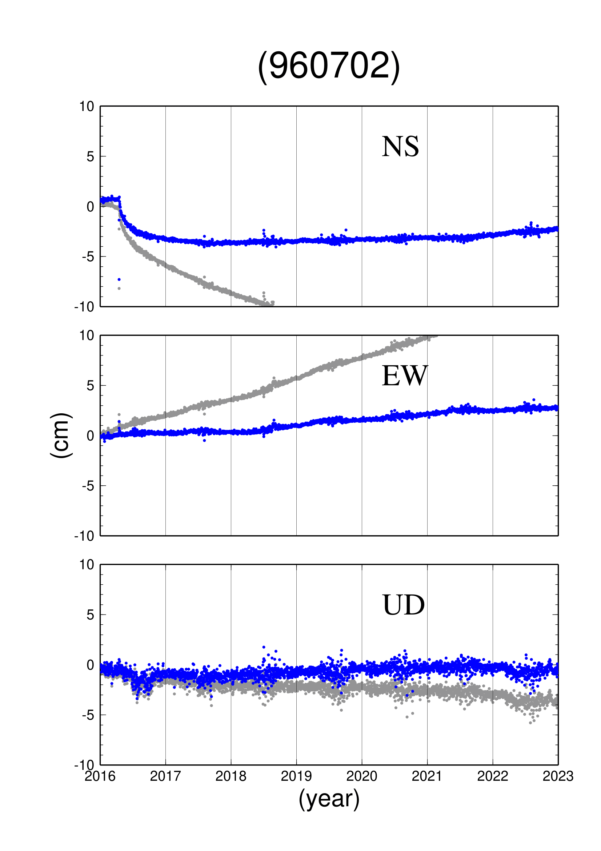
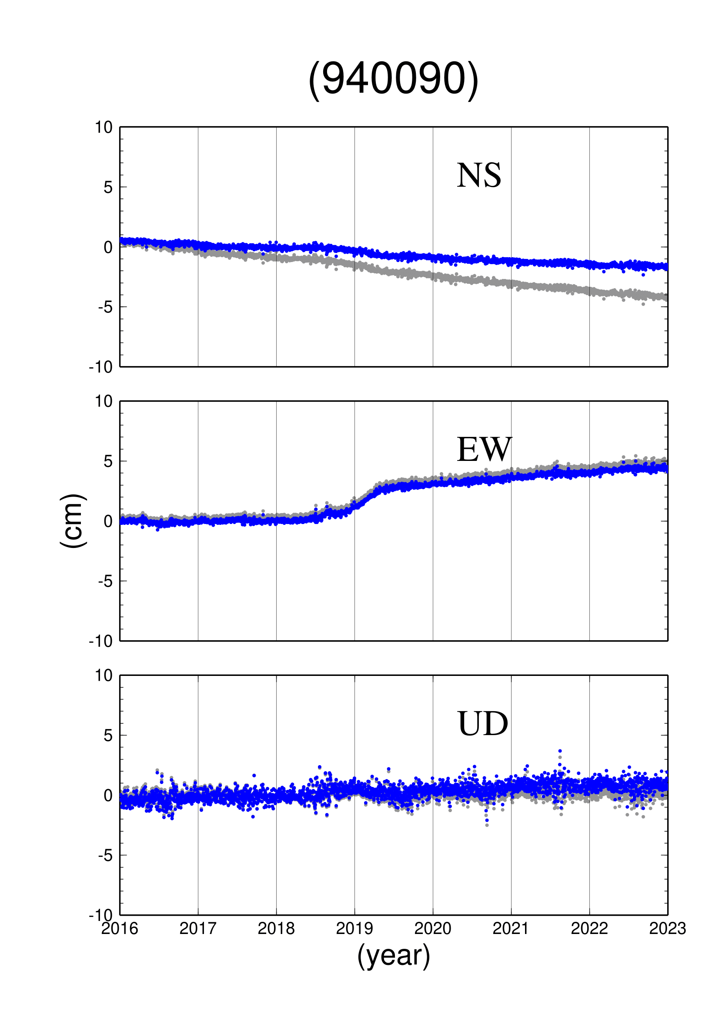
Figure S1 Time series data at GNSS stations affected by transient slip caused by the 2018-2019 Bungo Channel L-SSE and the postseismic deformation associated with the 2016 Kumamoto earthquake. The north‒south component, east‒west component, and vertical component are represented from the top, middle, and bottom, respectively. The gray dots represent time series data before making corrections, and the blue dots represent time series data after making corrections using Eq. (1). (a) 940090 (for transient slip caused by the 2018-2019 Bungo Channel L-SSE). (b) 960702 (for the postseismic deformation associated with the 2016 Kumamoto earthquake).
(b)
(a)

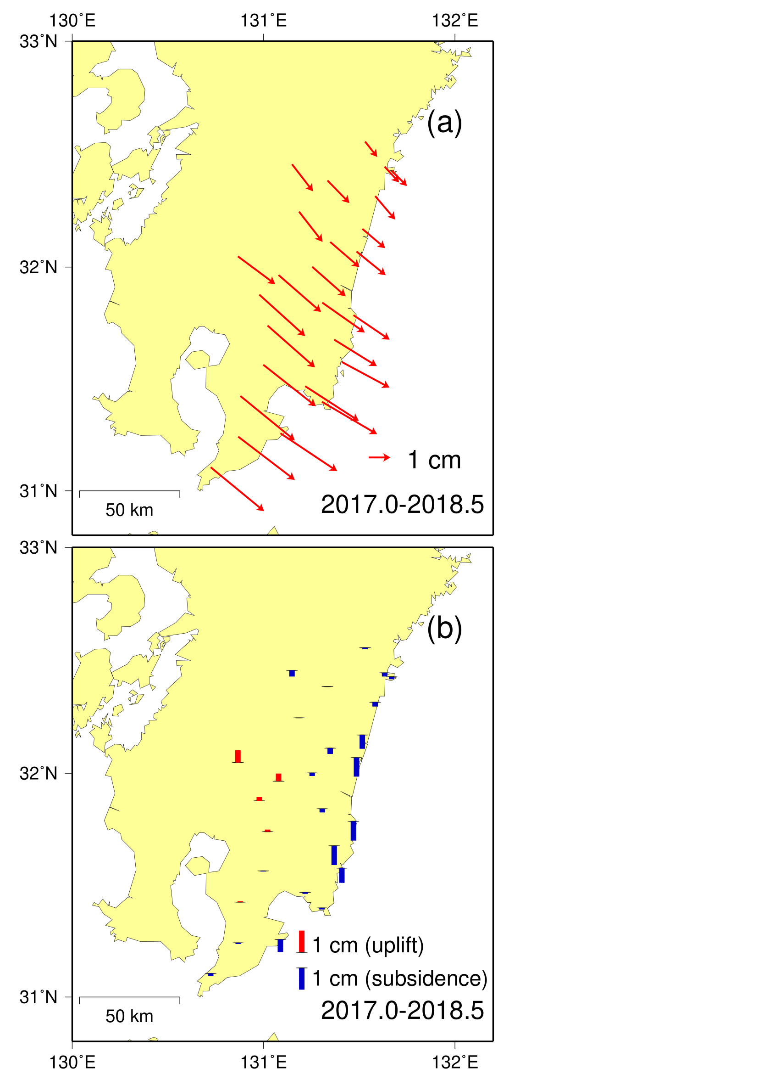
Figure S2 Map plots of the linear trend obtained by Eq. (1) at each GNSS station. The view of the figure is similar to that of Fig. 3.

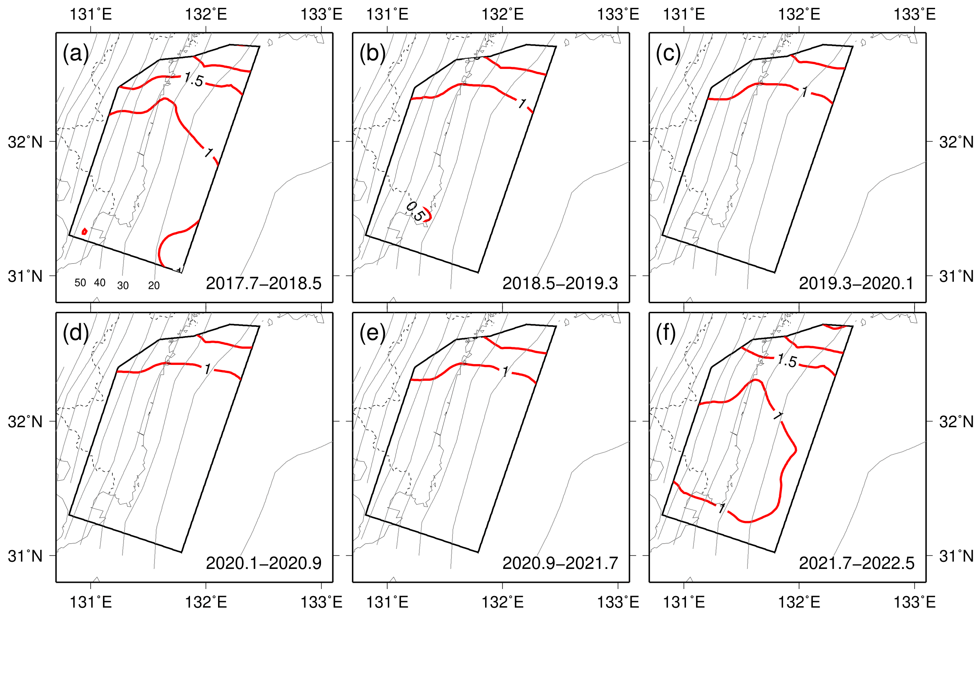
Figure S3 Distributions of the estimation error of 1σ for the inverted slip distributions shown in Fig. 6. Red lines represent contour lines with intervals of 0.5 cm. The other information is the same as that in Fig. 6.

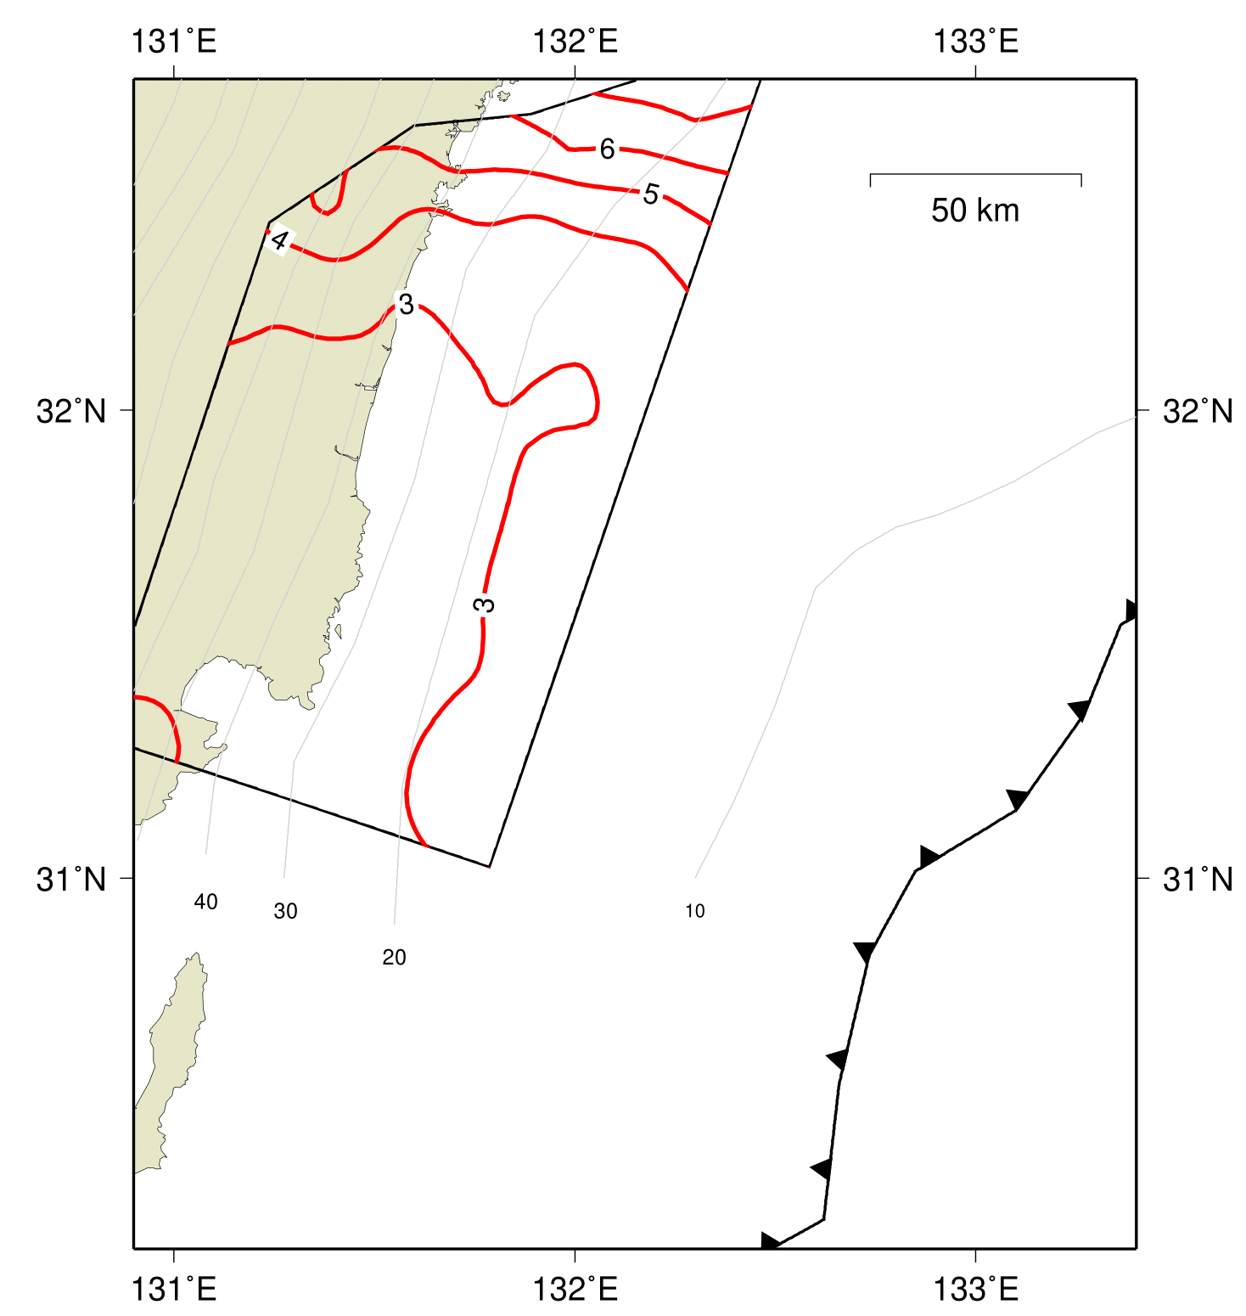
Figure S4 Distributions of estimation errors of 1σ for the cumulative slip distribution shown in Fig. 7. The red lines represent the contour lines with intervals of 1 cm. The other information is the same as that in Fig. 7.

