Appendix III: Sample TH19HC-03 40Ar/39Ar dating

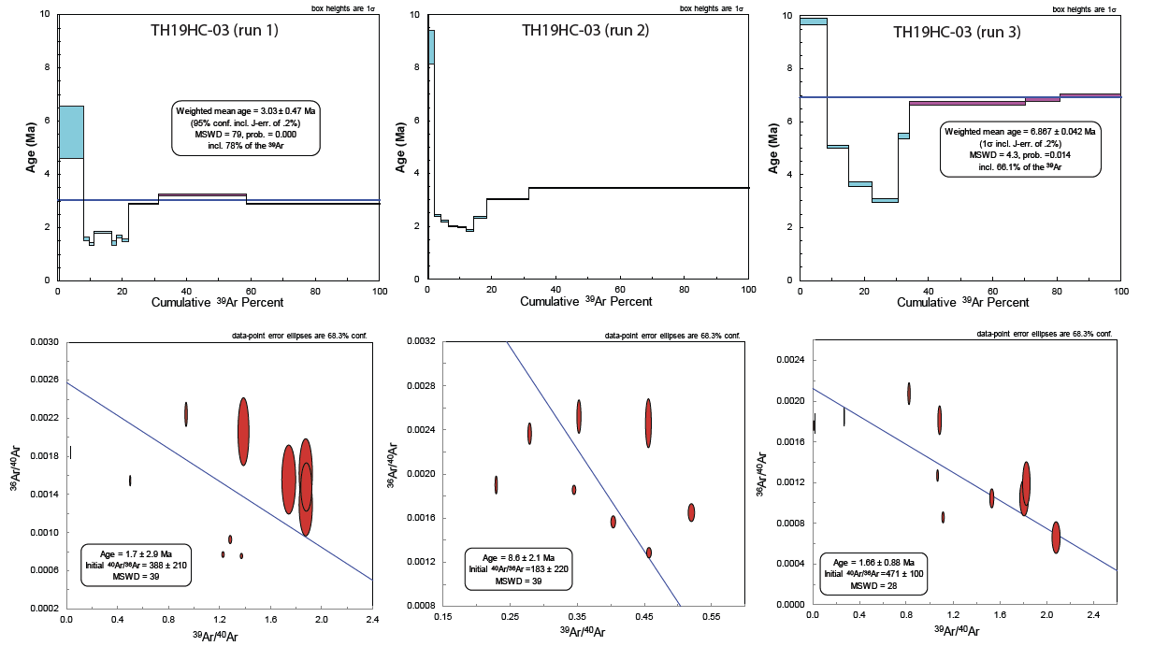

Fig 1. Step-heating and inverse isochrons for the chlorite-coated sample, T19HC-03, demonstrated a more complex thermal history (appendix). Analysis of three single-grain aliquots produced inverse isochron ages of 1.7±2.9 Ma, 1.66 ± 0.88 Ma, and 8.6 ± 2.1 Ma with a MSWD = ~35. Discordant age spectrums from step heating runs show relatively old apparent ages in the early stages of Ar39 released with well-developed saddle geometries between 20%-40% of Ar39 released. The minimum age associated in the intermediate temperature steps is ~2 Ma. Although discordant, the flattest part of the age spectrum yielded a weighted mean age of ~3.0 Ma, excluding the run 03.

