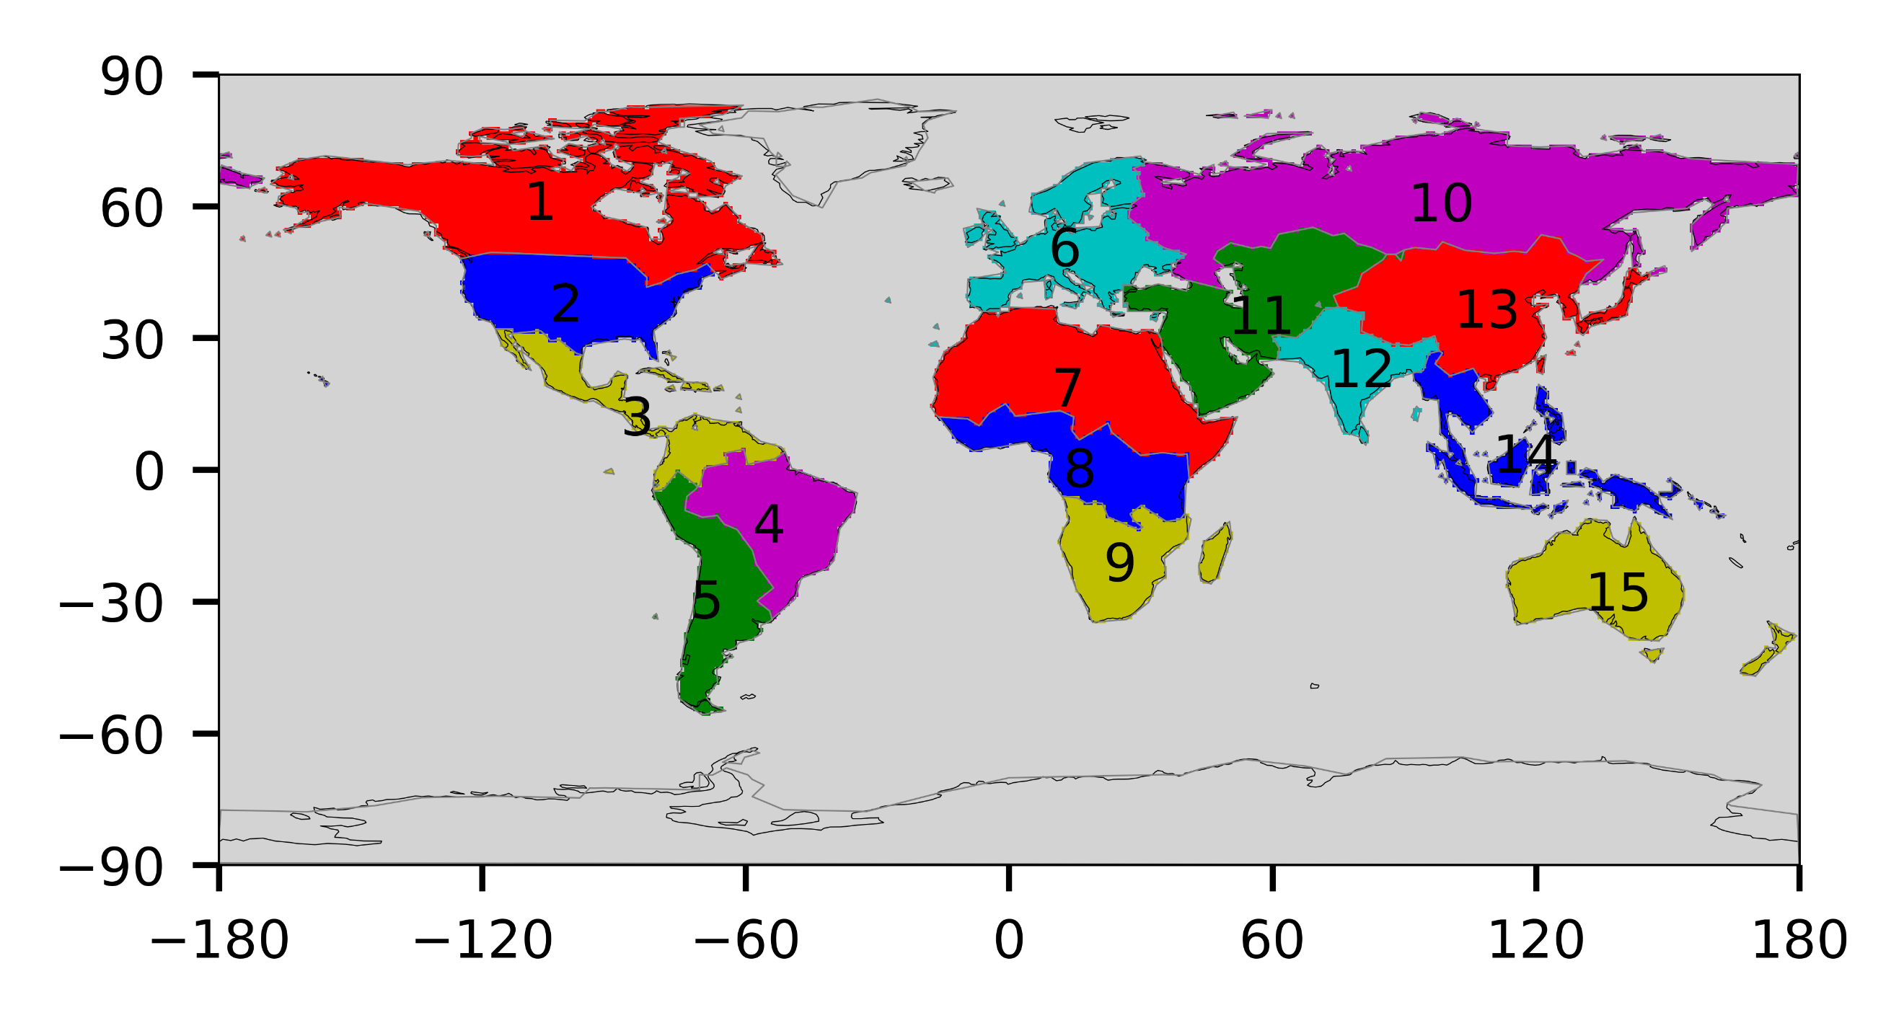
Figure S1. The flux aggregation regions represented by the plotted numbers.
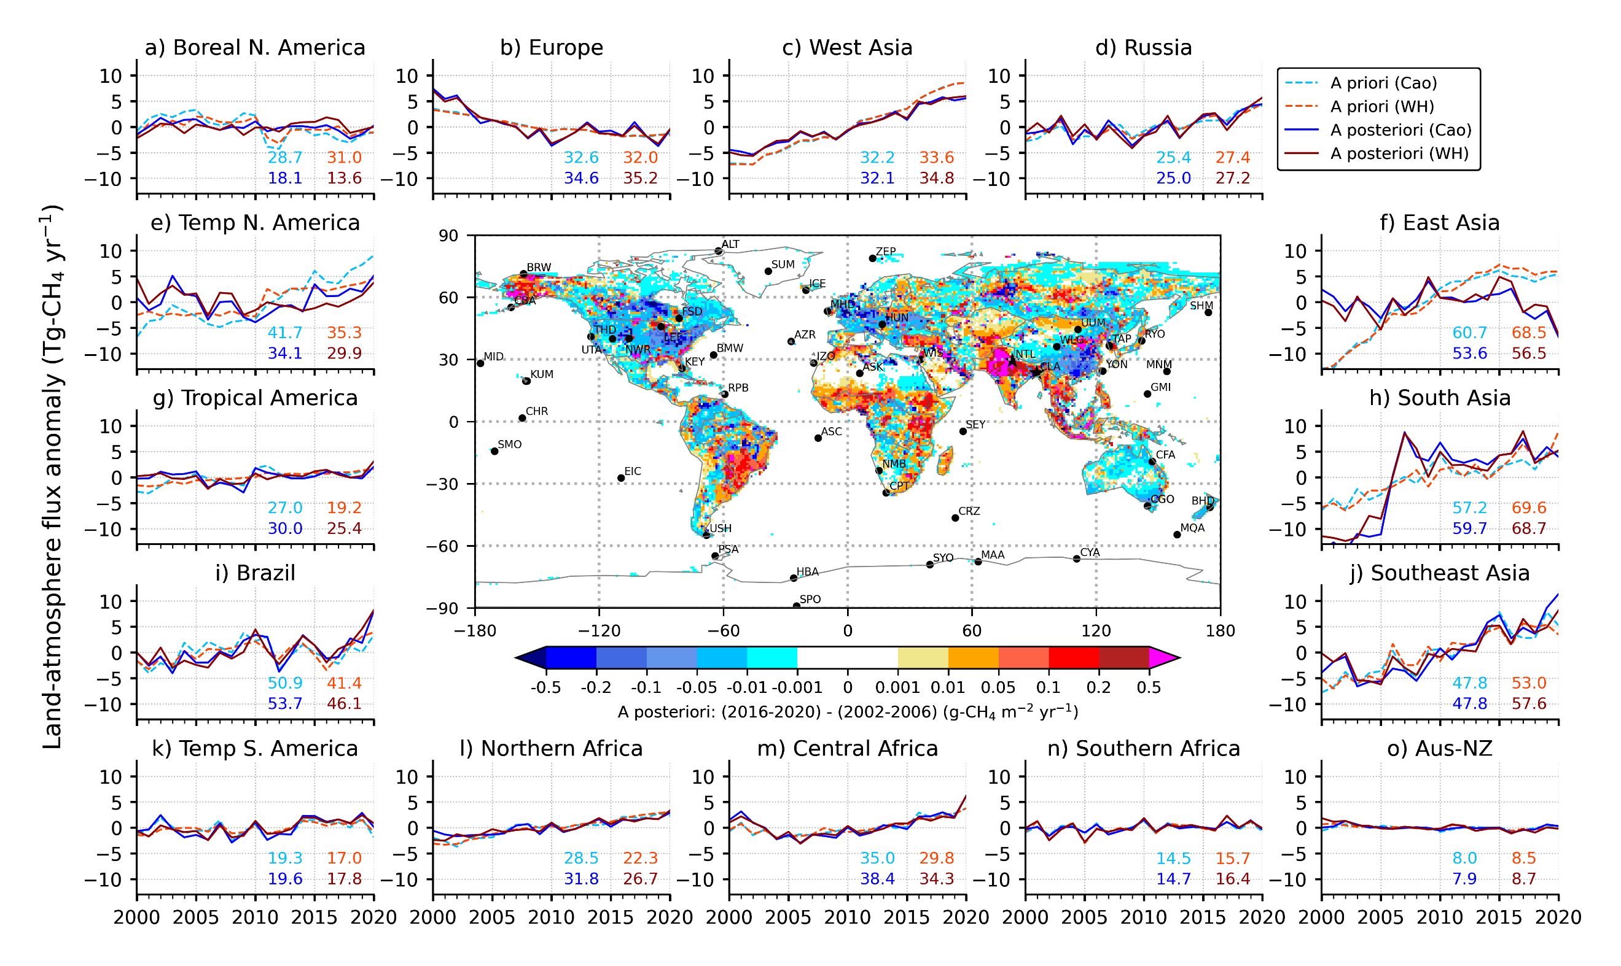
Figure S2. Time series (2000 – 2020) of regional CH4 emission anomalies as derived from the a priori and a posteriori for 2 inversion cases (for detail see legends) are shown around the map of a posteriori emission changes between the last 5 and first 5 years. Divisions of 15 regions are marked by a grey line over the continents. The 62 sites (at 54 locations) networks are shown by black circles. The numbers in each panel are the long-term mean emissions (in Tg-CH4 yr−1) for the individual emission cases of a priori (the upper row) and a posteriori (the lower row) for 2000 – 2020. These long-term values are subtracted to calculate the respective emission anomalies.
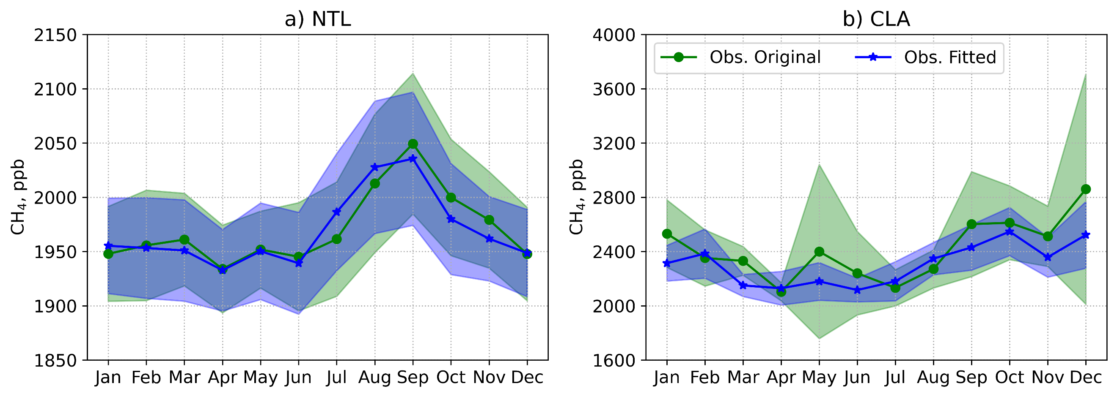
Figure S3. The multi-year seasonal cycle of monthly CH₄ from the original and fitted observational datasets for NTL (a) and CLA (b) sites.

Table S1. The performance of digital filtering for NTL and CLA sites.
Site | Total number of observations | Number of rejected observations | Rejection rate, % | 1σ standard deviation | Difference between original and fitted observations, ppb
 |  |  |  |  | Min | Max | Mean
NTL | 714 | 6 | 0.84 | 49.92 | -24.97 | 19.94 | 3.33
CLA | 413 | 31 | 7.53 | 142.31 | -76.21 | 447.52 | 125.29

