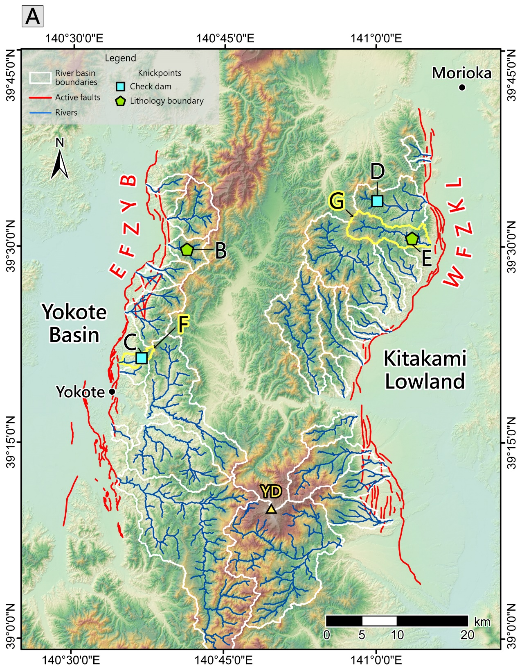
Figure S1. Examples of knickpoint photos and river profiles in this study. (A) Map showing photo points (B) to (E) and profiles of river basins (F) and (G). YD: Yakeishi Dake. (B)(C) Examples of knickpoints along the western OBR. A knickpoint (waterfall) caused by a local lithologic boundary is shown in (B), and a knickpoint corresponding to a check dam is shown in (C). (D)(E) Examples of knickpoints along the eastern OBR. A knickpoint corresponding to a check dam is shown in (D), and a knickpoint (waterfall) caused by a local lithologic boundary is shown in (E). (F)(G) Representative river profiles, one along the western OBR (F) and one along the eastern OBR (G).
