Figure S1. Molar percentages of AAs in (a) residual muscle and (b) collagen of Girella punctata, and Turbo sazae.
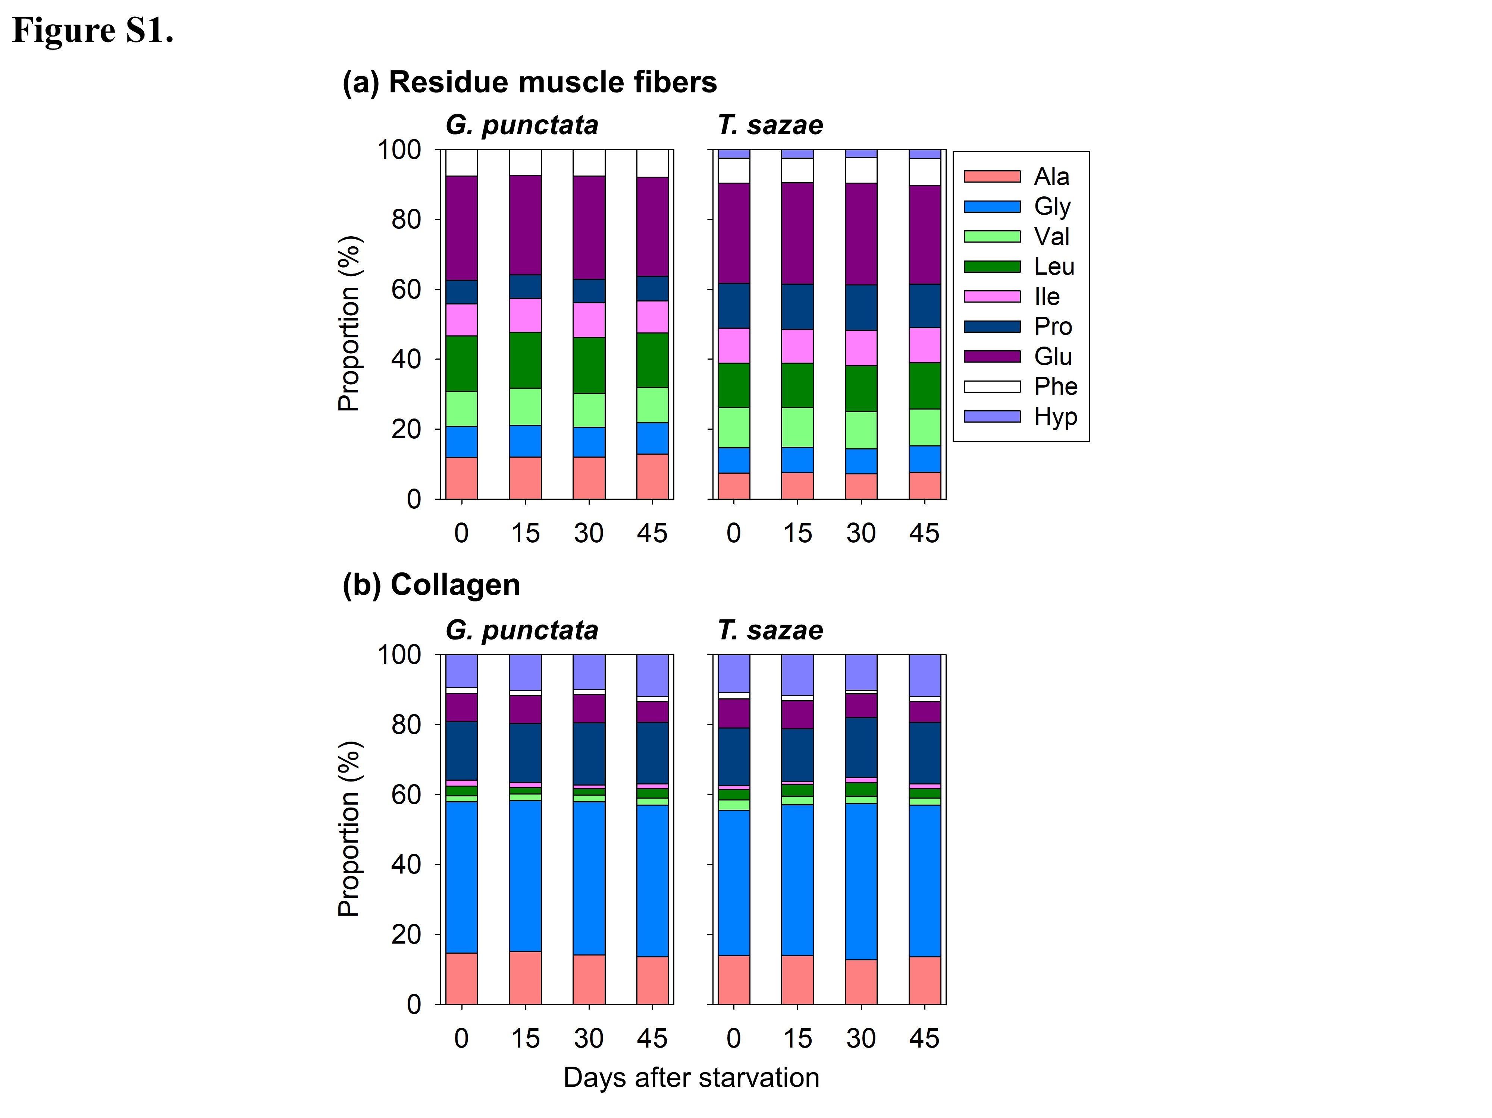
Figure S2. The δ¹⁵N_{AAs} values (normalized by t=0) of whole, residual muscle, and collagen for (a) Girella punctata and (b) Turbo sazae.
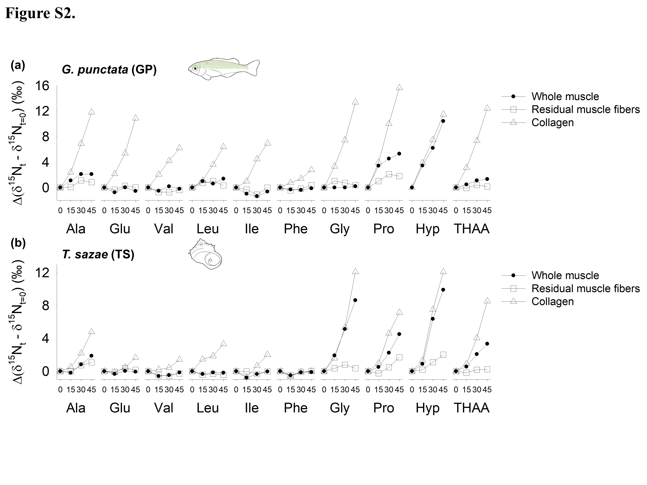

Figure S3. Collagen contents (a) and molar percentages of AAs in (b) residual muscle and (c) collagen of five reference fishes.
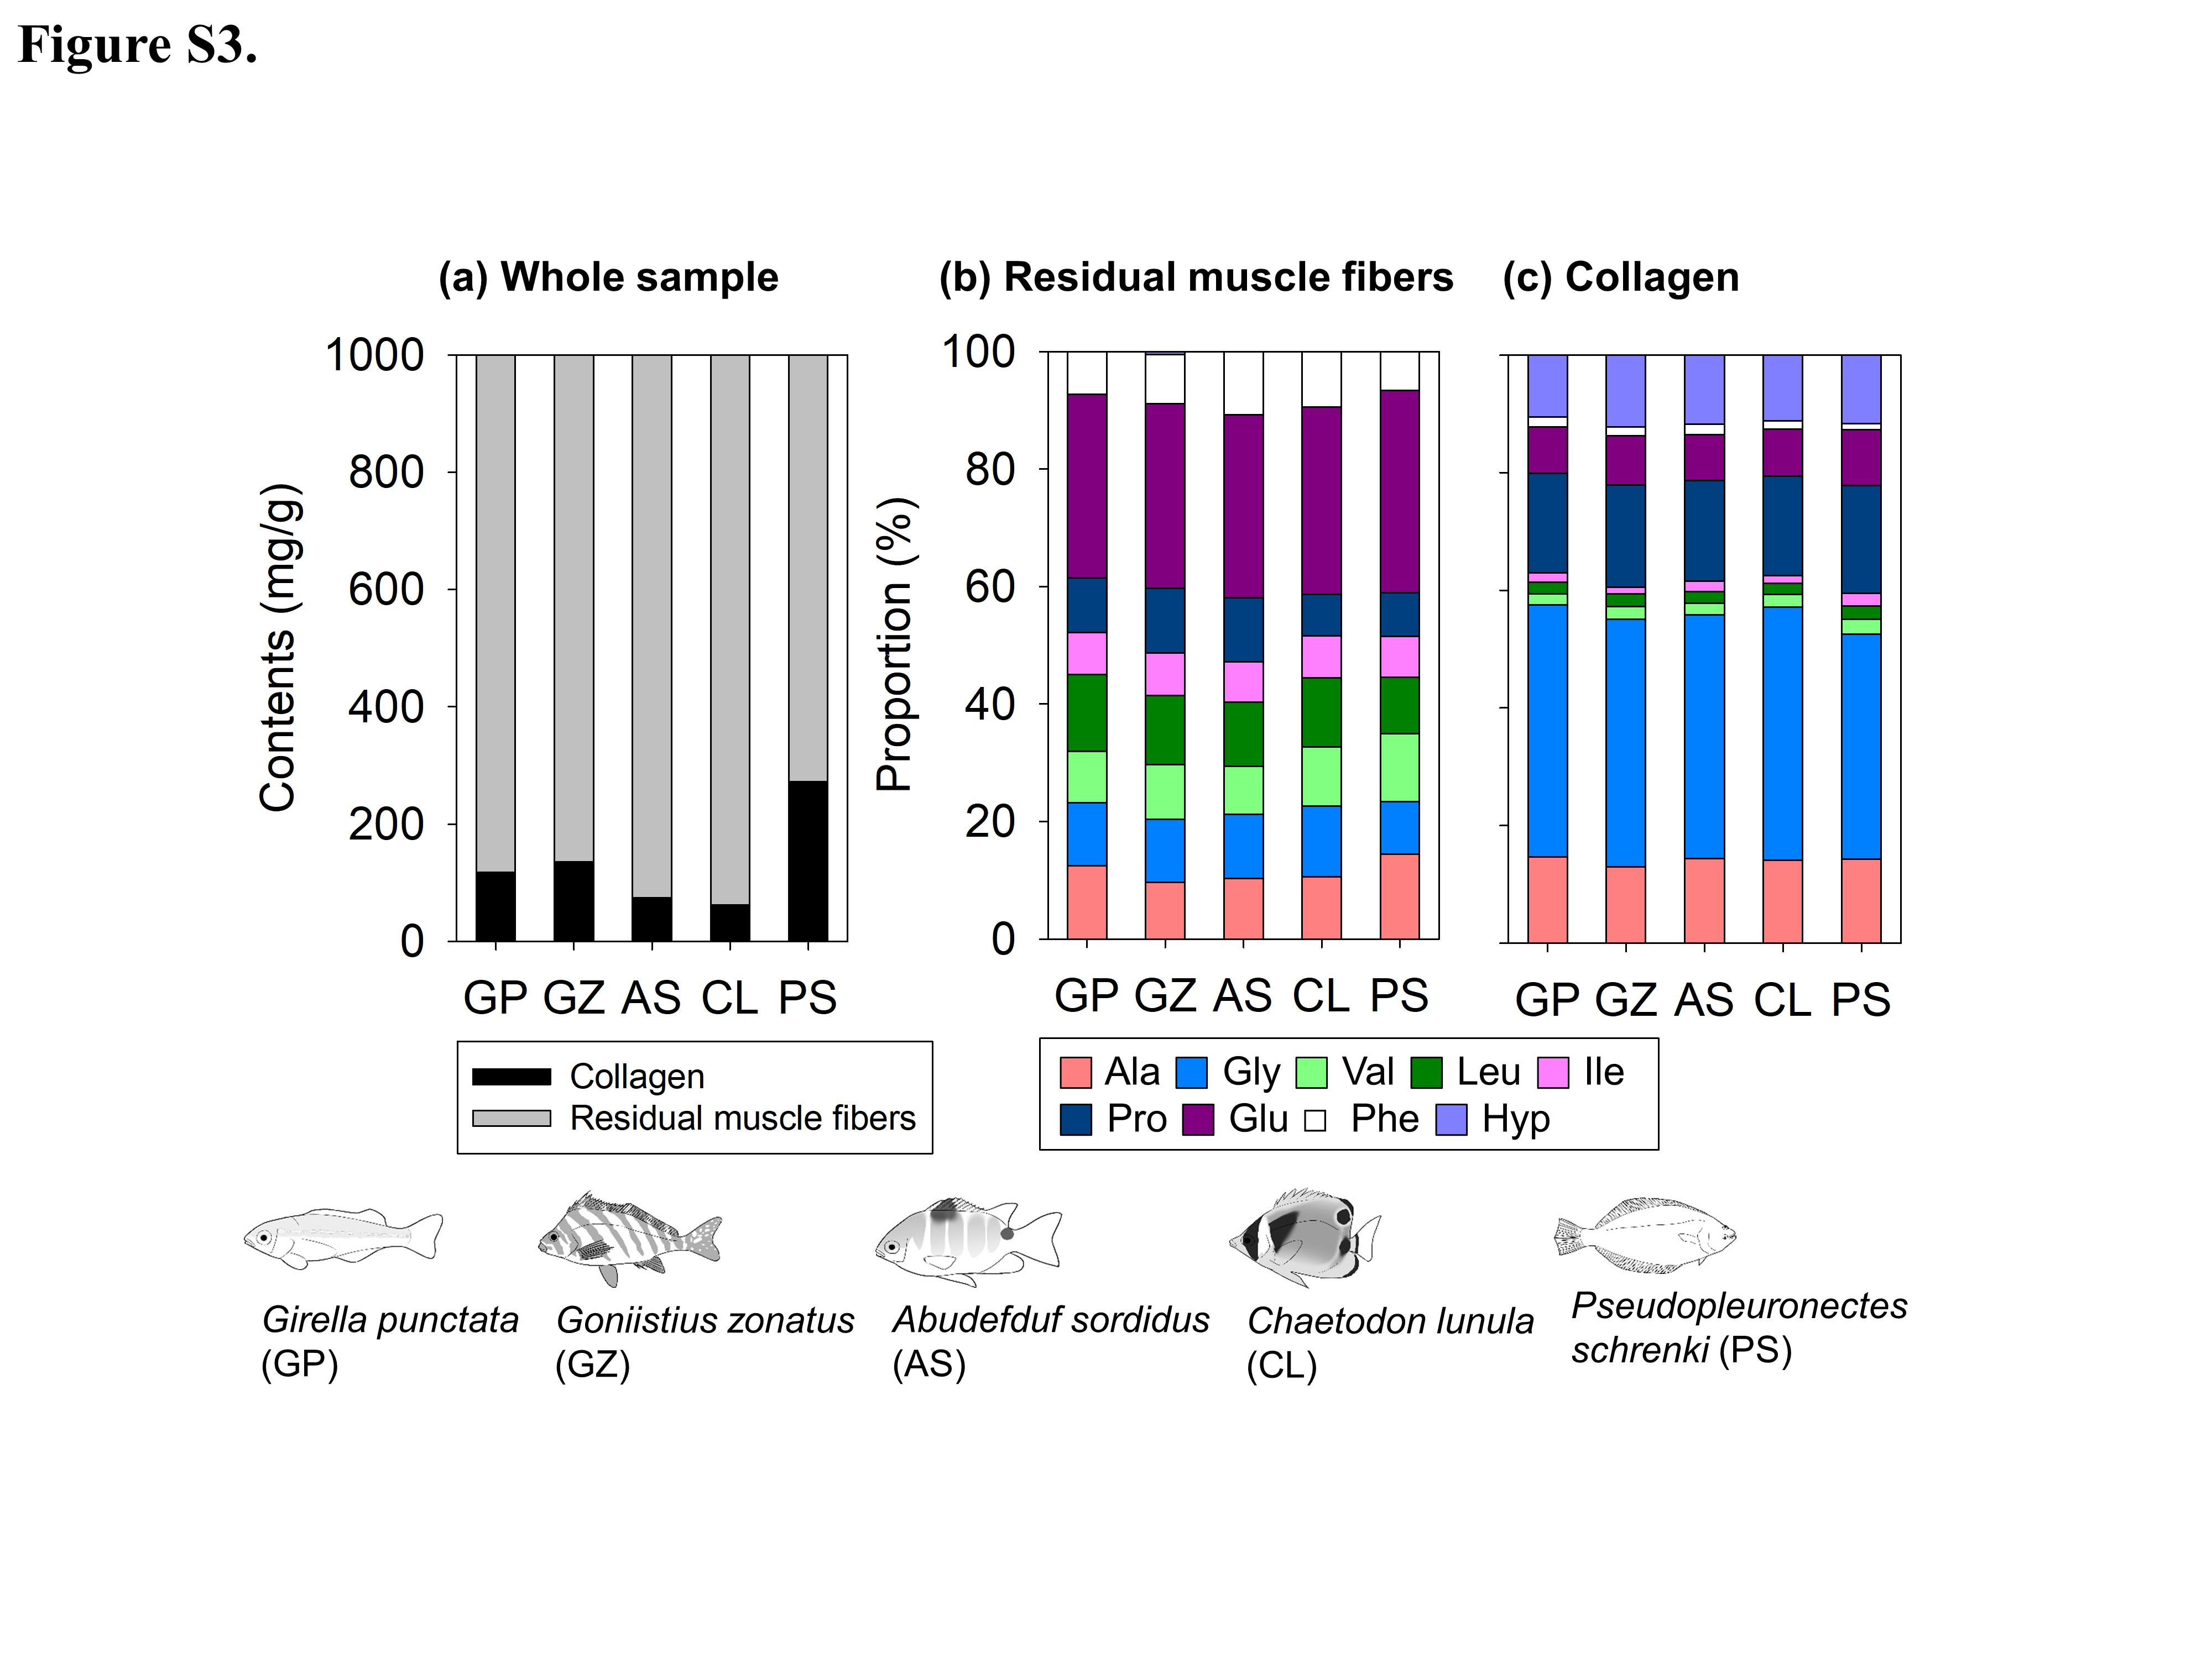

Figure S4. (a) The δ¹⁵N_{AAs} values of whole, residual muscle, and collagen and (b) Δ¹⁵N_{Collagen–RMF} values for five reference fishes.
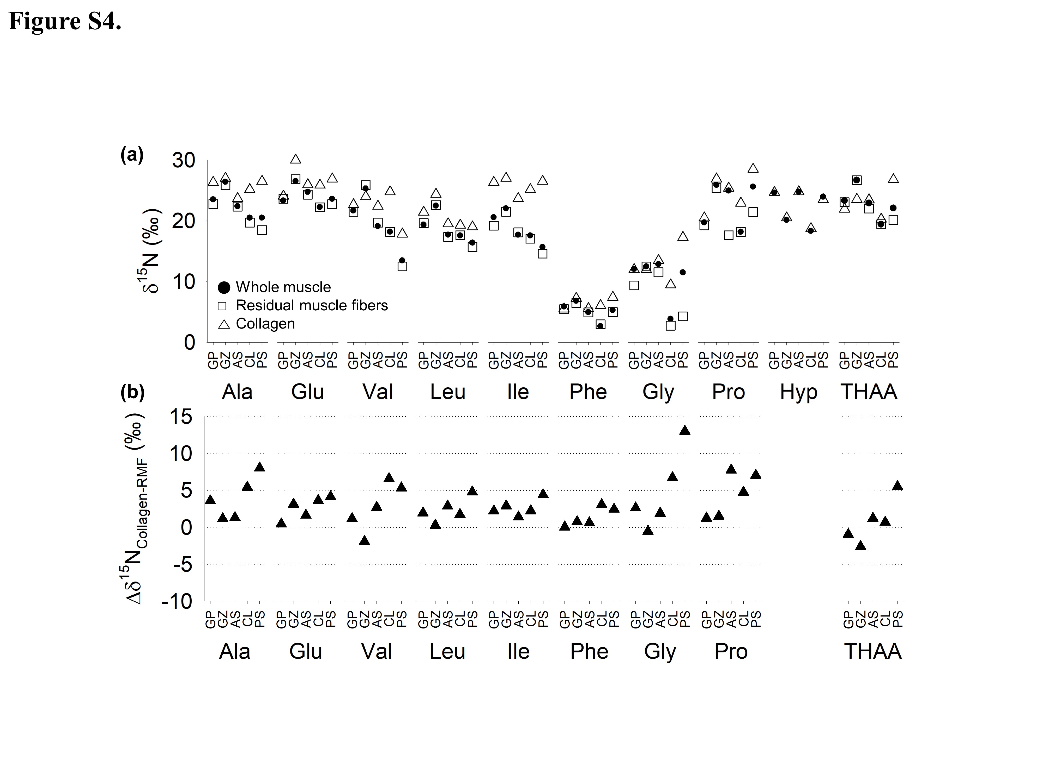

Figure S5. A possible scenarios of the carbon isotope fractionation of Xaa-Gly peptide during collagenolysis mediated by cysteine protease (including cathepsin K) with detailed chemical processes from previous literature (Cstorer and Ménard, 1994; Lalmanach et al., 2020; Rzychon et al., 2004). (1) to (2) First, the thiolate anion of cysteine has strong nucleophilicity and attacks the carbonyl carbon of the scissile amide, forming a tetrahedral intermediate. (2) to (3) Next, the proton bound with imidazolium cation moves to the nitrogen of the target peptide, and cleavage occurs. (4) to (6) Finally, a water molecule is polarized by imidazole nitrogen in histidine and attacks the carbonyl carbon to cleave the thioester. Note that we cannot predict nitrogen isotope fractionation of Gly in this enzymatic reaction. The red circle highlighted in the figure indicates a potential ¹³C enrichment in amino acid (Xaa) during the reaction.
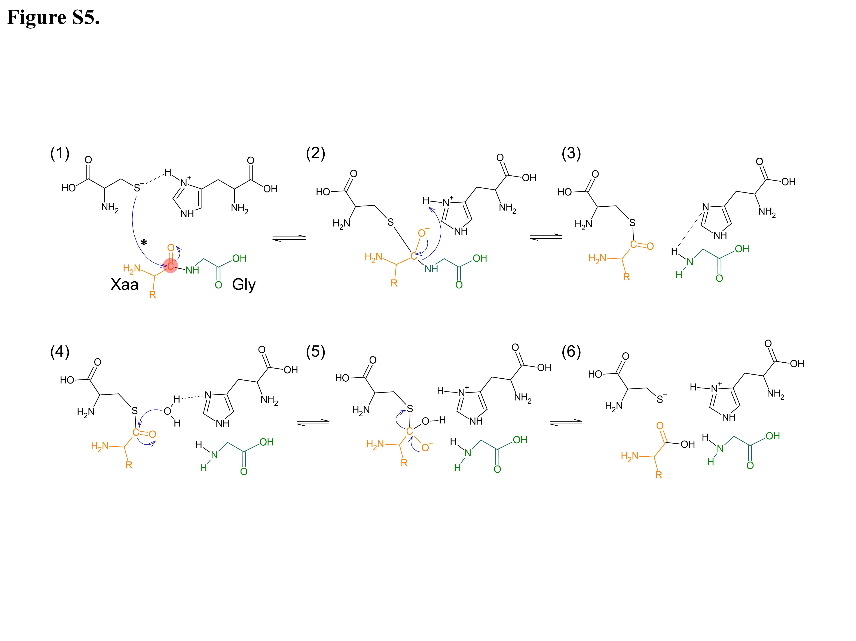

Figure S6. GC/C/IRMS chromatograms on (a) muscle vs. (b) collagen samples of Girella punctata.
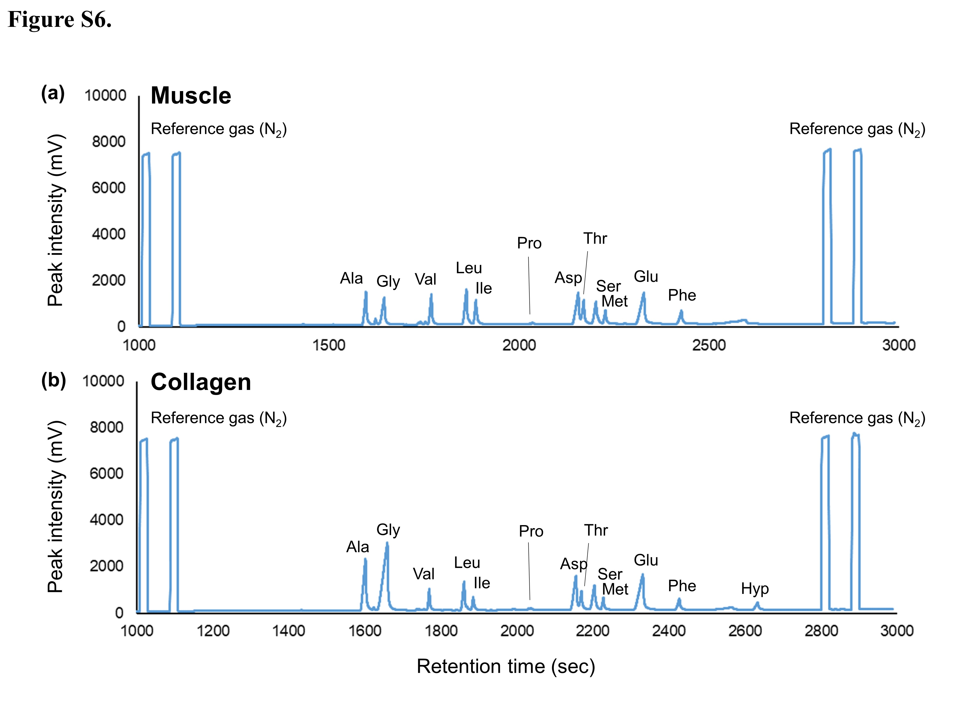

References
Cstorer, A., and Ménard, R. (1994), [33] Catalytic mechanism in papain family of cysteine peptidases, in Methods in enzymology, edited, pp. 486-500, Elsevier, doi:https://doi.org/10.1016/0076-6879(94)44035-2.
Lalmanach, G., Saidi, A., Bigot, P., Chazeirat, T., Lecaille, F., and Wartenberg, M. (2020), Regulation of the proteolytic activity of cysteine cathepsins by oxidants, International journal of molecular sciences, 21(6), 1944, doi:https://doi.org/10.3390/ijms21061944.
Rzychon, M., Chmiel, D., and Steć-Niemczyk, J. (2004), Modes of inhibition of cysteine proteases, Acta Biochimica Polonica, 51(4), 861-873.

