Supporting Information

Distributions of heme B and its implications on Fe biogeochemistry in the eastern Indian Ocean and the western North Pacific Ocean

Yuta Isaji¹*, Koji Sugie², Naoto F. Ishikawa¹, Nanako O. Ogawa¹, Kazuhiko Matsumoto², Chisato Yoshikawa¹, Hajime Obata³, Makio C. Honda², Naohiko Ohkouchi¹

¹Biogeochemistry Research Center, Japan Agency for Marine-Earth Science and Technology (JAMSTEC), 2-15 Natsushimacho, Yokosuka, Kanagawa 237-0061, Japan
²Earth Surface System Research Center, JAMSTEC, 2-15 Natsushimacho, Yokosuka, Kanagawa 237-0061, Japan
³Atmosphere and Ocean Research Institute, The University of Tokyo, 5-1-5 Kashiwanoha, Kashiwa, Chiba 277-8564, Japan
Text S1.
The f-ratio was estimated at the SCM along the 88°E transect in the EIO in Isaji et al. (2022), based on δ¹⁵N of chlorophyll a (δ¹⁵N_{chla}) and divinylchlorophyll a (δ¹⁵N_{dvchla}) in the SPM. Briefly, δ¹⁵N of phytoplankton biomass was estimated according to the following equations:
$$\begin{aligned}{\text{δ}}^{\text{15}}{\text{N}}_{\text{PRO}}\text{ =}{\text{ δ}}^{\text{15}}{\text{N}}_{\text{dvchla}}\text{ – 1.0}\#\left(1\right)\end{aligned}$$
$$\begin{aligned}{\text{δ}}^{\text{15}}{\text{N}}_{\text{EU+SYN}}\text{ =}{\text{ δ}}^{\text{15}}{\text{N}}_{\text{chla}}\text{ + }\left\{\left(\text{4.8 × }\frac{\left[\text{EU}\right]}{\left[\text{EU+SYN}\right]}\right)\text{ + }\left(\text{–0.9 × }\frac{\left[\text{SYN}\right]}{\left[\text{EU+SYN}\right]}\right)\right\}\#\left(2\right)\end{aligned}$$
$$\begin{aligned}{\text{δ}}^{\text{15}}{\text{N}}_{\text{EU+SYN}}\text{=}{\text{δ}}^{\text{15}}{\text{N}}_{\text{EU}}\text{×}\frac{\left[\text{EU}\right]}{\left[\text{EU}\right]\text{+}\left[\text{SYN}\right]}\text{+}{\text{δ}}^{\text{15}}{\text{N}}_{\text{SYN}}\text{×}\frac{\left[\text{SYN}\right]}{\left[\text{EU}\right]\text{+}\left[\text{SYN}\right]}\#\left(3\right)\end{aligned}$$
$$\begin{aligned}{\text{δ}}^{\text{15}}{\text{N}}_{\text{SYN}}\text{=}{\text{δ}}^{\text{15}}{\text{N}}_{\text{PRO}}\#\left(4\right)\end{aligned}$$
such that
$$\begin{aligned}{\text{δ}}^{\text{15}}{\text{N}}_{\text{EU}}\text{=}\frac{\left({\text{δ}}^{\text{15}}{\text{N}}_{\text{EU+SYN}}\text{-}{\text{δ}}^{\text{15}}{\text{N}}_{\text{PRO}}\text{×}\frac{\left[\text{SYN}\right]}{\left[\text{EU}\right]\text{+}\left[\text{SYN}\right]}\right)}{\frac{\left[\text{EU}\right]}{\left[\text{EU}\right]\text{+}\left[\text{SYN}\right]}}\#\left(5\right)\end{aligned}$$

where δ¹⁵N_{PRO}, δ¹⁵N_{SYN}, and δ¹⁵N_{EU} represent δ¹⁵N of Prochlorococcus, Synechococcus, and eukaryotic phytoplankton, respectively. [PRO], [SYN], and [EU] represent relative contributions of Prochlorococcus, Synechococcus, and eukaryotic phytoplankton to the Chl a pool determined from the CHEMTAX analysis, respectively.
The f-ratio was then estimated according to the following equation:
$$\begin{aligned}f=\frac{\left(f_{PRO}×\left[PRO\right]+f_{SYN}×\left[SYN\right]+f_{EU}×\left[EU\right]\right)}{\left(\left[PRO\right]+\left[SYN\right]+\left[EU\right]\right)}\#\left(6\right)\end{aligned}$$

f_{x} (x: PRO, SYN, EU) is calculated as follows:
$$\begin{aligned}f_{x}=\frac{\left(δ^{15}N_{x}-δ^{15}N_{RN}\right)}{\left(δ^{15}N_{NN}-δ^{15}N_{RN}\right)}\#\left(7\right)\end{aligned}$$

We assumed that δ¹⁵N_{PRO} as a value representing δ¹⁵N of regenerated nitrogen (δ¹⁵N_{RN}) and the depth-averaged δ¹⁵N_{nitrate} below the SCM down to 250 m as that of new nitrogen (δ¹⁵N_{NN}). The above equation is then simplified as follows:
$$\begin{aligned}f_{PRO}=f_{SYN}=0\#\left(8\right)\end{aligned}$$
$$\begin{aligned}f=\frac{\left(f_{EU}×\left[EU\right]\right)}{\left(\left[PRO\right]+\left[SYN\right]+\left[EU\right]\right)}\#\left(9\right)\end{aligned}$$
At stations where δ¹⁵N of divinylchlorophyll a was not available (st. E2, E5, E8), the δ¹⁵N value of divinylchlorophyll a averaged over the transect was used to calculate the f-ratio. Because the above estimation of the f-ratio assumes complete assimilation of nitrate supplied from the subsurface, the estimation was not applicable to st. E7 where strong eddy-driven upwelling caused partial assimilation of the upwelled nitrate. We therefore assumed that eukaryotic phytoplankton assimilated the upwelled nitrate as their sole nitrogen source. It follows that:
$$\begin{aligned}f_{EU}=1\#\left(8\right)\end{aligned}$$
$$\begin{aligned}f=\frac{[EU]}{\left(\left[PRO\right]+\left[SYN\right]+\left[EU\right]\right)}\#\left(9\right)\end{aligned}$$
Note that changing the assumed f-ratio at st. E7 did not affect the statistical analyses and interpretations in this study.

Table S1. Contribution of different phytoplankton groups to the total chlorophyll a obtained by CHEMTAX in the western North Pacific Ocean.
 | Depth (m) | Dinoflagellates | Diatoms-1 | Prasinophytes-3 | Prasinophytes-1 | Haptophytes-6 | Cryptophytes | Pelagophytes | Synechococcus | Prochlorococcus
st. W4 | 10 | 0.0% | 12.7% | 0.0% | 0.0% | 17.5% | 0.0% | 2.1% | 19.2% | 48.6%
st. W4 | 100 | 0.0% | 0.2% | 9.6% | 0.6% | 24.1% | 1.3% | 17.4% | 5.5% | 41.3%
st. W6 | 10 | 1.6% | 48.6% | 8.7% | 1.5% | 19.9% | 8.6% | 4.6% | 1.5% | 5.1%
st. W6 | 50 | 1.5% | 40.9% | 9.8% | 2.1% | 19.4% | 4.7% | 11.1% | 5.4% | 5.0%
st. W7 | 10 | 1.4% | 55.1% | 6.0% | 6.0% | 16.1% | 6.8% | 4.3% | 4.3% | 0.0%
st. W7 | 40 | 0.9% | 48.2% | 8.7% | 8.7% | 16.6% | 7.0% | 7.6% | 2.2% | 0.0%
st. W9 | 10 | 1.5% | 52.6% | 6.1% | 5.1% | 18.2% | 12.9% | 3.6% | 0.0% | 0.0%
st. W9 | 45 | 1.5% | 59.7% | 6.4% | 7.4% | 15.9% | 1.7% | 7.0% | 0.4% | 0.0%
st. W11 | 10 | 4.2% | 26.2% | 13.7% | 4.9% | 14.1% | 26.1% | 9.3% | 1.4% | 0.0%
st. W11 | 54 | 2.0% | 30.5% | 14.4% | 7.5% | 15.6% | 20.5% | 8.9% | 0.7% | 0.0%
st. W13 | 10 | 1.6% | 35.2% | 11.9% | 2.8% | 30.5% | 7.9% | 10.1% | 0.0% | 0.0%
st. W13 | 53 | 1.3% | 35.3% | 10.7% | 3.4% | 33.3% | 6.5% | 9.5% | 0.0% | 0.0%

Table S2. Theoretical calculation on heme B abundance relative to total Fe in the photosynthetic protein assembly based on published relative abundances of PSI, cytochrome b₆f, and PSII.
Species |  | Iron level | PSI | Cyt b₆f* | PSII | Heme B** | Total Fe | Heme B  /Total Fe | Reference
Diatom | T. weissflogii | low | 1.0 | 11.3 | 7.5 | 30.0 | 102.0 | 29.4% | Strzepek et al. (2019)
 |  | high | 1.0 | 16.2 | 10.8 | 43.2 | 141.6 | 30.5%
 | T. oceanica | low | 1.0 | 6.6 | 4.4 | 17.6 | 64.8 | 27.2% | Strzepek et al. (2019)
 |  | high | 1.0 | 2.6 | 1.7 | 6.8 | 32.4 | 21.0%
 | E. antarctica | low | 1.0 | 2.0 | 1.3 | 5.2 | 27.6 | 18.8% | Strzepek et al. (2019)
 |  | high | 1.0 | 3.6 | 2.4 | 9.6 | 40.8 | 23.5%
 | P. inermis | low | 1.0 | 3.0 | 2.0 | 8.0 | 36.0 | 22.2% | Strzepek et al. (2019)
 |  | high | 1.0 | 1.2 | 0.8 | 3.2 | 21.6 | 14.8%
 | P. tricornutum | low | 1.0 | 1.7 | 2.8 | 6.2 | 30.6 | 20.3% | Allen et al. (2008)
 |  | high | 1.0 | 1.0 | 1.0 | 3.0 | 21.0 | 14.3%
 | T. oceanica (low light) |  | 8.7 | 1.1 | 1 | 3.2 | 114.0 | 2.8% | Strzepek et al. (2004)
 | T. oceanica (high light) |  | 10.5 | 3.2 | 1 | 7.4 | 148.2 | 5.0%
 | T. weissflogii (low light) |  | 2.2 | 2 | 1 | 5.0 | 41.4 | 12.1%
 | T. weissflogii (high light) |  | 4.4 | 1.9 | 1 | 4.8 | 67.2 | 7.1%
Haptophyte | P. antarctica | low | 1.0 | 2.7 | 1.8 | 7.2 | 33.6 | 21.4% | Strzepek et al. (2019)
 |  | high | 1.0 | 2.1 | 1.4 | 5.6 | 28.8 | 19.4%
Cyanobacteria | Trichodesmium | low | 1.0 | 6.0 | 4.0 | 16.0 | 60.0 | 26.7% | Berman-Frank et al. (2001)
 |  | high | 1.0 | 1.2 | 0.8 | 3.2 | 21.6 | 14.8%
 | Synechococcus sp. |  | 3 | 1.25 | 1 | 3.5 | 46.5 | 7.5% | Nanba & Katoh (1985)
 | Synechocystis sp. |  | 3.61 | 1.03 | 1 | 3.1 | 52.5 | 5.8% | Murakami & Fujita (1988)
Green algae | P. meiringensis |  | 0.43 | 0.48 | 1 | 2.0 | 11.0 | 17.8% | Buchel et al. (1988)
 |  |  | 0.35 | 0.14 | 1 | 1.3 | 8.0 | 15.9%
 | C. reinhardtii |  | 0.37 | 0.91 | 1 | 2.8 | 12.9 | 21.9% | Neale & Melis (1986)
 |  |  | 0.74 | 1.04 | 1 | 3.1 | 18.1 | 17.0%
 | D. tertiolecta |  | 1.3 | 1.8 | 1 | 4.6 | 29.4 | 15.6% | Sukenik et al. (1987)
 |  |  | 1.4 | 1.7 | 1 | 4.4 | 30.0 | 14.7%
*Abundance of cytochrome b₆f is assumed to be 1.5 times of PSII in case not reported (Falkowski and Raven, 2013).
**12 Fe atoms per PSI, 6 Fe atoms per cytochrome b₆f (2 heme B), 3 Fe atoms per PSII (1 heme B).

Table S3. Meridional profiles of relative abundance of eukaryotic algae (Isaji et al., 2022), dissolved Fe concentrations at 10 m depth, SCM, and SML (Ikhsani et al., 2023), f-ratio (Isaji et al., 2022), TP, and ΣV in the eastern Indian Ocean.
Sample location |  | Eukaryote  (%) | dFe  (nmol L⁻¹) | dFe SCM  (nmol L⁻¹) | dFe SML  (nmol L⁻¹) | f-ratio | TP | ΣV
Eastern Indian Ocean
 | st. E1 | 79.9% | 0.40 | 0.080 | 0.205 | 0.53 | 1.5 | 1.0
 | st. E2 | 73.5% | 0.25 | 0.000 | 0.077 | 0.00** | 1.4 | 1.4
 | st. E3 | 70.3% | 0.10 | 0.161 | 0.112 | 0.11 | 1.5 | 1.9
 | st. E4 | 62.0% | 0.04 | 0.405 | 0.158 | 0.36 | 1.2 | 0.8
 | st. E5 | 69.8% | 0.08 | 0.070 | 0.074 | 0.29** | 1.0 | 1.1
 | st. E7 | 65.9% | 0.08 | 0.100 | 0.073 | 0.66*** | 1.5 | 1.0
 | st. E8 | 53.9% | 0.085* | 0.079* | 0.071* | 0.15** | 1.2 | 0.7
 | st. E9 | 46.3% | 0.09 | 0.058 | 0.070 | 0.00 | 1.5 | 1.2
 | st. E10 | 33.3% | 0.10 | 0.058 | 0.077 | 0.00 | 1.5 | 0.9
*Interpolated from the proximal stations.
**Nitrogen isotopic composition of divinylchlorophyll a averaged over the transect was used for the calculation.
***The relative abundance of eukaryotic algae was selected as the value of f-ratio, assuming that eukaryotic algae is completely dependent on the upwelled nitrate as the nitrogen source.

Table S4. Nitrogen isotopic compositions of individual amino acids and bulk nitrogen in SPM collected at the SCM along the 88°E transect in the eastern Indian Ocean.
 |  | δ¹⁵N (‰)
Station | Bulk | Ala | error | Gly | error | Val | error | Pro | error | Ser | error | Glu | error | Phe | error
st. E1 | 3.47 | 6.23 | 0.60 | 0.43 | 0.69 | 8.58 | 0.07 | 5.49 | 1.29 | −2.04 | 0.26 | 6.98 | 0.74 | −0.05 | 1.78
st. E2 | 3.05 | 4.59 | 0.14 | 0.38 | 0.39 | 8.14 | 1.09 | 8.73 | 0.45 | −1.71 | 0.17 | 6.49 | 0.09 | 0.35 | 0.77
st. E3 | 3.12 | 7.12 | 0.34 | 1.47 | 0.26 | 8.78 | 1.08 | 2.68 | 0.00 | −1.47 | 0.40 | 7.45 | 0.24 | 0.40 | 0.90
st. E4 | 3.94 | 6.91 | 0.62 | 2.01 | 0.65 | 8.80 | 1.87 | 5.97 | 0.55 |  |  | 7.32 | 0.10 | 2.14 | 0.81
st. E5 | 4.45 | 5.11 | 0.24 | 1.12 | 0.62 | 8.20 | 0.27 | 5.52 | 0.57 | −3.22 | 0.00 | 6.78 | 0.39 | 3.31 | 0.50
st. E7 | −2.04 | −0.59 | 0.26 | −5.58 | 0.89 | 1.23 | 0.54 | −1.55 | 0.42 | −9.78 | 1.35 | 0.52 | 0.32 | −6.71 | 1.71
st. E8 | 3.33 | 5.65 | 0.38 | −0.42 | 0.62 | 7.82 | 0.62 | 6.56 | 0.31 | −1.90 | 0.23 | 6.04 | 0.36 | 0.77 | 1.19
st. E9 | 3.83 | 7.25 | 1.43 | 0.42 | 1.06 | 8.97 | 0.68 | 5.00 | 0.96 | −3.23 | 0.82 | 8.24 | 0.48 | 0.69 | 0.51
st. E10 | 3.96 | 4.70 | 1.05 | -2.55 | 1.08 | 6.76 | 1.85 |  |  |  |  | 6.92 | 0.35 | −0.51 | 1.56

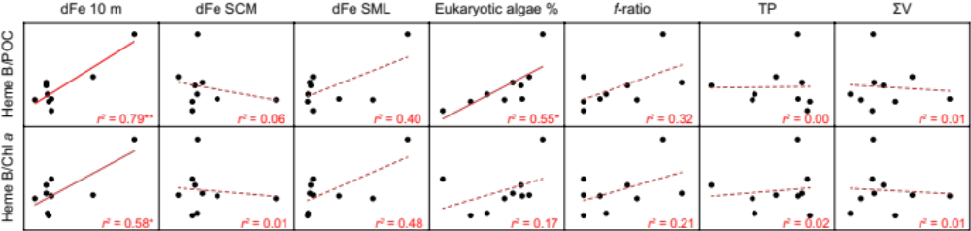
Figure S1. Molar ratios of heme B/POC and heme B/chl a plotted against dissolved Fe at the depth of 10 m and the SCM, and that averaged over the SML (Ikhsani et al., 2022), relative contribution of eukaryotic algae to total chlorophyll a at the SCM (Isaji et al., 2022), f-ratio (Isaji et al., 2022), TP, and ΣV. Determination coefficients (r²) are provided for each regression line, and statistically significant correlations are indicated by asterisks (p < 0.05*, p < 0.01**).
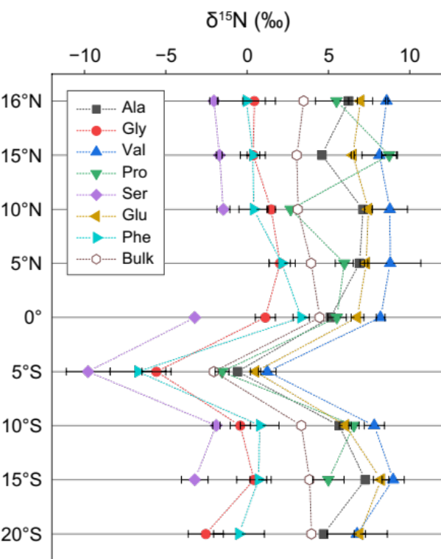
Figure S2. Nitrogen isotopic compositions of individual amino acids and bulk nitrogen in the SPM collected at the SCM along the 88°E transect in the eastern Indian Ocean.
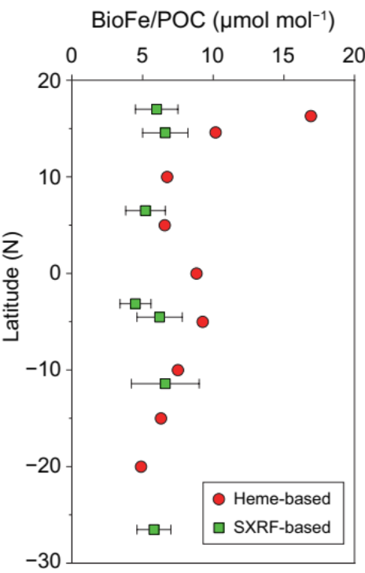
Figure S3. Comparison of heme B-based estimates of BioFe/POC with those determined by SXRF along the latitudinal transect in the EIO (Twining et al., 2019).

References
Allen AE, LaRoche J, Maheswari U, Lommer M, Schauer N, Lopez PJ, Finazzi G, Fernie AR, Bowler C (2008) Whole-cell response of the pennate diatom Phaeodactylum tricornutum to iron starvation. Proc Natl Acad Sci USA 105: 10438–10443
Berman-Frank I, Cullen JT, Shaked Y, Sherrell RM, Falkowski PG (2001) Iron availability, cellular iron quotas, and nitrogen fixation in Trichodesmium. Limnol Oceanogr 46: 1249–1260
Büchel C, Wilhelm C, Lenartz‐Weiler I (1988) The molecular analysis of the light adaptation reactions in the yellow‐green alga Pleurochloris meiringensis (Xanthophyceae). Bot Acta 101: 306–310
Falkowski PG, Raven JA (2013) Aquatic photosynthesis. Princeton University Press
Ikhsani IY, Wong KH, Ogawa H, Obata H (2023) Dissolved trace metals (Fe, Mn, Pb, Cd, Cu, and Zn) in the eastern Indian Ocean. Mar Chem 248: 104208
Isaji Y, Yoshikawa C, Ogawa N, Matsumoto K, Makabe A, Toyoda S, Ishikawa N, Ogawa H, Saito H, Honda M, Ohkouchi N (2022) Nitrogen sources for phytoplankton in the eastern Indian Ocean determined from δ¹⁵N of chlorophyll a and divinylchlorophyll a. Geochem Geophys Geosyst 23: e2021GC010057
Murakami A, Fujita Y (1988) Steady state of photosynthesis in cyanobacterial photosynthetic systems before and after regulation of electron transport composition: Overall rate of photosynthesis and PSI/PS II composition. Plant Cell Physiol 29: 305–311
Nanba M, Katoh S (1985) Electron transport from cytochrome b₆-f complexes to Photosystem I reaction center complexes in Synechococcus sp. Is cytochrome c-553 a mobile electron carrier?. Biochim Biophys Acta 808: 39–45.
Neale PJ, Melis A (1986) Algal Photosynthetic membrane complexes and the photosynthesis-irradiance curve: a comparison of light-adaptation responses in Chlamydomonas reinhardtii (Chlorophyta) J Phycol 22: 531–538
Strzepek RF, Boyd PW, Sunda WG (2019) Photosynthetic adaptation to low iron, light, and temperature in Southern Ocean phytoplankton. Proc Natl Acad Sci USA 116: 4388–4393
Strzepek RF, Harrison PJ (2004) Photosynthetic architecture differs in coastal and oceanic diatoms. Nature 431: 689–692
Sukenik A, Bennett J, Falkowski, PG (1987) Changes in pool sizes of photosynthetic electron transport components and Rubisco with growth irradiance-evidence for the limiting step in light saturated photosynthesis. In: Progress in Photosynthesis Research: Volume 2 Proceedings of the VIIth International Congress on Photosynthesis Providence, Rhode Island, USA, Springer Netherlands.
Twining BS, Rauschenberg S, Baer SE, Lomas MW, Martiny AC, Antipova O (2019) A nutrient limitation mosaic in the eastern tropical Indian Ocean. Deep Sea Res Part II 166: 125–140

