Supplementary information of “Effect of particle characteristics on granular friction evaluated by dual-slip-plane friction tests”

Wataru Tanikawa1,*, Takehiro Hirose1, Yohei Hamada1, Keishi Okazaki2, Osamu Tadai3, Takahiro Suzuki3, Manami Kitamura4, and Hirofumi Asahi5

1Japan Agency for Marine-Earth Science and Technology, X-star, Kochi Institute for Core Sample Research, Nankoku, 783-8502, Japan
2Hiroshima University, Graduate School of Advanced Science and Engineering, Higashi-Hiroshima, 739-0046, Japan
3Marine Works Japan Ltd., Nankoku, 783-8502, Japan
4National Institute of Advanced Industrial Science and Technology, Geological Survey of Japan, Tsukuba, 305-8567, Japan
5Fukui Prefectural Satoyama-Satoumi Research Institute, Mikatakaminaka-gun, 919-1331, Japan

*corresponding.author@email.example

Introduction
The supplementary information includes explanations of separate supplementary data, such as videos and tables, as well as supplementary documents and figures that support the main reports.

Supplementary Information
Definition of Parameters for Particle Size and Shape^{1,2,3}
Representative parameters of particle size (diameter) and shape (Fig. S1) are crucial for investigating their influence on peak friction. The following are definitions of these parameters:
1. Average (Mean) or D [4,3]: This represents the volume-weighted arithmetic mean, where n-component grain size is expressed by the following formula:
$$D\left[4,3\right]=\sum_{i=1}^{n}{{δV}_{i}d_{i}}$$
where δV_{i} is the volume fraction of grains size of d_{i}.
2. Geometric Mean (GM): The geometric mean of the n-component grain size is calculated as the product of each component's grain size raised to the power of its fractional proportion:
$$GM=\prod_{i=1}^{n}{{d_{i}}^{{δV}_{i}}}$$
3. Median or D (v, 50): This is the value of the particle size that divides the population exactly into two equal halves. It indicates that 50% of the distribution is above this value and 50% below. It is also known as the Mass Median Diameter (MMD) or the median of the volume distribution. The v in the expression D (v, 0.5) signifies that this refers to the volume distribution.
4. Mode: This is the grain size with the highest frequency in the volume particle size distribution.
5. Span: The span is the measure of the width of the PSD. A narrower distribution results in a smaller span, and it is calculated as:
Span =D(v,90) – D(v,10)/D(v, 50),
where D(v, 0.1) and D(v,90) are the sizes below which 10% and 90 % of the sample lies.
6. Aspect ratio: It is the ratio of the shortest axis to the longest axis of a grain. The maximum aspect ratio is 1, indicating no elongation.
7. Circularity: Circularity is the ratio of a circle perimeter with an equivalent area of grain to grain perimeter. The maximum circularity is 1, and smaller circularity values correspond to more irregular particle shapes.
8. Convexity: Convexity measures particle edge roughness and compactness. It is the ratio of the particle area to the area of its convex hull. The maximum convexity is 1.
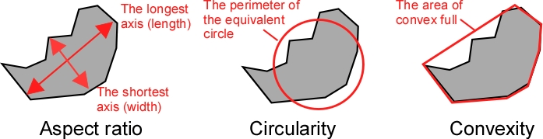
Figure S1. Description of particle shape parameters.

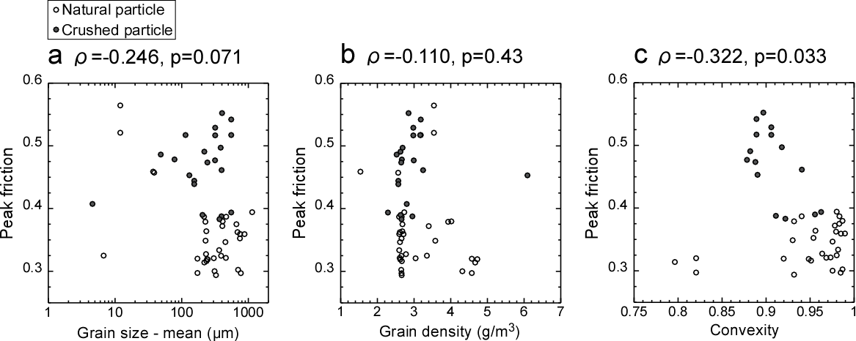
Figure S2. Correlation between peak friction and lithological feature of sandy particles: (a) Mean grain size. (b) Grain density. (c) Convexity. ρ and p are correlation coefficient and the p-value of Pearson’s correlation test.

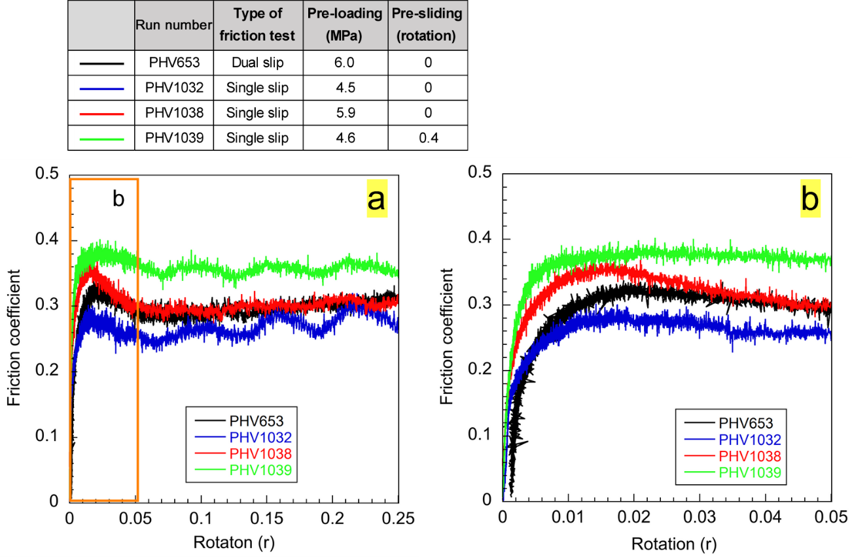
Figure S3. Dual- and single -slip-plane friction tests using the specimen of A4 (Beach sand of Hamakurosaki Beach/Toyama Pref.). Single-slip-plane friction tests were performed to investigate the influence of pre-loading and pre-sliding on friction behavior. (b) Closeup of initial rotation of (a). The other results of single-slip-plane friction tests were listed on Supplementary Table S9.

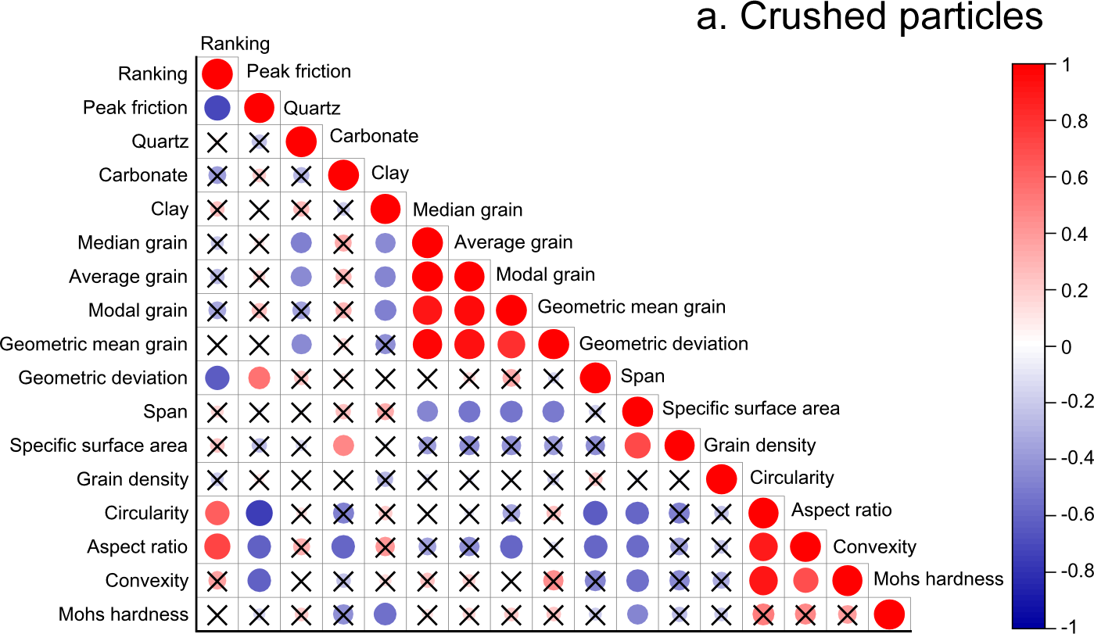
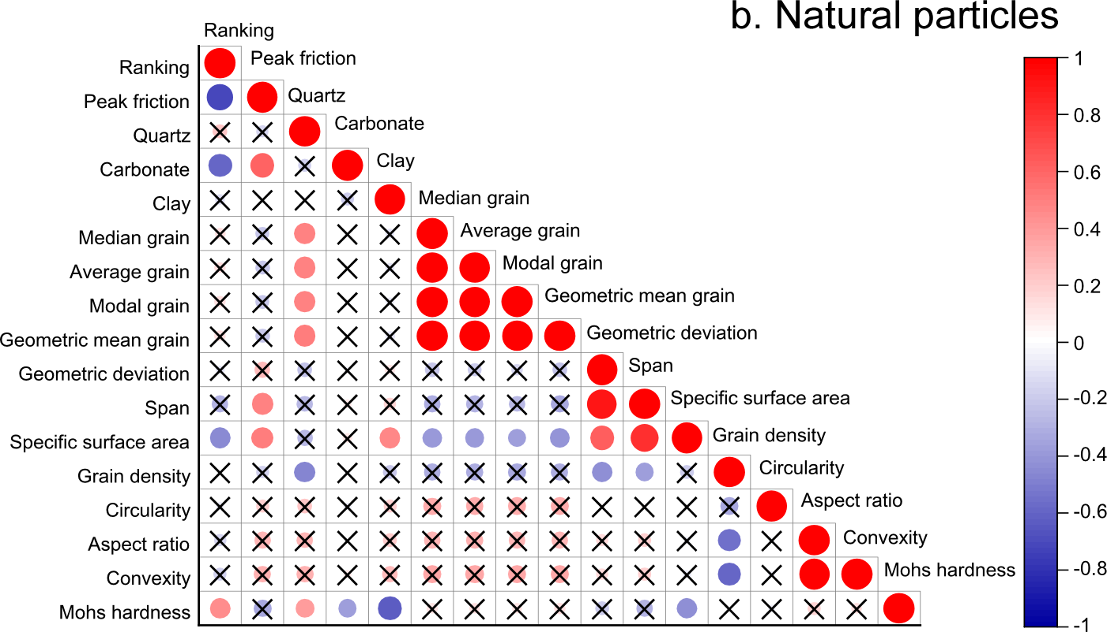
Figure S4. Correlation coefficient matrix for (a) crushed particles, and (b) natural particles.

Separated Supplementary Files
Supplementary Video Files
Supplementary Video S1 to S4 files (.mp4) were movies captured using a digital camera (TG5, Olympus, Japan) during a match in "Non-slippery Sand Koshien". For reference, mechanical data illustrating the relationship between torque and elapsed time is provided on the left side of the screen. Each video corresponds to a specific match:
Supplementary Video S1: PHV666, Spinel (B4, upper particles) vs. Beach Sand (B5, lower particles, winner).
Supplementary Video S2: PHV758, the final match between Oyster shell (A12, upper particles, winner) and Gabbro (C13, lower particles).
Supplementary Video S3: PHV760, the final match between Oyster shell (A12, winner, lower particles) and Gabbro (C13, upper particles).
Supplementary Video S4: PHV707, Beach sand (C1, lower particles) vs. Mud of hot spring (C3, upper particles, winner).

Supplementary Tables
Supplementary Tables S1 to S9 contain the original data used to generate Figures 3 to 8 in the paper.

References

1. Rawle, A. Technical Paper: Basic Principles of Particle Size Analysis. technical paper malvern 44, (2010).

2. Yu, J., Shen, C., Liu, S. & Cheng, Y. P. Exploration of the Survival Probability and Shape Evolution of Crushable Particles during One-Dimensional Compression Using Dyed Gypsum Particles. Journal of Geotechnical and Geoenvironmental Engineering 146, (2020).

3. ISO 9276-2:2001 : Representation of results of particle size analysis – Part 2: Calculation of average particle sizes/diameters and moments from particle size distributions

