Appendix A The Equivalence between binary classification tasks using neural network (NN) and calculation procedure for probability of a certain state of binary variable based on statistical mechanics model.

The following example is the simplest case to show equivalence between binary classification task using NN and calculation procedure for probability of a certain state of binary variable based on statistical mechanics model (Tanaka et al, 2021). For the more complex cases (e.g. deep neural networks), please see Tanaka et al. (2021).

Binary classification tasks using NN
Consider the simples NN (perceptron) consisting of two layers, such as an input layer consisting of two nodes with variables x = {x₁, x₂} and an output layer consisting of one node with variable d. Assume that variable d takes two values, 0 and 1, and then binary variable. Consider a binary classification task of the value of d with a given input value x. Let the weights of the adjustment parameters J between each node of the input and the output layers be J₁ and J₂, and the bias be J. The output X from the input layer is expressed as follows

X = J₁ x₁ + J₂ x₂ + J (s1)

The output layer d is given by the following sigmoid function

d = 1/(1+Exp(-X)) (s2)

The above sigmoid function is called the activation function. The function takes the following values

lim_{X->∞} d = 1, lim_{X->-∞} d = 0.

That is, it takes the values 0-1. From the obtained values, a threshold value is set to classify them as 0 or 1.

Calculation procedure for probability of a certain state of binary variable based on statistical mechanics model
Consider a variable x = {x1, x2} that describes a system, and a binary variable d that describes also a system. x is given by externally, and d represent a freedom of the system. Consider a probability distribution QJ with these variables as random variables, where J is an adjustment parameter. The energy E corresponding to the state {x, d} of the system is defined as follows (the simplest case).

E = -(J₁ x₁ + J₂ x₂ +J)d (s3)

When the state of the system is x, the probability that d = 1 is obtained by the following conditional probability.

QJ(d=1 | x) = Exp(-E)/(Σ_{d=1,0} Exp(-E))

The right-hand term of the above equation is the Boltzmann distribution, of which factors of k_{B} (Boltzmann constant) and T (absolute temperature) are included in the adjustment parameter J (Tanaka et al., 2021). Expanding summation of the right-hand side of the above equation,

QJ(d=1 | x) = 1/(1+Exp(E))

Using Eq. (s1) and (s3),

QJ(d=1 | x) = 1/(1+Exp(-X)) (s4)

The right-hand term of the above equation is sigmoidal function and also is the same as activation function of the binary classification task.

Conclusion
Equations (s2) and (s4) are equivalent. Therefore, the algorithms for eq (s2) and (s4) calculations are also equivalent.

Appendix B Values of geological variables

Values of geological variables, such as θ_{age}, θ_{rock}, and θ_{lithology}, are basically given by nine-digit codes defined in Japanese Industrial Standard A 0205 (JIS A 0205) (Japanese Industrial Standards Committee, 2012). The definition and terms of JIS A 0204 refer to IUGS standards and recommendations, such as IUGS geochronologic units (IUGS ICS, 2022), IUGS recommendation of igneous rock classification (IUGS Subcommission on the Systematics of Igneous Rocks, 2022), and IUGS recommendation of metamorphic rocks classification (IUGS Subcommission on the Systematics of Metamorphic Rocks, 2012). JIS A 0205 refers to typical sedimentary rock textbooks.
Nine-digits codes are used by JIS A 0204. We used basically nine-digits codes of JIS A 0204. However, geochronologic unit codes and metamorphic rock codes are exceptional. We used mean age of start and end ages of each geochronologic unit of IUGC geochronologic unit as values of θ_{age}. We make new nine-digits for values of protoliths of metamorphic rocks based on digits for sedimentary and igneous rocks (Table s1). We used this code as values of θ_{rock} of metamorphic rocks.
Table s2 to s5 and table s6 to s9 show values of θ_{age}, θ_{age}, θ_{rock}, and θ_{lithology} of unstructured and structured 1:200,000 geological maps of northern Kyushu and unstructured and structured 1:50,000 geological maps of the Sasebo-Imari area (northwestern part of the northern Kyushu), respectively.

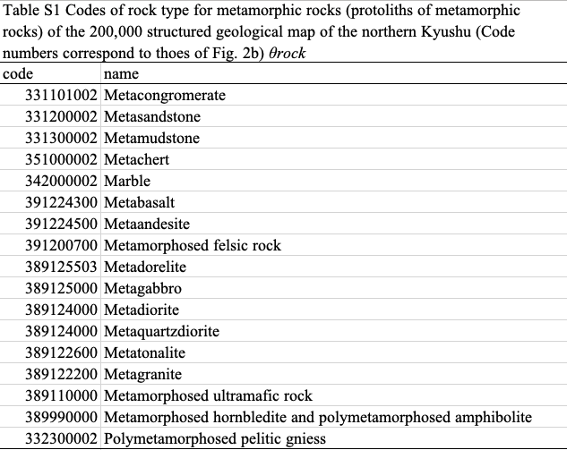

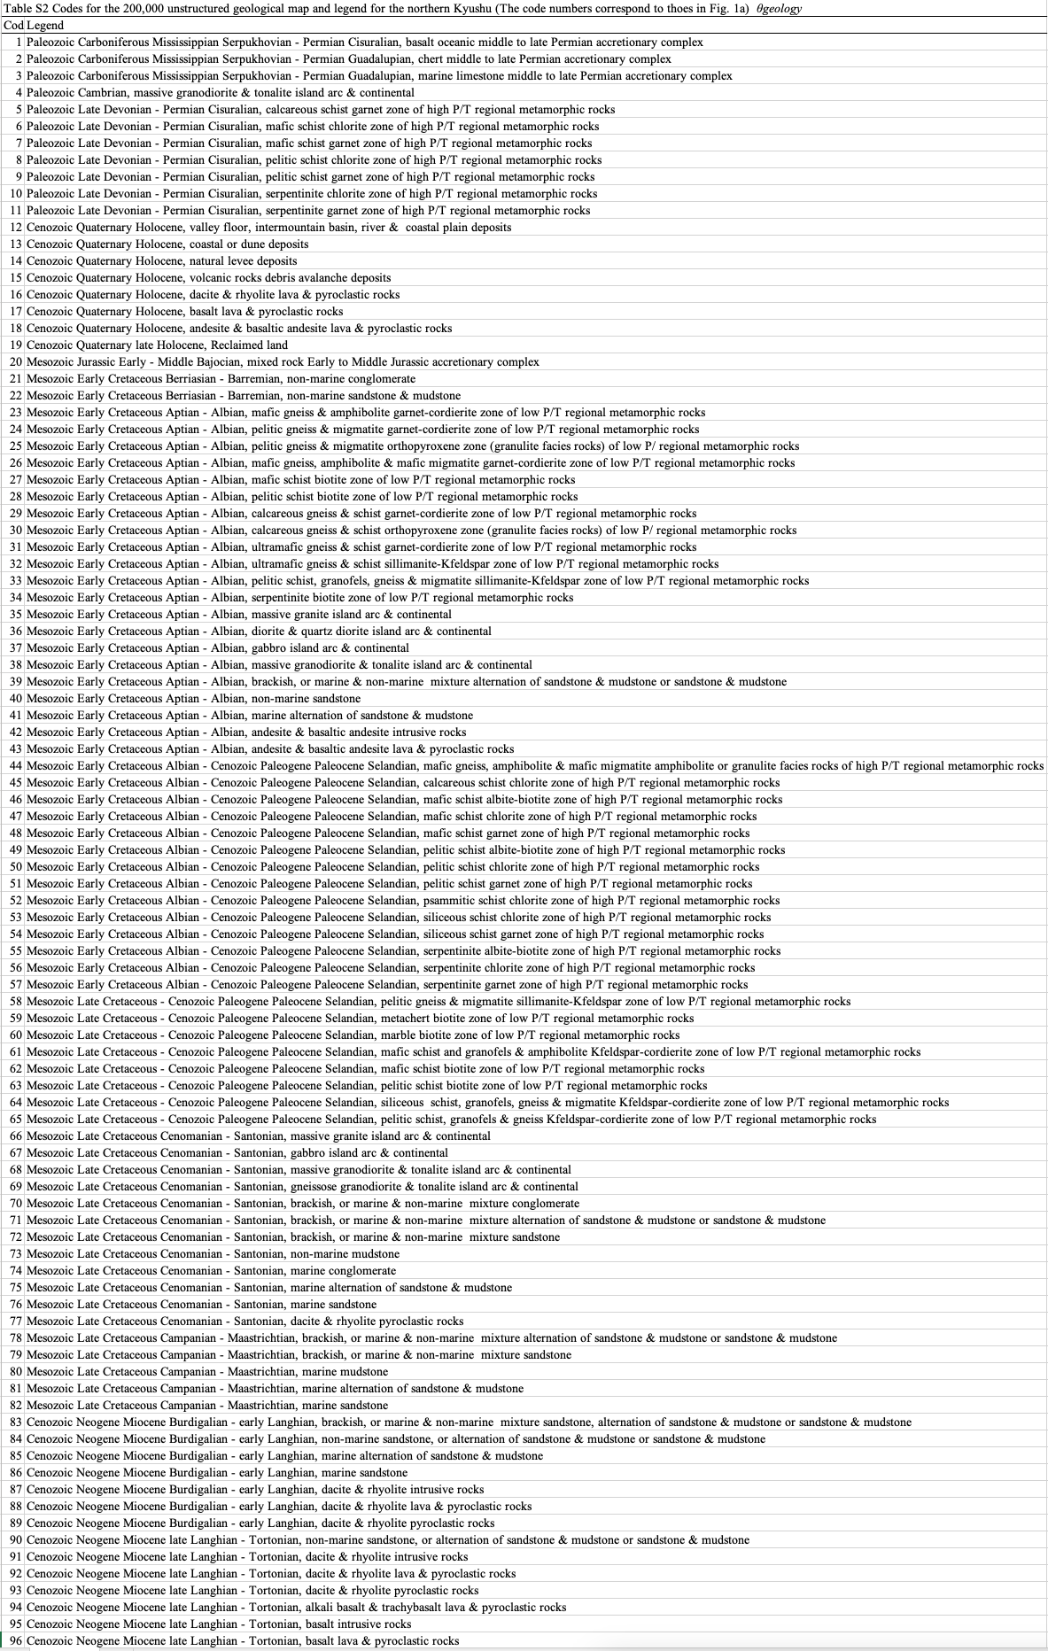
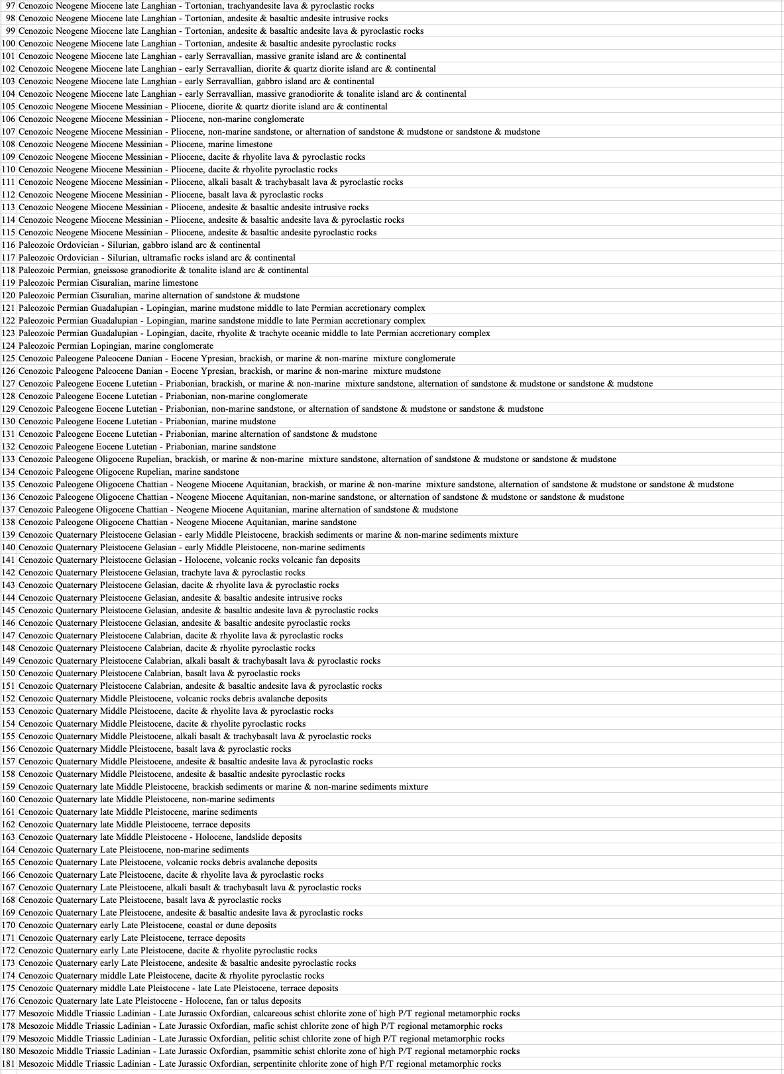

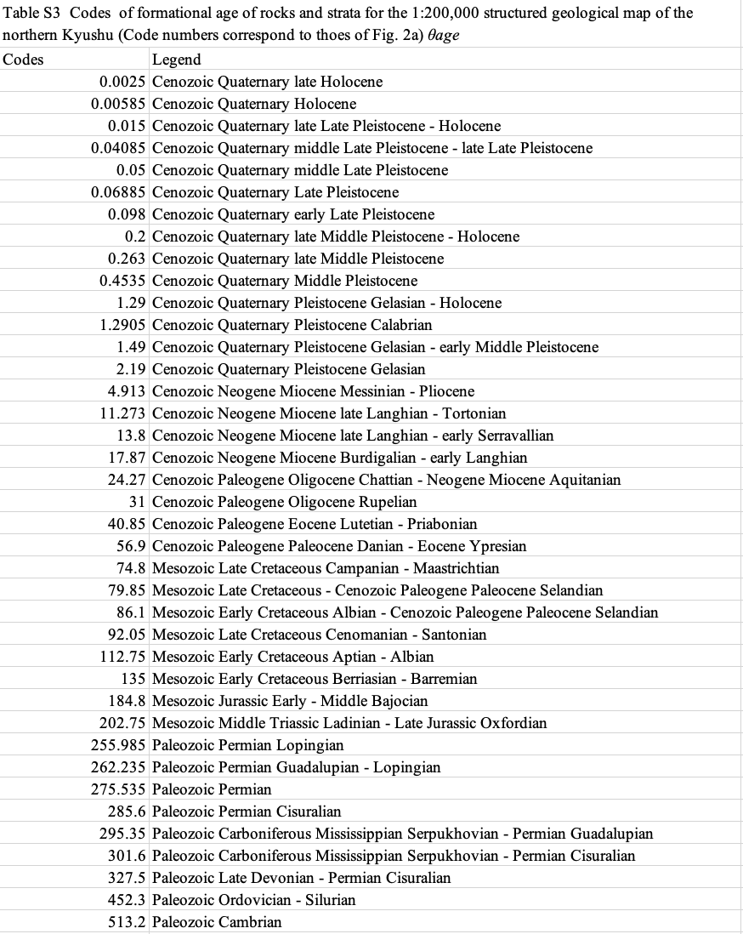

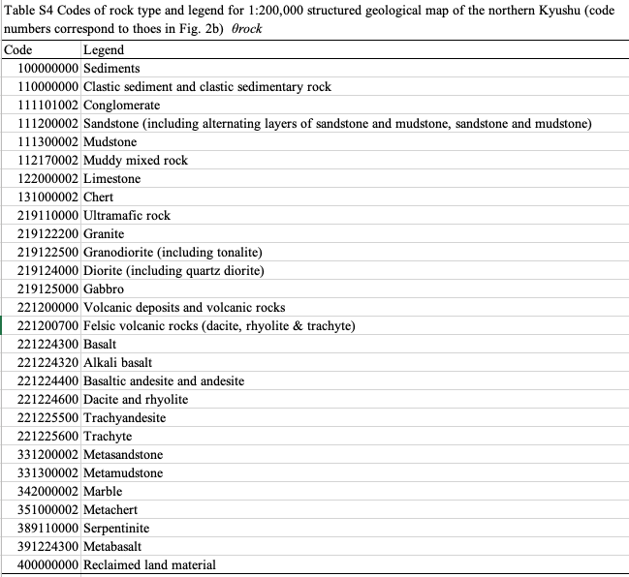

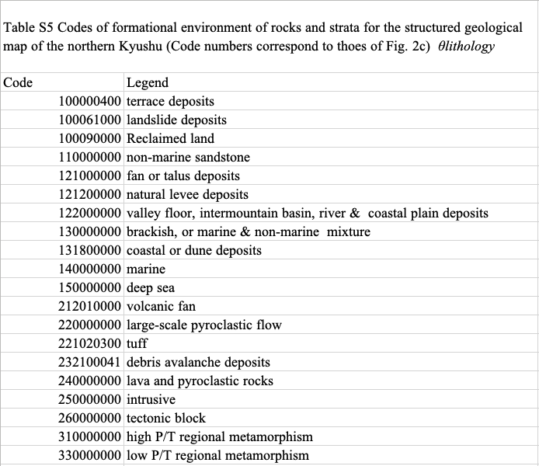

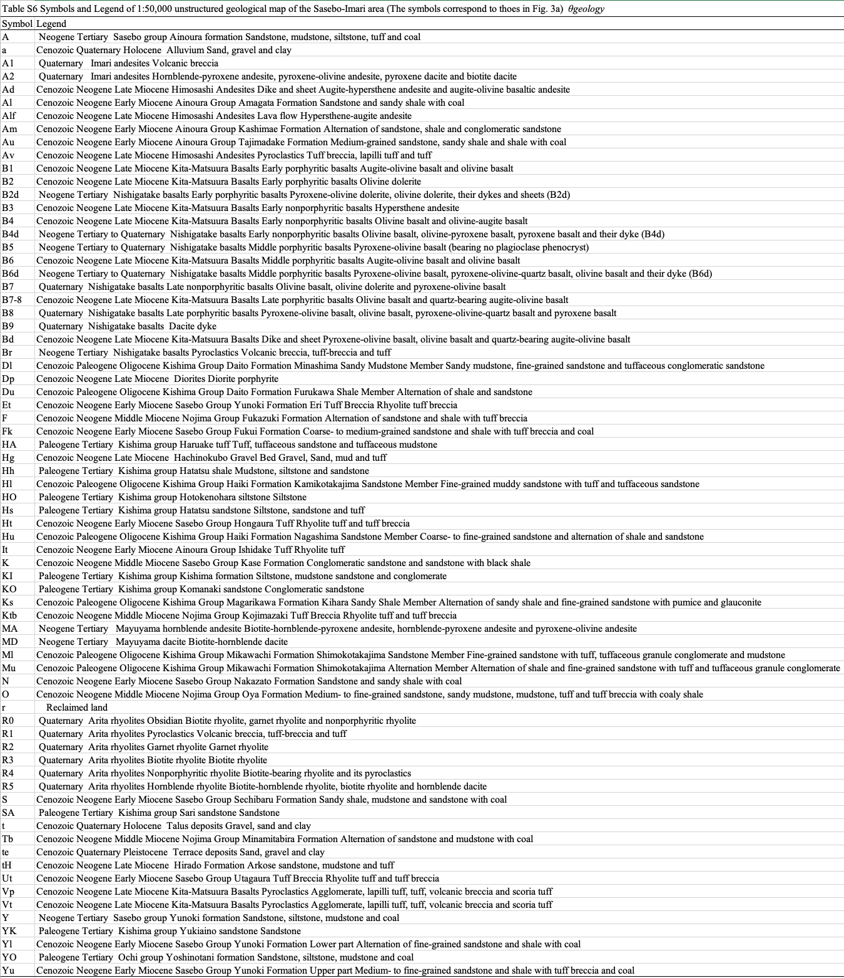

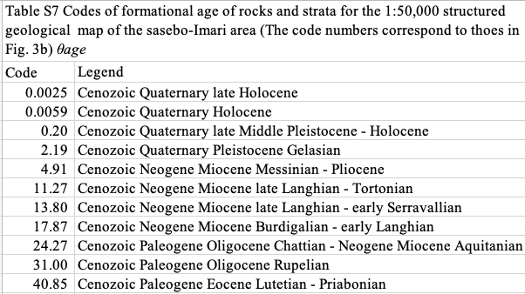
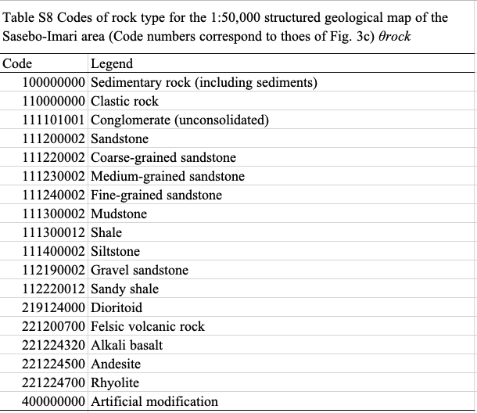

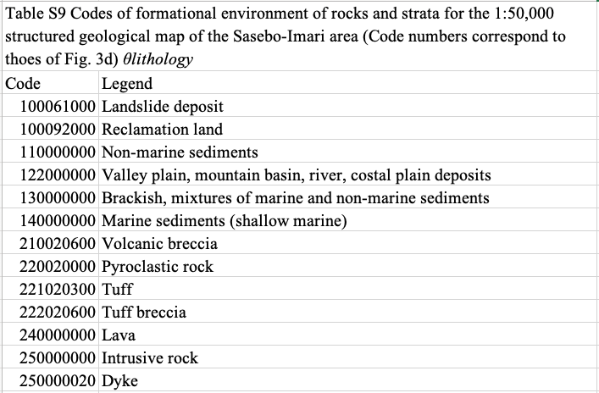

Appendix C Data flow of neural network calculation

Overall data flow of neural network calculation used in this paper is shown in Fig.S2.
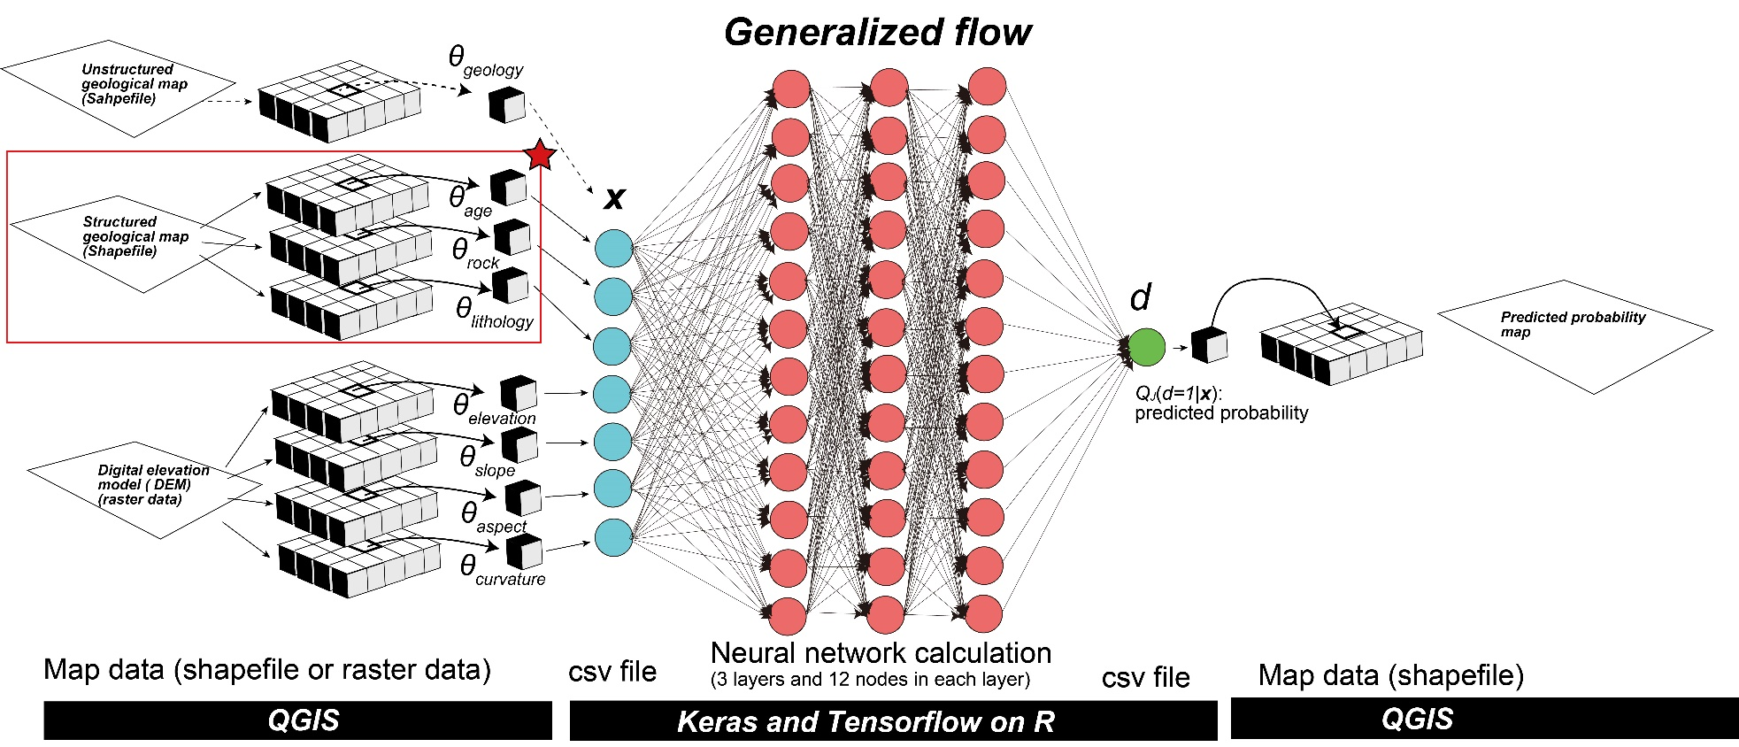

Figure S1 Overall data flow in the neural network calculation procedure. The red box marked with a red star indicates the data flow when using the structured geological map proposed in this study. The dashed arrows above represent the data flow in the conventional approach using the unstructured geological map.
Appendix D
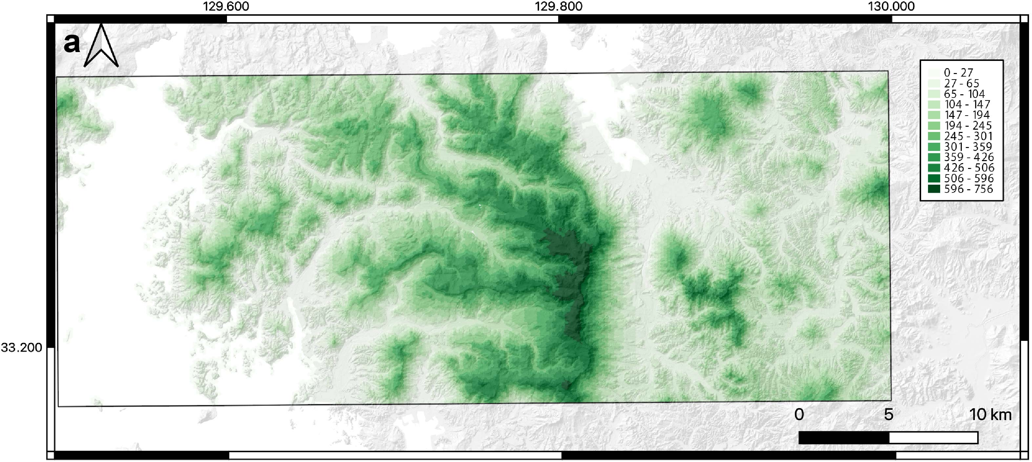
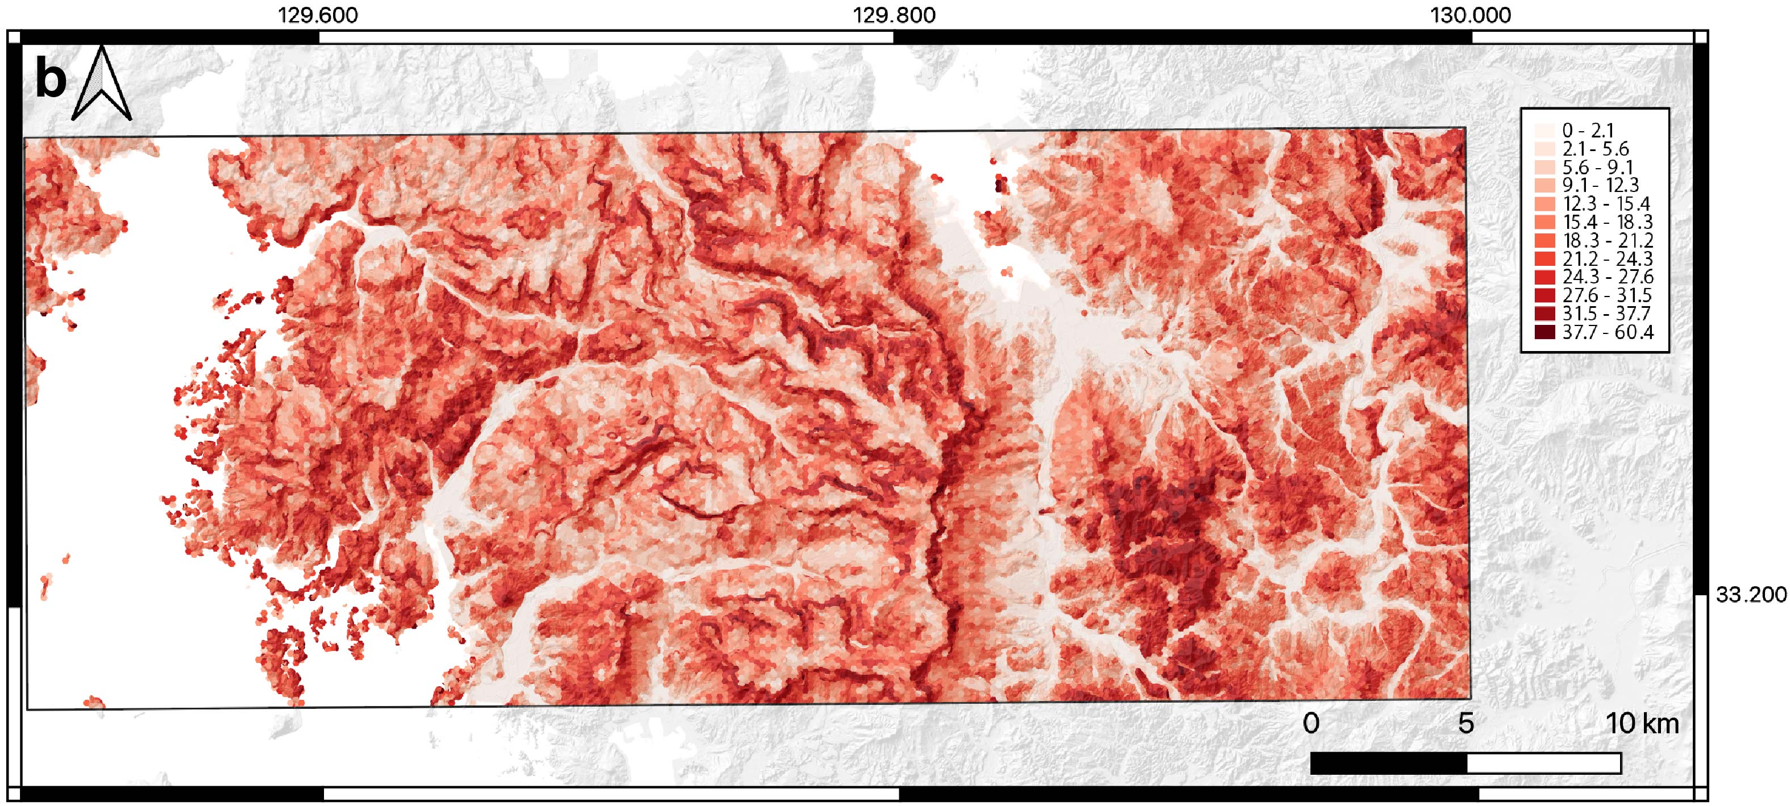
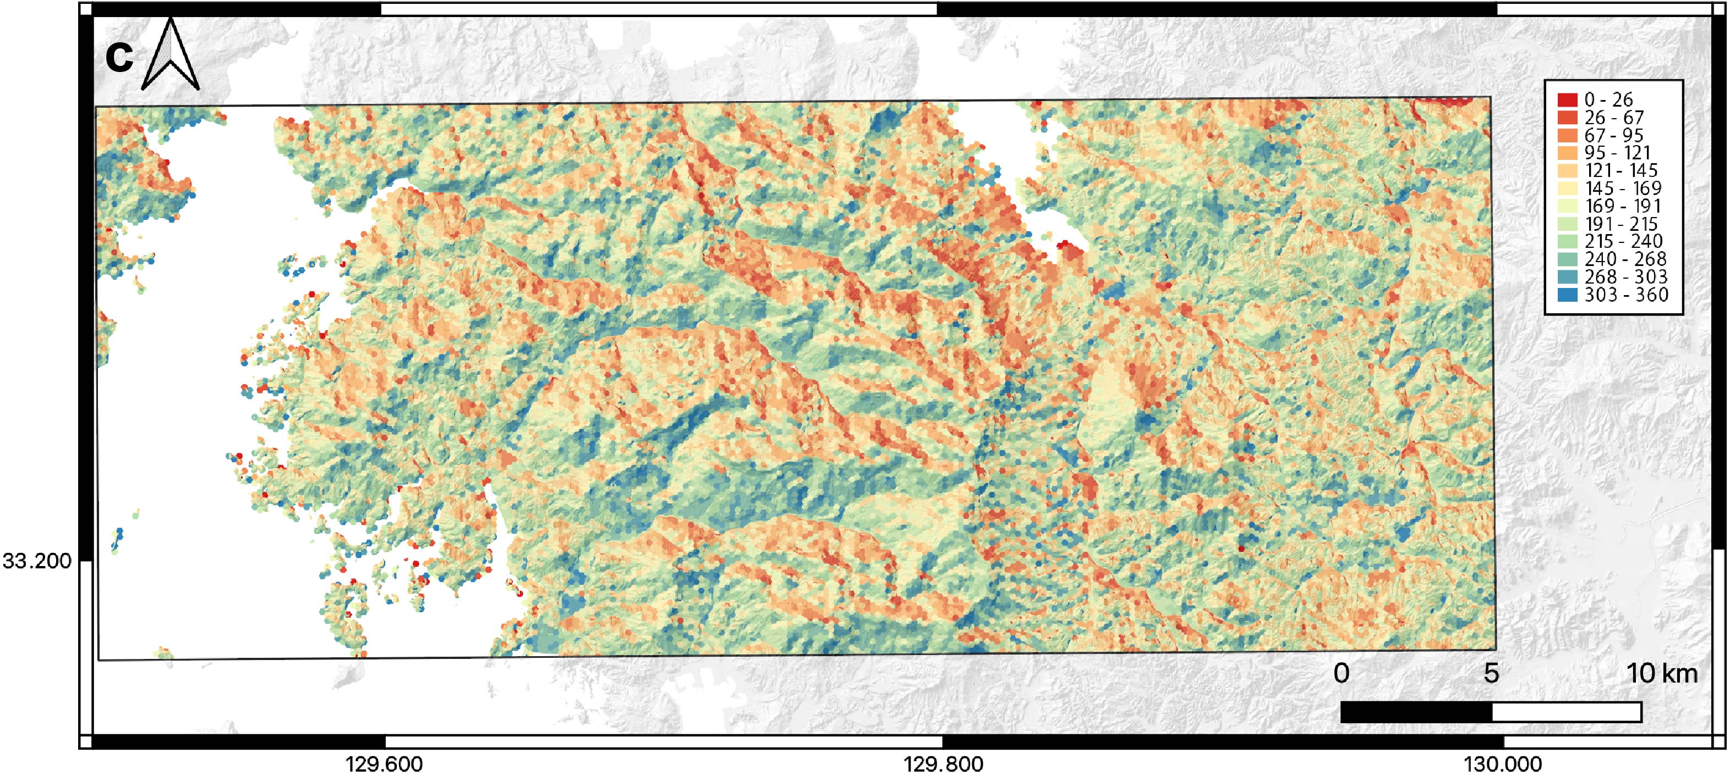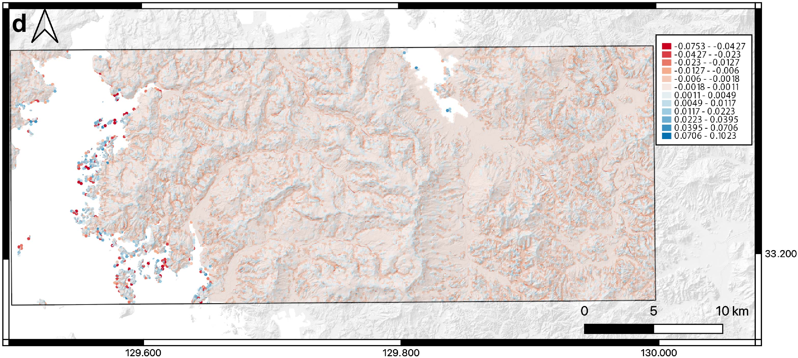

Figure S2. Topographic explanatory variables for the Sasebo–Imari area. (a) Elevation. The legend shows the elevation in meters. (b) Slope. The legend shows the slope classes in degrees. (c) Aspect. The legend shows the aspect classes in degrees clockwise from north. (d) Profile curvature. The legend shows the profile curvature classes in radians. (a)–(d) Data generated from the DEM (GIS website; https://fgd.gsi.go.jp/download/mapGis.php?tab=dem) using QGIS plugins.

Appendix E
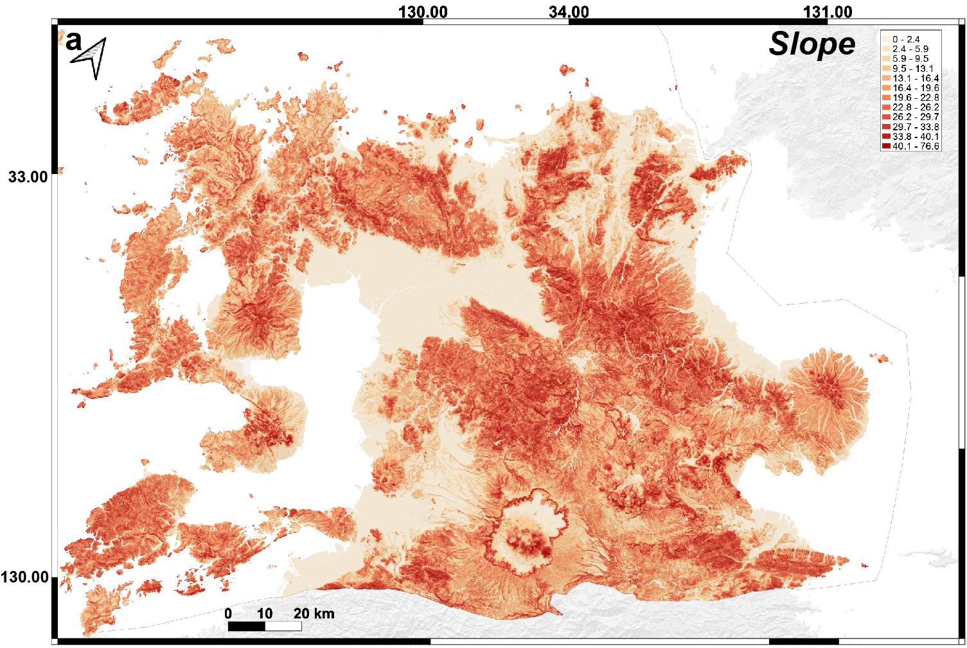
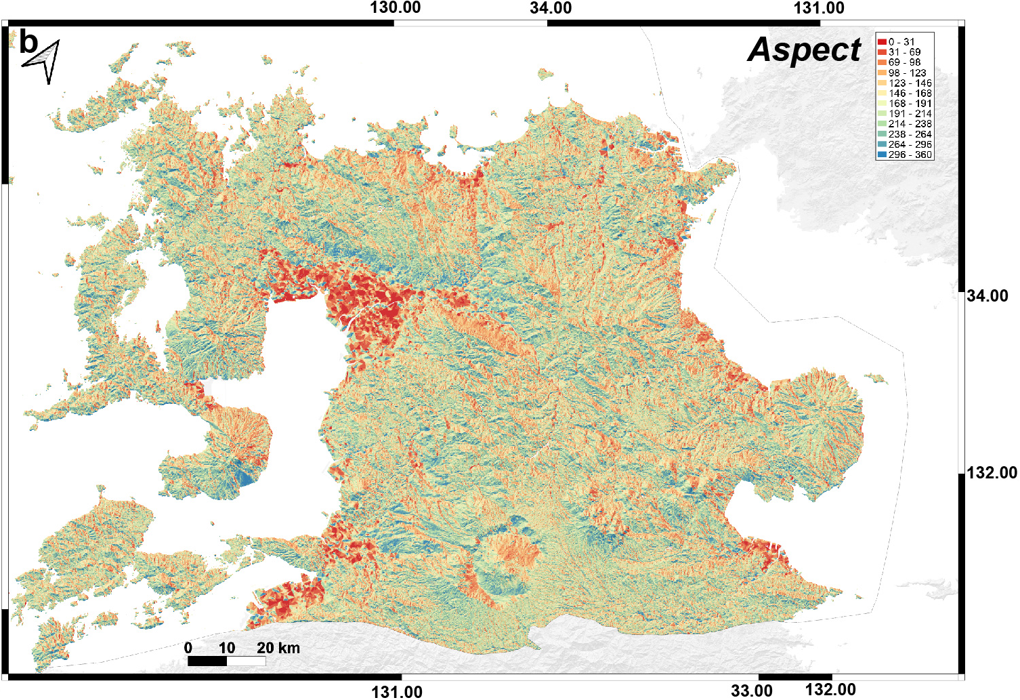

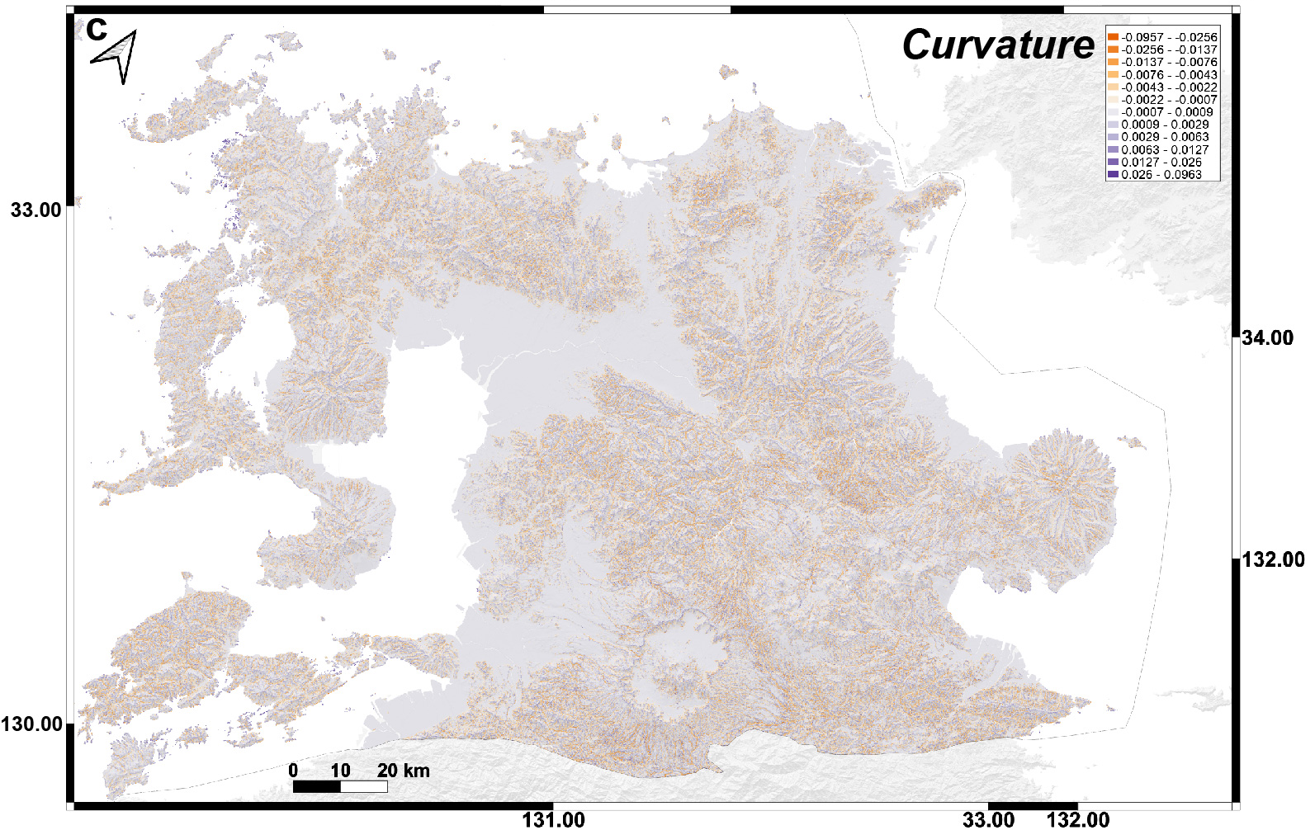
Figure S3. Topographic explanatory variables in northern Kyushu. (a) Slope. The legend shows the slope classes in degrees. (b) Aspect. The legend shows the aspect classes in degrees clockwise from north. (c) Profile curvature. The legend shows the profile curvature classes in radians. (a)–(c) Data generated from the DEM (GIS website; https://fgd.gsi.go.jp/download/ mapGis.php?tab=dem) using QGIS plugins.

Appendix F Learning curves

Typical learning curves for loss functions and accuracy increasing epochs are shown in the Fig. S3 figure. This learning curves when a structured geologic map is used for northern Kyushu.

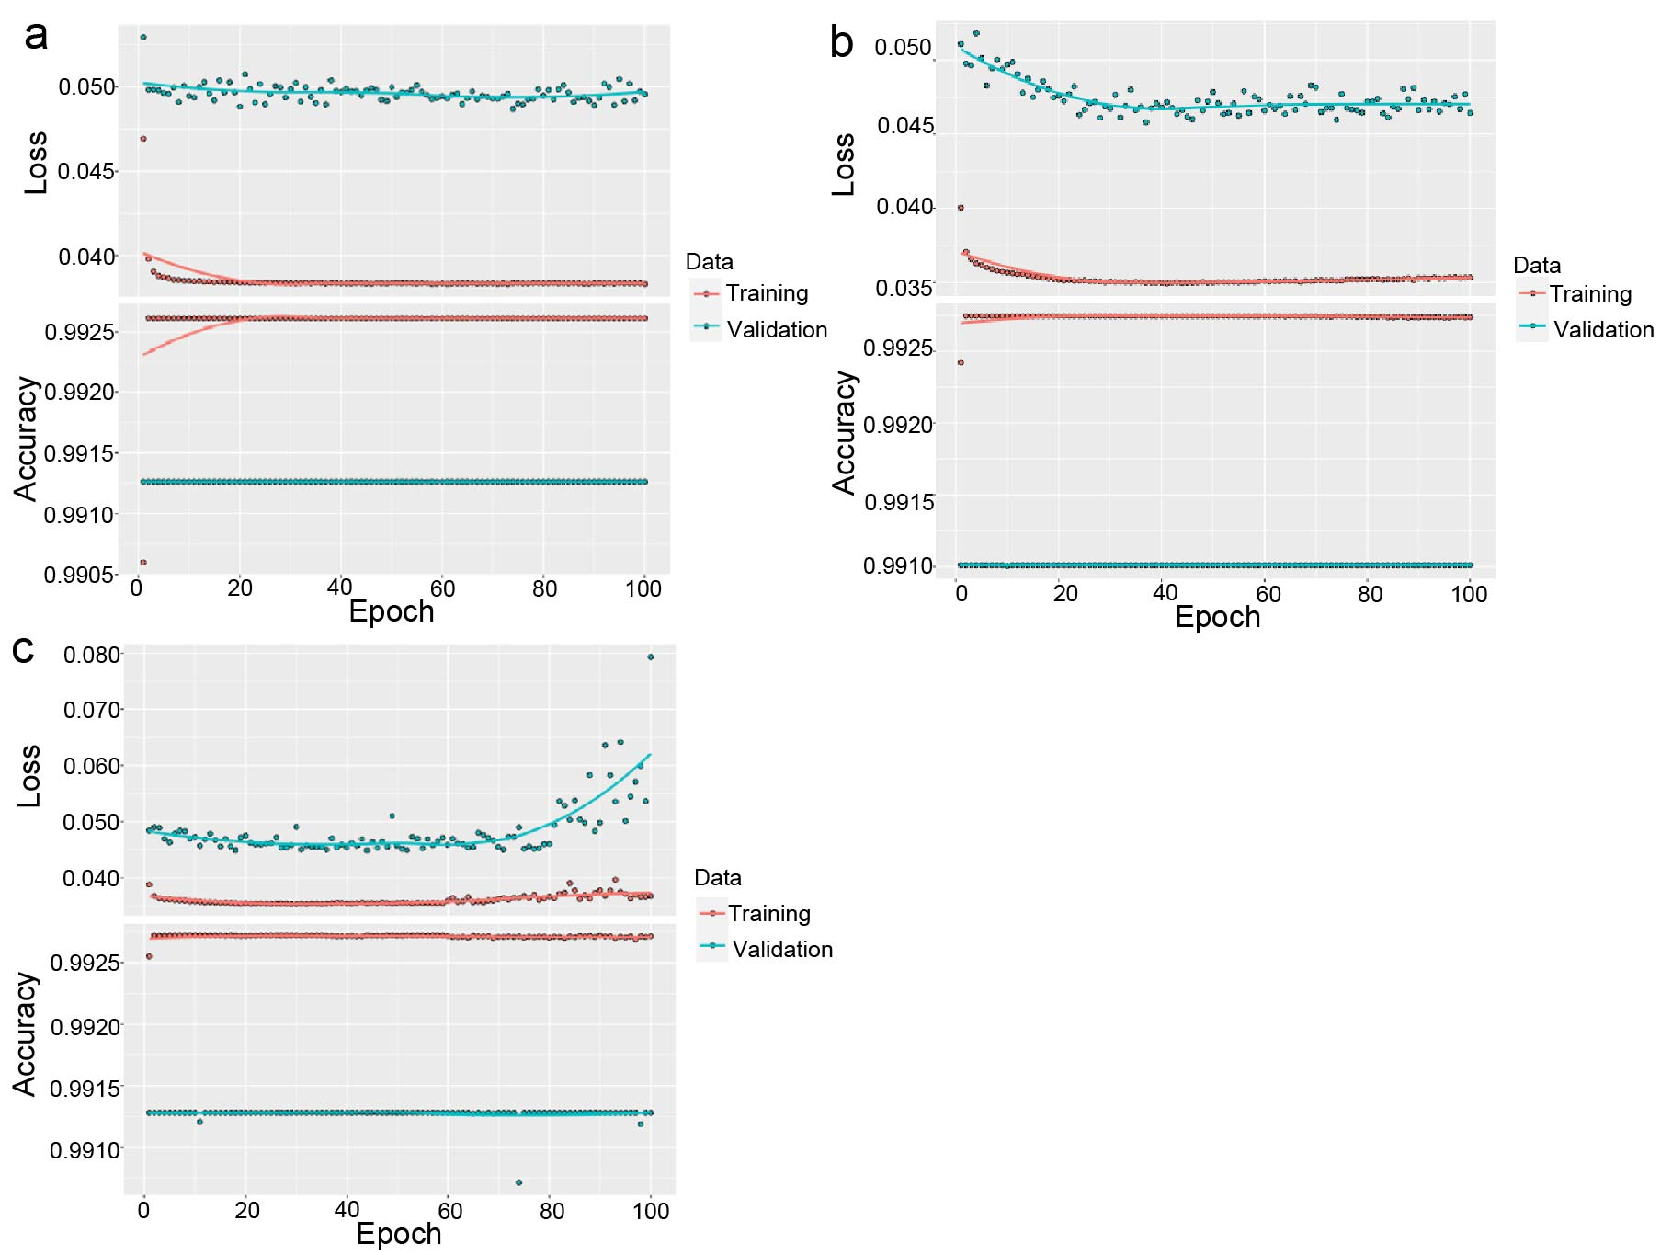

Figure S4 Learning curves (loss function and accuracy vs epochs) for calculating predicted probability of landslide occurrence in the Northern Kyushu. (a) 1 hidden layer and 5 nodes in hidden layer, total 46 parameters. (b) 3 hidden layers and 12 nodes in each hidden layer, total 421 parameters. (c) 5 hidden layers and 14 nodes in each hidden layer, total 967 parameters.

Appendix G Receiver operating characteristic (ROC) and precision-recall (PR) analysis

ROC and PR analyses are used when comparing the performance of prediction when random variable d takes two values, with and without landslides (e.g. Sergei). In both analyses, a critical predicted probability of landslide occurrence P_{c} is set and the following four values are used (Fig. s5). Using polygons which have actually landslides, 1) Ture Positive (TP) is proportion of polygons where PP ≥ P_{c}, 2) False Negative (FN) is proportion of polygons where PP < P_{c}. Using polygons which do not have actually landslides, 3) False Positive (FP) is proportion where PP ≥ P_{c}, 4) True Negative (TN) is proportion where PP < P_{c}. ROC analysis uses True Positive Rate (TPR) and False Negative Rate (FRP). These two values are

TPR = TP/(TP + FN), (s5)
FPR = FP/(FP + TN). (s6)

FRP versus TPR plots with decreasing P_{c} show a line with slope one or a convex curve at top left (Fig. s5). If predicted probability is random, that implies the model has no ability of prediction, The plots show a line with slope one. Increasing performance of prediction, more convex the curve is to the upper left (Fig. s5). The Area Under Curve (AUC) of ROC takes values between 0.5 and 1.0 and is an index of the performance of the prediction model. The higher AUC, the better the performance of prediction model.
PR analysis uses Precision (Pr) and Recall (Re) as follow,

Pr = TP/(TP + FP), (s7)
Re = TP/(TP + FN). (s8)

If there is no prediction ability of the probability model, the Re versus Pr plot is an almost horizontal straight line with Pr = 0.5. As the performance of the prediction increases, the curve becomes convex on the right. The AUC of PR approaches one. When the probabilities of landslide occurrence and non-occurrence are comparable, the difference from the AUC of PR increases from 0.5 to 1.0, as does the AUC for ROC. On the other hand, the difference from the AUC of ROC is more pronounced for imbalances where the occurrence of landslides is a very rare phenomenon. Even in such an imbalance, the AUC of ROC is more pronounced for imbalances where the occurrence of landslides is a very rare phenomenon. Even in such an imbalance, the AUC of ROC hardly changes, while the AUC of PR is smaller. However, even in this case, the AUC of the PR increases as the performance of the prediction model increases. It can therefore be used to compare performance between prediction models.

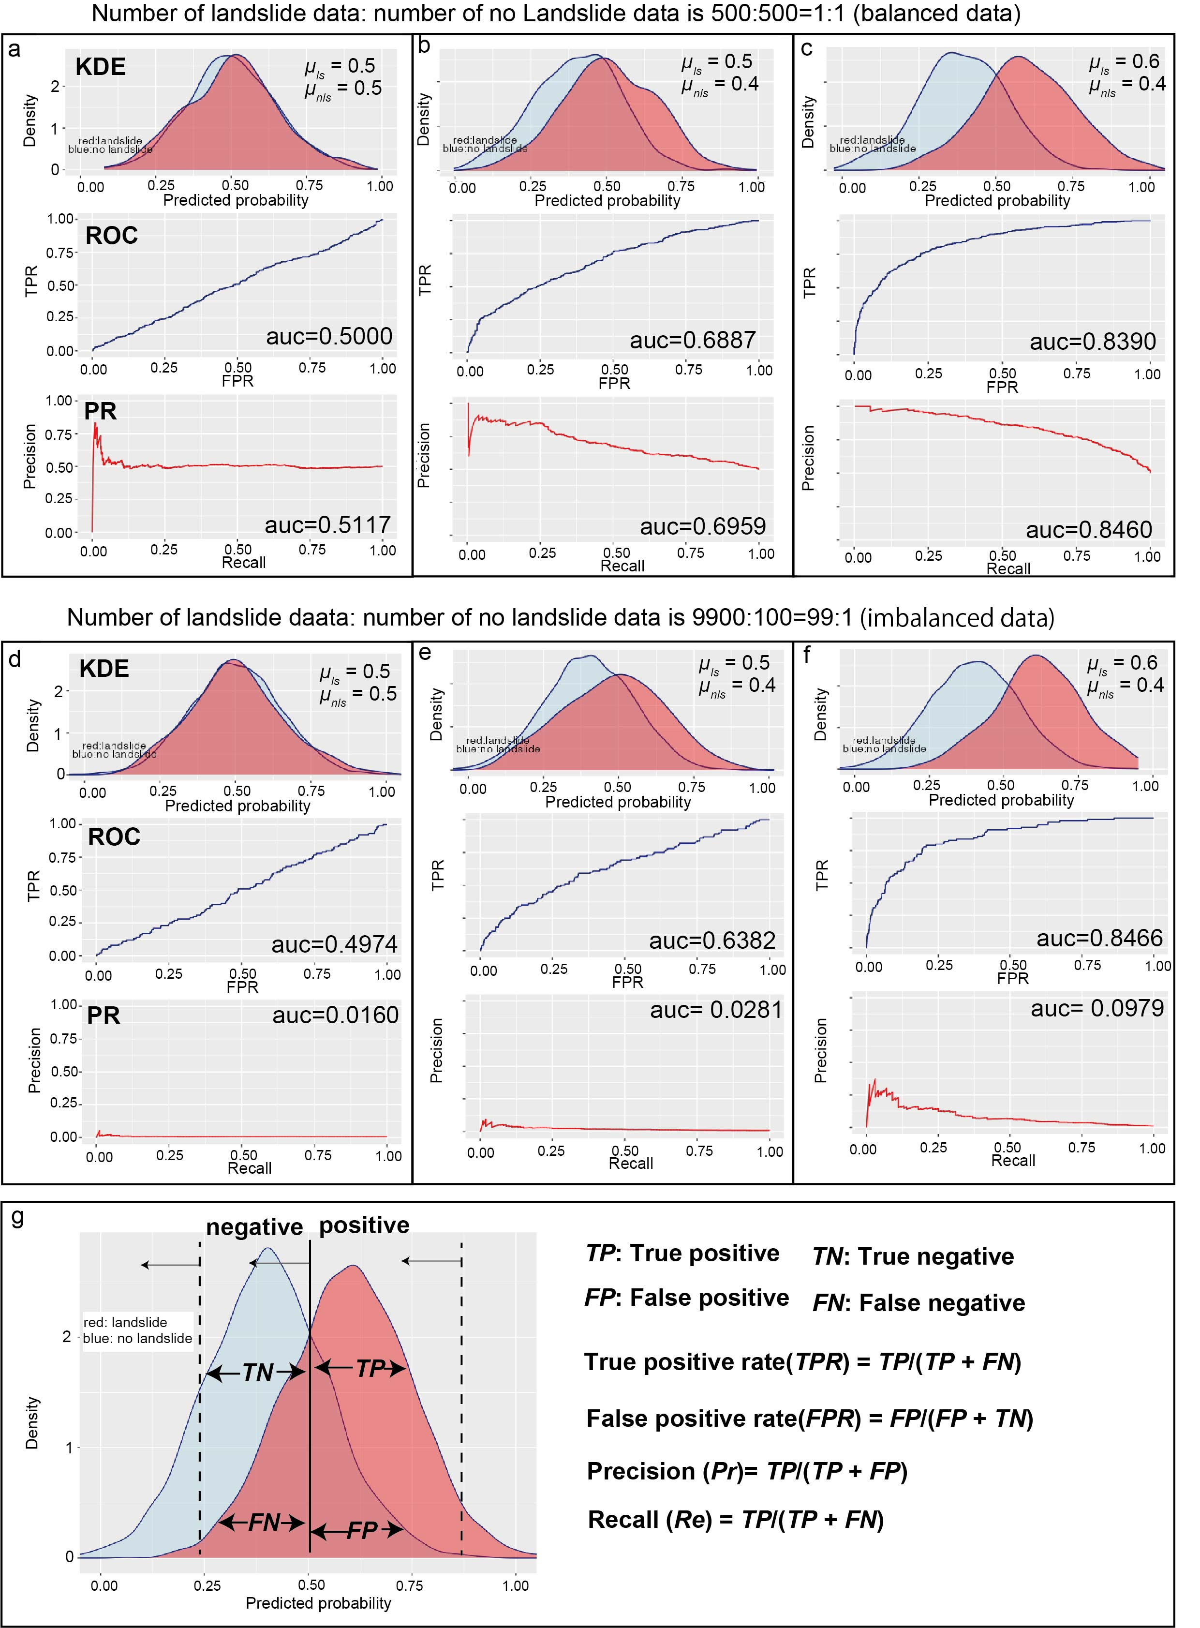
Figure S5 Kernel Density Estimation (KDE) of artificially generated predicted probability of landslide occurrence assuming Gaussian distribution. (a) Predicted probability generated by Gaussian distribution with mean µ_{sl} = 0.5 and standard deviation sd = 0.15 for landslide data and µ_{nsl} = 0.5 and sd =0.15 for no landslide data. (b) µ_{sl} = 0.5 and sd = 0.15, µ_{nsl} = 0.4 and sd = 0.15. (c) µ_{sl} = 0.6 and sd = 0.15, µ_{nsl} = 0.4 and sd = 0.15. (d) µ_{sl} = 0.5 and sd = 0.15, µ_{nsl} = 0.5 and sd = 0.15. (e) µ_{sl} = 0.5 and sd = 0.15, µ_{nsl} = 0.4 and sd = 0.15. (f) µ_{sl} = 0.6 and sd = 0.15, µ_{nsl} = 0.4 and sd = 0.15. (a)-(c): Balanced data set (number of landslide data: no landslide data is 500:500); (e) – (f) Imbalanced data set (number of landslide data: no landslide data is 9900:100). (g) Schematic diagram showing the relationship between the quantities required for ROC and PR analysis and density distribution of predicted probability of landslide occurrence. Vertical dashed lines and solid line indicate thresholds. The ROC and PR diagrams can be drawn by calculating the quantities while shifting the threshold value from the right to left, and plotting the values. Receiver Operating Characteristic (ROC), and Precision – Recall (PR). Pale red color distribution and pale blue distribution in KDE show density distribution of predicted probability for landslide and no landslide cases, respectively. auc: area under curve.

