Supplementary Information

Influence of minerals on aldose formation during hydrothermal processes in meteorite parent bodies
Fujii et al.

Contents:
Table S1. List of regents used in this study.
Table S2. Aldose concentrations in all samples.
Figure S1. Selected ion chromatograms (SIC) of aldoses from all experimental products, including control samples, and standards.
Figure S2. Selected ion chromatograms (SIC) of ribose standard and ribose standard with saponite.
Figure S3. Calibration lines used for aldose quantification.

Table S1. List of regents used in this study.
Regents, grade | Supplier
D-Erythrose Solution (~70 wt.%) | Fujifilm Wako Pure Chemical
L-Threose (~0.2 M in water) | Toronto Research Chemicals
D-(-)-Ribose | Tokyo Chemical Industry
D-(-)-Lyxose | Tokyo Chemical Industry
D-(-)-Arabinose | Tokyo Chemical Industry
D-(+)-Xylose, Guaranteed Reagent | Fujifilm Wako Pure Chemical
D-(+)-Allose | Tokyo Chemical Industry
D-(+)-Talose | Tokyo Chemical Industry
D(+)-Mannose, Guaranteed Reagent | Fujifilm Wako Pure Chemical
D-Altrose ≧99.5% | Nagara Science
D(+)-Glucose, Guaranteed Reagent | Fujifilm Wako Pure Chemical
L-Gulose | Tokyo Chemical Industry
L-idose (0.141 M solution) | Toronto Research Chemicals
D(+)-Galactose, Guaranteed Reagent | Fujifilm Wako Pure Chemical
Formaldehyde Solution (37.4 wt.%, containing 6.6 wt.% methanol), Guaranteed Reagent | Fujifilm Wako Pure Chemical
Ammonia Solution (27.1 wt.%), Guaranteed Reagent | Fujifilm Wako Pure Chemical
Hydroxylamine Hydrochloride | Tokyo Chemical Industry
4-Dimethylaminopyridine | Fujifilm Wako Pure Chemical
Pyridine (>99.5 wt.%), Infinity Pure | Fujifilm Wako Pure Chemical
Methanol (>99.8 wt.%), Guaranteed Reagent | Fujifilm Wako Pure Chemical
Acetic anhydride (99.3 wt.%) | Tokyo Chemical Industry
1,2-Dichloroethane, Guaranteed Reagent | Fujifilm Wako Pure Chemical
Hydrochloric acid (36.0 wt.%), for Amino Acid Automated Analysis | Fujifilm Wako Pure Chemical
Ethyl acetate (> 99.8 wt.%), for HPLC | Fujifilm Wako Pure Chemical
Hexane (98.2 wt.%), Guaranteed Reagent | Fujifilm Wako Pure Chemical
Phthalate pH standard solution pH4.01 (0.05 mol/L potassium hydrogen phthalate solution) | Toa DKK
Neutral phosphate pH standard solution pH6.86 (0.025 mol/L potassium dihydrogen phosphate and 0.025 mol/L sodium dihydrogen phosphate solution) | Toa DKK
Borate pH standard solution pH9.18 (0.01 mol/L sodium tetraborate solution) | Toa DKK

Table S2. Aldose concentrations in all samples in μM.
Sample | Erythrose | Threose | Ribose | Lyxose | Arabinose | Xylose | C4 total | C5 total | Total (C4+C5)
F-1d | 2.14 | 3.62 | - | - | - | - | 5.76 | - | 5.76
F-3d | - | - | - | - | - | - | - | - | -
F-7d | - | - | - | - | - | - | - | - | -
F-Oli(n)-1d | 2.63 | 3.74 | - | 1.29 | - | - | 6.37 | 1.29 | 7.66
F-Oli(n)-3d | 2.94 | 3.81 | 1.52 | - | - | - | 6.75 | 1.52 | 8.27
F-Oli(n)-7d | 9.85 | 5.94 | 1.87 | 1.56 | 2.17 | 2.16 | 15.79 | 7.76 | 23.55
F-Oli(s)-1d #1 | 4.93 | 4.35 | - | - | - | - | 9.28 | - | 9.28
F-Oli(s)-1d #2 | 5.16 | 4.38 | - | - | - | - | 9.54 | - | 9.54
F-Oli(s)-3d #1 | 3.47 | 3.93 | - | - | - | - | 7.40 | - | 7.40
F-Oli(s)-3d #2 | 3.44 | 3.90 | - | - | - | - | 7.34 | - | 7.34
F-Oli(s)-7d #1 | 6.42 | 4.89 | 1.22 | 1.26 | 1.70 | 1.28 | 11.31 | 5.46 | 16.77
F-Oli(s)-7d #2 | 9.97 | 6.00 | 2.24 | 1.76 | 2.56 | 3.00 | 15.97 | 9.56 | 25.53
F-Ant-1d #1 | 2.39 | 3.67 | - | - | - | - | 6.06 | - | 6.06
F-Ant-1d #2 | 2.49 | 3.69 | - | - | 1.63 | - | 6.18 | 1.63 | 7.81
F-Ant-3d #1 | 2.06 | 3.57 | - | - | - | - | 5.63 | - | 5.63
F-Ant-3d #2 | 2.96 | 3.83 | - | - | 1.65 | 1.71 | 6.79 | 3.36 | 10.15
F-Ant-7d #1 | 9.84 | 5.97 | 1.60 | 1.32 | 2.06 | 2.05 | 15.81 | 7.03 | 22.84
F-Ant-7d #2 | 9.42 | 5.91 | 1.75 | 1.38 | 2.01 | 2.26 | 15.33 | 7.40 | 22.73
F-Sap-1d #1 | - | - | 1.34 | - | - | - | - | 1.34 | 1.34
F-Sap-1d #2 | - | - | 1.34 | - | - | 1.63 | - | 2.97 | 2.97
F-Sap-3d #1 | - | - | 1.22 | - | - | - | - | 1.22 | 1.22
F-Sap-3d #2 | - | - | 1.37 | - | - | - | - | 1.37 | 1.37
F-Sap-7d #1 | 2.00 | 3.55 | 1.02 | - | - | - | 5.55 | 1.02 | 6.57
F-Sap-7d #2 | 5.56 | 4.61 | 1.11 | 0.90 | 1.61 | 1.49 | 10.17 | 5.11 | 15.28
FA-1d | 2.26 | 3.76 | 1.53 | 1.13 | 1.64 | 1.66 | 6.02 | 5.96 | 11.98
FA-3d | 36.71 | 14.32 | 7.50 | 4.89 | 8.33 | 7.06 | 51.03 | 27.78 | 78.81
FA-7d | 2.41 | 3.82 | - | 1.09 | 1.61 | 1.66 | 6.23 | 4.36 | 10.59
FA-Oli(n)-1d | 75.10 | 29.19 | 14.30 | 10.77 | 16.57 | 12.34 | 104.29 | 53.98 | 158.27
FA-Oli(n)-3d | 12.77 | 7.21 | 3.30 | 2.59 | 4.00 | 4.33 | 19.98 | 14.22 | 34.20
FA-Oli(n)-7d | 4.81 | 4.59 | - | 1.13 | 2.09 | 1.99 | 9.40 | 5.21 | 14.61
FA-Oli(s)-1d #1 | 9.56 | 6.63 | 3.60 | 1.90 | 2.93 | 3.25 | 16.19 | 11.68 | 27.87
FA-Oli(s)-1d #2 | 7.79 | 6.18 | 2.82 | 1.75 | 2.95 | 3.45 | 13.97 | 10.97 | 24.94
FA-Oli(s)-3d #1 | 3.15 | 4.04 | - | 1.40 | 1.86 | - | 7.19 | 3.26 | 10.45
FA-Oli(s)-3d #2 | 3.20 | 4.10 | - | - | 1.85 | - | 7.30 | 1.85 | 9.15
FA-Oli(s)-7d #1 | 2.81 | 3.76 | - | - | - | - | 6.57 | - | 6.57
FA-Oli(s)-7d #2 | 2.64 | 3.76 | - | - | - | - | 6.40 | - | 6.40
FA-Ant-1d #1 | 3.85 | 4.15 | - | 1.25 | 1.76 | 1.90 | 8.00 | 4.91 | 12.91
FA-Ant-1d #2 | 8.81 | 6.32 | 2.88 | 1.90 | 3.42 | 2.88 | 15.13 | 11.08 | 26.21
FA-Ant-1d #3 | 6.99 | 5.38 | 1.84 | 1.61 | 2.59 | 2.57 | 12.37 | 8.61 | 20.98
FA-Ant-3d #1 | 2.51 | 3.84 | - | - | 1.92 | - | 6.35 | 1.92 | 8.27
FA-Ant-3d #2 | 2.40 | 3.71 | - | - | 1.82 | - | 6.11 | 1.82 | 7.93
FA-Ant-3d #3 | 2.51 | 3.76 | - | - | 1.77 | - | 6.27 | 1.77 | 8.04
FA-Ant-7d #1 | 2.32 | 3.67 | - | - | - | - | 5.99 | - | 5.99
FA-Ant-7d #2 | 2.59 | 3.78 | - | - | - | - | 6.37 | - | 6.37
FA-Ant-7d #3 | 0.58 | - | - | - | - | - | 0.58 | - | 0.58
FA-Sap-1d #1 | 8.75 | 5.89 | 1.62 | 1.43 | 2.88 | 2.48 | 14.64 | 8.41 | 23.05
FA-Sap-1d #2 | 3.09 | 4.15 | 1.54 | 1.28 | 2.31 | 2.03 | 7.24 | 7.16 | 14.40
FA-Sap-3d #1 | 2.30 | - | - | - | - | - | 2.30 | - | 2.30
FA-Sap-3d #2 | - | - | - | - | - | - | - | - | -
FA-Sap-7d #1 | - | - | - | - | - | - | - | - | -
FA-Sap-7d #2 | - | - | - | - | - | - | - | - | -

The symbol "-" indicates not detected. Numbers in italic indicate tentatively identified.
Sample name rules are as follows; sample containing formaldehyde and methanol: F, ammonia: A, natural olivine: Oli(n), synthesized olivine: Oli(s), antigorite: Ant, saponite: Sap; 1d, 3d, 7d mean heating duration; and #1-3 indicates duplicate or triplicate experiments.

F-1d
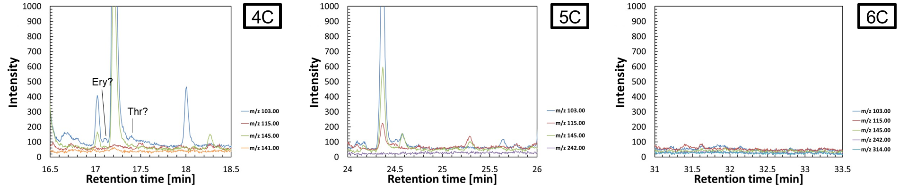
F-3d
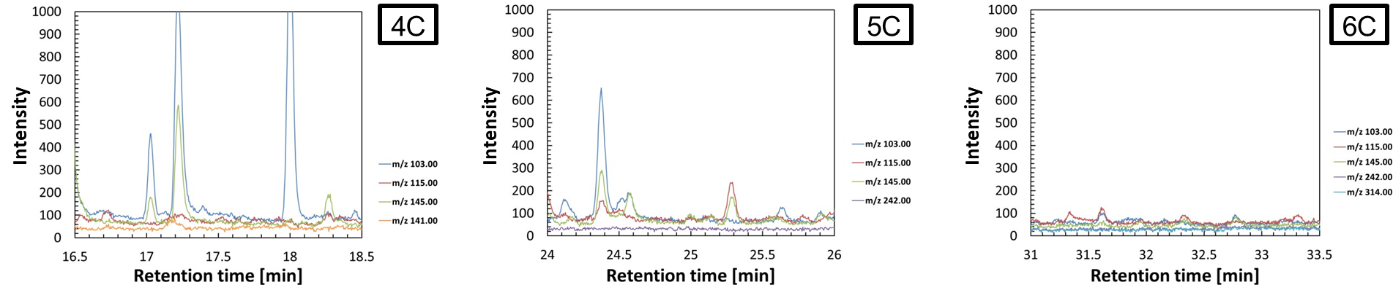
F-7d
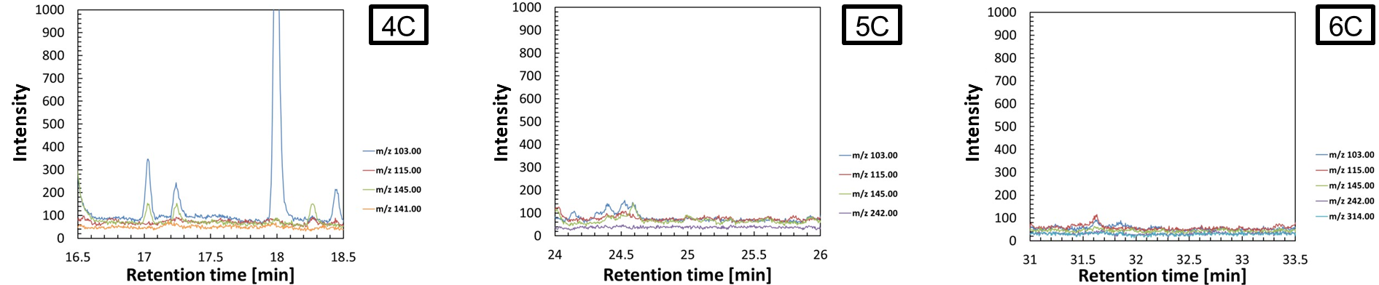

F-Oli(n)-1d
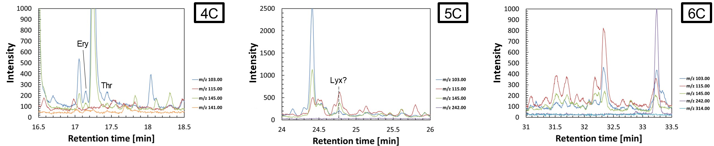
F-Oli(n)-3d
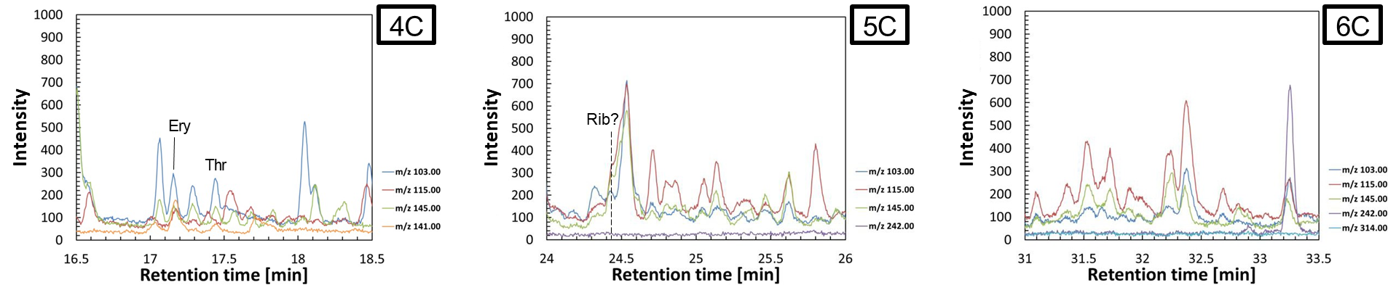
F-Oli(n)-7d
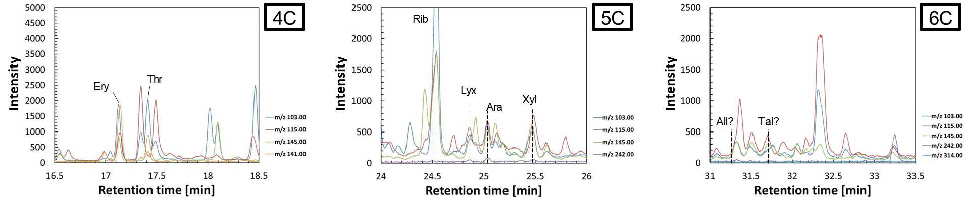

F-Oli(s)-1d #1
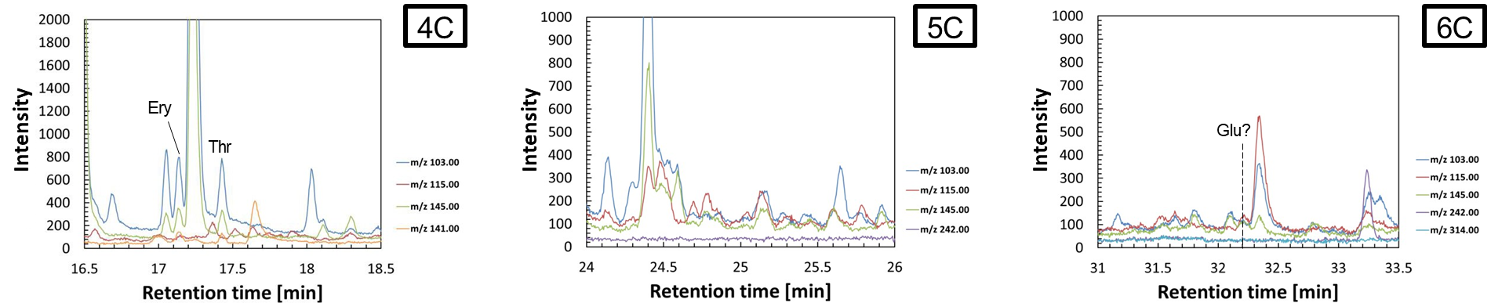
F-Oli(s)-1d #2
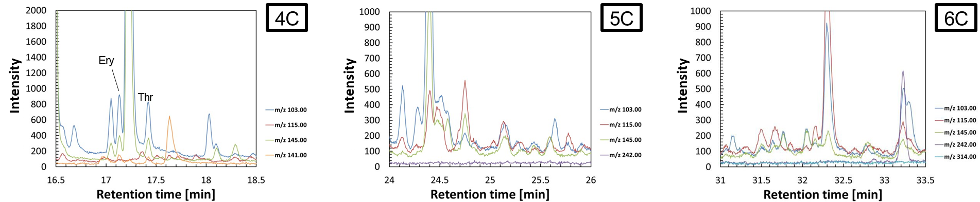
F-Oli(s)-3d #1
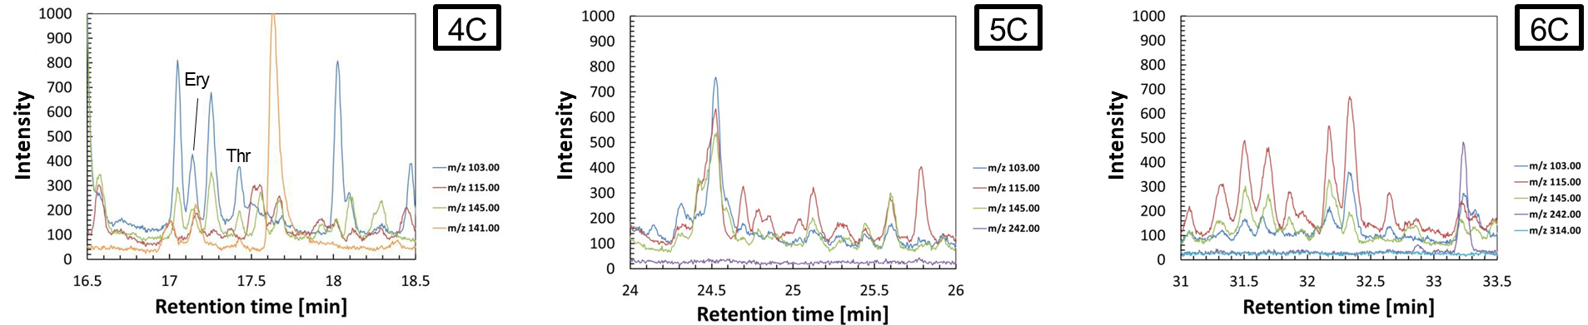

F-Oli(s)-3d #2
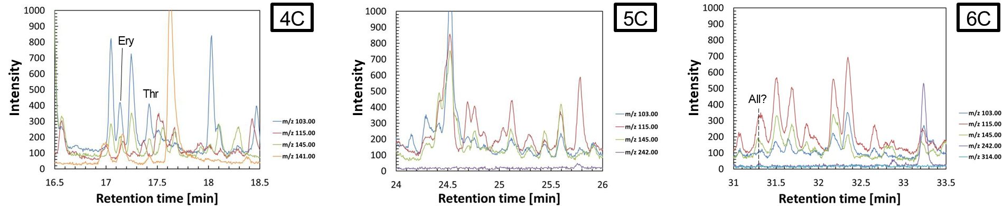
F-Oli(s)-7d #1
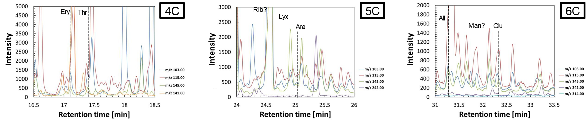
F-Oli(s)-7d #2
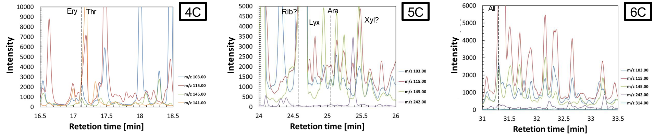

F-Ant-1d #1
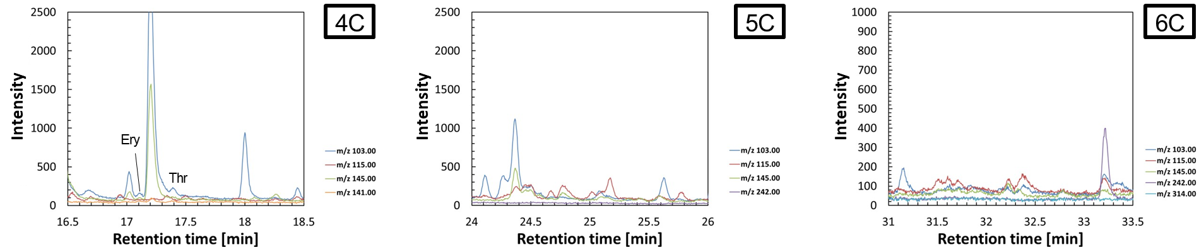
F-Ant-1d #2
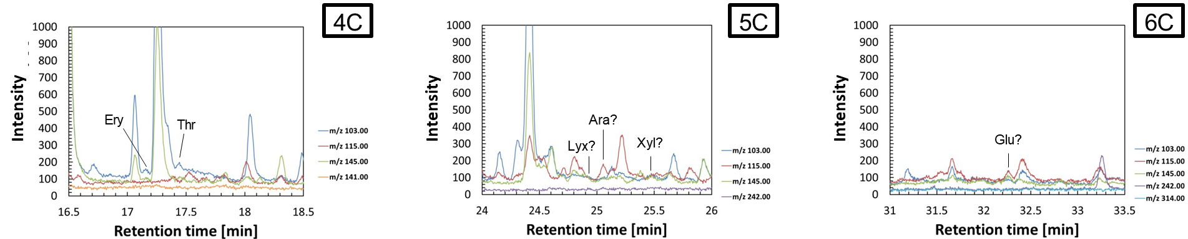
F-Ant-3d #1
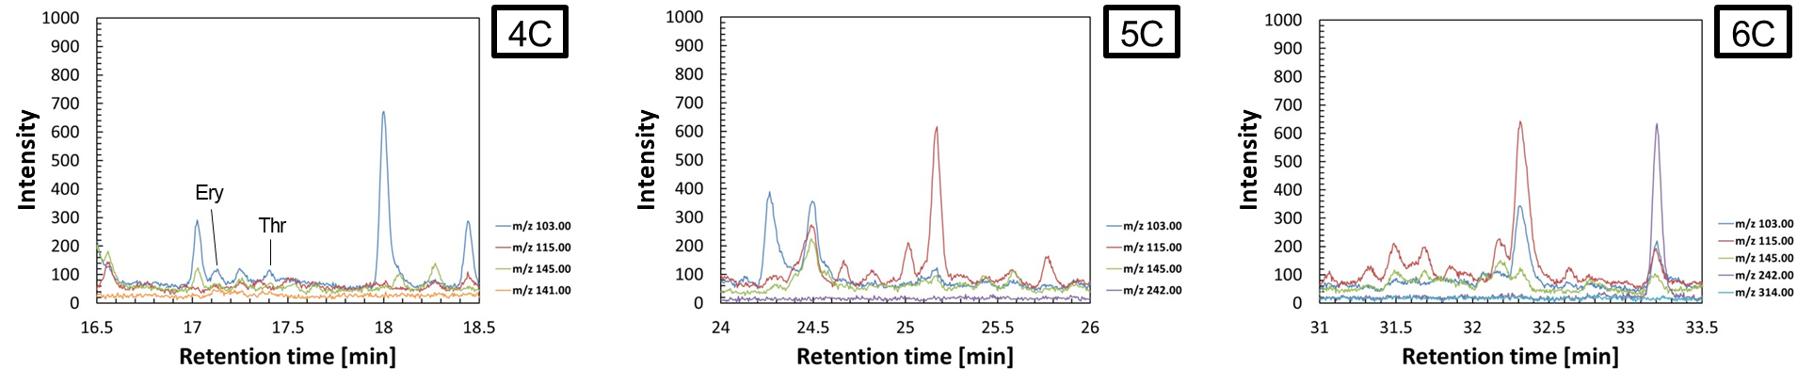

F-Ant-3d #2
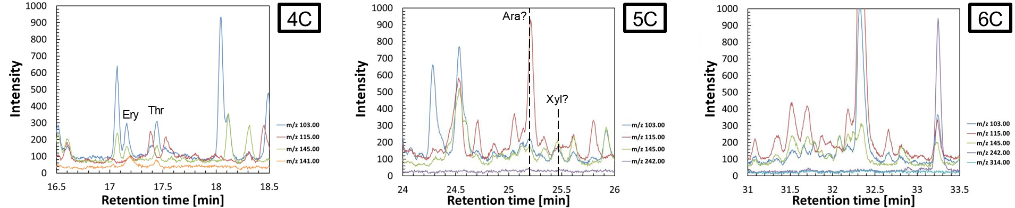
F-Ant-7d #1
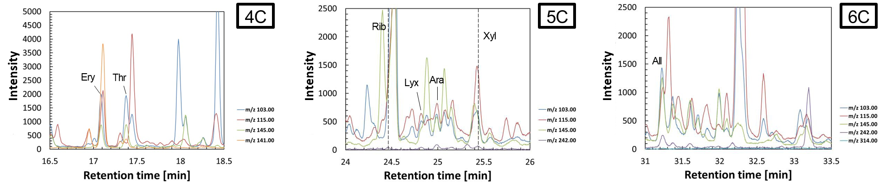
F-Ant-7d #2
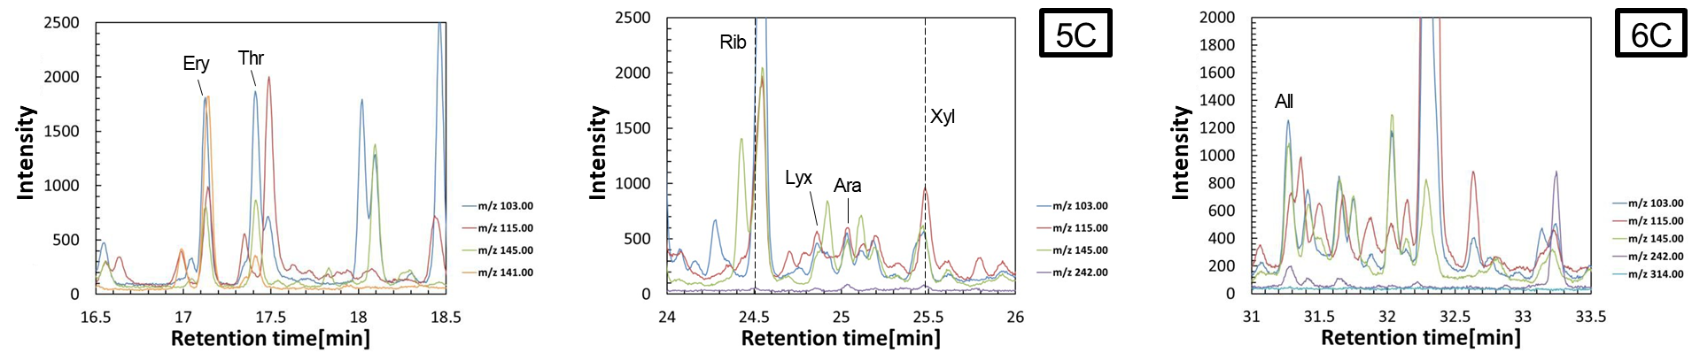

F-Sap-1d #1
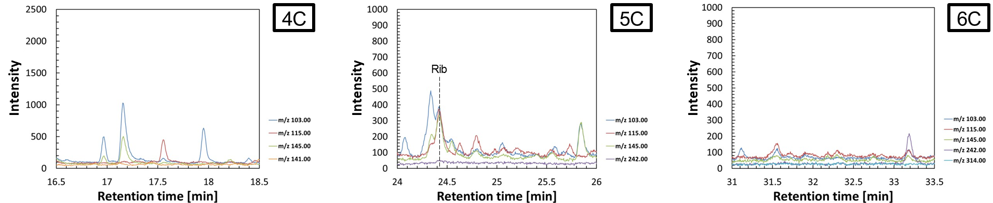
F-Sap-1d #2
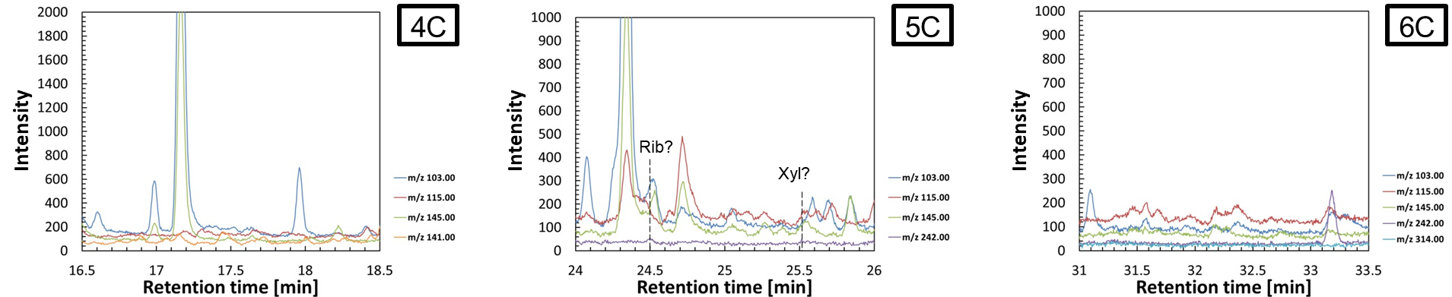
F-Sap-3d #1
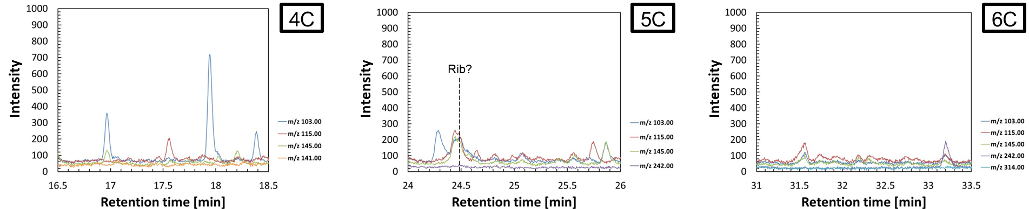

F-Sap-3d #2
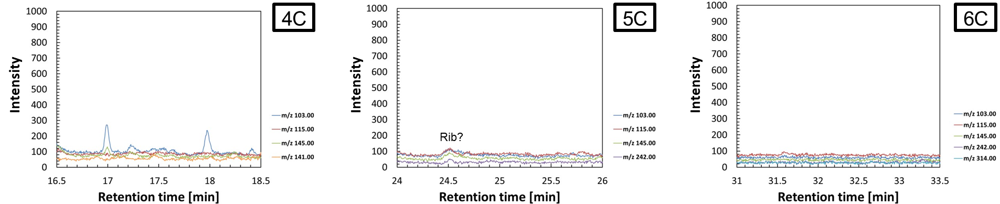
F-Sap-7d #1
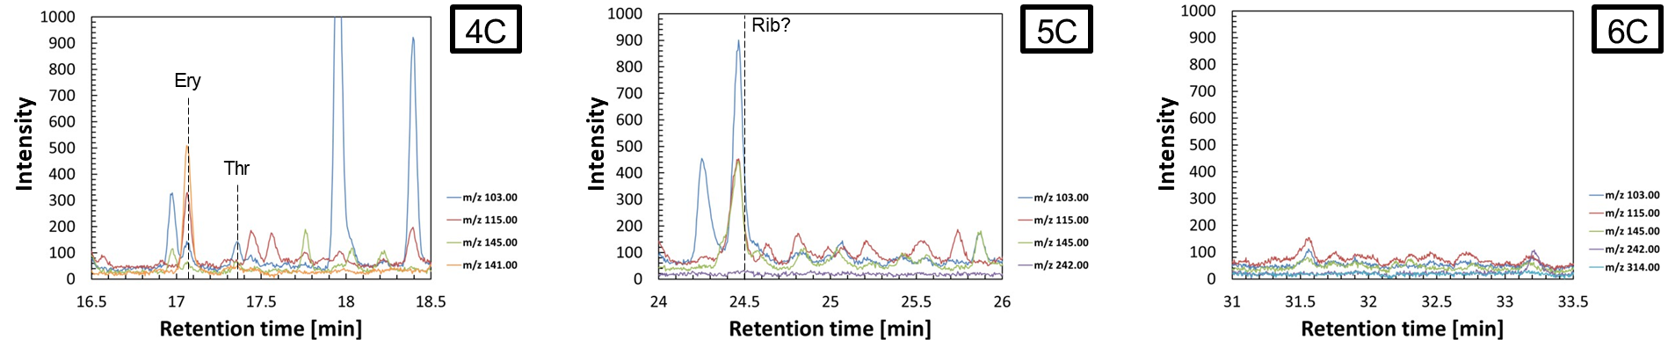
F-Sap-7d #2
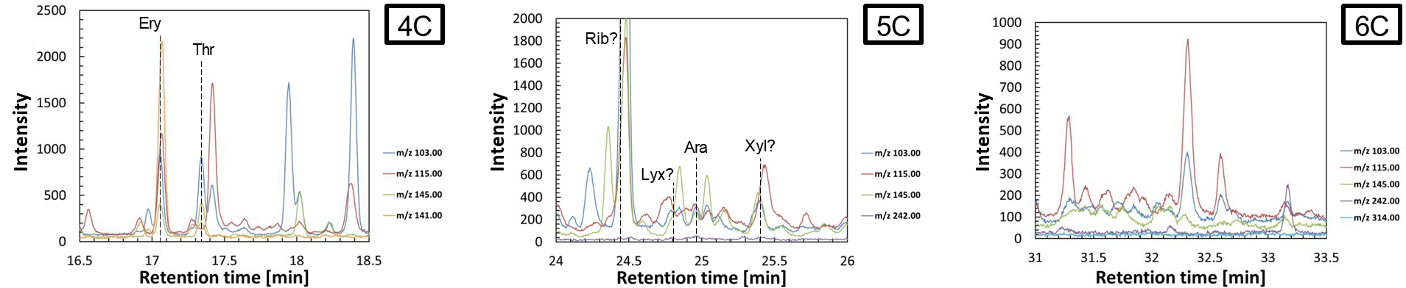

FA-1d
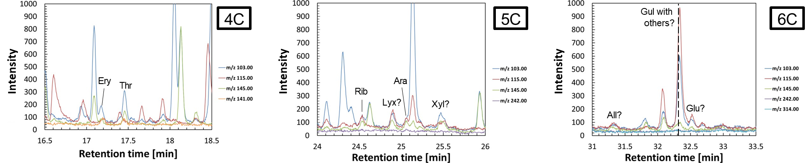
FA-3d
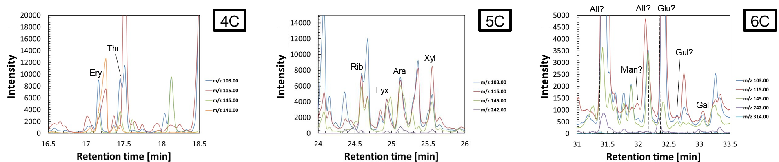
FA-7d
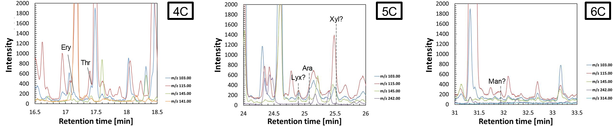

FA-Oli(n)-1d
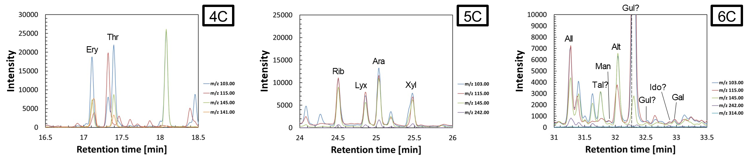
FA-Oli(n)-3d
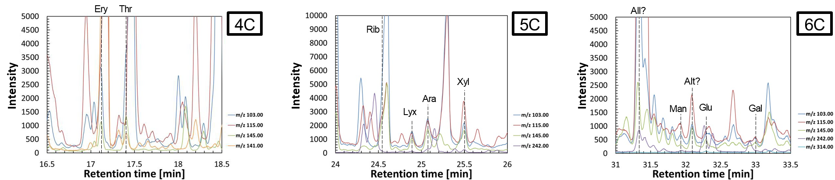
FA-Oli(n)-7d
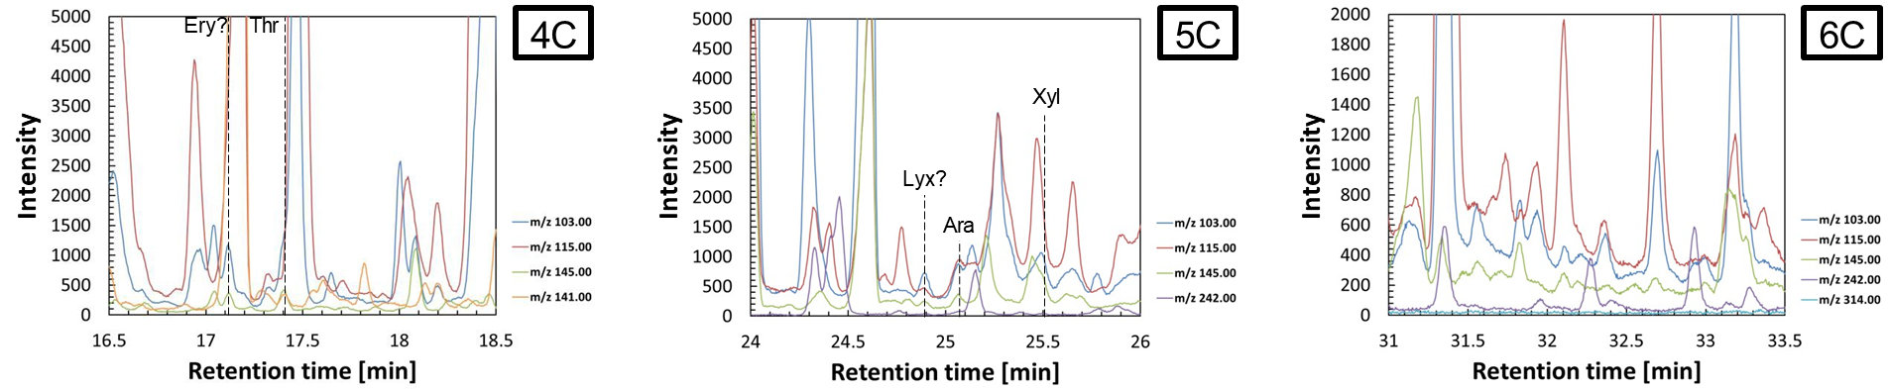
FA-Oli(s)-1d #1
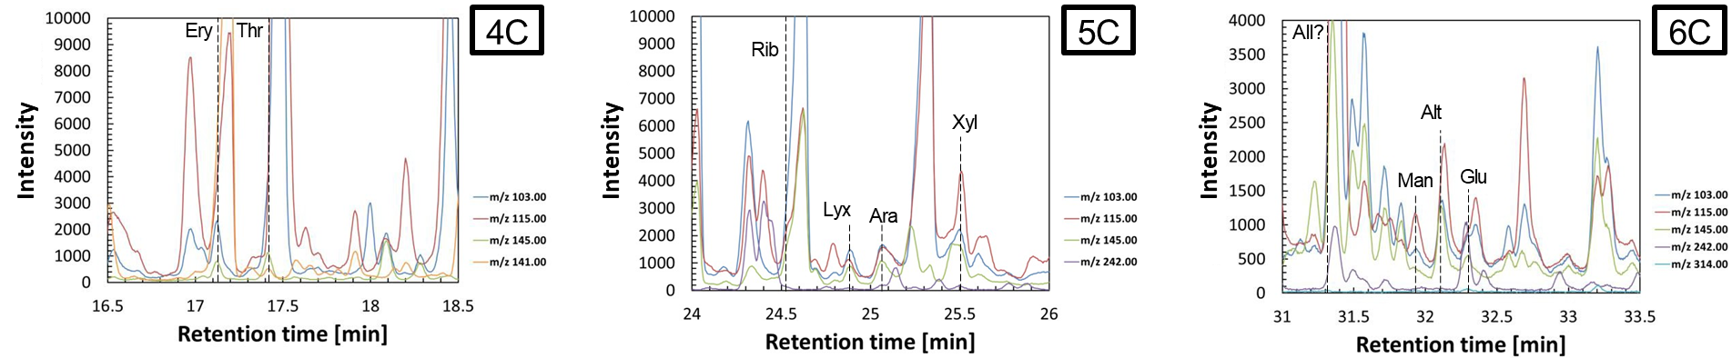
FA-Oli(s)-1d #2
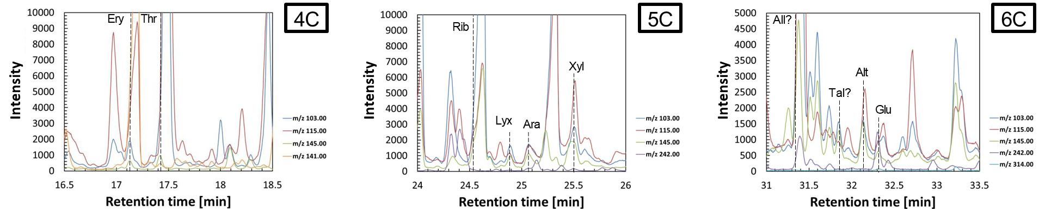
FA-Oli(s)-3d #1
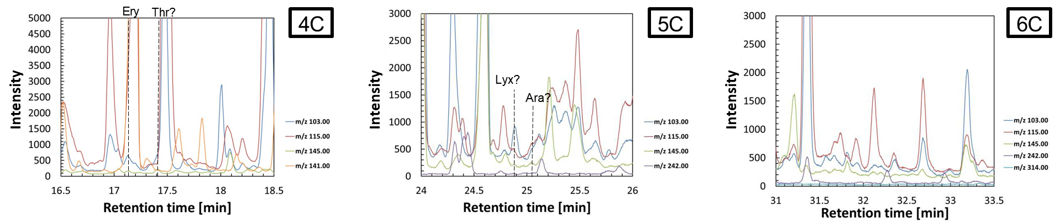
FA-Oli(s)-3d #2
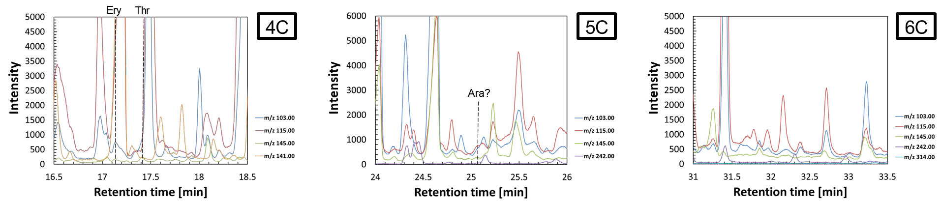
FA-Oli(s)-7d #1
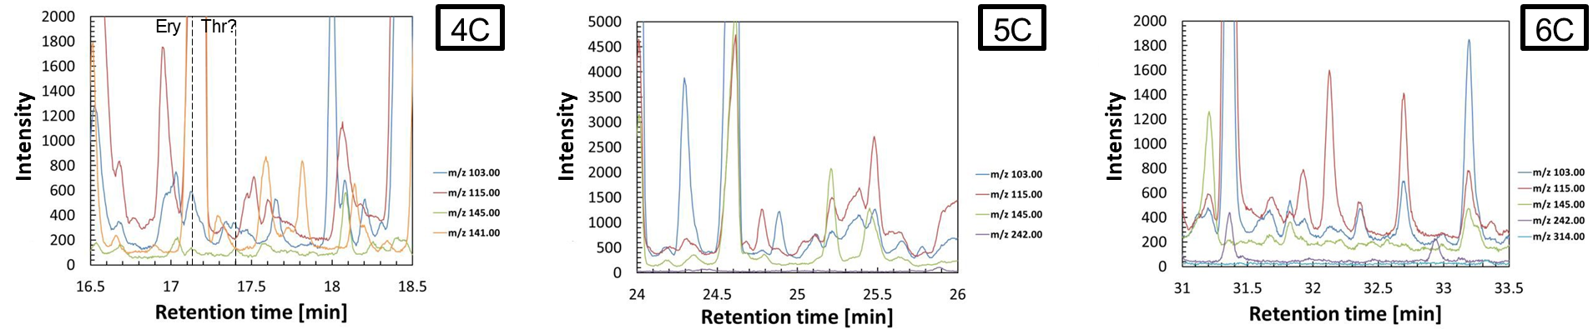
FA-Oli(s)-7d #2
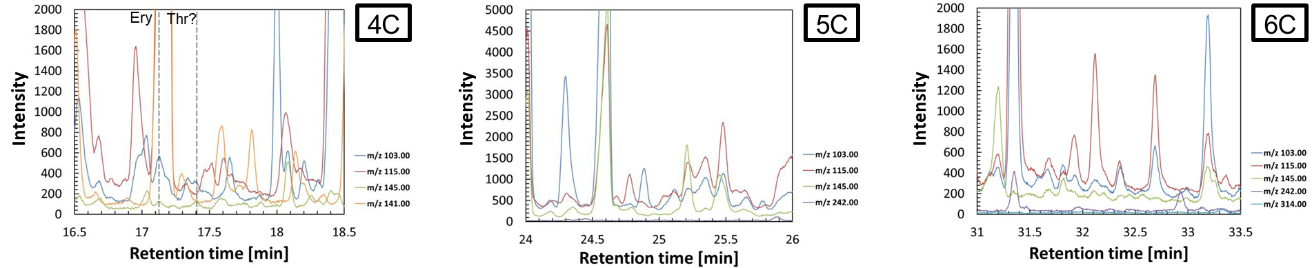
FA-Ant-1d #1
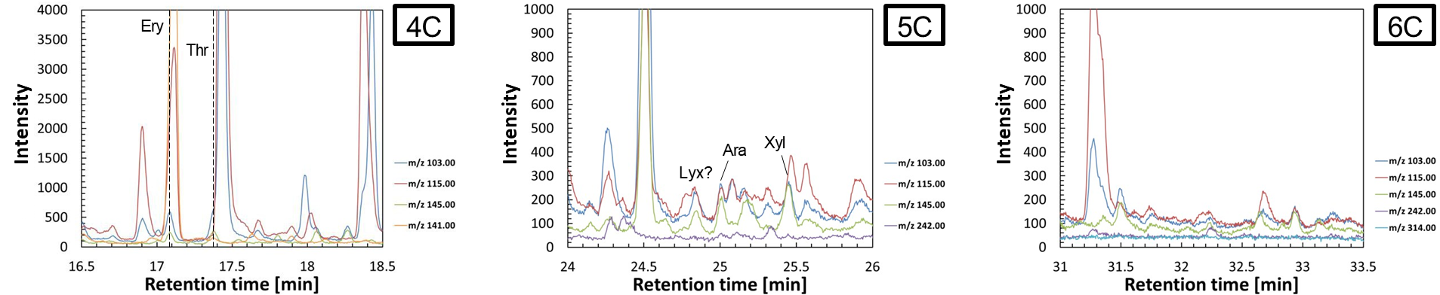
FA-Ant-1d #2
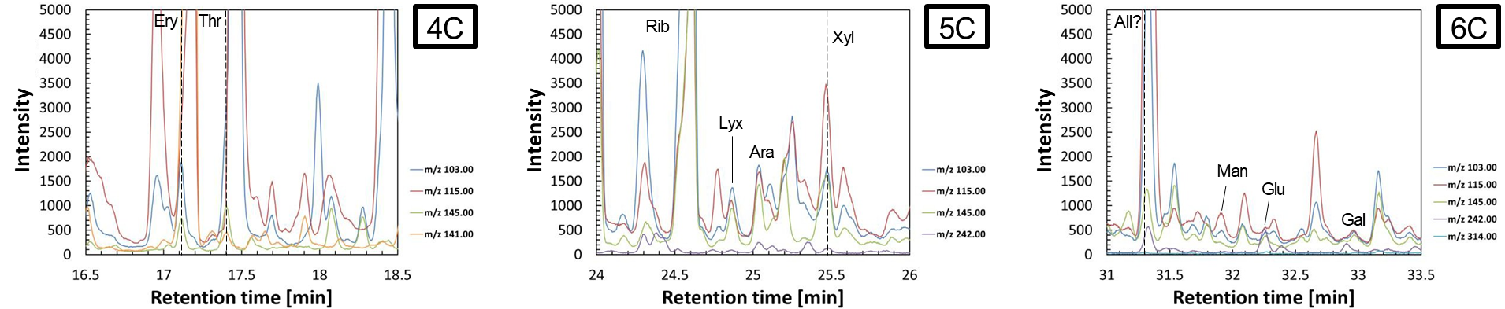
FA-Ant-1d #3
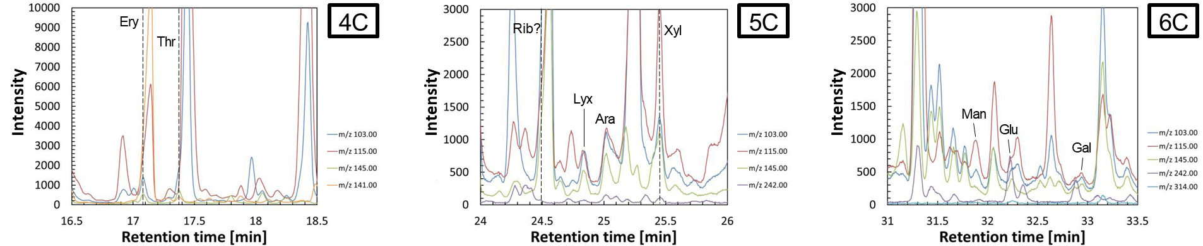

FA-Ant-3d #1
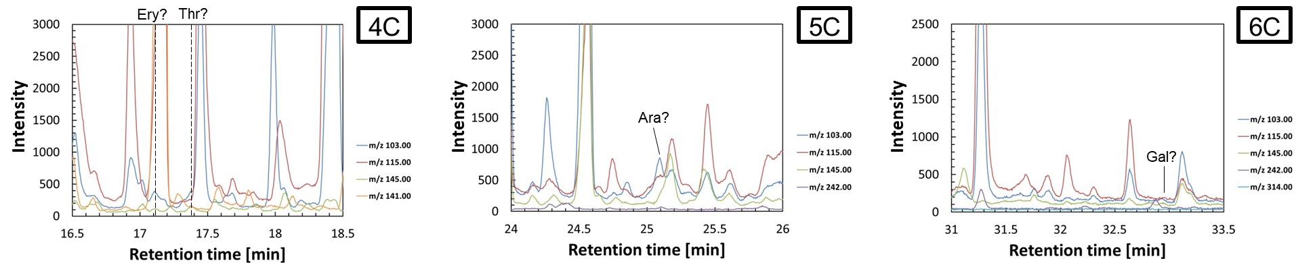
FA-Ant-3d #2
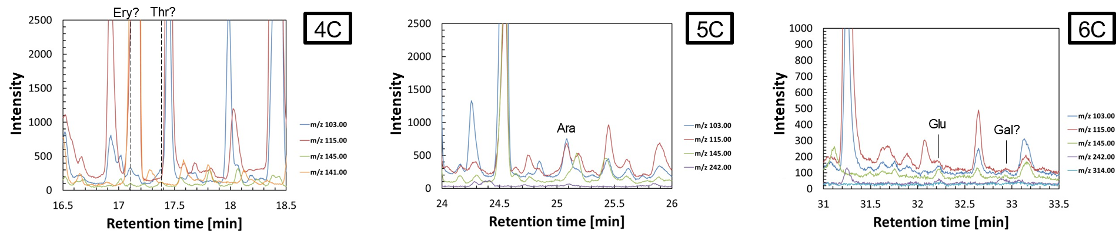
FA-Ant-3d #3
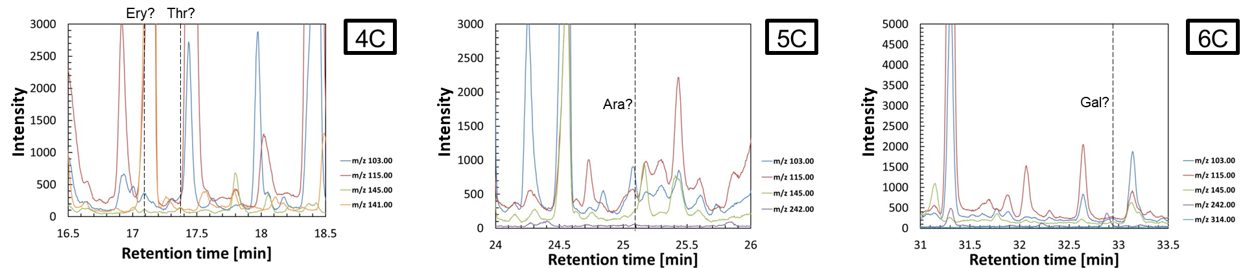
FA-Ant-7d #1
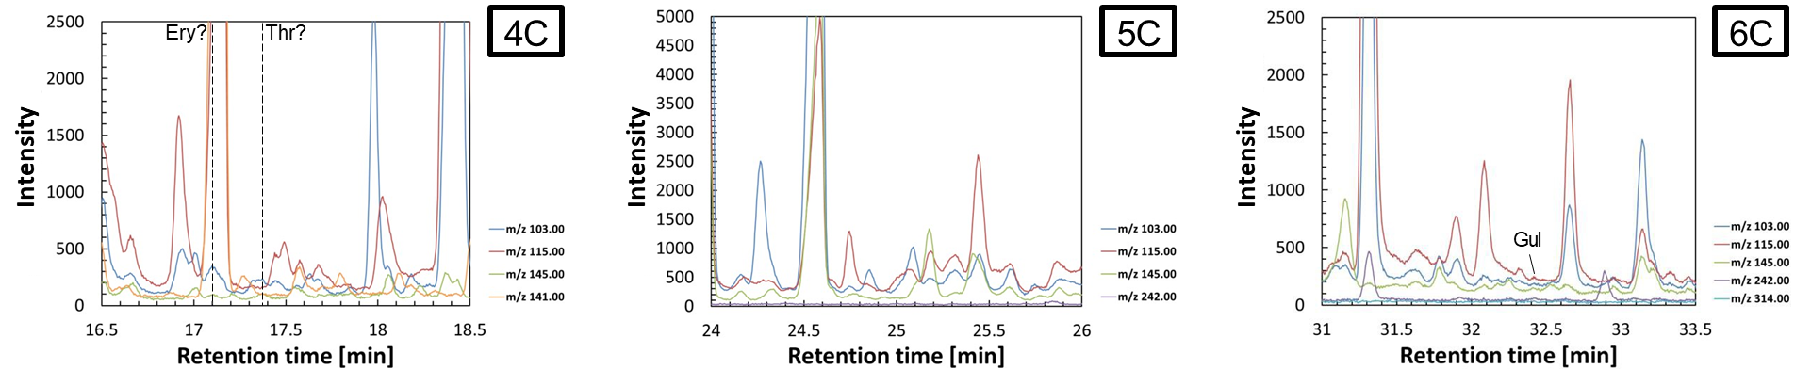
FA-Ant-7d #2
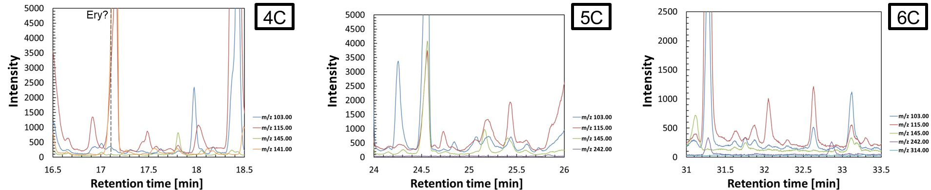
FA-Ant-7d #3

FA-Sap-1d #1
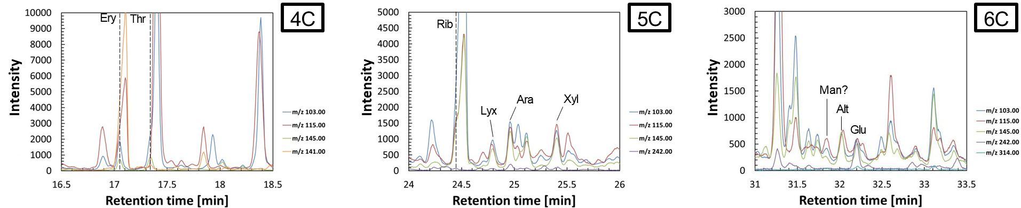
FA-Sap-1d #2
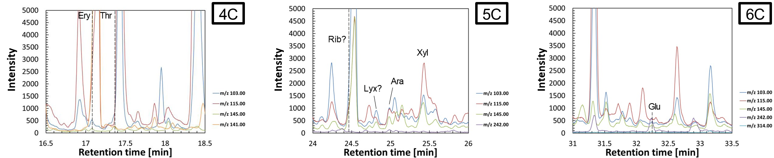
FA-Sap-3d #1
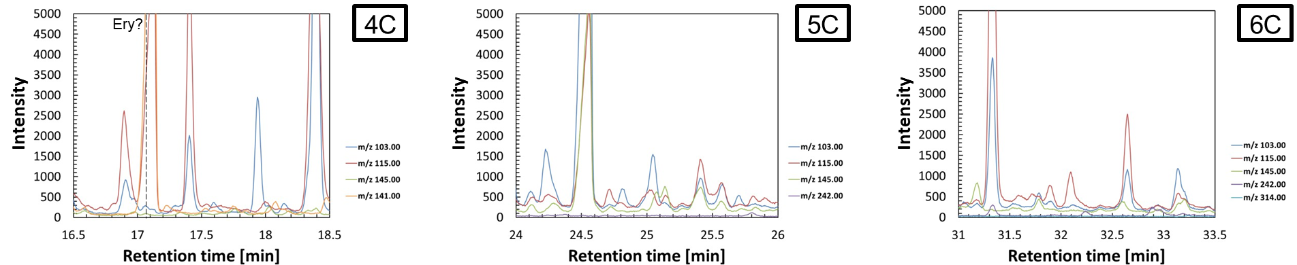

FA-Sap-3d #2
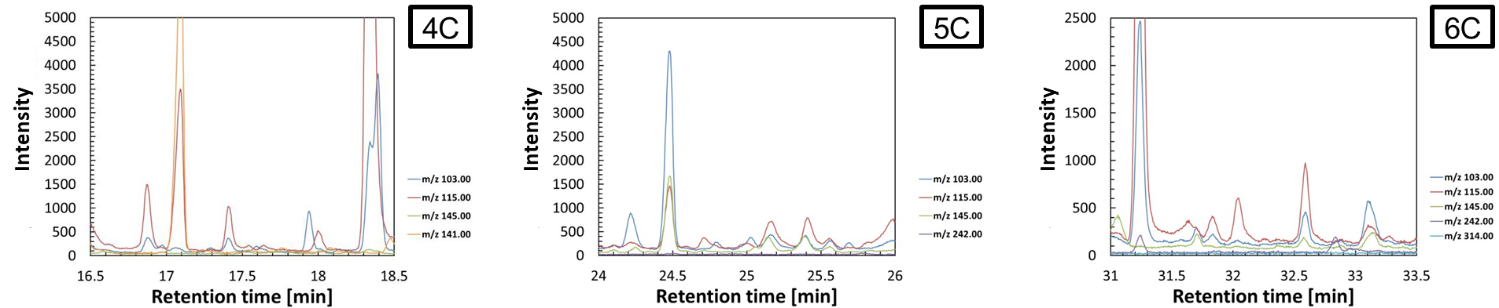
FA-Sap-7d #1
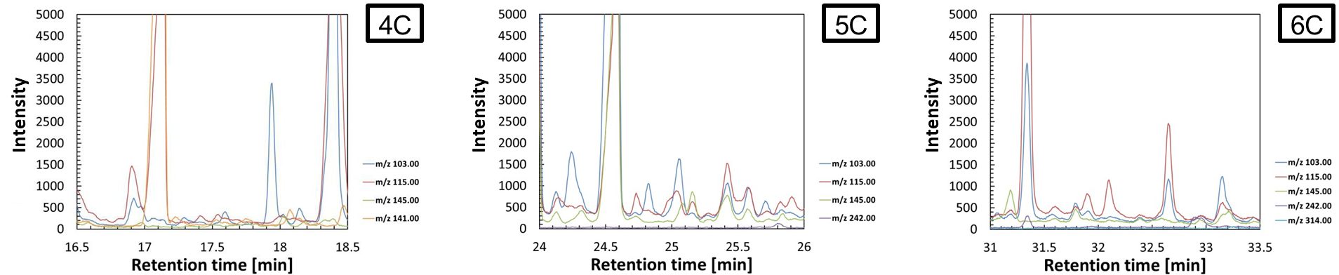
FA-Sap-7d #2
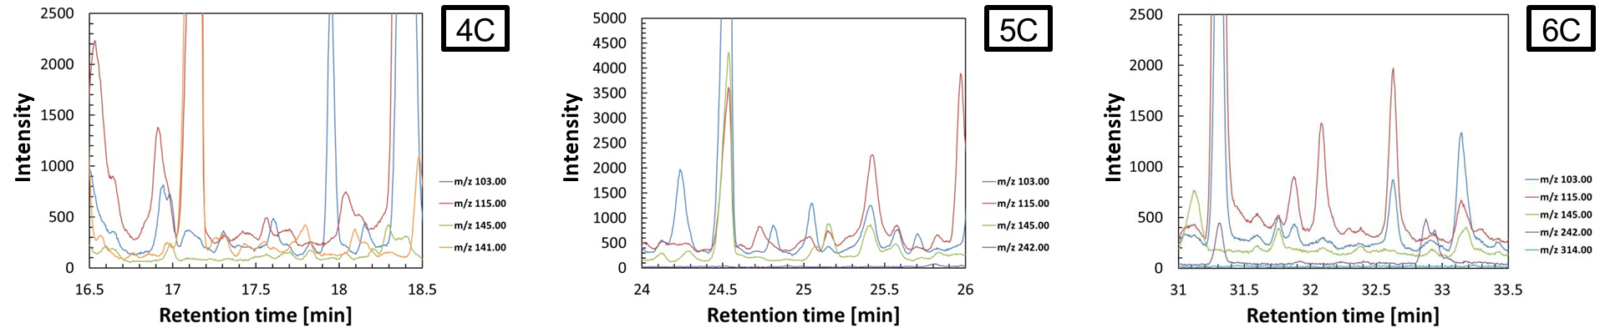

Oli(n)-7d (control)
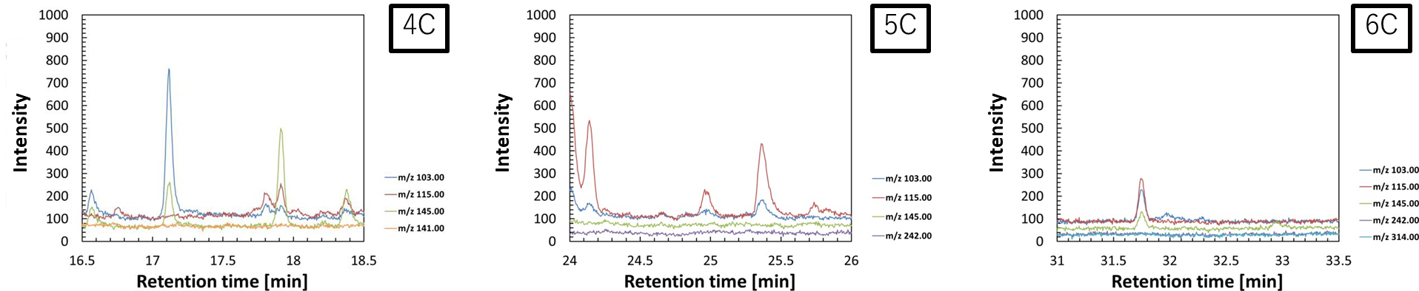
Ant-7d (control) #1
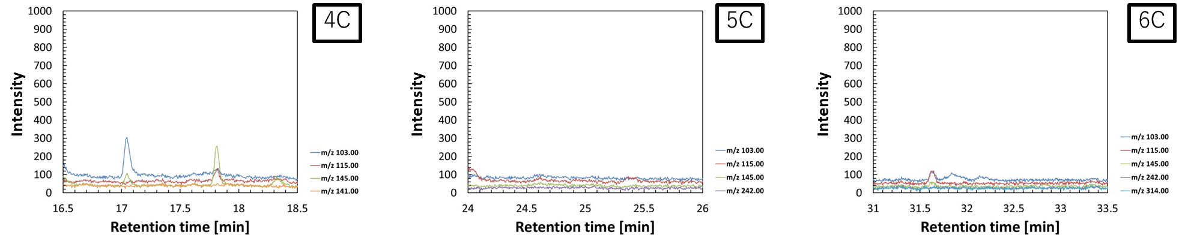
Ant-7d (control) #2
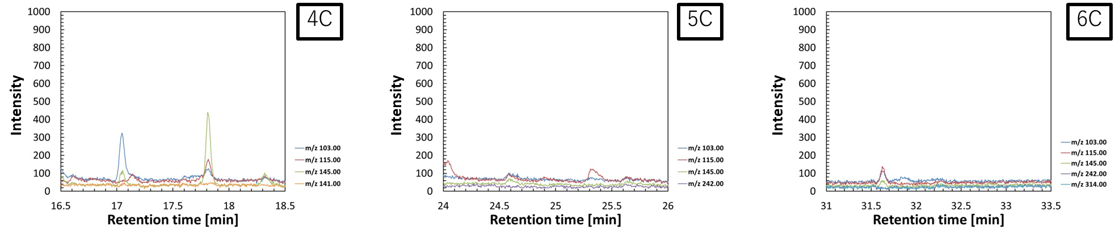
Sap-7d (control) #1
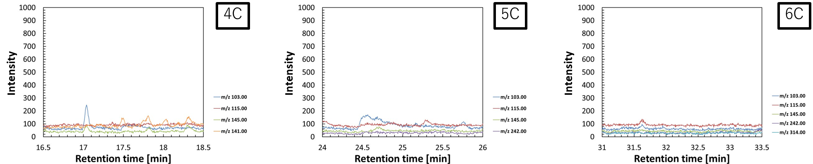
Sap-7d (control) #2
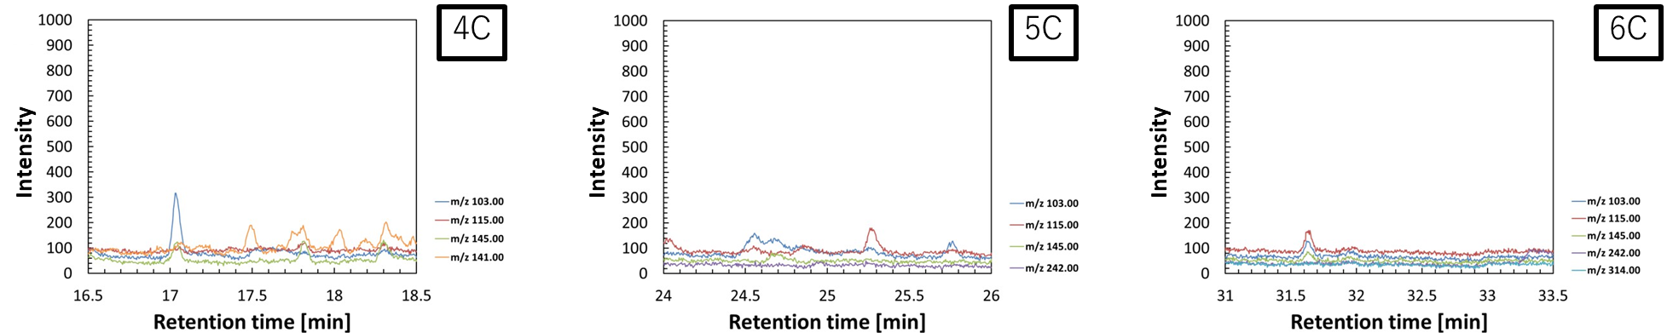
Blank
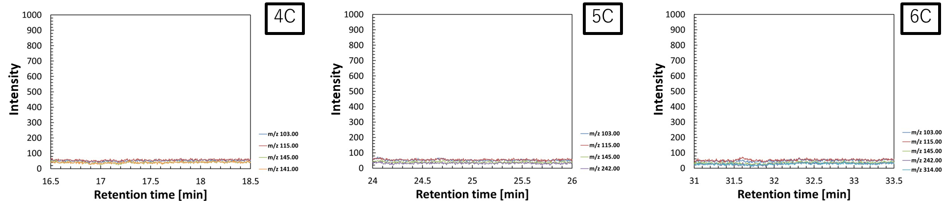
10 μM standard
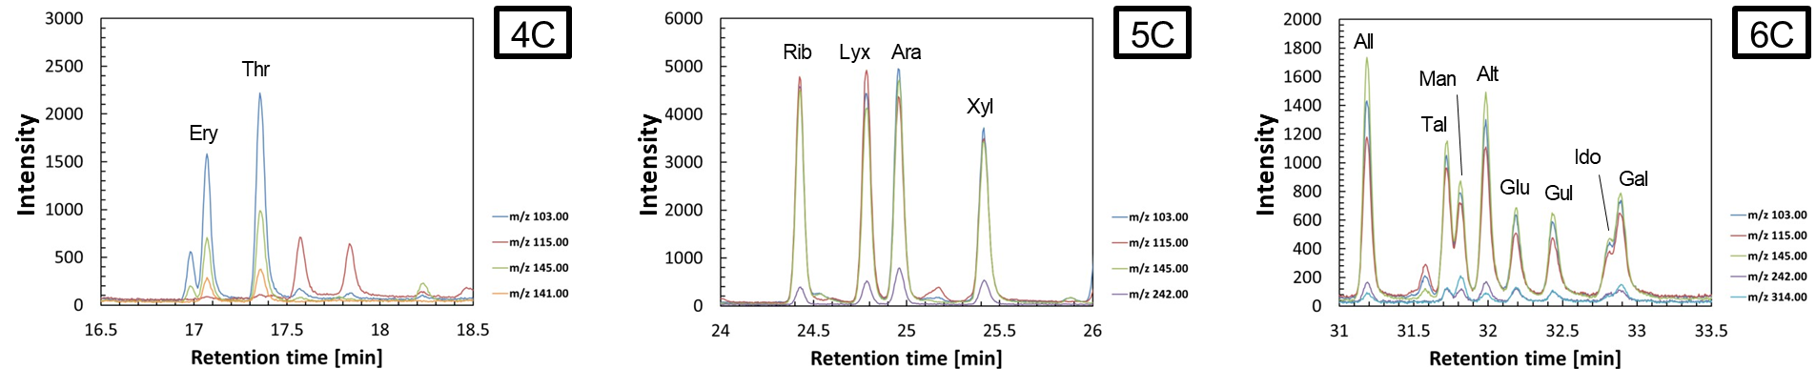
100 μM standard
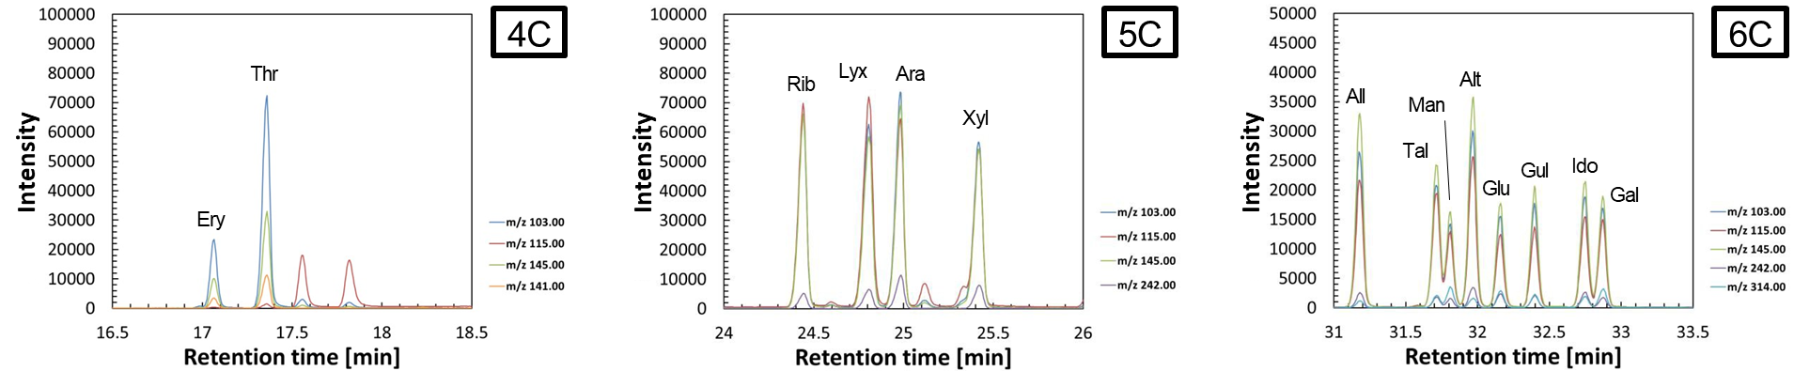
Figure S1. Selected ion chromatograms (SIC) of aldoses from all experimental products, including control samples, and standards. Ery: erythrose, Thr: threose, Rib: ribose, Lyx: lyxose, Ara: arabinose, Xyl: xylose, All: allose, Tal: talose, Man: mannose, Alt: altrose, Glu: glucose, Gul: gulose, Ido: idose, Gal: galactose.

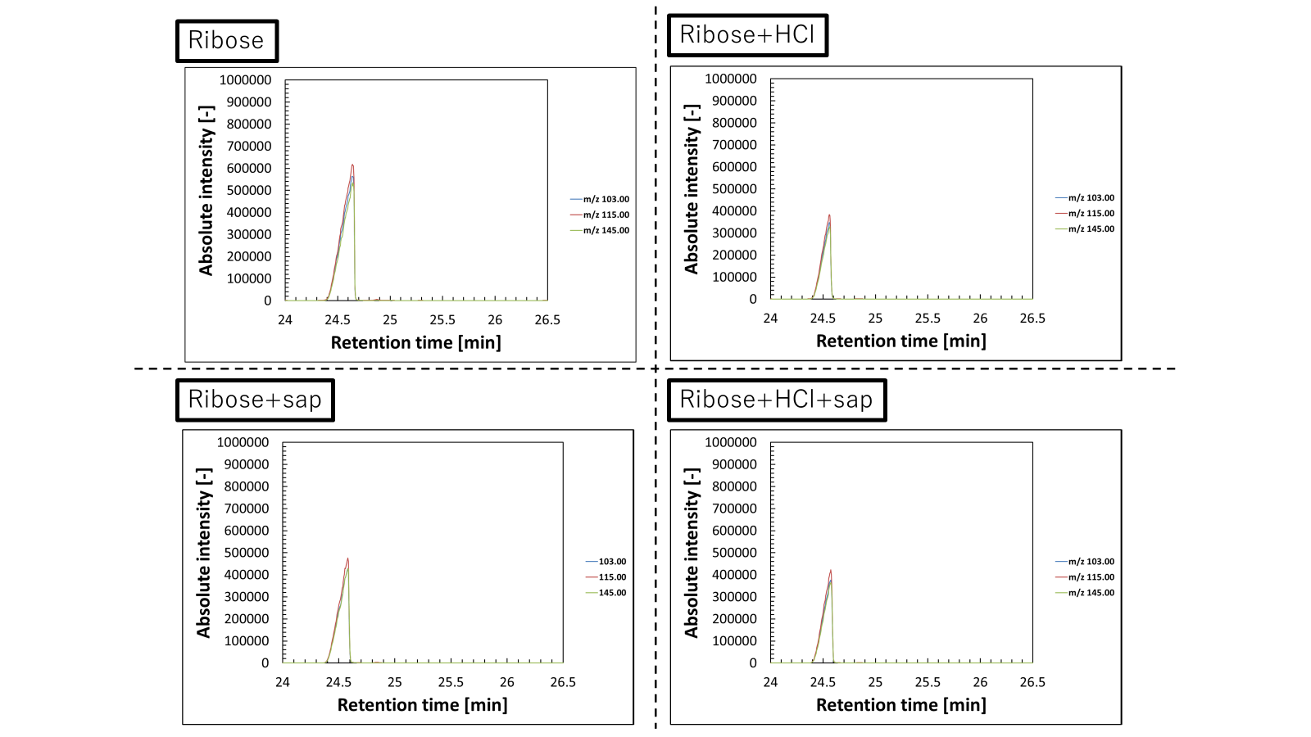
Intensity
Intensity
Figure S2. Selected ion chromatograms (SIC) of ribose standard (left panel) and ribose standard with saponite (right panel).

