Multi-technique SAR Coseismic Deformation Retrieval and Fault Modeling of the 2025 Mw 7.7 Myanmar Earthquake
V. Ruocco^{1,2}, S. Puliero^{2*}, S. Atzori², C. Tolomei², A. Antonioli², M. Polcari², M. Albano², M. Moro², S. Stramondo², M. Saroli^{1,2}, P. Striano³, F. Monterroso³, M. Bonano³, F. Casu³, C. De Luca³, R. Lanari³.
¹DICeM - Università degli Studi di Cassino e del Lazio meridionale, Cassino, Italy.
²Istituto Nazionale di Geofisica e Vulcanologia, Rome, Italy.
³Istituto per il Rilevamento Elettromagnetico dell’Ambiente, Consiglio Nazionale delle Ricerche (IREA-CNR), Naples-Milan, Italy.

Table of contents
ALOS-2 dataset 2
References 5

ALOS-2 dataset
Both ascending and descending ALOS-2 PALSAR-2 ScanSAR coseismic interferograms were generated (Table S1) to investigate the large-scale ground deformation (Figure S1). The dataset, provided by the Japan Aerospace Exploration Agency (JAXA), was acquired in L-band (~24 cm wavelength), which is suitable for this purpose.
Table S1. Characteristics of the ALOS-2 imagery
Orbit pass | Interferogram pair
Ascending | February 11, 2025  April 08, 2025
Descending | February 16, 2025  March 30, 2025
During the processing chain, topographic contributions were removed using the 30 m resolution ALOS World 3D Digital Elevation Model (Takaku et al., 2020), and interferometric phase noise was reduced through adaptive filtering (Goldstein & Werner, 1998). The unwrapped phase, obtained via the Minimum Cost Flow method (Costantini, 1998). Both the wrapped differential interferograms showed a high number of interferometric fringes with a rate increasing as one moves away from the fault. The latter excludes the possibility that these fringes are all coseismic. To understand the nature of these fringes, we tried to determine whether they were due to ionospheric effects.

Figure S1. (a) descending and (b) ascending ALOS-2 coseismic displacement maps.
To this end, the differential Total Electron Content (TEC) was evaluated over the region of interest using the ALOS-2 ScanSAR passages. The Global Ionospheric Maps (GIM, https://cddis.gsfc.nasa.gov/archive/gnss/products/ionex/) provided by IGS were initially attempted to use, but their spatial resolution of 2.5° x 5° (lat x lon) proved too coarse for our purposes. Similarly, the 1° x 1° global maps from MIT's MADRIGAL database (https://cedar.openmadrigal.org/ ) were also insufficient. Typically, this type of analysis relies on a dense local network of GNSS receivers. However, since there are very few receivers in this specific area, it's not feasible to accurately estimate the TEC as well. Finally, given the quiet geomagnetic conditions during both SAR acquisitions, as indicated by the Dst index (Figure S2), the ionospheric contribution can reasonably be considered negligible compared to other sources of error, such as those related to orbital parameter estimation.

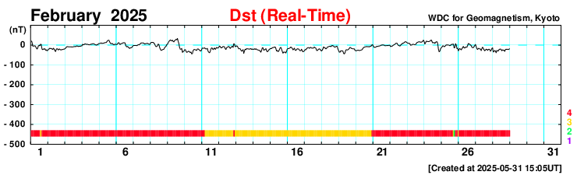
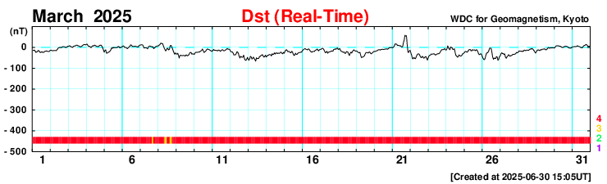
Figure S2. Dst index showing the geomagnetic conditions in February and March 2025 (World Data Center for Geomagnetism, Kyoto, 2015).

After ruling out the ionosphere as a possible cause, most of the fringes were estimated and removed using a moving-window filter. Although this procedure substantially improved the interferogram, it may also have removed part of the coseismic signal. Consequently, these results were not considered as input data into the source modeling, which was already well constrained by the 12 Sentinel-1 datasets employed.

References
Costantini, M. (1998). A novel phase unwrapping method based on network programming. IEEE Transactions on Geoscience and Remote Sensing, 36(3), 813–821. https://doi.org/10.1109/36.673674
Goldstein, R. M., & Werner, C. L. (1998). Radar interferogram filtering for geophysical applications. Geophysical Research Letters, 25(21), 4035–4038. https://doi.org/10.1029/1998GL900033
Takaku, J., Tadono, T., Doutsu, M., Ohgushi, F., & Kai, H. (2020). UPDATES OF ‘AW3D30’ ALOS GLOBAL DIGITAL SURFACE MODEL WITH OTHER OPEN ACCESS DATASETS. The International Archives of the Photogrammetry, Remote Sensing and Spatial Information Sciences, XLIII-B4-2020, 183–189. https://doi.org/10.5194/isprs-archives-XLIII-B4-2020-183-2020
World Data Center for Geomagnetism, Kyoto, M. Nose, T. Iyemori, M. Sugiura, T. Kamei, A. Matsuoka, S. Imajo, and T. Kotani (2015), Geomagnetic Dst index , doi:10.17593/14515-74000

