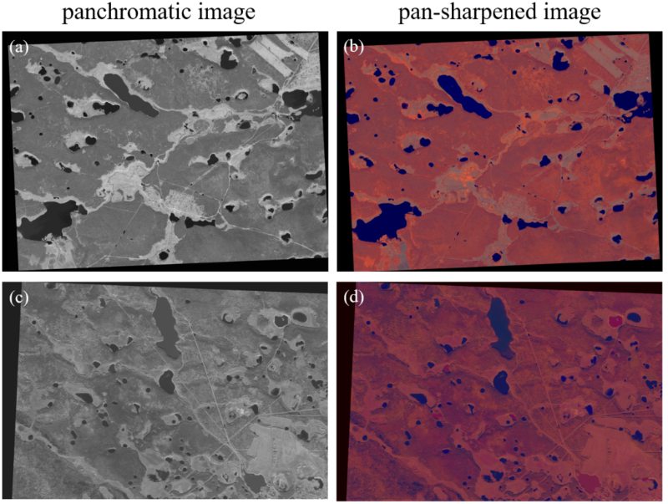

Supplementary Figure. 1. WorldView-2 images used in this study. (a) and (b) were taken on July 1, 2012. (c) and (d) were taken on September 11, 2021.
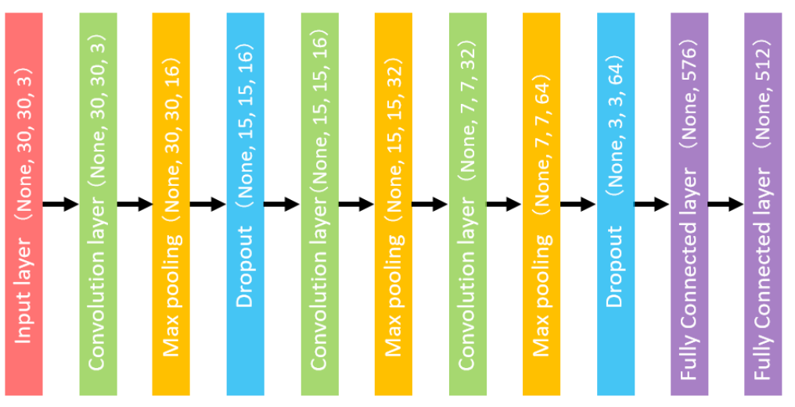

Supplementary Figure. 2. Architecture of the network.

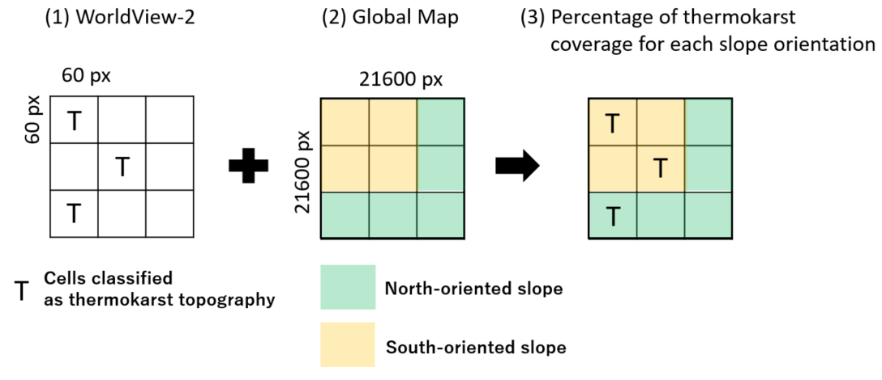

Supplementary Figure 3. (1) WorldView-2 images were divided into cells of 60 pixels in height and width. Each cell was classified as thermokarst or others. (2) Global Map Data with 21,600 pixels in height and width was used as raster data for slope orientation, with each 60 pixels classified as north or south. (3) For example, if two of the south-oriented slopes (4 cells) are classified as thermokarst, the thermokarst coverage is 2/4*100 = 50%.

Supplementary Figure 4. Classification of thermokarst topography. White represents thermokarst topography, and black represents others.

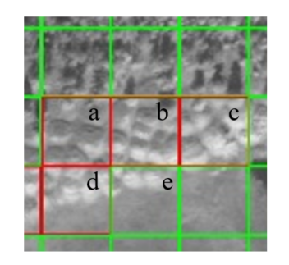

Supplementary Figure. 5. Examples of correctly or incorrectly classified classification results. When the percentage of thermokarst topography within a square is high, these squares were correctly classified (a-d). However, a low percentage of thermokarst topography within a square was not classified as thermokarst (e).

