Additional files
Table S1: Characters, associated states and their scores as given in Table 3.
Characters |  | State | Scores
1 | Disruptive markings | Plain | 0
 |  | Striped | 1
 |  | Semi-striped | 2
2 | Colour combination of head | Dark-brownish | 0
 |  | Blackish | 1
 |  | Rufous variegated | 2
3 | Dorsal patterns (crown) | Plain | 0
 |  | Banded | 1
 |  | Scattered | 2
 |  | Capped | 3
4 | Side view patterns | Plain | 0
 |  | Multiple | 1
 |  | Spots | 2
 |  | Eye stripe | 3
5 | Jaw stripe | Plain | 0
 |  | Full | 1
 |  | Partly | 2
6 | Back colours | Dark-brownish | 0
 |  | Blackish | 1
 |  | Rufous variegated | 2
7 | Back patterns | Plain | 0
 |  | Narrow | 1
 |  | Broad | 2
8 | Nose spots | Plain | 0
 |  | Present | 1

Table S2: Counts of character states associated with species arranged under three micro habitats to demonstrate association of species with habitat type.
 | Character | State | Open micro-habitat | Closed micro-habitat | Forest
 |  |  | Lagopus lagopus  Tympanuchus cupido  Phasianus colchicus  Peliperdix albogularis  Peliperdix coqui  Dendroperdix sephaena  Alectoris chukar  Francolinus spp.  Pternistis spp. | Acryllium vulturinum  Numida meleagris  Scleroptila spp.  Coturnix coturnix | Macrocephalon malea  Guttera pucherani  Agelastes meleagrides  Tetrao urogallus  Dendragapus obscurus  Gallus gallus  Peliperdix lathami
1 | Disruptive markings | Plain | 0 | 0 | 3
 |  | Striped | 1 | 7 | 1
 |  | Semi striped | 25 | 0 | 2
 |  | Chi-squares | χ² = 22.513, df = 1, p < 0.01 | χ² = 120.00, df = 2, p < 0.01 | χ² = 11.043, df = 2, p < 0.01
2 | Colour combination of head | Dark-brownish | 5 | 4 | 4
 |  | Blackish | 2 | 2 | 2
 |  | Rufous variegated | 18 | 1 | 1
 |  | Chi-squares | χ² =14.00, df = 2, p < 0.01 | χ² = 18.870, df = 2, p < 0.01 | χ² = 18.870, df = 2, p < 0.01
3 | Dorsal patterns (crown) | Plain | 0 | 0 | 1
 |  | Banded | 2 | 7 | 2
 |  | Scattered | 2 | 0 | 0
 |  | Capped | 23 | 0 | 4
 |  | Chi-squares | χ² = 32.667, df = 2, p < 0.01 | χ² = 120.00, df = 2, p < 0.01 | χ² = 18.870, df = 2, p < 0.01
4 | Side view patterns | Plain | 0 | 0 | 1
 |  | Multiple | 0 | 6 | 0
 |  | Spots | 2 | 0 | 4
 |  | Eye-stripe | 23 | 1 | 2
 |  | Chi-squares | χ² = 18.615, df = 1, p < 0.01 | χ² = 35.716, df = 1, p < 0.01 | χ² = 18.870, df = 2, p < 0.01
5 | Jaw stripe | Plain | 20 | 2 | 7
 |  | Full | 3 | 4 | 0
 |  | Partly | 3 | 0 | 0
 |  | Chi-squares | χ² = 24.000, df = 2, p < 0.01 | χ² = 6.667, df = 1, p < 0.01 | χ² =120.00, df = 2, p < 0.01
6 | Back colours | Dark-brownish | 4 | 0 | 6
 |  | Blackish | 2 | 1 | 1
 |  | Rufous variegated | 14 | 5 | 0
 |  | Chi-squares | χ² = 14.00, df = 2, p < 0.01 | χ² = 70.00, df = 2, p < 0.01 | χ² = 35.714, df = 1, p < 0.01
7 | Back patterns | Plain | 0 | 0 | 2
 |  | Narrow | 4 | 4 | 2
 |  | Broad | 15 | 3 | 2
 |  | Chi-squares | χ² = 17.332, df = 2, p < 0.01 | χ² = 47.667, df = 2, p < 0.01 | χ² = 0.000, df = 2, p = 0.000
8 | Nose spots | Plain | 16 | 3 | 4
 |  | Present | 3 | 3 | 3
 |  | Chi-squares | χ² = 7.200, df = 1, p < 0.01 | χ² = 0.000, df = 1, p = 1.000 | χ² = 1.429, df = 1, p = 0.232

Figure S1: Facial, crown and dorsal feather patterns of the chick selected for this study.
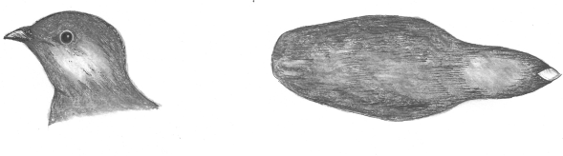
Macrocephalon malea

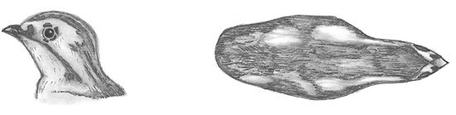
Guttera pucherani

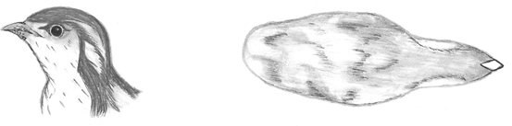
Agelastes meleagrides

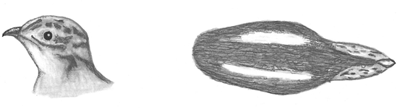
Acryllium vulturinum

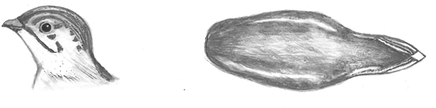
Numida meleagris
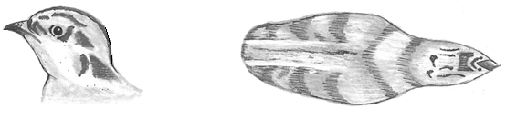
Tetrao urogallus

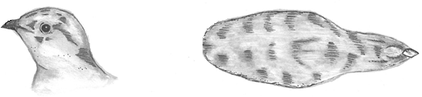
Dendragapus obscurus
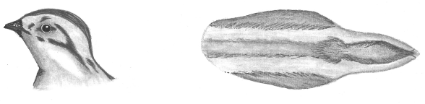
Lagopus lagopus
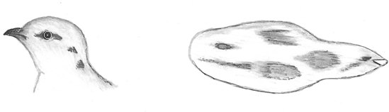
Tympanuchus cupido
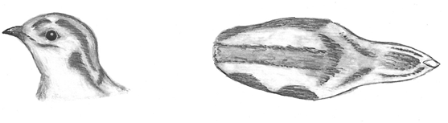
Phasianus colchicus
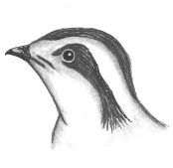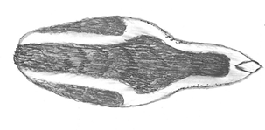
Gallus gallus
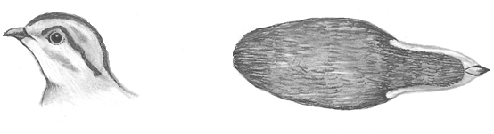
Peliperdix lathami
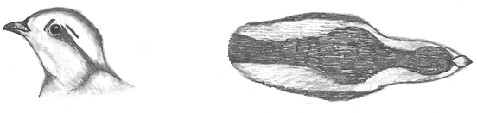
Peliperdix coqui (male)
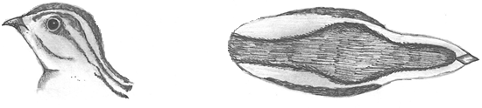
Peliperdix coqui (female)

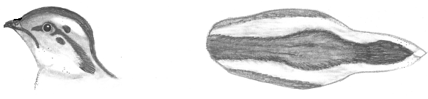
Dendroperdix sephaena
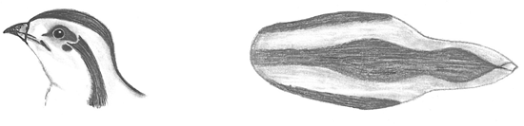
Francolinus gularis
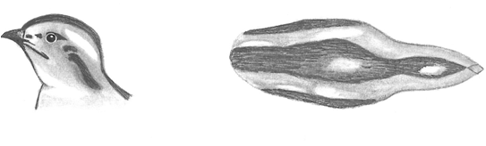
Francolinus pondicerianus
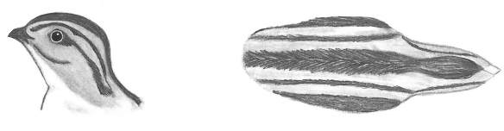
Francolinus francolinus
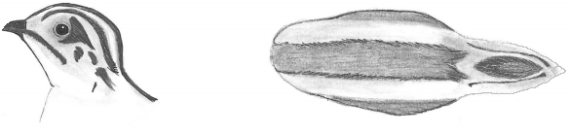
Scleroptila levalliantoides

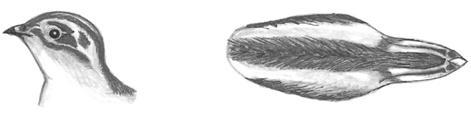
Scleroptila lavaillantii
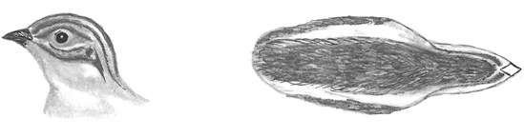
Scleroptila afra
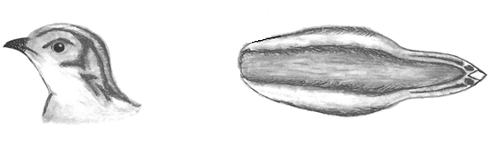
Scleroptila shelleyi
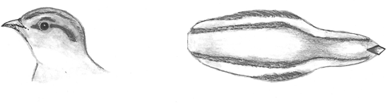
Alectoris chukar
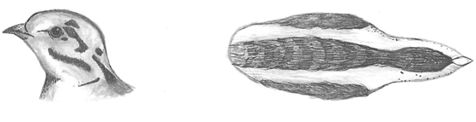
Coturnix coturnix

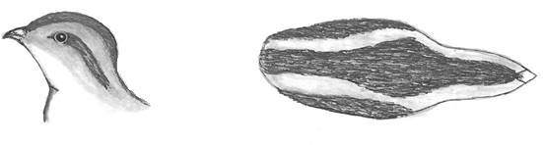
Pternistis hartlaubi
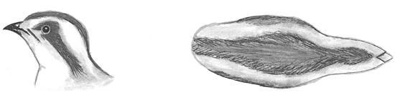
Pternistis nobilis
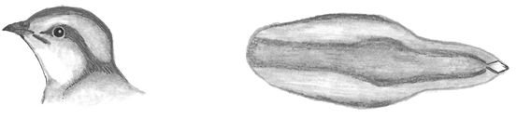
Pternistis castaneicollis
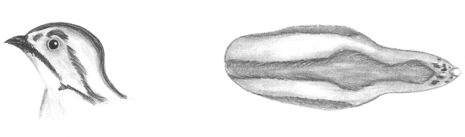
Pternistis erckelii
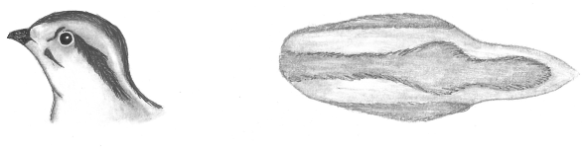
Pternistis squamatus
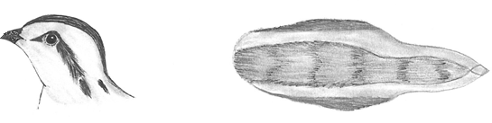
Pternistis ahantensis
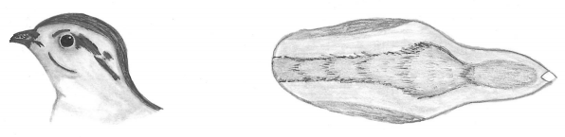
Pternistis adspersus

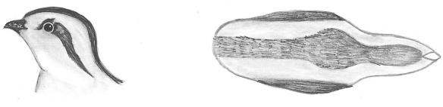
Pternistis capensis
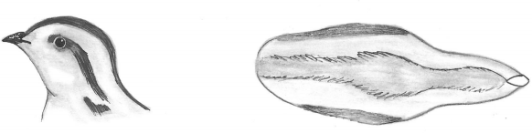
Pternistis natalensis
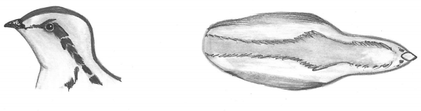
Pternistis hildebrandti
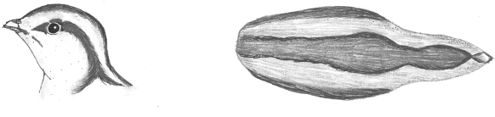
Pternistis icterorhynchus

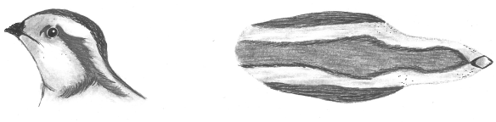
Pternistis swainsonii

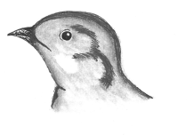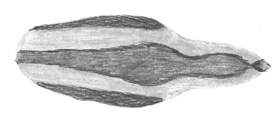
Pternistis rufopictus
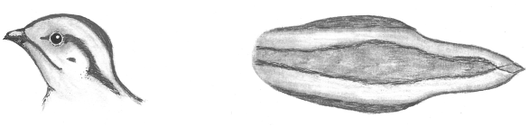
Pternistis leucoscepus

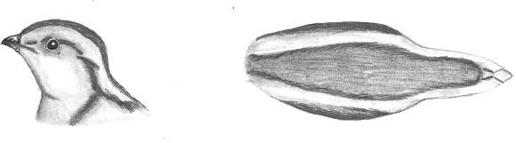
Pternistis afer

Figure S2: Ancestral state reconstruction for francolins and spurfowls based on Parsimony optimisation of disruptive markings traced on mitochondrial Cytochrome b phylogeny.

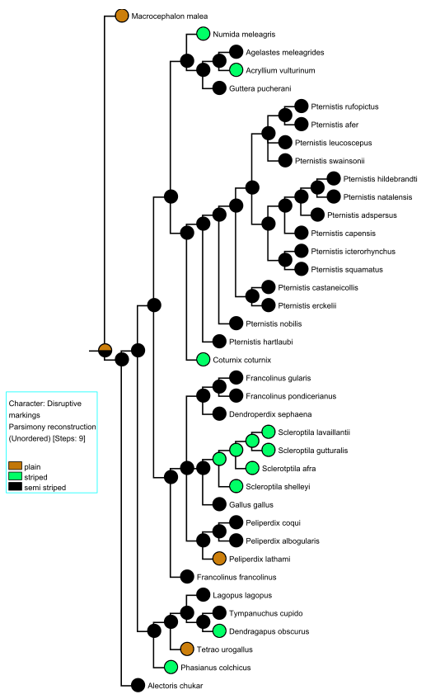

Figure S3: Ancestral state reconstruction for francolins and spurfowls based on Parsimony optimisation of colour combination of head traced on mitochondrial Cytochrome b phylogeny.
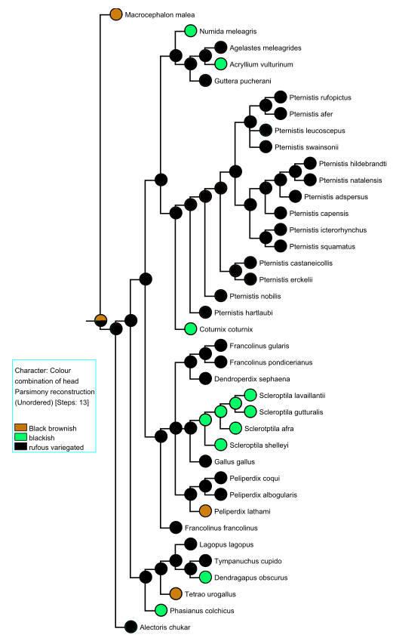
Figure S4: Ancestral state reconstruction for francolins and spurfowls based on Parsimony optimisation of dorsal patterns (crown) traced on mitochondrial Cytochrome b phylogeny.

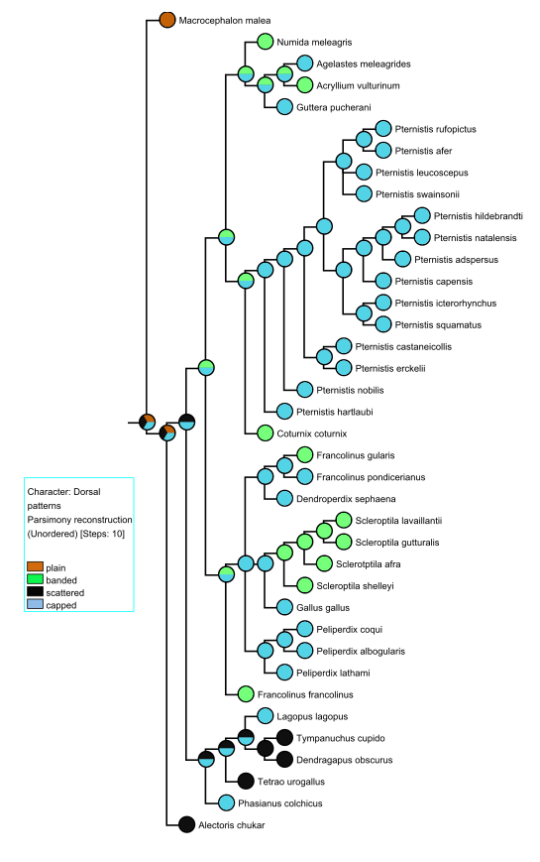

Figure S5: Ancestral state reconstruction for francolins and spurfowls based on Parsimony optimisation of side view patterns traced on mitochondrial Cytochrome b phylogeny.

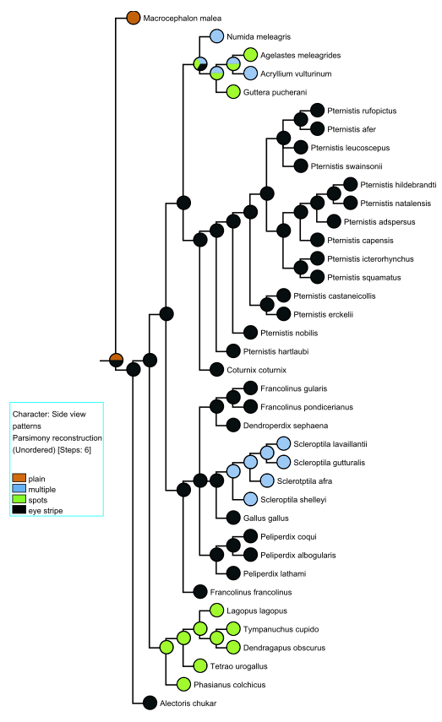

Figure S6: Ancestral state reconstruction for francolins and spurfowls based on Parsimony optimisation of jaw stripe traced on mitochondrial Cytochrome b phylogeny.
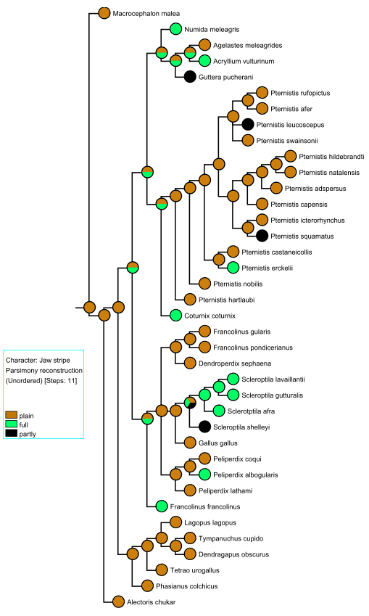

Figure S7: Ancestral state reconstruction for francolins and spurfowls based on Parsimony optimisation of back colours traced on mitochondrial Cytochrome b phylogeny

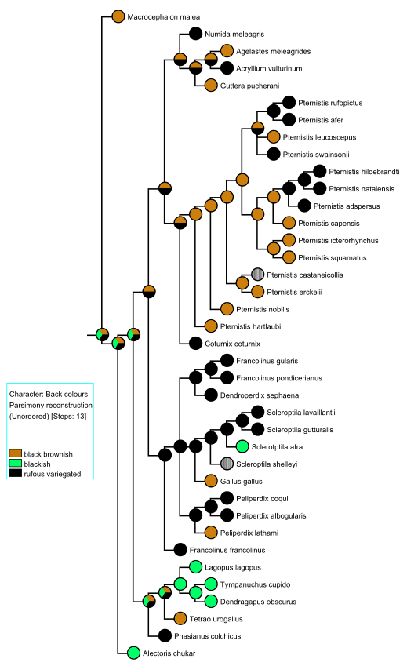

Figure S8: Ancestral state reconstruction for francolins and spurfowls based on Parsimony optimisation of back patterns traced on mitochondrial Cytochrome b phylogeny.

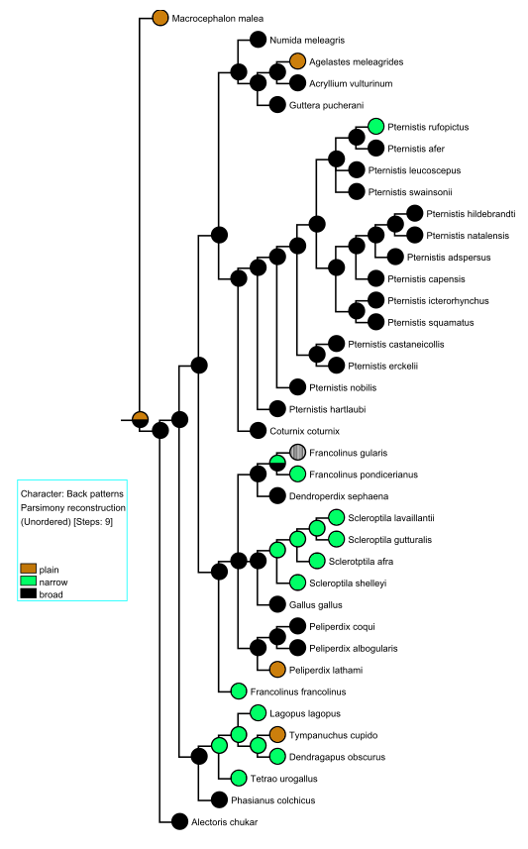

Figure S9: Ancestral state reconstruction for francolins and spurfowls based on Parsimony optimisation of nose spots traced on mitochondrial Cytochrome b phylogeny.
