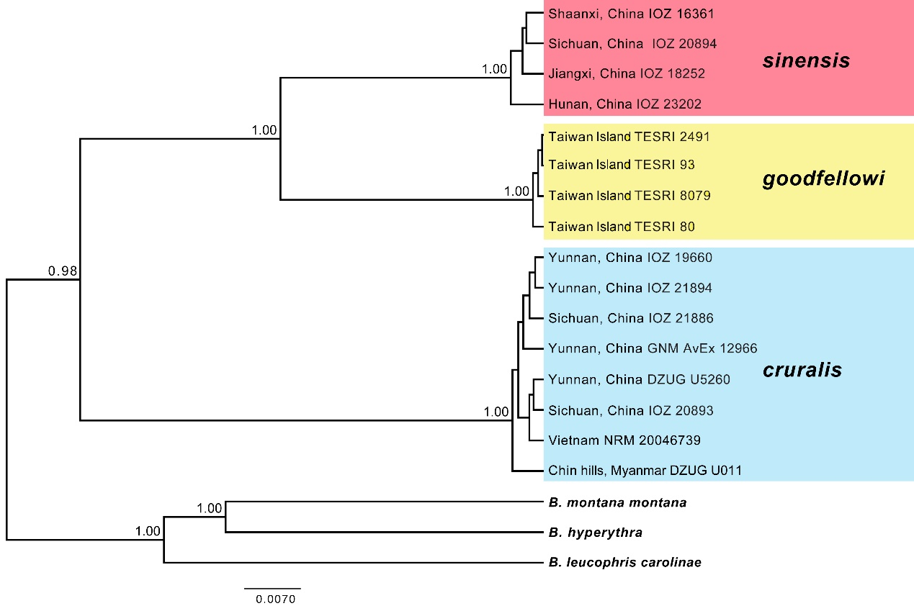
Fig. S1. Phylogeny of the continental and Taiwanese Brachypteryx montana taxa, with B. m. montana, B. leucophris carolinae and B. hyperythra as outgroups, based on BEAST analysis of the mitochondrial cytochrome b and ND2 and nuclear myoglobin and ODC introns analysed in four partitions. Includes three cruralis samples not included in Fig. 1 due to missing sequences.

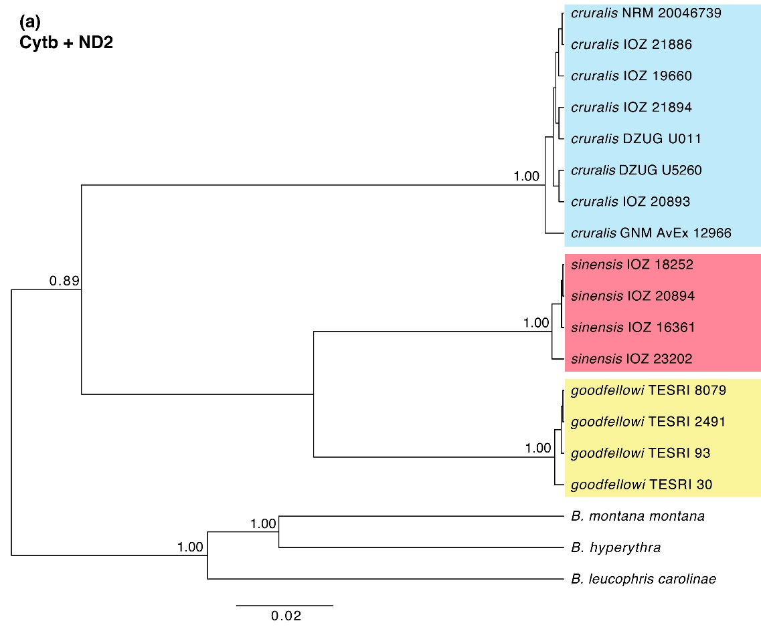
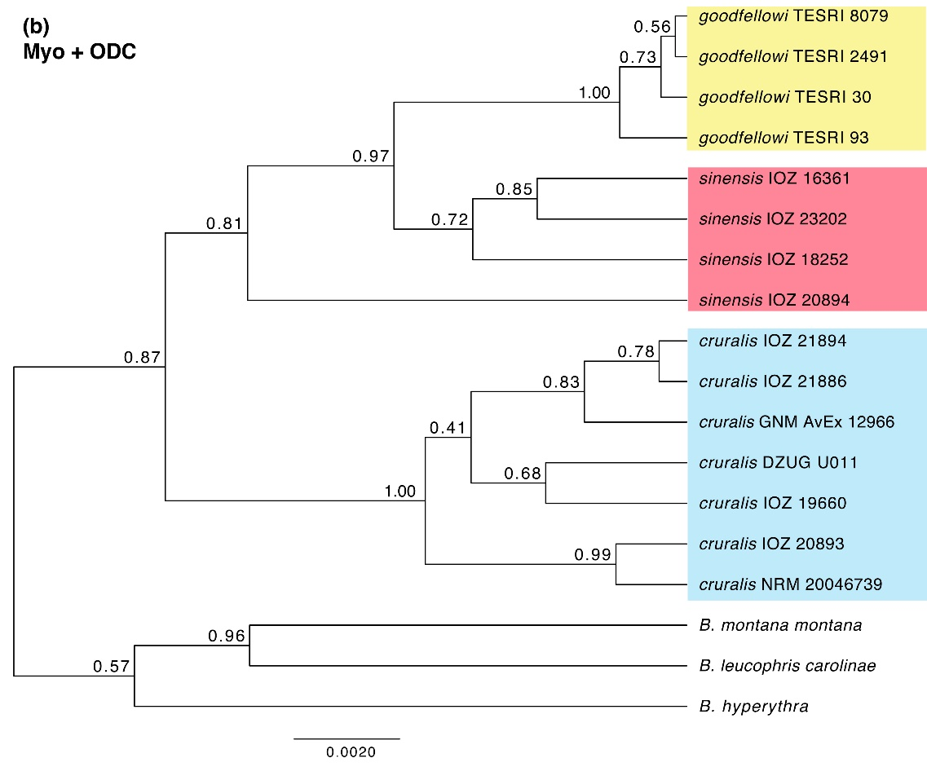

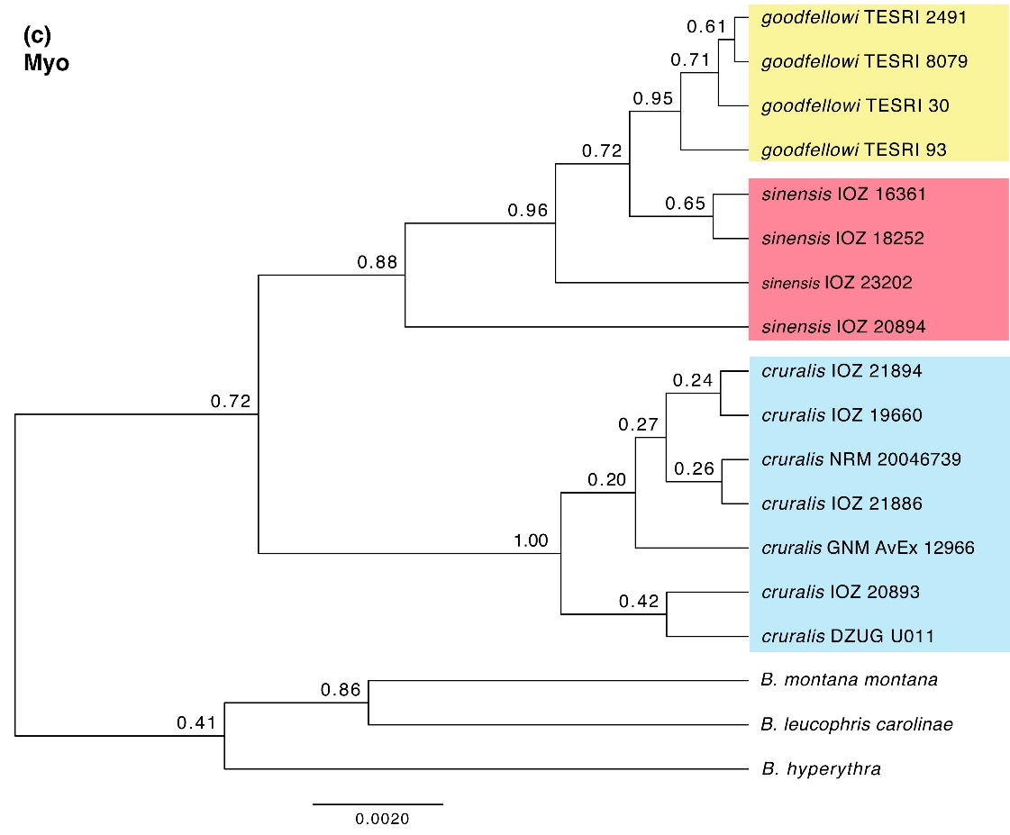
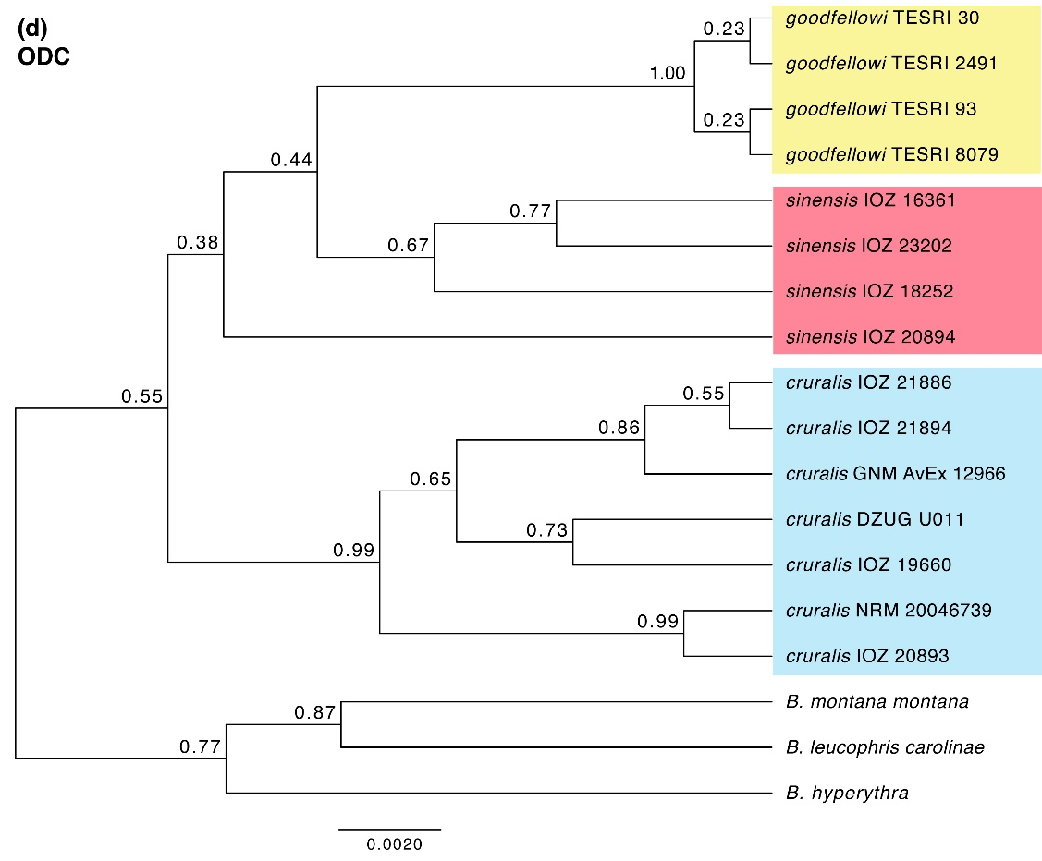
Fig. S2. Trees inferred by BEAST based on cytb and ND2 (a) and myo and ODC (b), each dataset analysed in two partitions; and single-locus analyses of myo (c) and ODC (d).

