Appendix 2. Spearman’s correlation Matrix of spatial autocorrelation analysis
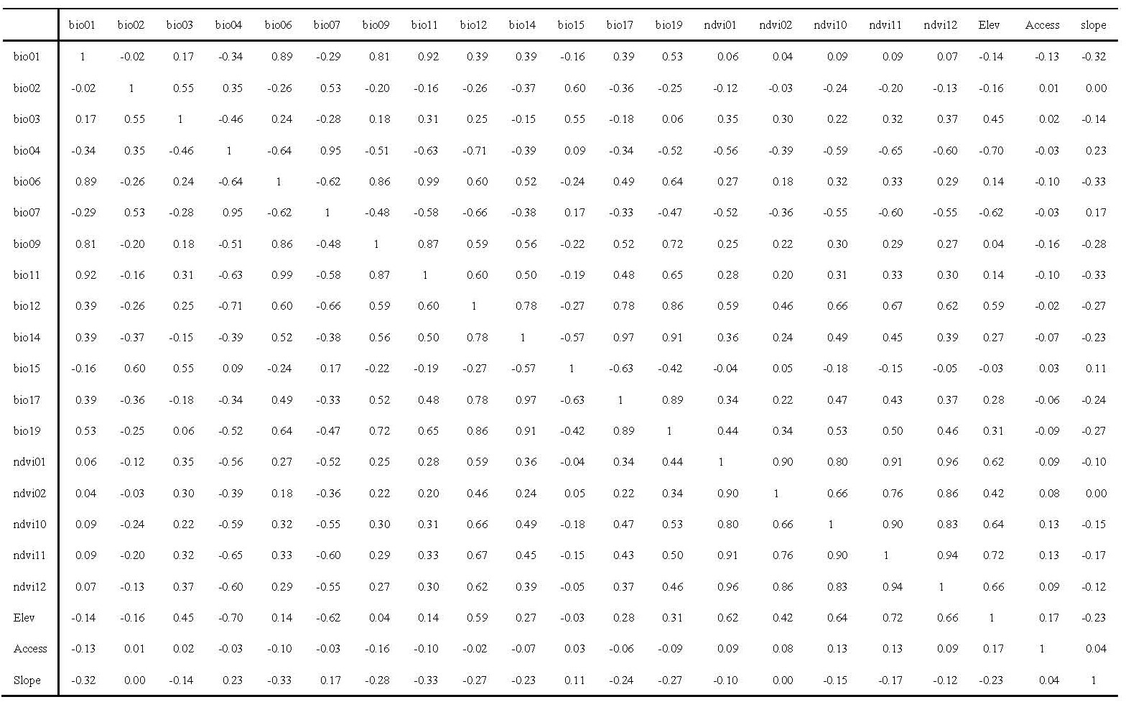
Abbreviations: Elev = Elevation; Access = Accessibility

