Appendix A: Probability of ring wear and loss (theta)
Combining ring colours for the left and right leg
Most oystercatchers have an engraved colour ring on both the left and right leg, but the leg with the worn or lost ring was not recorded, meaning that we cannot be certain which ring colour was worn or lost. To overcome this, we replicated the data so that every individual contained two entries, one for the left leg and another for the right leg. An alternative would be to analyse the ring colours on each leg separately, the results of which we present in this appendix. We applied the same model structure, using a binomial generalised linear model to determine the probability that an individual has a worn or lost ring in relation to the age of the ring and the colour of the ring.

Known ring loss or wear
In most instances, we did not know which ring had been lost or was worn, and this information could only be obtained from comments that were provided with an observation. We recorded all information provided in the comments relating to the ring that was lost or worn, and thus ran an additional model using a much reduced sample size of individuals for which we knew the lost (n = 248) or worn (n = 153) ring. We could not model the probabilities of worn or lost colour markers (non-engraved rings) since too few colour markers (non-engraved rings) were reported worn (n = 5) or lost (n = 8), therefore we only report summary statistics for the colour markers.

Results
Combining ring colours for the left and right leg
The coefficients for the analyses of the left or right leg differed for some leg colours (Table A1, A2), for example, the probability that a green ring was worn was higher for the left leg than the right leg, whereas orange rings had a higher probability of being worn on the right leg (Table A1). However, when the coefficients were averaged for both the left and right models, in general these closely matched our analysis that replicated the data (Table A1, A2). The differences in the coefficients may be due to how sample sizes for each ring colour varied for the left (Fig. A1) and right (Fig. A2) legs. How ring wear and loss was ranked varied depending on the left or right leg. The only clear pattern that emerged was that in both analyses the red and white rings had a higher probability of wear, and that black rings were highly ranked for probability of ring loss (Fig. A1, A2). The similarity in the results between analysing each leg separately, and combining colour-ring information, hence supports the approach we have used in the main analysis of our study.

Table A1 Model coefficients for the probability that an individual has a worn ring in relation to the age and colour of the ring, with analyses focused on either the left, right or on both legs.
Ring Colour | Coefficients Left | Coefficients Right | Average LeftRight | Coefficients BothLegs | Difference
BarCode | 0.189 | 0.188 | 0.188 | 0.189 | ‒0.001
Black | 0.204 | 0.254 | 0.229 | 0.228 | 0.001
Blue | 0.195 | 0.235 | 0.215 | 0.219 | ‒0.004
Green | 0.240 | 0.170 | 0.205 | 0.220 | ‒0.015
Lime | 0.264 | 0.203 | 0.233 | 0.250 | ‒0.017
Orange | 0.159 | 0.232 | 0.196 | 0.231 | ‒0.035
Red | 0.327 | 0.291 | 0.309 | 0.312 | ‒0.003
White | 0.250 | 0.271 | 0.261 | 0.269 | ‒0.009
Yellow | 0.224 | 0.277 | 0.251 | 0.236 | 0.015

Table A2 Model coefficients for the probability that an individual has a lost ring in relation to the age and colour of the ring, with analyses focused on either the left, right or on both legs.
Ring  Colour | Coefficients  Left | Coefficients Right | Average LeftRight | Coefficients BothLegs | Difference
BarCode | ‒0.090 | ‒0.090 | -0.090 | ‒0.092 | ‒0.002
Black | 0.151 | 0.204 | 0.178 | 0.172 | 0.006
Blue | 0.074 | 0.162 | 0.118 | 0.124 | ‒0.006
Green | 0.083 | 0.134 | 0.109 | 0.103 | 0.006
Lime | 0.146 | 0.117 | 0.131 | 0.135 | ‒0.004
Orange | 0.123 | 0.124 | 0.124 | 0.122 | 0.002
Red | 0.123 | 0.029 | 0.076 | 0.091 | ‒0.015
White | 0.183 | 0.096 | 0.140 | 0.117 | 0.023
Yellow | 0.111 | 0.051 | 0.081 | 0.100 | ‒0.019

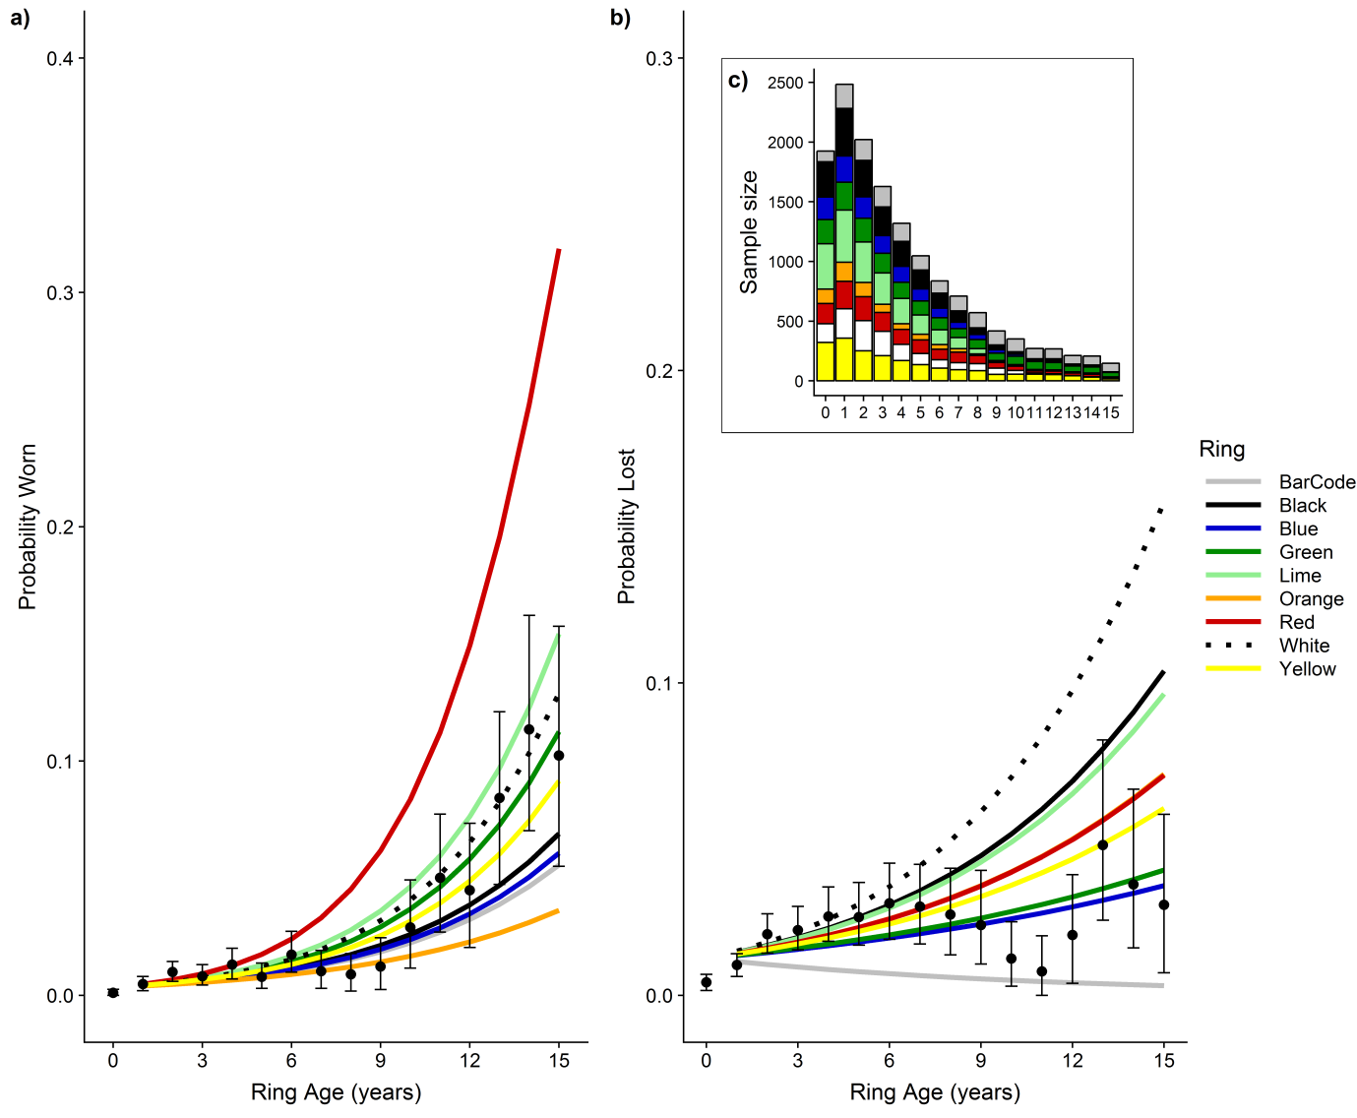
Figure A1 Probability that an oystercatcher is reported with a worn (a) or lost (b) ring dependent on ring age and colour, and an inset graph of sample size for each age category (c), with the analysis only focused on information from the left leg. The coloured lines indicate the predicted wear or loss from the model coefficients whereas the points indicate the actual data in relation to ring age (but independent of ring colour) with 95% error bars. The sample size in c) indicates the number of observations, including only left leg rings for colour-ringed birds, but only a single entry for barcode-ringed birds. The analysis focused on whether an individual is reported with a worn or lost ring rather than an observation of which there may be multiple per year.

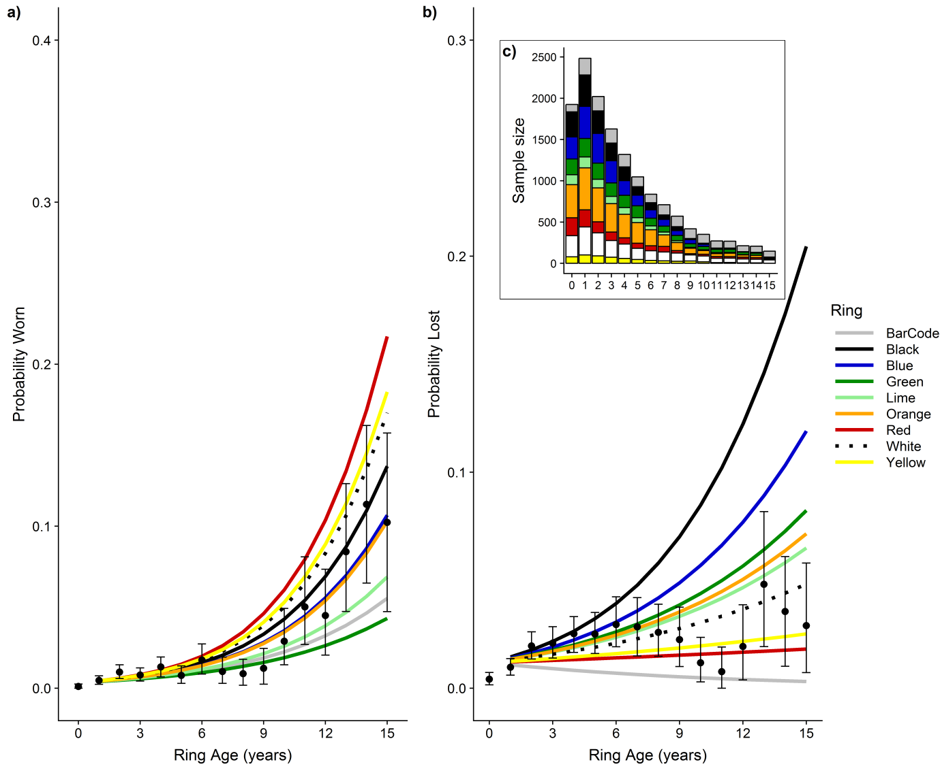
Figure A2 Probability that an oystercatcher is reported with a worn (a) or lost (b) ring dependent on ring age and colour, and an inset graph of sample size for each age category (c), with the analysis only focused on information from the right leg. The coloured lines indicate the predicted wear or loss from the model coefficients whereas the points indicate the actual data in relation to ring age (but independent of ring colour) with 95% error bars. The sample size in c) indicates the number of observations, including only right leg rings for colour-ringed birds, but only a single entry for barcode-ringed birds. The analysis focused on whether an individual is reported with a worn or lost ring rather than an observation of which there may be multiple per year.

Reported ring loss or wear
The comments provided with observations indicated that red and green rings were most frequently reported as lost or worn (Table A3). Yellow markers were reported worn or lost most frequently, whilst no green markers were reported lost or worn (only black, green, red or yellow markers were used). The results of the binomial model support previous analyses that red rings have the highest rate of wear (Fig. A3). The difference between red and the other ring colours was much stronger when only including the information about known ring wear. The results for the probability of losing a ring were similar to previous analyses (Fig. 3, A1, A2) with a large overlap among ring colours (Fig. A3).

Table A3 The comments provided with observations of lost or worn rings helped to identify which ring was lost or worn for 386 individuals.
Ring colour | Engraved lost | Engraved worn | Marker lost | Marker worn
Black | 31 | 7 | 1 | 1
Blue | 32 | 19
Green | 49 | 37 | 0 | 0
Lime | 20 | 1
Orange | 20 | 4
Red | 47 | 62 | 3 | 1
White | 32 | 15
Yellow | 17 | 8 | 4 | 3
The table sums to 414 because an individual may first have a worn ring and then a lost ring. The information was tallied per ring colour, showing the number of engraved rings that have been lost or worn by colour, as well as the colour marker that has been lost or worn. Only one metal ring was reported lost.
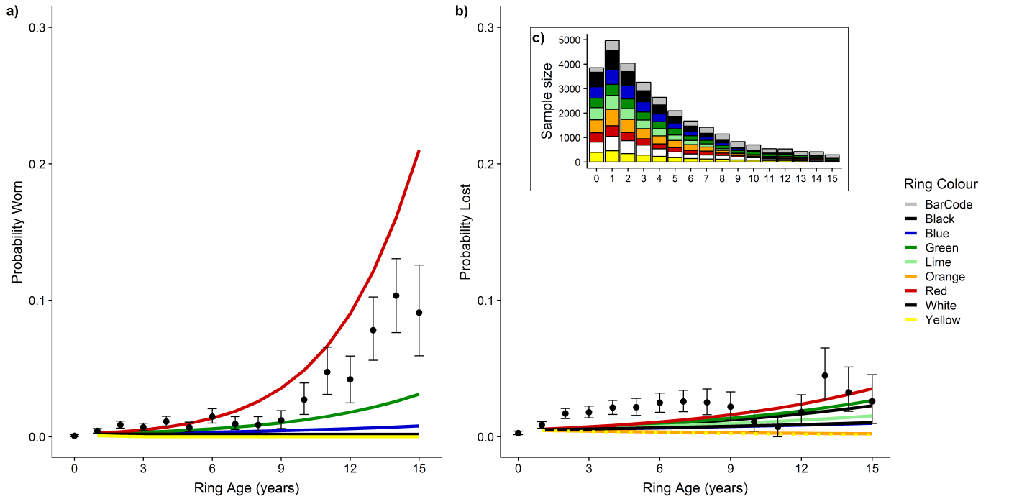
Figure A3 Probability that an oystercatcher was reported with a worn (a) or lost (b) ring dependent on ring age and colour, and an inset graph of sample size for each age category (c), with the analysis only focused on information of individuals where the worn or lost ring was known, as derived from the comments provided with observations. The coloured lines indicate the predicted wear or loss from the model coefficients whereas the points indicate the actual data in relation to ring age (but independent of ring colour) with 95% error bars. The sample size in c) indicates the number of rings per colour. The analysis focused on whether an individual is reported with a worn or lost ring rather than an observation of which there may be multiple per year.

Appendix B: Ring colour resighting probabilities
The colour of a ring may affect resighting probabilities, for reasons that include ease to read in the field together with differing rates of wear or loss (e.g. Appendix A). We performed a mark-recapture analysis to determine how the resighting probability varied amongst ring colours, and whether this varied over time (study period was 2008 to 2017). We created a group for each ring colour, but since individuals with engraved rings would always have two ring colours, an individual would belong to two groups. Therefore, a challenge in modelling resighting probabilities is that the ring colours are not independent since the resighting of one ring may be impacted by the colour of the ring on the other leg.
We performed additional analyses to support our results, and describe resighting probabilities for ring combinations. The sample size was more than 100 for all ring combinations, with an average 202 individuals per colour combination. The most frequently used ring combinations were Black/Orange (n = 392) and Black/Lime (n = 319) and the least frequently used were Red/Lime (n = 112) and Red/White (n = 121). All individuals were adults to ensure that resighting probabilities were not influenced by the lower survival rates of juveniles. The analysis would provide insights about how ring colour resighting probabilities may be influenced by other ring colours, for example if a ring colour tended to reduce or increase average resighting rates. We compared different model structures within the mark-recapture analysis for the resighting rates, and report the best model based on differences in AIC.

Results
Engraved rings may be one of eight colours, and a different colour was always used for each leg. Although 28 different colour combinations are possible, only 16 have been used. Black, blue, green and red rings have never been combined together, and instead are combined with lime, orange, white or yellow (Fig. B1). Similarly, lime, orange, white and yellow rings have never been combined together, thus providing a total of 16 colour-ring combinations, plus the barcode ring which is never combined with an engraved colour ring (Fig. B1).

Figure B1 Resighting probabilities from a mark-recapture analysis for all ring combinations used during the study period. The model structure included time varying survival but resighting probabilities only varied amongst ring combinations (Model 3; Table B1). The colours of the image represent the colour-combination (also see y-axis labels) but not the order of rings, i.e. a combination of Black_yellow does not mean that the black ring was on the left leg, but simply that a black and a yellow ring were used, and that the black ring could be on either the right or left leg.
The top performing model included resighting rates varying by ring colour and time, and the second ranked model included resighting rates that varied by ring combination and time (Table B1). The lower AIC of the model with ring combinations is likely due to the high number of parameters (n = 306) compared with the top performing model (n = 90, Table B1). Red rings had the highest resighting probabilities (Fig. 4 in main text) despite having the highest rates of ring wear (Fig. 3 in main text), and the results appear independent of the second ring as all four red combinations ranked in the top 7 (Fig. B1). Black and yellow rings had the lowest resighting probabilities (0.65 and 0.63 respectively), and the black-yellow combination ranked last with a resighting probability of 0.57 (Fig. B1). The influence of the second ring on the colour-specific resighting rate, indicated that resighting rates were reduced by black and yellow rings (‒0.03 reduction each) whilst red rings increased resighting rates by 0.05. Green and orange rings had a mildly positive effect (0.02 each) on resighting rates, lime had a mildly negative effect (‒0.02 each) whilst blue and lime rings had a minor effect on resighting rates (‒0.01 and 0.01 respectively).

Table B1 Mark-recapture results showing model comparisons for each ring colour individually (Colour), and the ring combination (Combined).
Model | Survival | Resighting | npar | AICc | ∆AICc | Deviance
1 | time | Colour:time | 90 | 29,148.5 | 0.0 | 9791.8
2 | time | Combined:time | 306 | 29,157.7 | 9.3 | 9357.4
3 | time | Combined | 42 | 29,325.3 | 176.9 | 10,065.5
4 | time | Colour | 18 | 29,391.0 | 242.6 | 10,179.4
Survival was modelled as fully time-dependent. The resighting probability included model structures with a fully time-dependent model, containing a parameter for each year (2008‒2017), and a time-independent model which only estimates resightings rates across the entire study period for each ring colour. Npar is the number of parameters and ∆AICc is the delta AIC.

