Appendix C: Ring wear survey
Citizen scientists have had a strong involvement in research projects of the Eurasian Oystercatcher (Haematopus ostralegus), beginning with an initiative called the “Year of the Oystercatcher”, which was organised by Sovon Dutch Centre for Field Ornithology and Birdlife Netherlands. More recently, a research project was started titled “the Cumulative Human Impacts on Bird Populations” (Allen et al. 2018; www.chirpscholekster.nl), and additional outreach initiatives with citizen scientist have been started since the project began. One of these outreach initiatives was a volunteer day, where ringers and ring-readers were invited to attend an informal event in which updates were provided about oystercatcher research in the Netherlands. During the volunteer day held this year (13 October 2018), the lead author (AA) created a quiz in which the level of ring wear had to be reported. The four ring wear options of the data portal Wadertrack (www.wadertrack.nl) were used, namely:
? = Unknown
0 = No Wear
1 = Worn, easy to read
2 = Worn, difficult to read
The quiz was created using an online tool (www.kahoot.it) and participants could join either via their smartphone or laptop. The quiz participants were presented with 13 images that contained varying levels of ring wear, and also different types of ring wear including fading of colour rings and an image of a damaged ring (cracks). We circled a particular ring on the image that participants should rate, rather than reporting the ring wear status of all rings. The quiz participants had 20 seconds to select one of the four codes for ring wear. Two examples are shown in Fig. B1. We also asked the participants to classify themselves into one of four groups, namely 1) Birdwatcher, 2) Ringer only, 3) Ring Reader only or 4) Ringer & Ring Reader (Table B1).

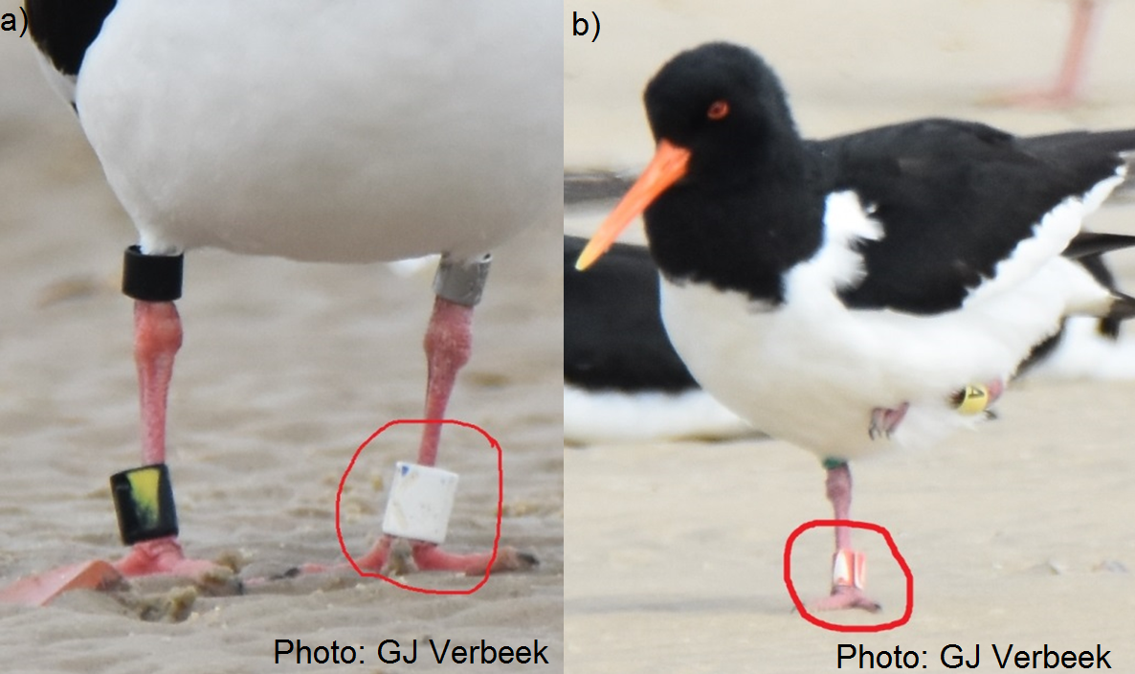
Figure B1 Example images used during a quiz about the ring wear code that should be reported on the online portal Wadertrack. a) provides an example of extreme wear for a blue ring with the letter K (ring wear code = 2, difficult to read) whilst b) provides an example of mild wear for a red ring with the letter A (ring wear code = 1, easy to read). Photos provided by Gert-Jan Verbeek.

Results
Twenty-four participants took part in the quiz and on average 21 participants provided an answer to each question (min = 15, median = 22, max = 24). Generally, there was little consensus about the level of ring wear, and in only five instances more than 80% of participants provided the same answer (Fig. B2). Four of these concerned cases of extreme ring wear (e.g. Fig. B1a). Question 11 concerned the only image that contained a ring that was damaged (instead of faded), which likely explains the high consensus for this question. In the remaining eight questions with less than 80% agreement, a question would regularly be answered with three levels of ring wear (i.e. 0, 1 or 2), such as question 3 (Fig. B2) which was an image of the bird shown in Fig. B1b. Most images contained rings with some degree of wear, and only images in questions 1 and 7 could be considered to have no wear. We had predetermined the ring wear code based on our own experience, and among the four groups, there was no clear pattern that ring readers, ringers, or birdwatchers provided more correct answers (Table B1).
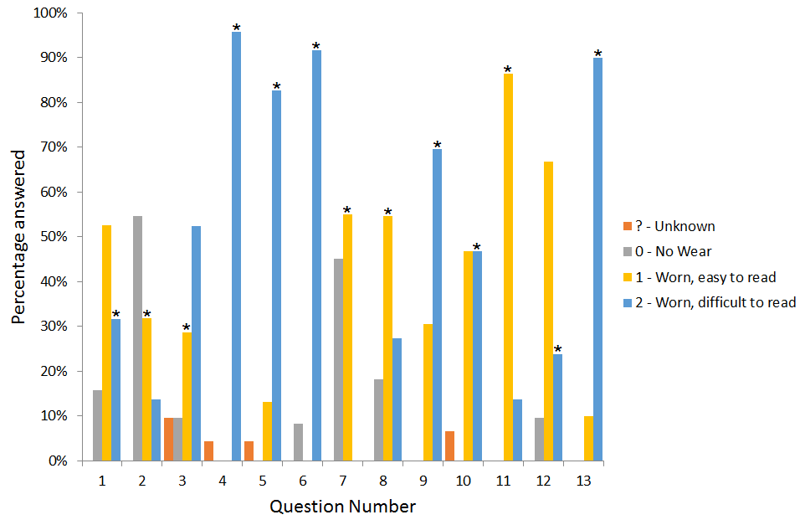
Figure B2 – Results of the ring wear survey showing the percentage of participants that chose one of the four ring wear codes per question. The correct answers, as determined by researchers in the project, are shown with an asterisk (*).

Table B1 The number of correct and incorrect answers from the participants of the ring wear quiz, split between whether the participant considers themselves to be a birdwatcher, ringer, ring reader or ringer & ring reader and the sample size for each group (n).
Row Labels | n | Correct | Incorrect | Total | Percentage
Ring reader | 6 | 48 | 27 | 75 | 64%
Ringer | 1 | 9 | 3 | 12 | 75%
Ringer & ring reader | 10 | 71 | 37 | 108 | 66%
Birdwatcher | 7 | 47 | 33 | 80 | 59%
Note that only one participant was a ringer only.

Implications
An issue that emerged during the current research for ring wear and loss is that worn rings were less likely to be reported. One potential cause is that determining ring wear can be subjective, in contrast with ring loss where a ring is either lost or not. The quiz provided an opportunity to survey a small subset of volunteers about ring wear and how worn rings should be reported. The results clearly demonstrated that opinions varied strongly among participants, independent of whether they were regularly reading rings or opportunistically whilst birdwatching. The results demonstrate the need for clear guidance for reporting ring wear, in which perhaps several examples are needed upon which observations can be compared. Communication between researchers and citizen scientists is ongoing to improve how ring wear is recorded within the oystercatcher project.

