Additional file 2:
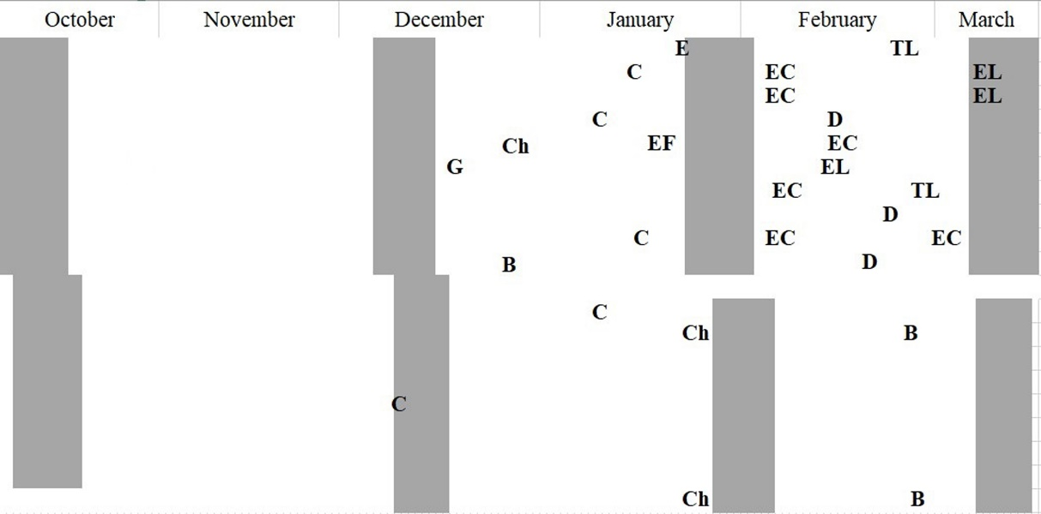
Fig. S1 Sampling scheme in soybean fields and borders (vertical) showing survey dates (grey) and insecticide applications over time. Insecticides used: Bifenthrin (B), Chlorpyrifos (Ch), Cypermethrin (C), Deltamethrin (D), Endosulfan (E), Fenitrothion (F), Gamma-cyhalotrin (G), Lambda-cyhalotrin (L), Thiametoxam (T).

Fig. S2 Detection ($\hat{p}$ ± 95%CI) (a) and occupancy ($\hat{Psi}$ ± 95%CI) probabilities (b) for different bird groups, in the interior of soybean fields at different seasons in 2007‒2009, Paraná department, Entre Ríos, Argentina. BARLO = Upland Sandpiper, NOTMA = Spotted Nothura, VANCH = Southern Lapwing, COL = Columbiformes, GRGR = Ground nesting granivore gleaners, AER = Aerial foragers. Details of species in Table 1.

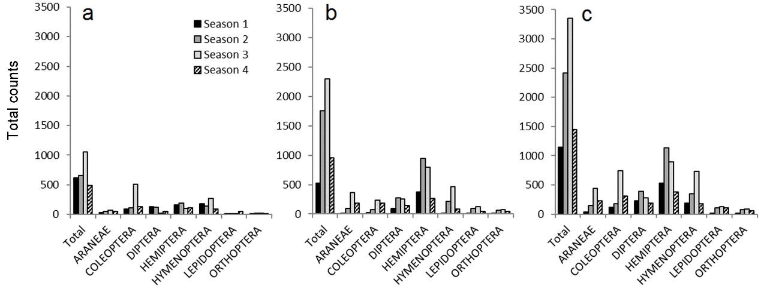
Fig. S3 Total arthropod counts collected with (a) vacuum, (b) sweep-net, and (c) pooled in the interior of soybean fields at different seasons in 2007‒2009, Paraná department, Entre Ríos, Argentina.

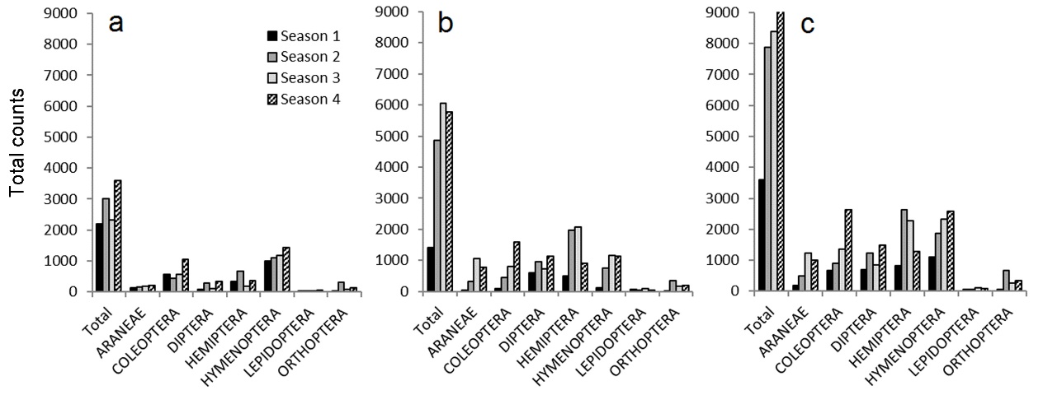
Fig. S4 Total arthropod counts collected with (a) vacuum, (b) sweep-net, and (c) pooled in the borders of soybean fields at different seasons in 2007‒2009, Paraná department, Entre Ríos, Argentina.

