Additional file 1:
Fig. S1 Daily light level change of all six individuals of Beijing Swift in the reproduction period. The dot line is the base line which indicates light level is 0. The nearest line above it shows the light level change of this day. The dark signals in red line region are more and longer, which is the potential incubation period of birds.
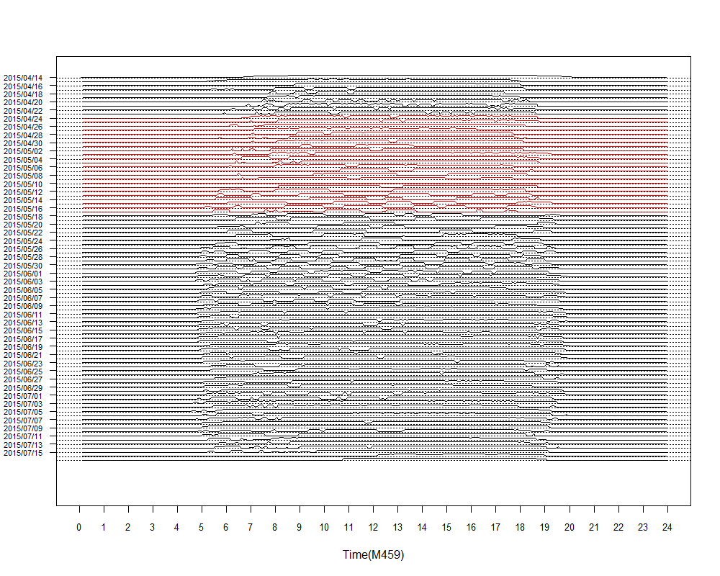
a
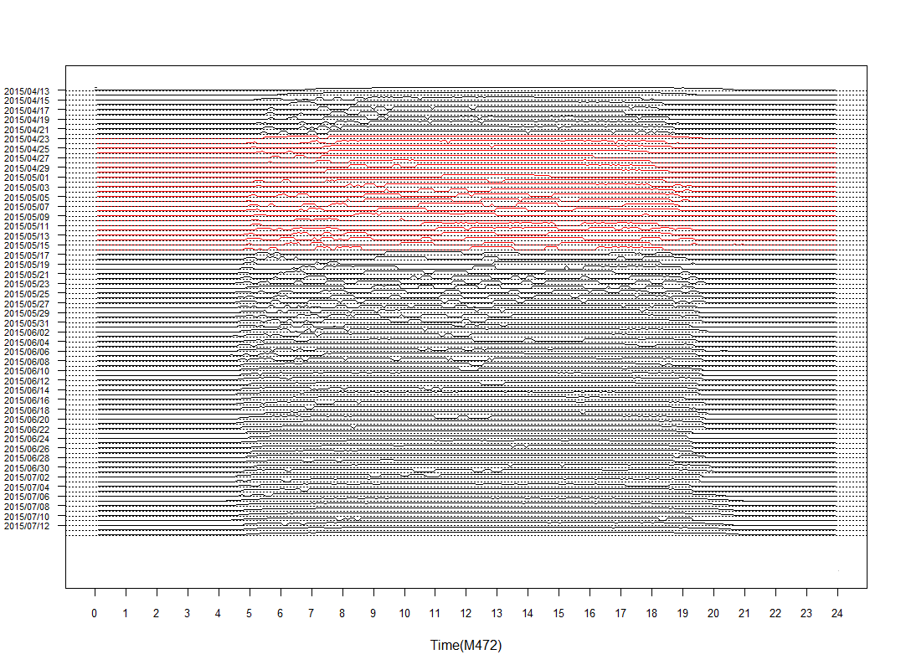
b

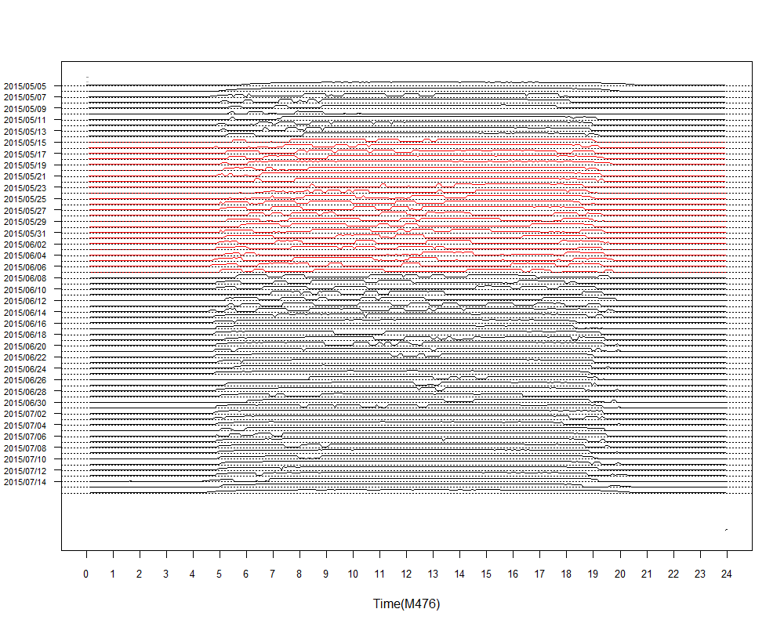
c
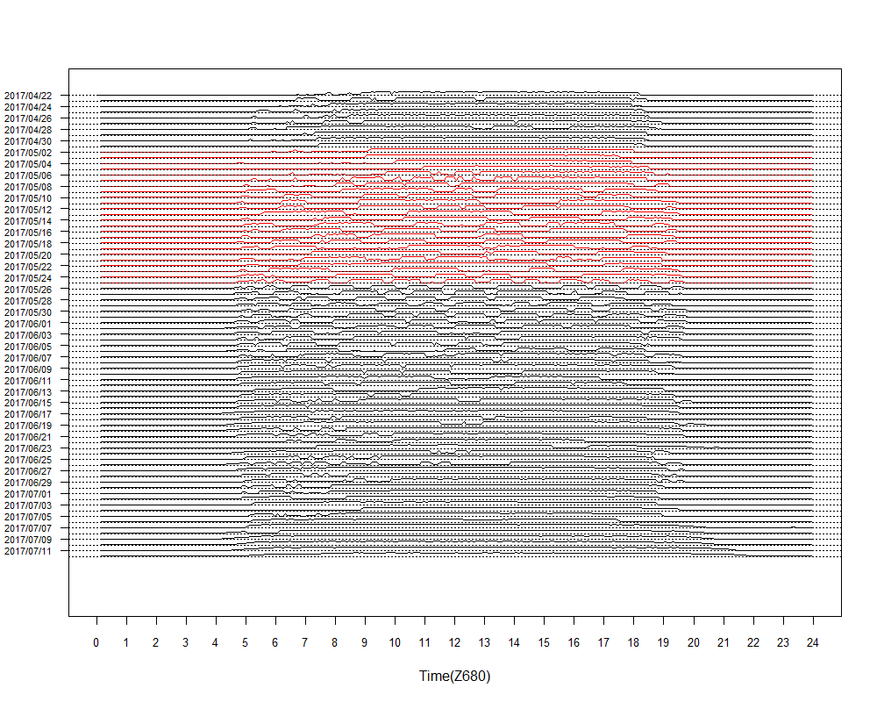
d

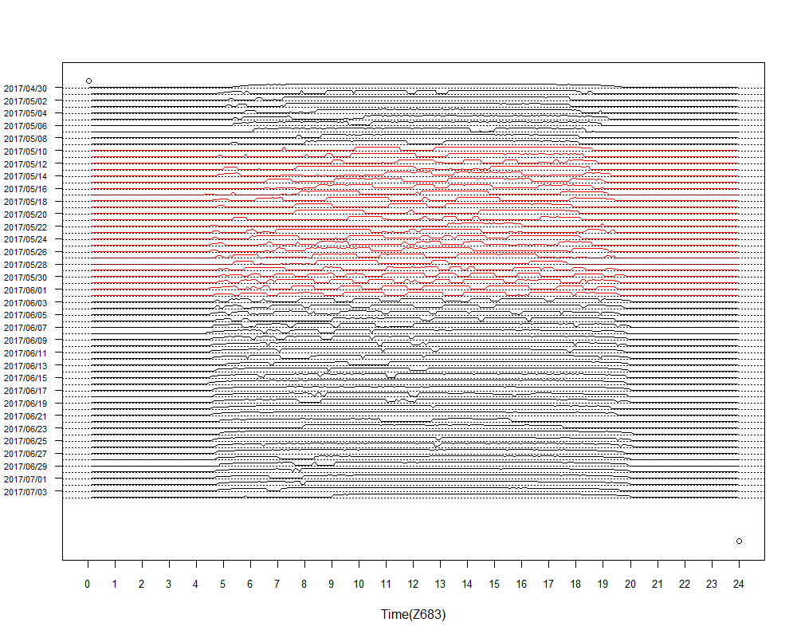
e
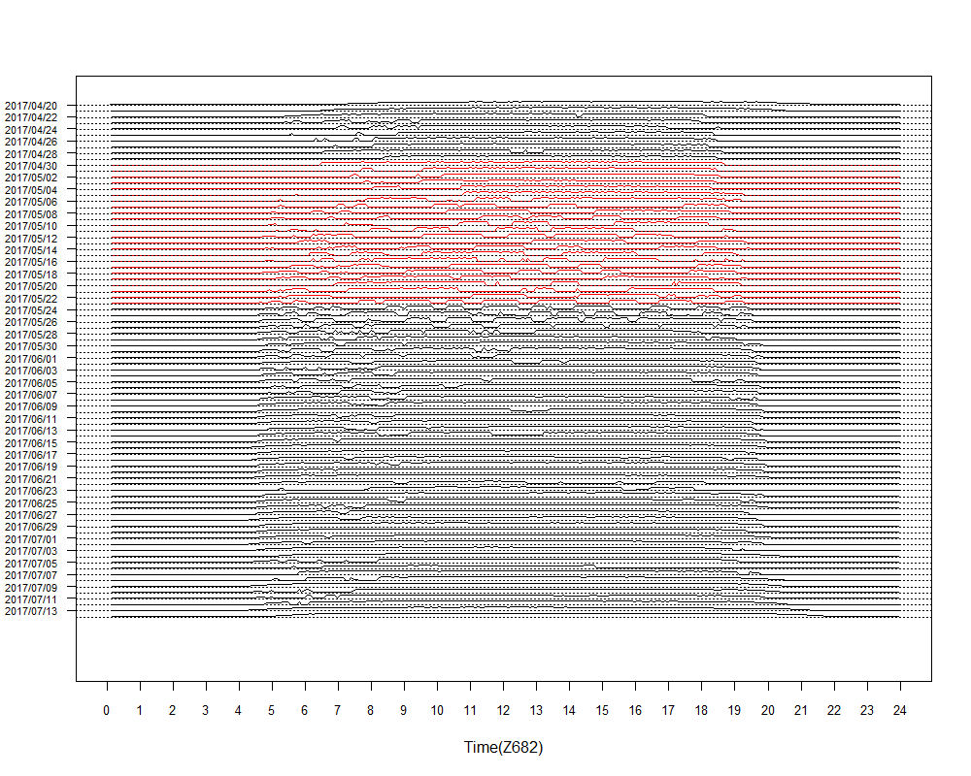
f

Fig. S2 box plots of possible incubation bouts in the whole breeding season of six Beijing Swifts. The y axis shows length of the bout (min) and x axis shows the date. Different color shows different reproduction period.
