APPENDIX: DECAY SCHEMES OF RADIOISOTOPES FOR PET

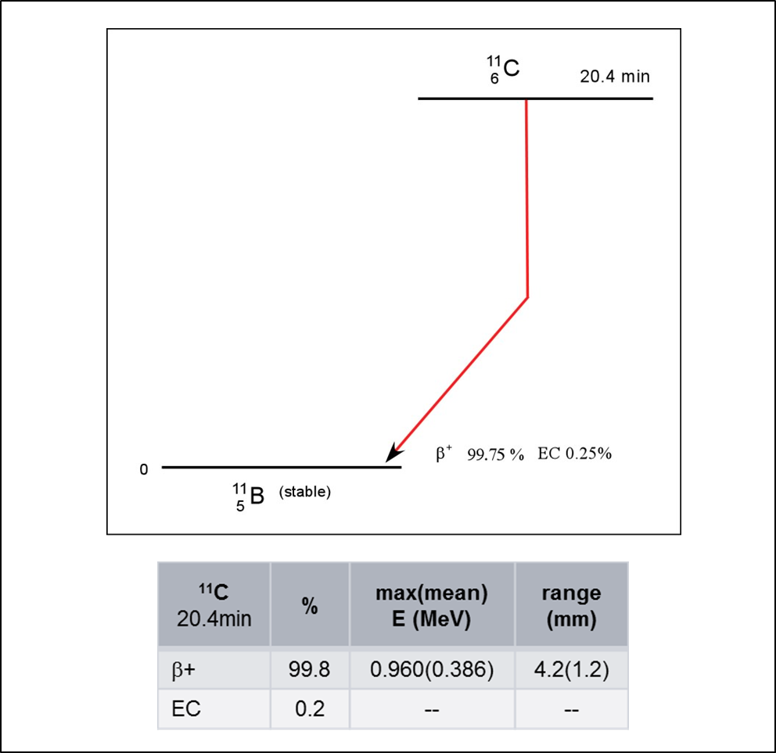
Figure A1: ¹¹C
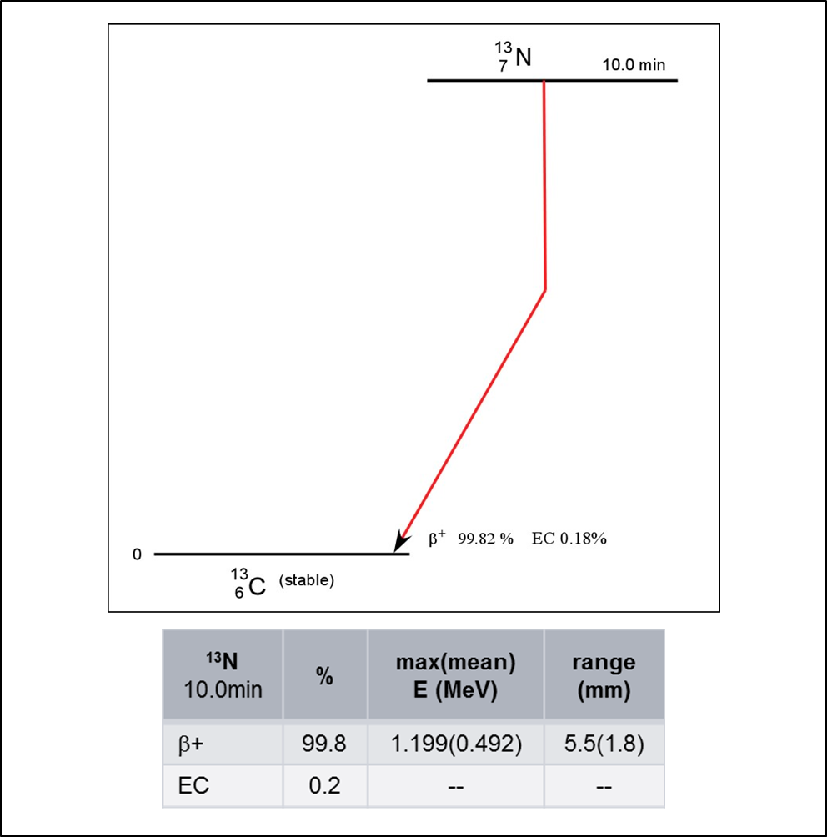
Figure A2: ¹³N
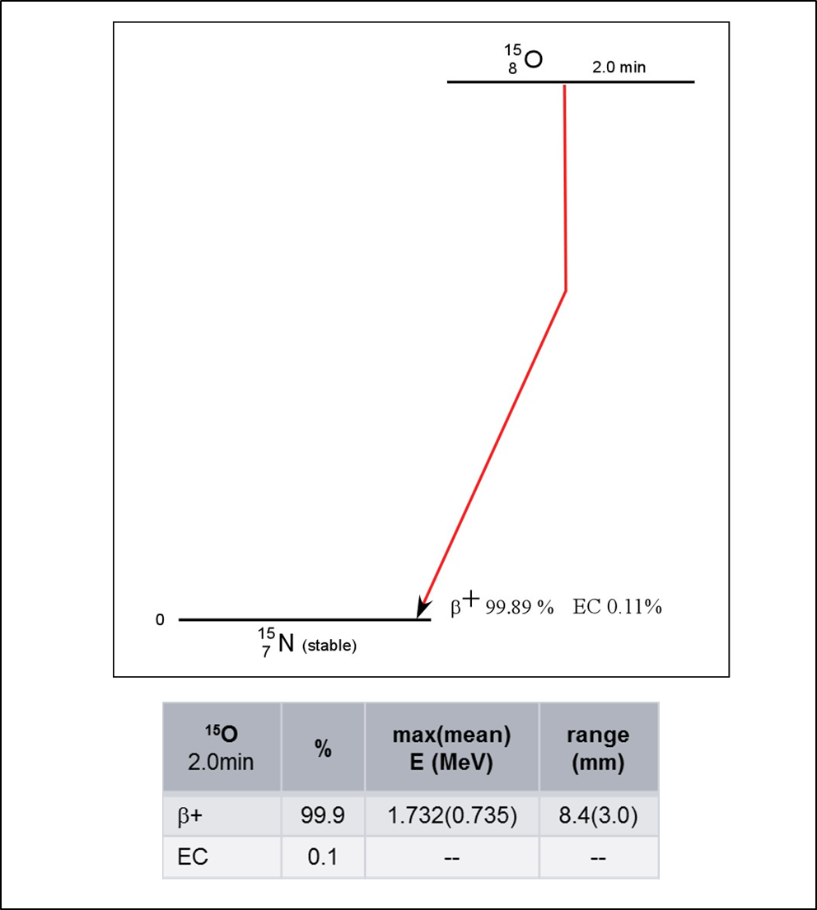
Figure A3: ¹⁵O
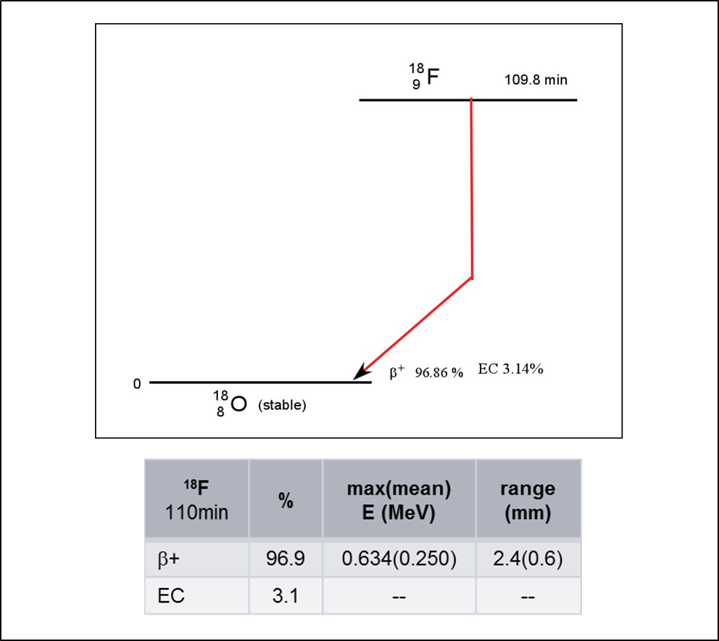
Figure A4: ¹⁸F

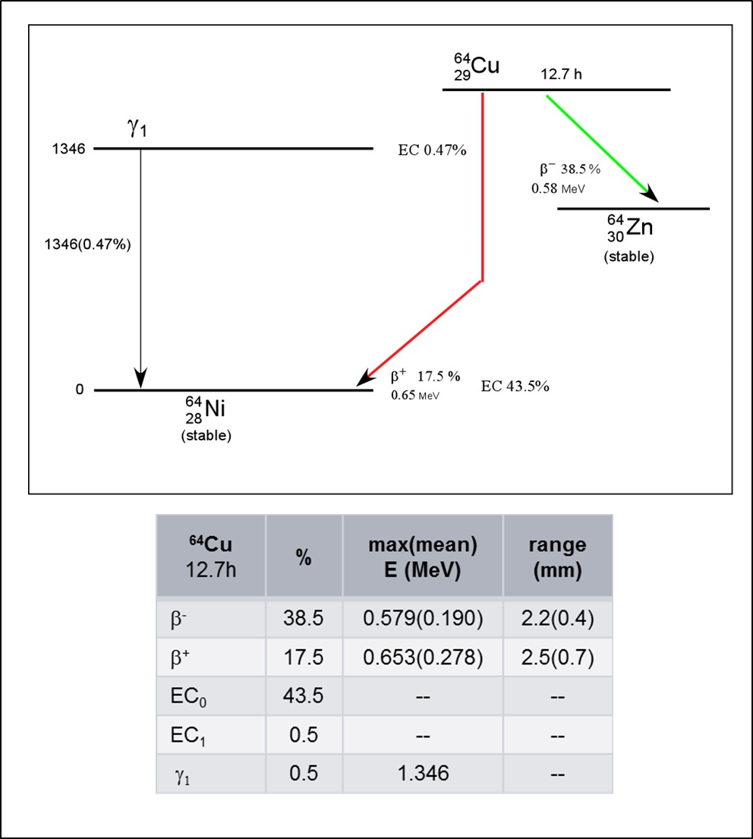
Figure A5: ⁶⁴Cu
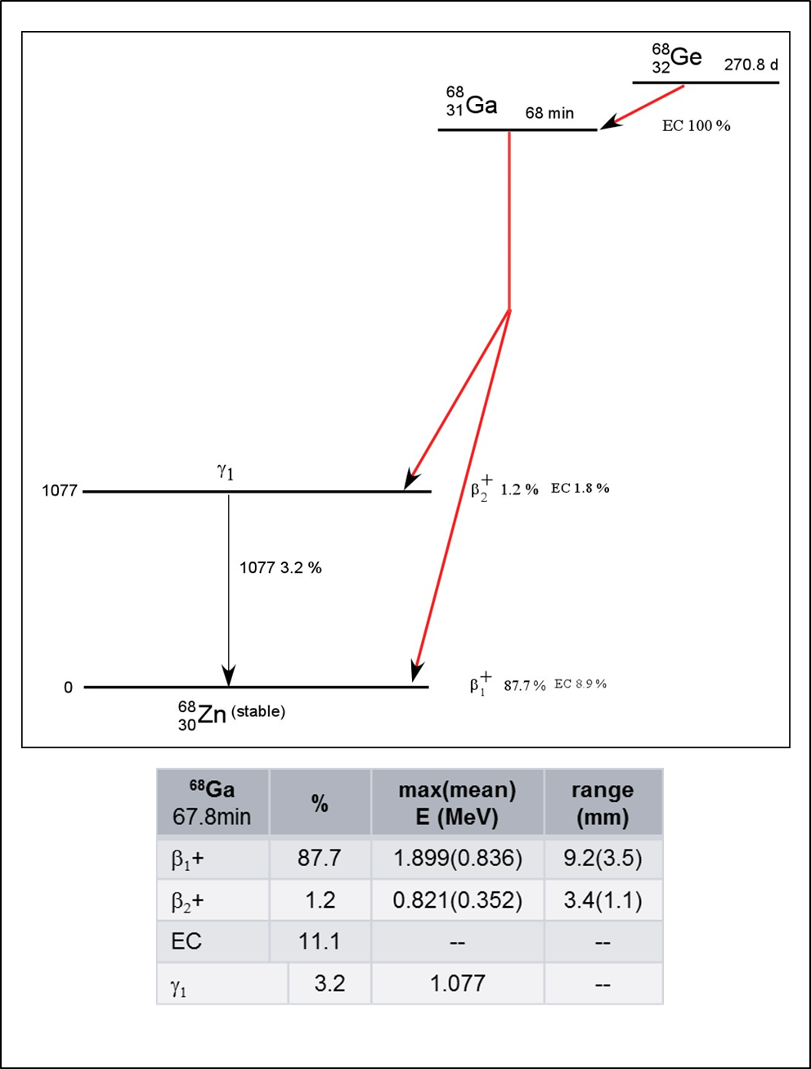
Figure A6: ⁶⁸Ga

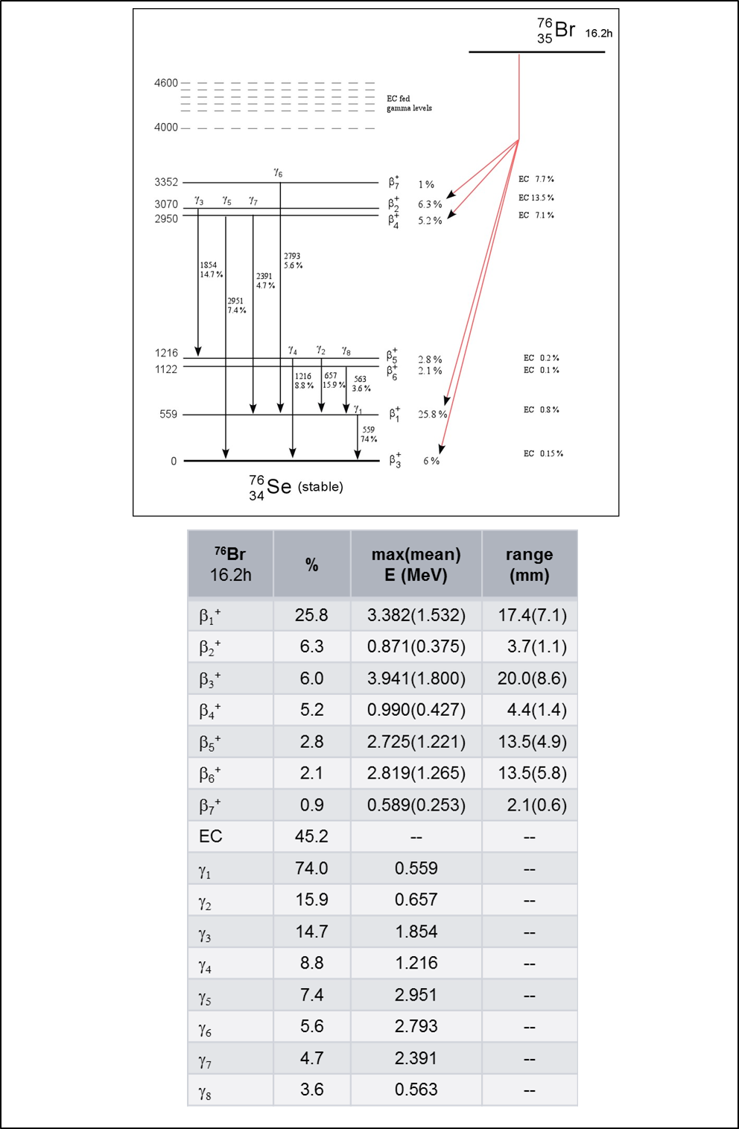
Figure A7: ⁷⁶Br

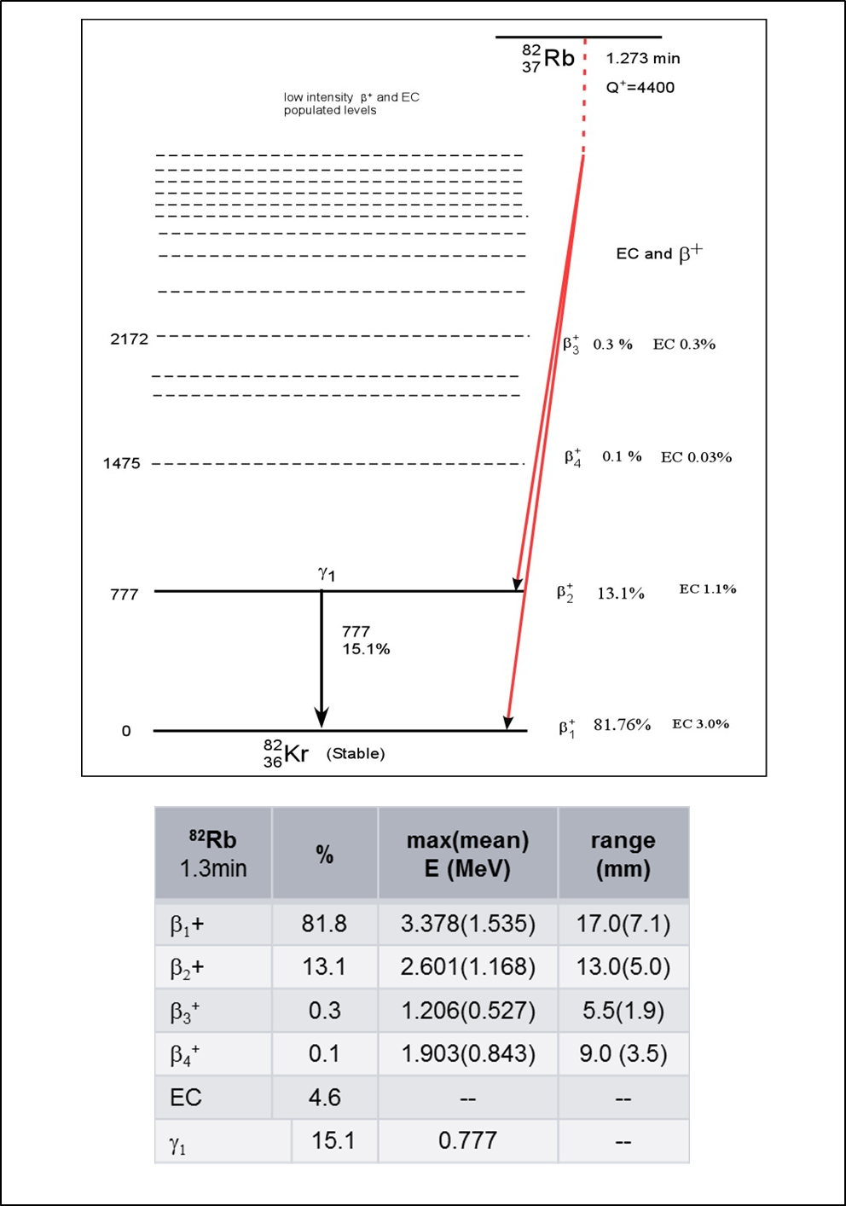Figure A8: ⁸²Rb
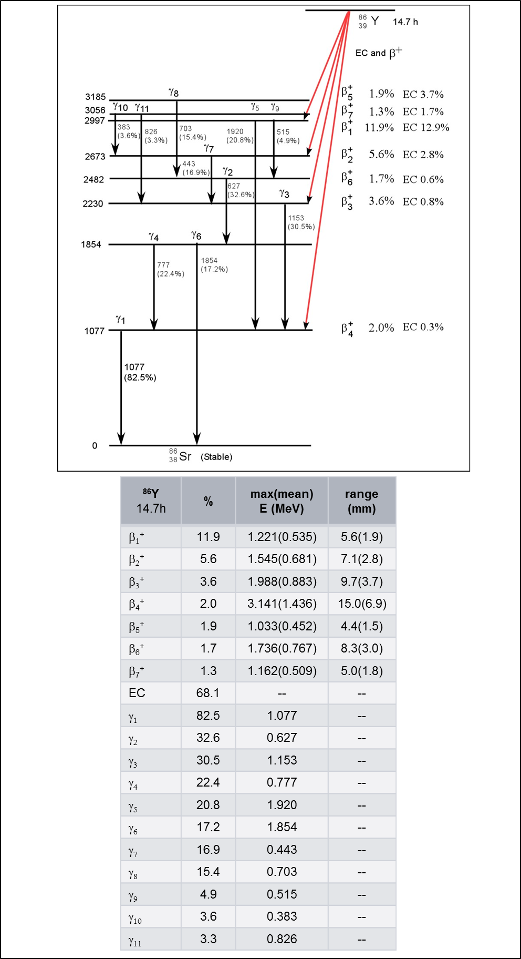
Figure A9: ⁸⁶Y

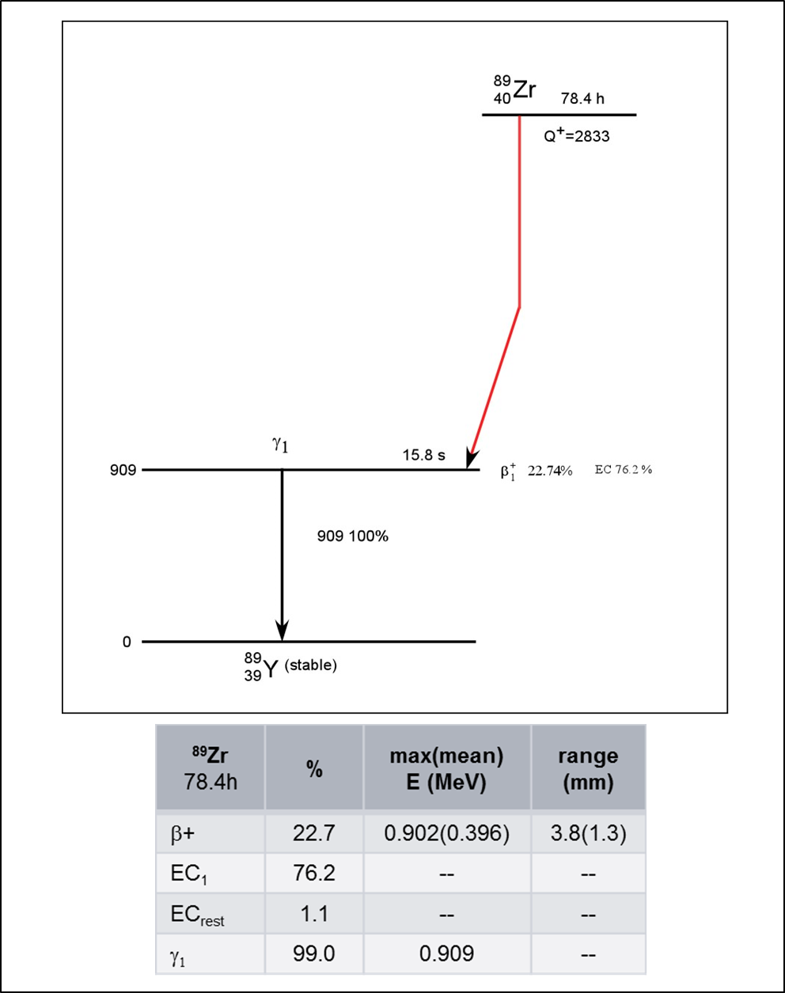
Figure A10: ⁸⁹Zr

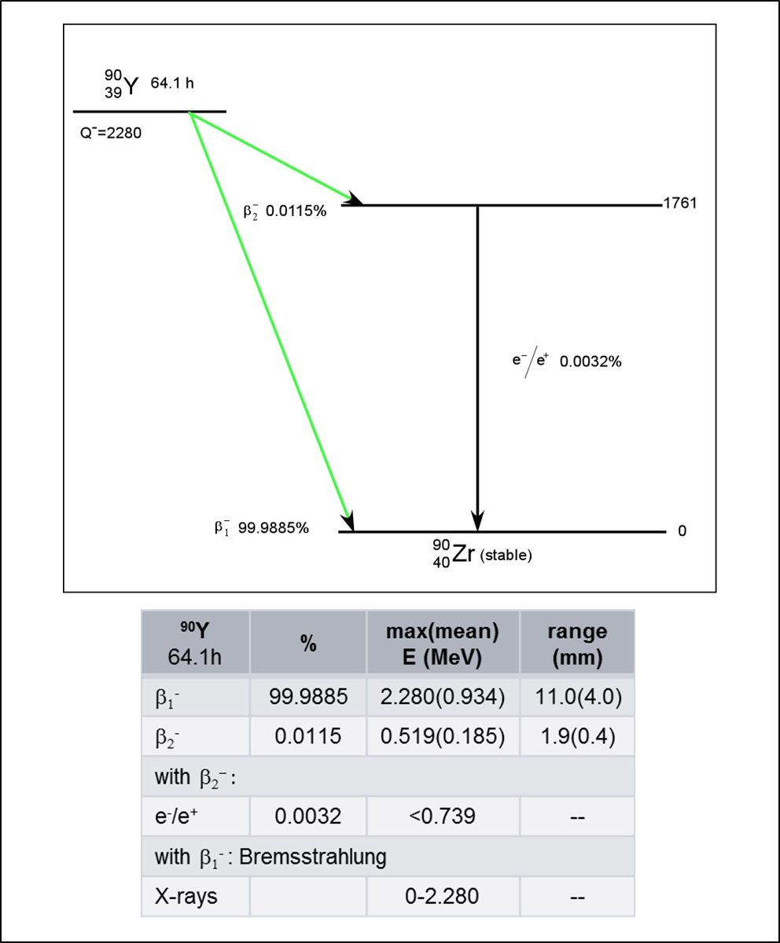
Figure A11: ⁹⁰Y
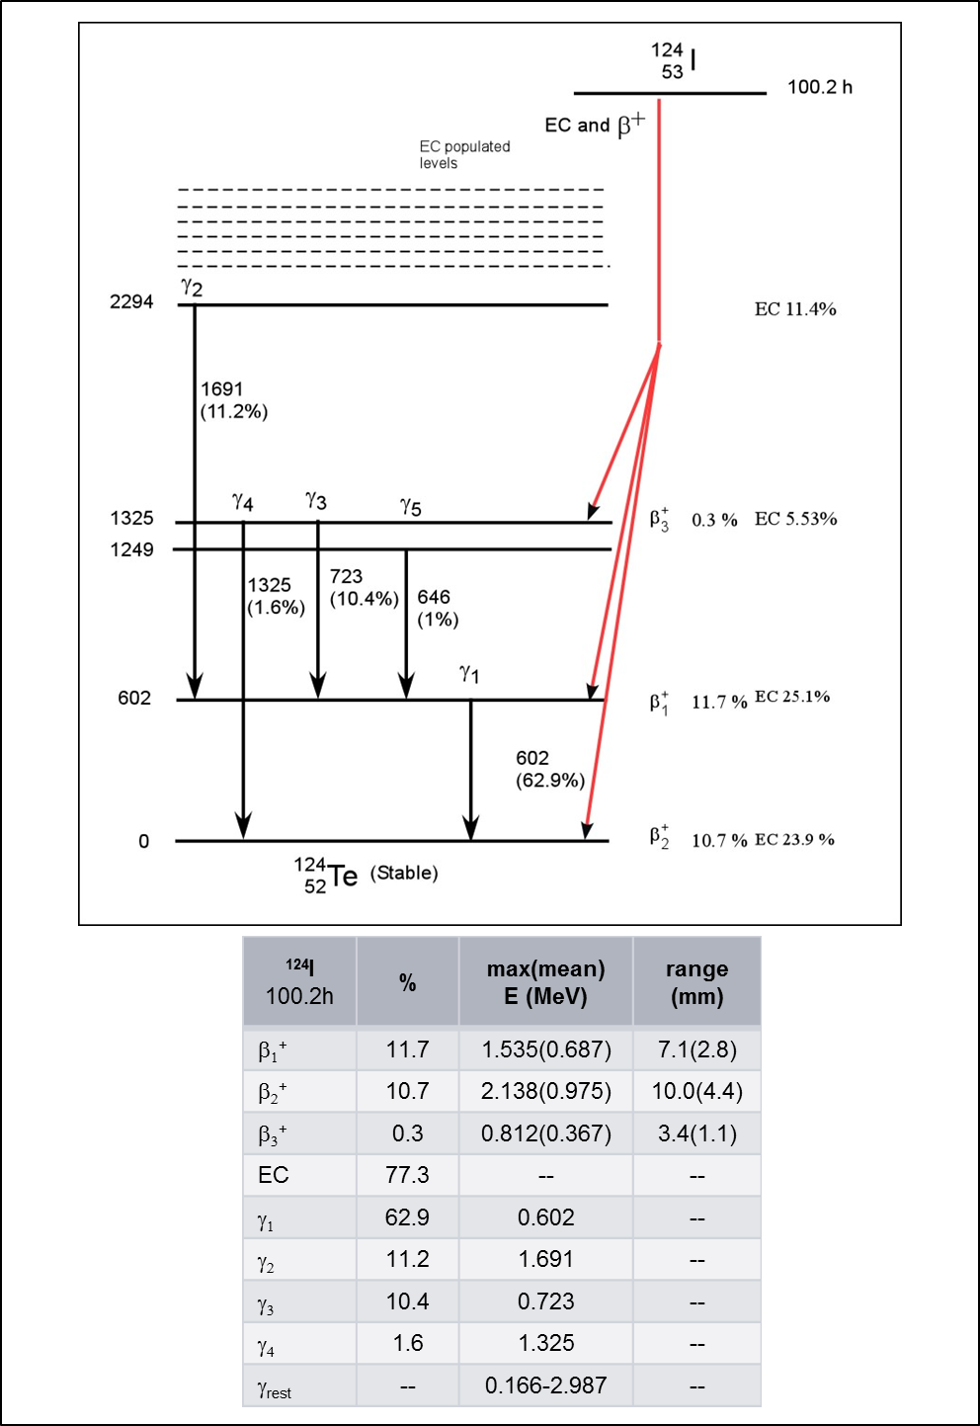
Figure A12: ¹²⁴I

