Supplementary Data
Supplementary Figure 1: Detailed view of some of the results of the image processing and their relationships. On the top: Original MRI and PET images and results of the MRI normalization (warped atlas) and segmentation. On the bottom: GM patient-specific atlas generated from the warped atlas and the GM. PVC labels including WM and CSF together with the GM specific atlas and BrainVIset input (iteration 0) activity and attenuation maps.
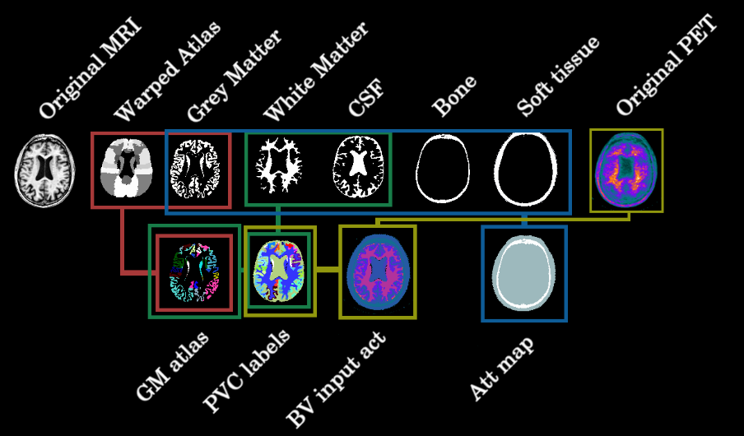
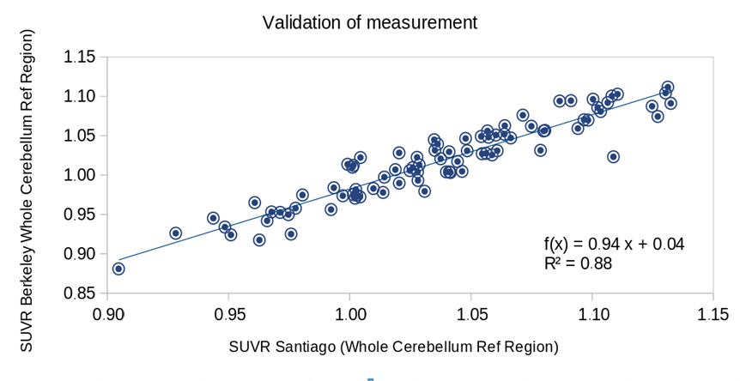
Supplementary Figure 2: Comparison of SUVR values measured on our lab (x-axis) and data calculated by the ADNI PET Core at Berkeley (y-axis) for our final subject sample. Average differences between Berkeley calculations and ours were found to be ± 4.6%. These small differences are mainly due to different processing pipelines, such as different segmentation methods (CAT vs. Freesurfer), atlas (Hammersmith vs. Desikan) or quantification space (patient vs. MNI).

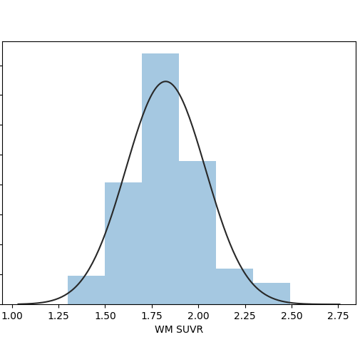
Supplementary Figure 3: Distribution of WM values across the studied ADNI2 sub-sample. Only amyloid-negative patients are presented. The bars represent the number of patients on each bin of the histogram, while the black solid line represent the Gaussian distribution of the histogram.

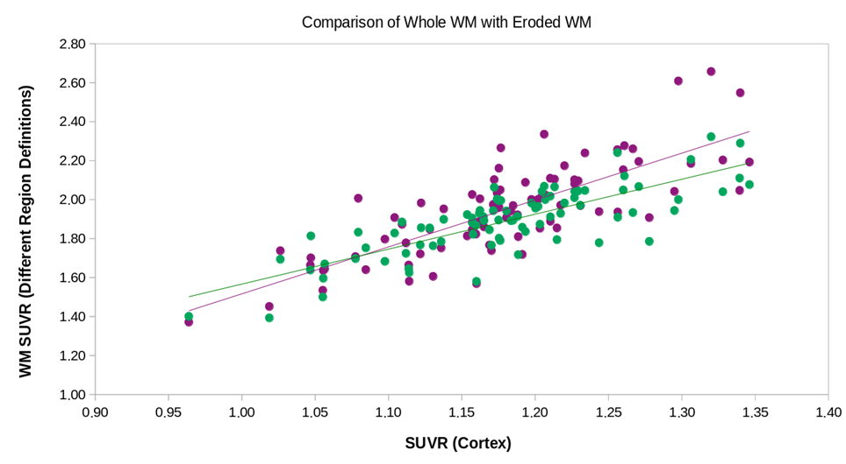
8iu7Supplementary Figure 4: Visual comparison of the correlations of cortex SUVR (x-axis) with WM-SUVR_{CGM}, using both the whole WM (green) and the Eroded WM (purple) as WM regions.

Supplementary Figure 5: Relation between WM-SUVR_{CGM} (x-axis) and GM SUVR using the whole cerebellum as a reference region (SUVR_{WC}). The Figure represents the actual cohort used for this work (amyloid-negative patients, blue points), and patients excluded for being positive according to the ADNI SUVR_{WC} =1.11 threshold (red and orange dots). The correlation coefficient between WM-SUVR_{CGM} and SUVR_{WC} when including amyloid-positive patients was r=0.55
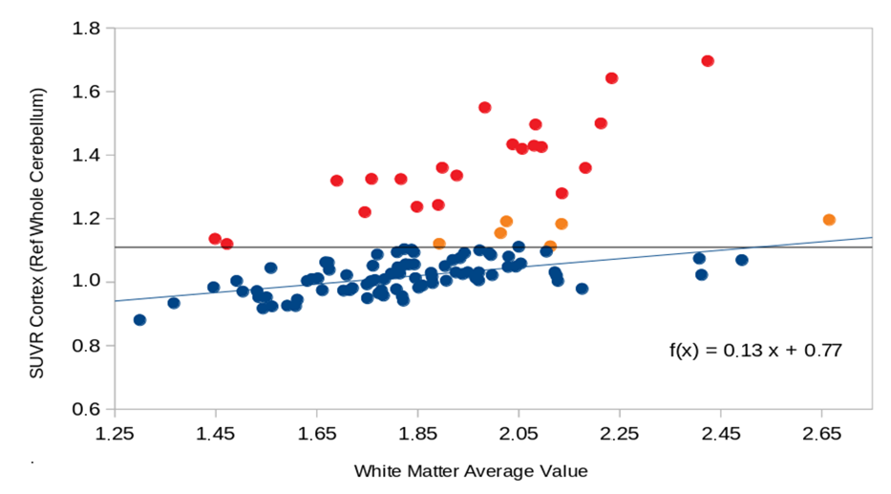

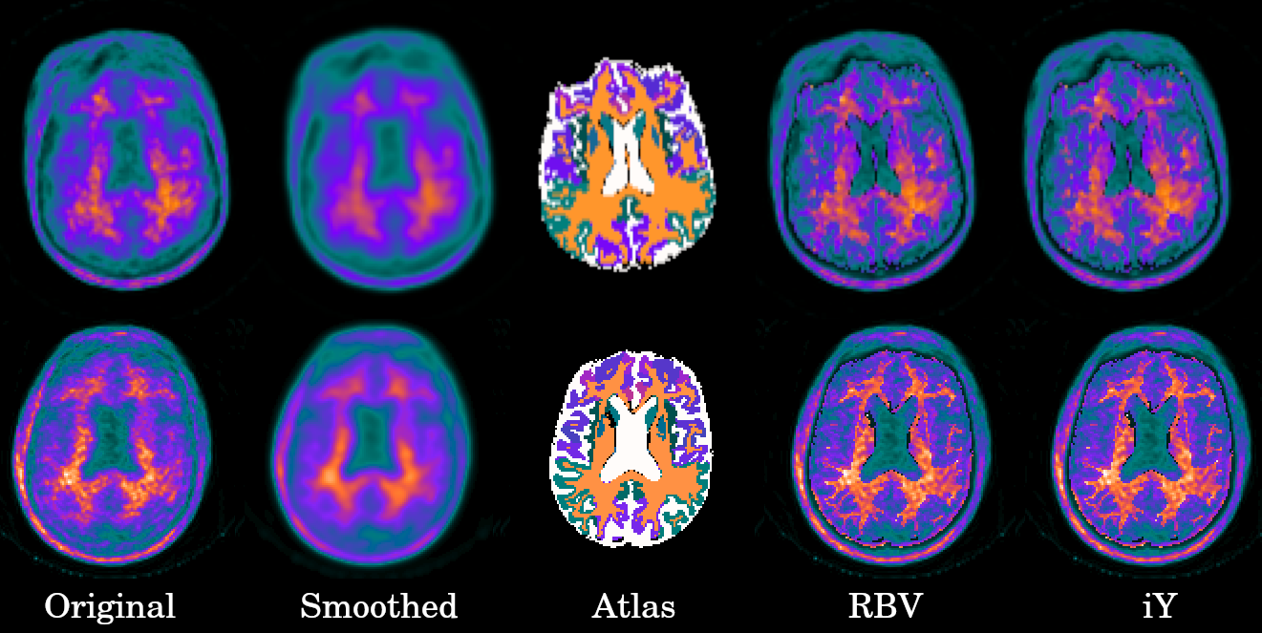
Supplementary Figure 6: Example images for the different levels of processing for some of the simulated images. Each row shows the original image (left), smoothed image (center-left), atlas used for the PVC (center). RBV-corrected image (center-right) and iY-corrected image (right), for each of the cases.

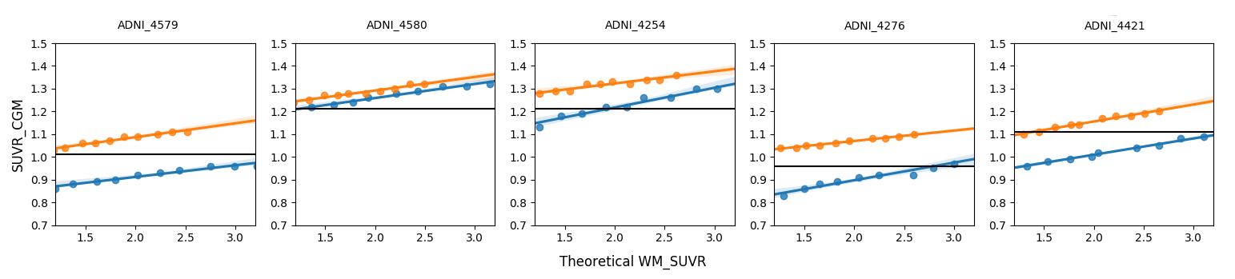
Supplementary Figure 7: Comparison of ground truth and measured SUVR_{CGM} values for RBV (blue lines) and iY (orange line) for different WM- SUVR_{CGM}.

Supplementary Table 1: Measured PF for each of the scanners present in the ADNI database (measured by the ADNI) and smoothing applied to each of the scanners to obtain an isotropic 8-mm resolution (as proposed by the ADNI).
 |  | Measured PSF |  | Applied Smoothing
Manufacturer | Scanner | in-plane | axial | XY smoothing | Z smoothing
Siemens | HRRT | 4.5 | 4.5 | 6.0 | 6.0
Siemens | BioGraph 1080 | 5.5 | 5.5 | 5.5 | 5.5
Siemens | BioGraph TruePoint (1093/1094) | 5.5 | 5.5 | 5.5 | 5.5
Siemens | BioGraph mCT | 5.5 | 5.5 | 5.5 | 5.5
Philips | GemTF Sharp | 5.5 | 5.5 | 4.5 | 5.0
Siemens | ECAT Exact HR+ | 6.0 | 6.0 | 5.0 | 5.0
Siemens | ECAT Exact HR | 5.5 | 7.0 | 5.5 | 3.5
GE | Disc600_3D IR | 5.5 | 6.0 | 5.5 | 5.0
GE | Disc600_RP | 6.0 | 7.0 | 5.0 | 3.5
GE | Disc690_3D IR | 5.5 | 6.0 | 5.5 | 5.0
GE | Disc690_RP | 6.0 | 7.0 | 5.0 | 3.5
GE | DiscRX_3D IR | 5.5 | 6.0 | 5.5 | 5.0
GE | DiscRX RP | 6.0 | 7.0 | 5.0 | 3.5
GE | DiscSTE_3D IR | 5.5 | 6.0 | 5.5 | 5.0
GE | DiscSTE_RP | 6.0 | 7.0 | 5.0 | 3.5
GE | DiscST_3D IR | 6.0 | 6.0 | 5.0 | 5.0
GE | DiscST_FORE 2D IR | 7.5 | 7.0 | 3.0 | 3.5
GE | DiscST_RP | 7.0 | 7.0 | 3.5 | 3.5
GE | DiscLS_FORE 2D IR | 6.5 | 7.0 | 4.5 | 3.0
GE | DiscLS_RP | 6.0 | 7.5 | 5.0 | 2.0
GE | Advance_FORE 2D IR | 6.5 | 7.0 | 4.5 | 3.0
GE | Advance_RP | 6.0 | 7.5 | 5.0 | 2.0
Philips | Allegro | 7.5 | 7.5 | 3.0 | 3.0
Philips | Gemini GXL | 7.5 | 7.5 | 3.0 | 3.0
Philips | Gemini | 7.5 | 7.5 | 3.0 | 3.0
Siemens | BioGraph (47 slice) | 7.5 | 7.0 | 2.0 | 3.0
Siemens | ECAT Accel | 7.5 | 7.0 | 2.0 | 3.0
Siemens | ECAT Exact | 7.5 | 7.0 | 2.0 | 3.0

Supplementary Table 2: Quantification results for all the analyzed patients, including the ADNI label for the patient (Patient), the quantified Cortex average (Cortex AVG), cerebellum grey matter average (CGM AVG), whole cerebellum average (WC AVG), white matter average (WM AVG), SUVR_{CWM}, SUVR_{WC} and the PET scanner.
Patient | Cortex AVG | CGM AVG | WC AVG | WM AVG | SUVR_{CWM} | SUVR_{WC} | Scanner
002_S_4225 | 1.76 | 1.01 | 1.17 | 2.08 | 1.74 | 1.51 | GEMINI TF TOF
002_S_4262 | 1.75 | 1.03 | 1.14 | 1.98 | 1.71 | 1.54 | GEMINI TF TOF
002_S_4270 | 2.00 | 1.07 | 1.22 | 2.23 | 1.87 | 1.64 | GEMINI TF TOF
003_S_4119 | 1.31 | 1.04 | 1.26 | 2.13 | 1.25 | 1.04 | SIEMENS 1094
003_S_4288 | 1.49 | 1.09 | 1.27 | 2.01 | 1.36 | 1.18 | SIEMENS 1094
003_S_4555 | 1.38 | 1.12 | 1.24 | 1.84 | 1.23 | 1.11 | SIEMENS 1094
003_S_4644 | 1.29 | 1.01 | 1.13 | 1.89 | 1.28 | 1.14 | SIEMENS 1094
003_S_4872 | 1.29 | 1.07 | 1.20 | 1.83 | 1.21 | 1.08 | SIEMENS 1094
003_S_4900 | 1.24 | 1.03 | 1.16 | 1.93 | 1.20 | 1.07 | SIEMENS 1094
006_S_4150 | 1.17 | 1.00 | 1.16 | 1.81 | 1.17 | 1.01 | Siemens HR+
007_S_4387 | 1.27 | 1.04 | 1.24 | 1.97 | 1.22 | 1.03 | Discovery RX
007_S_4488 | 1.22 | 1.00 | 1.15 | 1.93 | 1.22 | 1.06 | Discovery RX
007_S_4516 | 1.22 | 1.01 | 1.17 | 1.88 | 1.21 | 1.05 | Discovery RX
007_S_4620 | 1.12 | 1.00 | 1.09 | 1.56 | 1.13 | 1.04 | Discovery RX
007_S_4637 | 1.30 | 1.03 | 1.15 | 1.82 | 1.26 | 1.13 | Discovery RX
009_S_4388 | 1.07 | 0.95 | 1.07 | 1.50 | 1.12 | 1.00 | Discovery LS
009_S_4612 | 1.21 | 1.02 | 1.11 | 1.47 | 1.19 | 1.09 | Discovery LS
010_S_4345 | 1.15 | 0.98 | 1.14 | 1.78 | 1.17 | 1.00 | Siemens HR+
011_S_4105 | 1.21 | 1.03 | 1.16 | 1.76 | 1.17 | 1.04 | SIEMENS 1094
011_S_4120 | 1.55 | 1.06 | 1.18 | 1.82 | 1.47 | 1.32 | SIEMENS 1094
011_S_4222 | 1.13 | 1.02 | 1.13 | 1.65 | 1.11 | 1.00 | SIEMENS 1094
011_S_4278 | 1.75 | 1.06 | 1.24 | 2.10 | 1.65 | 1.41 | SIEMENS 1094
012_S_4545 | 1.31 | 1.07 | 1.24 | 2.03 | 1.23 | 1.06 | Discovery LS
013_S_4579 | 0.94 | 0.97 | 1.04 | 1.30 | 0.97 | 0.91 | Discovery STE
013_S_4580 | 1.22 | 1.02 | 1.19 | 1.81 | 1.19 | 1.02 | Discovery STE
013_S_4616 | 1.72 | 1.04 | 1.22 | 2.18 | 1.65 | 1.41 | Discovery STE
014_S_4080 | 1.31 | 1.04 | 1.16 | 1.77 | 1.27 | 1.13 | Philips Medical Systems
014_S_4093 | 1.49 | 1.07 | 1.27 | 2.11 | 1.39 | 1.18 | Philips Medical Systems
016_S_4121 | 1.14 | 1.03 | 1.17 | 1.75 | 1.11 | 0.98 | BioGraph TruePoint
016_S_4638 | 1.36 | 1.07 | 1.24 | 2.05 | 1.27 | 1.09 | BioGraph TruePoint
016_S_4688 | 1.60 | 1.10 | 1.24 | 2.14 | 1.45 | 1.29 | BioGraph TruePoint
016_S_4952 | 1.21 | 1.05 | 1.20 | 1.85 | 1.15 | 1.01 | BioGraph TruePoint
018_S_4349 | 1.24 | 1.02 | 1.17 | 1.76 | 1.22 | 1.06 | GEMS Advance
018_S_4399 | 1.30 | 1.10 | 1.23 | 1.90 | 1.18 | 1.06 | GEMS Advance
018_S_4400 | 1.70 | 1.06 | 1.20 | 2.04 | 1.61 | 1.42 | GEMS Advance
019_S_4367 | 1.25 | 1.02 | 1.21 | 1.85 | 1.22 | 1.03 | BioGraph TruePoint
019_S_4835 | 1.34 | 1.01 | 1.21 | 1.97 | 1.32 | 1.11 | BioGraph TruePoint
021_S_4254 | 1.36 | 1.12 | 1.31 | 2.12 | 1.21 | 1.04 | Discovery STE
021_S_4276 | 1.00 | 0.94 | 1.08 | 1.59 | 1.06 | 0.93 | Discovery STE
021_S_4335 | 1.42 | 1.01 | 1.15 | 1.89 | 1.41 | 1.23 | Discovery STE
021_S_4421 | 1.13 | 0.99 | 1.12 | 1.72 | 1.14 | 1.00 | Discovery STE
022_S_4173 | 1.20 | 0.96 | 1.10 | 1.81 | 1.24 | 1.09 | GEMINI TF TOF
022_S_4196 | 1.32 | 1.00 | 1.12 | 1.85 | 1.32 | 1.18 | GEMINI TF TOF
022_S_4266 | 1.74 | 1.05 | 1.20 | 2.08 | 1.65 | 1.44 | GEMINI TF TOF
022_S_4291 | 1.57 | 1.03 | 1.15 | 1.90 | 1.52 | 1.36 | GEMINI TF TOF
023_S_4020 | 1.28 | 1.05 | 1.22 | 1.97 | 1.22 | 1.05 | SIEMENS 1093
023_S_4164 | 1.20 | 1.02 | 1.21 | 1.82 | 1.18 | 0.99 | SIEMENS 1093
Patient | Cortex AVG | CGM AVG | WC AVG | WM AVG | SUVR_{CWM} | SUVR_{WC} | Scanner
023_S_4448 | 1.26 | 1.01 | 1.15 | 1.92 | 1.24 | 1.10 | SIEMENS 1093
024_S_4084 | 1.16 | 1.00 | 1.13 | 1.78 | 1.16 | 1.03 | Siemens HR+
029_S_4384 | 1.18 | 1.01 | 1.11 | 1.67 | 1.17 | 1.06 | Siemens HRRT
029_S_4385 | 1.46 | 1.07 | 1.13 | 1.69 | 1.36 | 1.29 | Siemens HRRT
029_S_4585 | 1.21 | 1.01 | 1.12 | 1.84 | 1.20 | 1.09 | Siemens HRRT
029_S_4652 | 1.21 | 1.04 | 1.10 | 1.45 | 1.17 | 1.10 | Siemens HRRT
031_S_4021 | 1.18 | 1.01 | 1.21 | 1.78 | 1.17 | 0.98 | Siemens HR+
031_S_4474 | 1.51 | 1.01 | 1.12 | 1.76 | 1.50 | 1.35 | Siemens HR+
031_S_4496 | 1.24 | 1.01 | 1.17 | 1.94 | 1.23 | 1.06 | Siemens HR+
032_S_4348 | 1.60 | 1.07 | 1.18 | 2.06 | 1.50 | 1.36 | Siemens HRRT
032_S_4386 | 2.75 | 1.19 | 1.42 | 3.35 | 2.30 | 1.93 | Siemens HRRT
032_S_4429 | 1.48 | 1.07 | 1.21 | 2.14 | 1.39 | 1.22 | Siemens HRRT
032_S_4921 | 1.40 | 1.05 | 1.27 | 2.03 | 1.34 | 1.10 | Siemens HRRT
033_S_4176 | 1.39 | 1.02 | 1.14 | 1.75 | 1.36 | 1.22 | Discovery ST
033_S_4177 | 1.59 | 1.23 | 1.43 | 2.41 | 1.29 | 1.11 | Discovery ST
033_S_4508 | 1.53 | 1.01 | 1.15 | 1.93 | 1.52 | 1.33 | Discovery ST
035_S_4082 | 1.40 | 1.12 | 1.36 | 2.18 | 1.25 | 1.03 | SIEMENS 1094
035_S_4464 | 1.22 | 1.01 | 1.15 | 1.84 | 1.21 | 1.06 | SIEMENS 1094
036_S_4491 | 1.04 | 0.98 | 1.08 | 1.54 | 1.06 | 0.96 | Siemens HR+
036_S_4878 | 1.27 | 1.02 | 1.18 | 1.95 | 1.24 | 1.08 | Siemens HR+
037_S_4308 | 1.21 | 1.00 | 1.13 | 1.81 | 1.21 | 1.07 | Siemens HR+
037_S_4410 | 1.07 | 0.99 | 1.08 | 1.45 | 1.08 | 0.99 | Siemens HR+
041_S_4200 | 1.23 | 1.03 | 1.15 | 1.67 | 1.20 | 1.08 | Siemens HR+
041_S_4427 | 1.12 | 0.93 | 1.07 | 1.63 | 1.20 | 1.04 | Siemens HR+
068_S_4174 | 1.78 | 1.08 | 1.22 | 2.21 | 1.65 | 1.46 | Discovery ST
070_S_5040 | 1.32 | 1.11 | 1.32 | 1.97 | 1.19 | 1.00 | GEMS Advance
072_S_4103 | 1.22 | 1.02 | 1.15 | 1.81 | 1.19 | 1.06 | BioGraph TruePoint
072_S_4391 | 1.27 | 1.07 | 1.24 | 2.00 | 1.19 | 1.03 | BioGraph TruePoint
073_S_4155 | 2.04 | 1.07 | 1.23 | 2.42 | 1.91 | 1.66 | Discovery STE
073_S_4382 | 1.17 | 0.98 | 1.12 | 1.88 | 1.20 | 1.04 | Discovery STE
073_S_4393 | 1.17 | 0.99 | 1.15 | 1.77 | 1.18 | 1.02 | Discovery STE
073_S_4552 | 1.15 | 0.98 | 1.11 | 1.68 | 1.18 | 1.04 | Discovery STE
073_S_4739 | 1.06 | 1.01 | 1.12 | 1.61 | 1.05 | 0.94 | Discovery STE
073_S_4762 | 1.13 | 0.99 | 1.13 | 1.64 | 1.14 | 1.00 | Discovery STE
073_S_4795 | 1.14 | 1.01 | 1.19 | 1.77 | 1.13 | 0.96 | Discovery STE
073_S_5023 | 1.22 | 1.01 | 1.15 | 1.80 | 1.20 | 1.06 | Discovery STE
082_S_4090 | 1.55 | 1.15 | 1.37 | 2.41 | 1.35 | 1.13 | LSO HI-REZ (CPS)
082_S_4208 | 1.22 | 1.06 | 1.20 | 1.86 | 1.16 | 1.02 | LSO HI-REZ (CPS)
082_S_4224 | 1.40 | 1.12 | 1.35 | 2.13 | 1.25 | 1.04 | LSO HI-REZ (CPS)
082_S_4428 | 1.38 | 1.07 | 1.25 | 1.94 | 1.30 | 1.11 | LSO HI-REZ (CPS)
094_S_4234 | 1.18 | 0.99 | 1.15 | 1.75 | 1.20 | 1.03 | Siemens HR+
094_S_4503 | 1.18 | 0.96 | 1.09 | 1.83 | 1.23 | 1.08 | Siemens HR+
094_S_4649 | 1.04 | 0.90 | 1.03 | 1.53 | 1.15 | 1.00 | Siemens HR+
098_S_4506 | 1.22 | 1.04 | 1.20 | 1.88 | 1.17 | 1.01 | Discovery STE
116_S_4043 | 1.03 | 0.95 | 1.09 | 1.56 | 1.09 | 0.95 | Discovery ST
116_S_4092 | 1.52 | 1.07 | 1.21 | 1.94 | 1.43 | 1.26 | Discovery ST
116_S_4453 | 1.15 | 0.99 | 1.15 | 1.72 | 1.16 | 1.00 | Discovery ST
116_S_4483 | 1.08 | 1.01 | 1.12 | 1.54 | 1.07 | 0.97 | Discovery ST
116_S_4855 | 1.49 | 1.03 | 1.20 | 1.85 | 1.45 | 1.24 | Discovery ST
127_S_4604 | 1.31 | 1.03 | 1.18 | 2.00 | 1.27 | 1.10 | Siemens HR+
127_S_4645 | 1.42 | 1.01 | 1.16 | 1.98 | 1.41 | 1.22 | Siemens HR+
127_S_4843 | 1.56 | 1.08 | 1.24 | 2.26 | 1.44 | 1.25 | Siemens HR+
128_S_4586 | 1.47 | 1.18 | 1.33 | 2.11 | 1.25 | 1.10 | Siemens HRRT
Patient | Cortex AVG | CGM AVG | WC AVG | WM AVG | SUVR_{CWM} | SUVR_{WC} | Scanner
128_S_4607 | 1.21 | 1.07 | 1.20 | 1.71 | 1.13 | 1.01 | Siemens HRRT
128_S_4609 | 1.14 | 1.00 | 1.11 | 1.49 | 1.14 | 1.03 | Siemens HRRT
129_S_4369 | 1.13 | 1.01 | 1.15 | 1.66 | 1.11 | 0.98 | Siemens HR+
129_S_4396 | 1.05 | 1.00 | 1.08 | 1.55 | 1.05 | 0.97 | Siemens HR+
129_S_4422 | 1.32 | 0.98 | 1.09 | 1.72 | 1.35 | 1.22 | Siemens HR+
130_S_4352 | 1.54 | 1.17 | 1.40 | 2.49 | 1.32 | 1.10 | Siemens Biograph 64
135_S_4446 | 1.20 | 1.00 | 1.14 | 1.82 | 1.19 | 1.05 | Siemens HR+
135_S_4566 | 1.38 | 1.02 | 1.18 | 2.03 | 1.36 | 1.18 | Siemens HR+
135_S_4598 | 1.27 | 0.96 | 1.13 | 1.99 | 1.33 | 1.13 | Siemens HR+
136_S_4269 | 1.28 | 1.08 | 1.22 | 1.91 | 1.18 | 1.05 | Discovery ST
137_S_4466 | 1.09 | 1.01 | 1.11 | 1.61 | 1.08 | 0.98 | Discovery STE
137_S_4482 | 1.88 | 1.11 | 1.28 | 2.28 | 1.69 | 1.46 | Discovery STE
137_S_4587 | 1.62 | 1.03 | 1.22 | 2.15 | 1.58 | 1.33 | Discovery STE
137_S_4632 | 1.11 | 0.95 | 1.11 | 1.70 | 1.17 | 1.00 | Discovery STE
153_S_4125 | 1.18 | 1.08 | 1.22 | 1.82 | 1.10 | 0.97 | BioGraph TruePoint
153_S_4151 | 1.80 | 1.10 | 1.31 | 2.38 | 1.63 | 1.37 | BioGraph TruePoint
153_S_4372 | 1.33 | 1.10 | 1.26 | 2.04 | 1.21 | 1.05 | BioGraph TruePoint
941_S_4100 | 1.41 | 0.96 | 1.06 | 1.68 | 1.46 | 1.33 | GEMINI TF TOF
941_S_4255 | 1.39 | 1.06 | 1.23 | 2.05 | 1.32 | 1.13 | GEMINI TF TOF
941_S_4365 | 1.40 | 0.99 | 1.16 | 2.03 | 1.41 | 1.21 | GEMINI TF TOF
941_S_4376 | 1.04 | 1.01 | 1.09 | 1.37 | 1.03 | 0.95 | GEMINI TF TOF

