Experimental validation of absolute SPECT/CT quantification for response monitoring in patients with coronary artery disease

EJNMMI Physics
Alina van de Burgt, MSc, Petra Dibbets-Schneider, BSc, Cornelis H. Slump, PhD, Arthur J.H.A. Scholte, MD PhD, Douwe E. Atsma, MD PhD, Lioe-Fee de Geus-Oei, MD PhD and Floris H.P. van Velden, PhD
First Author: Alina van de Burgt, MSc.
l.oei@utwente.nl

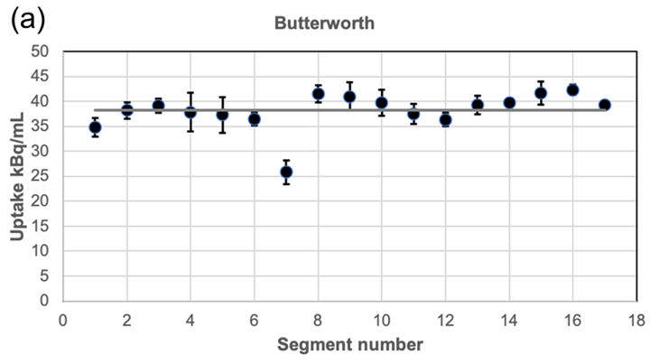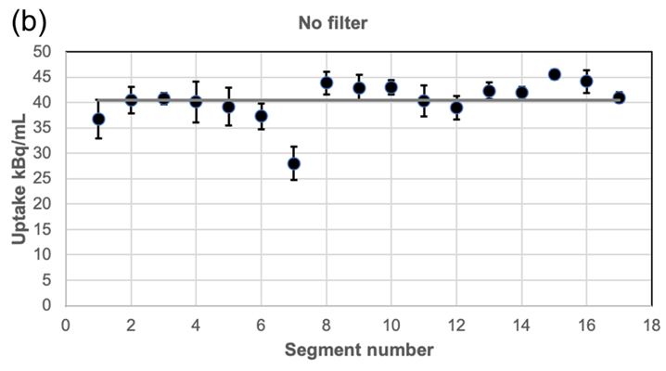
Fig. S1 Mean activity concentration for the defect per segment for the S-configuration, obtained with (a) and without (b) post-filtering. The grey line represents the mean of the 17 segments. The error bars indicate the standard deviation per segment obtained over 6 acquisitions.

