Comparison of image quality and spatial resolution between ¹⁸F, ⁶⁸Ga and ⁶⁴Cu phantom measurements using a digital Biograph Vision PET/CT

Authors
Anja Braune; University Hospital Carl Gustav Carus at the Technische Universität Dresden, Department of Nuclear Medicine, Dresden, Germany;
anja.braune@uniklinikum-dresden.de (corresponding author)
Liane Oehme; University Hospital Carl Gustav Carus at the Technische Universität Dresden, Department of Nuclear Medicine, Dresden, Germany;
liane.oehme@uniklinikum-dresden.de
Robert Freudenberg; University Hospital Carl Gustav Carus at the Technische Universität Dresden, Department of Nuclear Medicine, Dresden, Germany;
robert.freudenberg@uniklinikum-dresden.de
Frank Hofheinz; PET Center, Institute of Radiopharmaceutical Cancer Research, Helmholtz-Zentrum Dresden-Rossendorf, Dresden, Germany; hofheinz@hzdr.de
Jörg van den Hoff; PET Center, Institute of Radiopharmaceutical Cancer Research, Helmholtz-Zentrum Dresden-Rossendorf, Dresden, Germany; j.van_den_hoff@hzdr.de
Jörg Kotzerke; University Hospital Carl Gustav Carus at the Technische Universität Dresden, Medizinische Fakultat Carl Gustav Carus, Department of Nuclear Medicine, Dresden, Germany;
joerg.kotzerke@uniklinikum-dresden.de
Sebastian Hoberück; University Hospital Carl Gustav Carus at the Technische Universität Dresden, Department of Nuclear Medicine, Dresden, Germany;
Helios Klinikum Erfurt, Erfurt, Germany.
Sebastian.Hoberueck@uniklinikum-dresden.de

Keywords: PET/CT, ¹⁸F-FDG, ⁶⁸Ga, ⁶⁴Cu, NEMA PET Body phantom, Jaszczak phantom, spatial resolution, image quality

Journal: EJNMMI Physics

Attachment – Figure 1A: Transversal (left), coronal (middle), and sagittal plane of the NEMA PET Body phantom filled with ¹⁸F-FDG and illustration of the regions of interest.
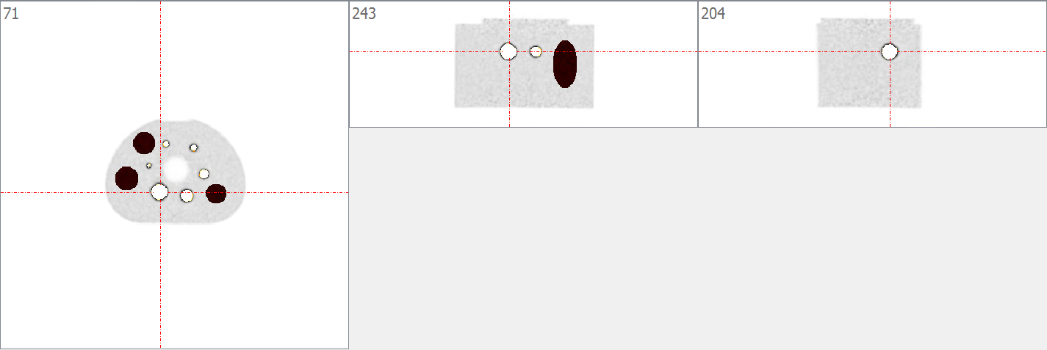
Figure Legend: Regions of interest of the spheres are shown in white and the three uniform background regions are shown in black. Regions of interest were used for semi-quantitative evaluation of image quality.

