Additional file 1
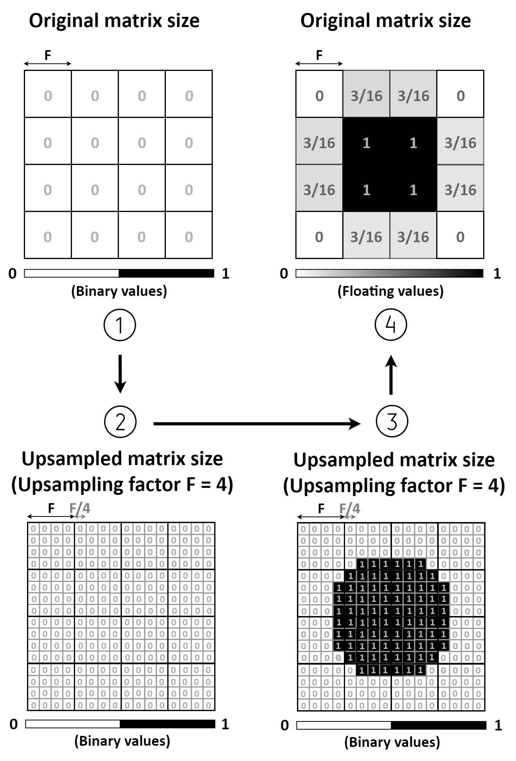
Figure S1: Schematic illustration of the modeling phase for the sphere mask generation.

